Alicia Cortez Elementary School

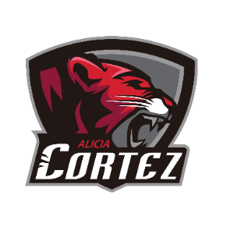

To the Cortez Community,

Welcome back to the 2021-2022 school year! I am so happy to be able to continue working on a campus with such dedicated staff, students, and parents. I know this year will be challenging and different, but we are so excited that we are back on campus and seeing our Cougars everyday!

The last two years have been challenging and we have grown as a community here at Cortez. I look forward to working with each and every one of you to support students here at Cortez. One of my main focuses this year will continue to be partnering with the families of Cortez to continue to build a collaborative, respectful community of persistent learners. With this in mind, I know that the teachers, students and parents will continue to push us towards our goals.

If you have any questions or concerns, please feel free to contact me so that I can assist you.

Sincerely,

Amy Fauce

Assistant Principal