Chapter 8
An Introduction to Metabolism
Lecture Outline
Overview: The Energy of Life
Concept 8.1 An organism’s metabolism transforms matter and energy, subject to the laws of thermodynamics.
- The totality of an organism’s chemical reactions is called metabolism.
- Metabolism is an emergent property of life that arises from interactions between molecules within the orderly environment of the cell.
The chemistry of life is organized into metabolic pathways.
- A metabolic pathway begins with a specific molecule, which is then altered in a series of defined steps to form a specific product.
- A specific enzyme catalyzes each step of the pathway.
- Catabolic pathways release energy by breaking down complex molecules to simpler compounds.
- A major pathway of catabolism is cellular respiration, in which the sugar glucose is broken down in the presence of oxygen to carbon dioxide and water.
- The energy released by catabolic pathways becomes available to do the work of the cell, such as ciliary beating or membrane transport.
- Anabolic pathways, also called biosynthetic pathways, consume energy to build complicated molecules from simpler compounds.
- The synthesis of protein from amino acids is an example of anabolism.
- Energy released from the downhill reactions of catabolic pathways can be stored and then used to drive the uphill reactions of anabolic pathways.
- Energy is fundamental to all metabolic processes, and therefore an understanding of energy is key to understanding how the living cell works.
- Bioenergetics is the study of how energy flows through living organisms.
Organisms transform energy.
- Energy is the capacity to cause change.
- In everyday life, some forms of energy can be used to do work—that is, to move matter against opposing forces, such as gravity and friction.
- Energy exists in various forms, and cells transform energy from one type to another.
- Kinetic energy is the energy associated with the relative motion of objects.
- Objects in motion can perform work by imparting motion to other matter.
- Heat or thermal energy is kinetic energy associated with the random movement of atoms or molecules.
- Photons of light can be captured and their energy harnessed to power photosynthesis in green plants.
- Potential energy is the energy that matter possesses because of its location or structure.
- Water behind a dam possesses energy because of its altitude above sea level.
- Molecules possess energy because of the arrangement of their atoms.
- Chemical energy is a form of potential energy stored in molecules because of the arrangement of their atoms.
- Energy can be converted from one form to another.
- For example, as a boy climbs stairs to a diving platform, he is releasing chemical energy stored in his cells from the food he ate for lunch.
- The kinetic energy of his muscle movement is converted to potential energy as he climbs.
- As the boy dives, the potential energy is converted back to kinetic energy.
- Kinetic energy is transferred to the water as the boy enters it.
- Some energy is converted to heat due to friction.
The energy transformations of life are subject to two laws of thermodynamics.
- Thermodynamics is the study of energy transformations that occur in a collection of matter.
- In this field, the term system refers to the matter under study, and the surroundings include the rest of the universe—everything outside the system.
- An isolated system, approximated by liquid in a thermos, is unable to exchange either energy or matter with its surroundings.
- In an open system, energy and matter can be transferred between the system and its surroundings.
- Organisms are open systems: They absorb energy—light or chemical energy in the form of organic molecules—and release heat and metabolic waste products, such as urea or CO₂, to their surroundings.
- The first law of thermodynamics states that the energy of the universe is constant:
Energy can be transferred and transformed, but it cannot be created or destroyed.
- The first law is also known as the principle of conservation of energy.
- Plants do not produce energy; they transform light energy to chemical energy.
- During every transfer or transformation of energy, some energy is converted to heat, which is the energy associated with the random movement of atoms and molecules.
- A system can use heat to do work only when there is a temperature difference that results in heat flowing from a warmer location to a cooler one.
- If temperature is uniform, as in a living cell, heat can be used only to warm the organism.
- Energy transfers and transformations make the universe more disordered due to the loss of usable energy.
- Entropy is a measure of disorder or randomness: The more random a collection of matter, the greater its entropy.
- The second law of thermodynamics states:
Every energy transfer or transformation increases the entropy of the universe.
- Although order can increase locally, there is an unstoppable trend toward randomization of the universe.
- Much of the increased entropy of the universe takes the form of increasing heat, which is the energy of random molecular motion.
- In most energy transformations, ordered forms of energy are converted at least partly to heat.

- Automobiles convert only 25% of the energy in gasoline to motion; the rest is lost as heat.
- Living cells unavoidably convert organized forms of energy to heat.
- For a process to occur on its own, without outside help in the form of energy input, it must increase the entropy of the universe.
- The word spontaneous describes a process that can occur without an input of energy.
- Spontaneous processes need not occur quickly.
- Some spontaneous processes are instantaneous, such as an explosion. Some are very slow, such as the rusting of an old car.
- A process that cannot occur on its own is said to be nonspontaneous; it will happen only if energy is added to the system.
- Water flows downhill spontaneously but moves uphill only with an input of energy, such as when a machine pumps the water against gravity.
- Here is another way to state the second law of thermodynamics:
For a process to occur spontaneously, it must increase the entropy of the universe.
- Living systems increase the entropy of their surroundings, even though they create ordered structures from less ordered starting materials.
- For example, amino acids are ordered into polypeptide chains.
- The structure of a multicellular body is organized and complex.
- However, an organism also takes in organized forms of matter and energy from its surroundings and replaces them with less ordered forms.
- For example, an animal consumes organic molecules as food and catabolizes them to low-energy carbon dioxide and water.
- Over evolutionary time, complex organisms have evolved from simpler ones.
- This increase in organization does not violate the second law of thermodynamics.
- The entropy of a particular system, such as an organism, may decrease as long as the total entropy of the universe—the system plus its surroundings—increases.
- Organisms are islands of low entropy in an increasingly random universe.

Concept 8.2 The free-energy change of a reaction tells us whether the reaction occurs spontaneously.

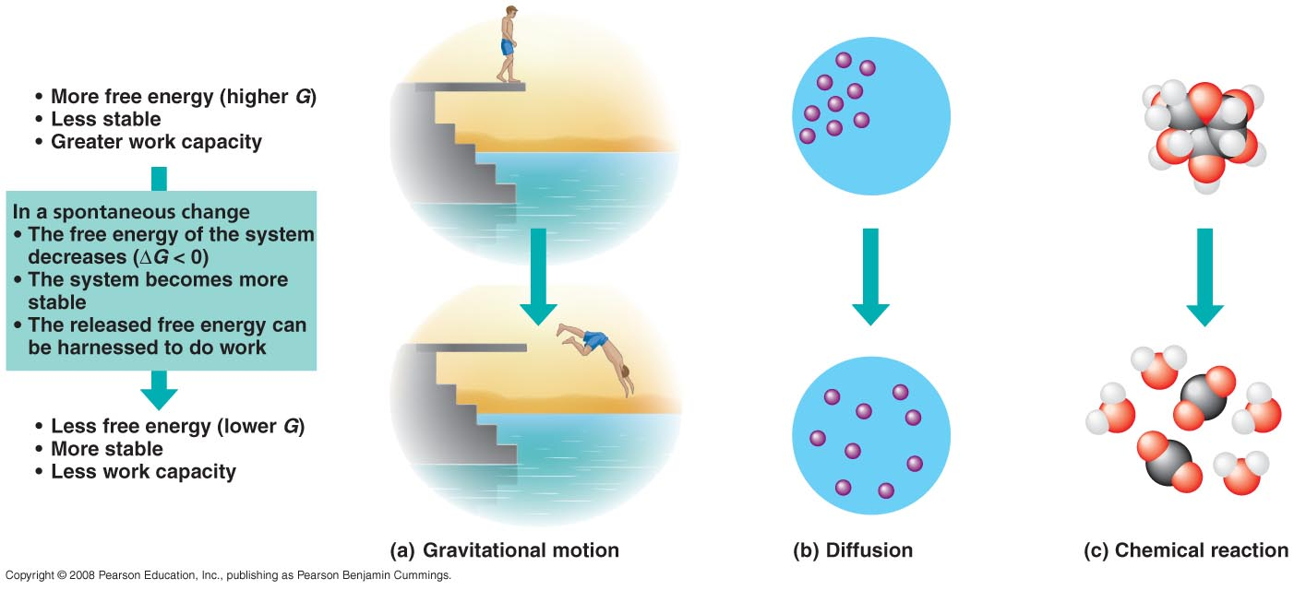
- How can we determine which reactions occur spontaneously and which ones require an input of energy?
- The concept of free energy (symbolized by the letter G) is useful for measuring the spontaneity of a system.
- Free energy is the portion of a system’s energy that can perform work when temperature and pressure are uniform throughout the system, as in a living cell.
- The change in free energy, ∆G, can be calculated for any specific chemical reaction with the formula
∆G = ∆H – T∆S
- In this formula, ∆H symbolizes the change in the system’s enthalpy (in biological systems, equivalent to total energy); ∆S is the change in the system’s entropy; and T is the absolute temperature in Kelvin (K) units (K = °C + 273).
- For a process to occur spontaneously, the system must give up enthalpy ([H] must decrease), give up order (TS must increase), or both.
- ∆G must have a negative value (∆G < 0) in order for a process to be spontaneous.
- Knowing the value of ΔG gives biologists the power to predict which kinds of change can happen without help.
- Such spontaneous changes can be harnessed to perform work.
- This information is important in the study of metabolism, where a major goal is to determine which reactions can supply energy to do work in the living cell.
- In any spontaneous process, the free energy of a system decreases (∆G is negative).
- We can represent the change in free energy from the start to the finish of a process by
ΔG = G_{final state} − G_{starting state}
- ∆G can be negative only when the process involves a loss of free energy during the change from initial state to final state.
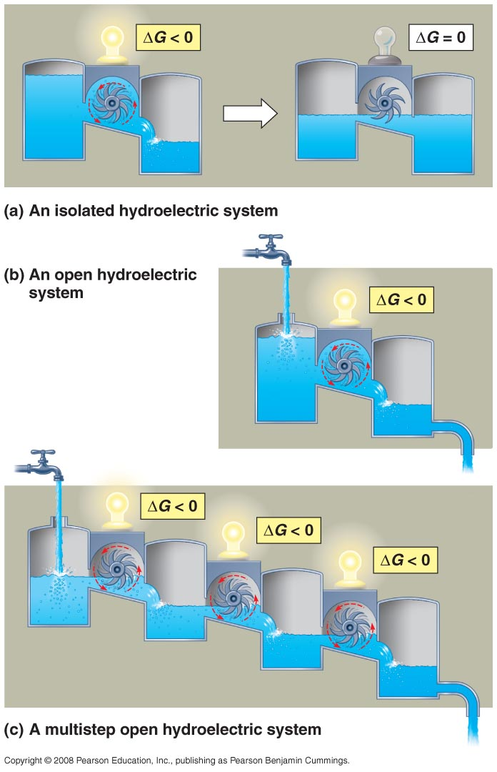
- Because it has less free energy, the system in its final state is less likely to change and is therefore more stable than it was previously.
- A system at equilibrium is at maximum stability.
- Unstable systems (higher G) tend to change in such a way that they become more stable (lower G).
- Another term for a state of maximum stability is equilibrium.
- In a chemical reaction at equilibrium, the rates of forward and backward reactions are equal, and there is no change in the relative concentrations of products or reactants.
- At equilibrium, ΔG = 0, and the system can do no work.
- A process is spontaneous and can perform work only when it is moving toward equilibrium.
- Movements away from equilibrium are nonspontaneous and require the addition of energy from an outside energy source (the surroundings).
- Chemical reactions can be classified as either exergonic or endergonic.
- An exergonic reaction proceeds with a net release of free energy; ΔG is negative.
- The magnitude of ΔG for an exergonic reaction is the maximum amount of work the reaction can perform.
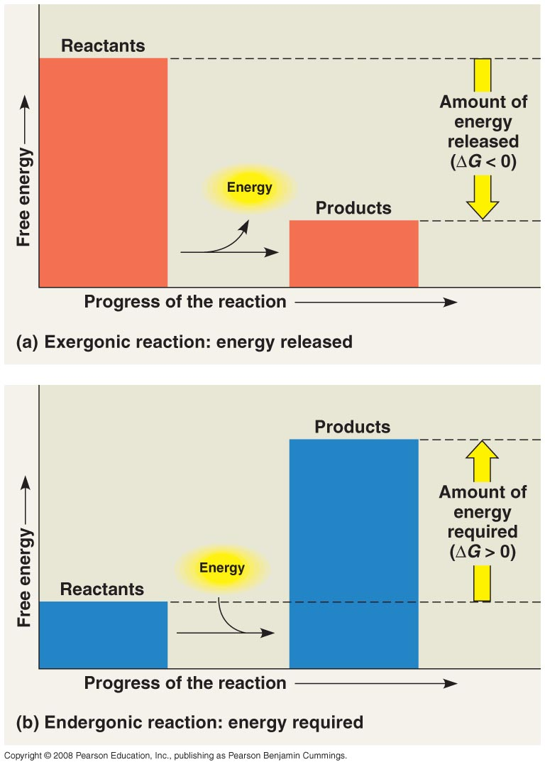
- The greater the decrease in free energy, the greater the amount of work that can be done.
- For the overall reaction of cellular respiration, C₆H₁₂O₆ + 6O₂ → 6CO₂ + 6H₂O, ΔG = −686 kcal/mol.
- For each mole (180 g) of glucose broken down by respiration under standard conditions (1 M of each reactant and product, 25°C, pH 7), 686 kcal of energy are made available to do work in the cell.
- The products have 686 kcal less free energy per mole than the reactants.
- An endergonic reaction is one that absorbs free energy from its surroundings.
- Endergonic reactions store energy in molecules; ΔG is positive.
- Endergonic reactions are nonspontaneous, and the magnitude of ΔG is the quantity of energy required to drive the reaction.
- If cellular respiration releases 686 kcal/mol, then photosynthesis, the reverse reaction, must require an equivalent investment of energy.
- For the conversion of carbon dioxide and water to sugar, ΔG = +686 kcal/mol.
- Photosynthesis is strongly endergonic, powered by the absorption of light energy.
- Reactions in an isolated system eventually reach equilibrium and can do no work.
- A cell that has reached metabolic equilibrium has a ΔG = 0 and is dead!
- Metabolic disequilibrium is one of the defining features of life.
- Cells maintain disequilibrium because they are open systems. The constant flow of materials into and out of the cell keeps metabolic pathways from ever reaching equilibrium.
- A cell continues to do work throughout its life.
- A catabolic process in a cell releases free energy in a series of reactions, not in a single step.
- Some reversible reactions of respiration are constantly “pulled” in one direction, as the product of one reaction does not accumulate but becomes the reactant in the next step.
- The overall sequence of reactions is kept going by the huge free-energy difference between glucose and oxygen at the top of the energy “hill” and carbon dioxide and water at the “downhill” end.
- As long as cells have a steady supply of glucose or other fuels and oxygen and can expel waste products to the surroundings, their metabolic pathways never reach equilibrium and can continue to do the work of life.
- Sunlight provides a daily source of free energy for photosynthetic organisms.
- Nonphotosynthetic organisms depend on a transfer of free energy from photosynthetic organisms in the form of organic molecules.

Concept 8.3 ATP powers cellular work by coupling exergonic reactions to endergonic reactions.
- A cell does three main kinds of work:
- Chemical work, pushing endergonic reactions such as the synthesis of polymers from monomers
- Transport work, pumping substances across membranes against the direction of spontaneous movement
- Mechanical work, such as the beating of cilia, contraction of muscle cells, and movement of chromosomes during cellular reproduction
- Cells manage their energy resources to do this work by energy coupling, using an exergonic process to drive an endergonic one.
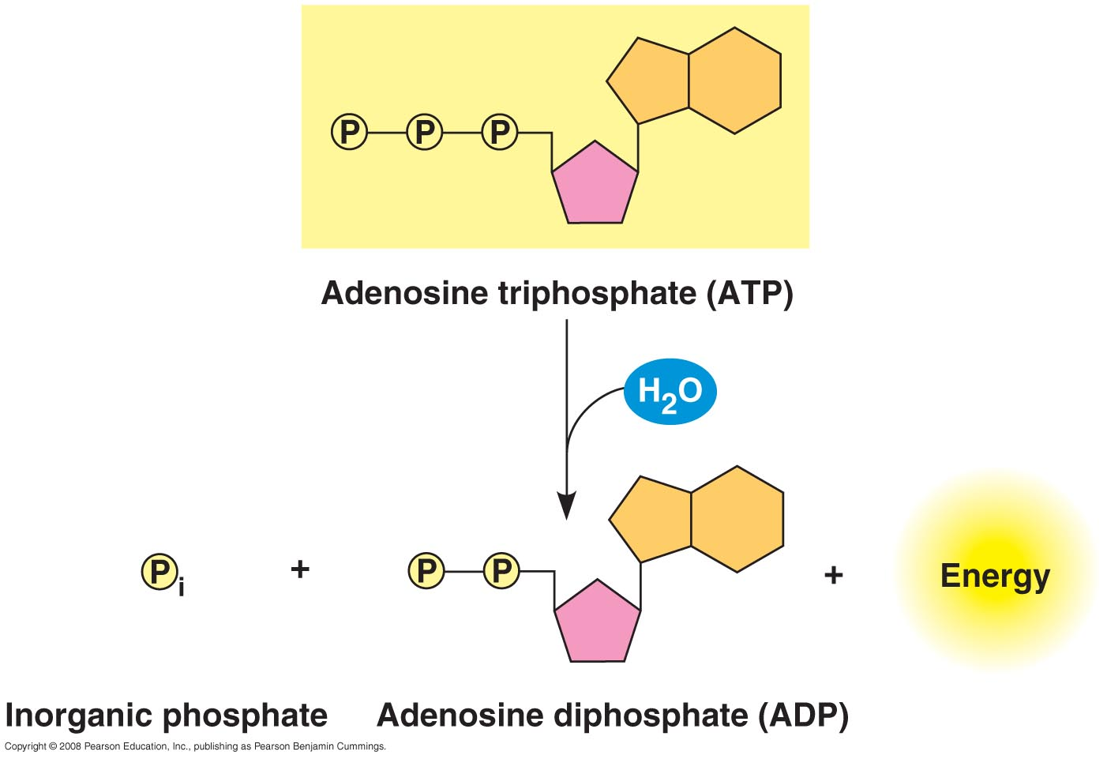
- ATP is responsible for mediating most energy coupling in cells, and in most cases it acts as the immediate source of energy that powers cellular work.
- ATP (adenosine triphosphate) is a nucleotide triphosphate consisting of the sugar ribose, the nitrogenous base adenine, and a chain of three phosphate groups.
- The bonds between the phosphate groups on ATP can be broken by hydrolysis.
- When the terminal phosphate bond is broken, a molecule of inorganic phosphate (HOPO₃²⁻, abbreviated P_{i} here) leaves ATP, which then becomes adenosine diphosphate, or ADP:
ATP + H₂O → ADP + P_{i}
- Under standard conditions, ∆G = −7.3 kcal/mol (−30.5 kJ/mol).
- In the cell, ΔG for the hydrolysis of ATP is about −13 kcal/mol because reactant and product concentrations differ from 1 M.
- Although the phosphate bonds of ATP are sometimes referred to as high-energy phosphate bonds, these are actually fairly weak covalent bonds.
- The reactants (ATP and water) themselves have high energy relative to the energy of the products (ADP and P_{i}).
- The release of energy during the hydrolysis of ATP comes from the chemical change to a state of lower free energy, not from the phosphate bonds themselves.
- Why does the hydrolysis of ATP yield so much energy?
- Each of the three phosphate groups has a negative charge.
- These three like charges are crowded together, and their mutual repulsion contributes to the instability of this region of the ATP molecule.
- The triphosphate tail of ATP is the chemical equivalent of a compressed spring.
- In the cell, the energy from the hydrolysis of ATP is directly coupled to endergonic processes by the transfer of the phosphate group to another molecule.
- This recipient molecule is now phosphorylated; it is more reactive (less stable) than the original unphosphorylated molecules.
- Mechanical, transport, and chemical work in the cell are nearly always powered by the hydrolysis of ATP.
- In each case, ATP hydrolysis leads to a change in a protein’s shape and often its ability to bind another molecule.
- This change may occur via a phosphorylated intermediate.
- In most examples of mechanical work involving motor proteins “walking” on cytoskeletal elements, a cycle occurs in which ATP is bound noncovalently to the motor protein and hydrolyzed, then ADP and P_{i} are released, followed by binding of another ATP molecule.
- In each state, the motor protein exhibits a different shape and ability to bind the cytoskeleton, resulting in movement of the protein along the cytoskeletal track.
- Although organisms use ATP continuously, ATP is a renewable resource that can be regenerated by the addition of a phosphate group to ADP.
- The free energy to phosphorylate ADP comes from exergonic (catabolic) reactions in the cell.
- The ATP cycle, the shuttling of inorganic phosphate and energy, couples the cell’s energy-yielding (exergonic) processes to the energy-consuming (endergonic) ones.
- A working muscle cell recycles its entire pool of ATP once each minute.
- More than 10 million ATP molecules are consumed and regenerated per second per cell.
- Regeneration of ATP is an endergonic process, requiring an investment of energy:
ADP + P_{i} → ATP + H₂O
where ΔG = +7.3 kcal/mol, under standard conditions.
- Catabolic (exergonic) pathways, especially cellular respiration, provide the energy for the endergonic regeneration of ATP.
- Plants also use light energy to produce ATP.
- The chemical potential energy temporarily stored in ATP drives most cellular work.

Concept 8.4 Enzymes speed up metabolic reactions by lowering energy barriers.
- Spontaneous chemical reactions may occur so slowly as to be imperceptible.
- The hydrolysis of table sugar (sucrose) to glucose and fructose is exergonic, with ΔG = −7 kcal/mol.
- Despite this, a solution of sucrose dissolved in sterile water may sit for years at room temperature with no appreciable hydrolysis.
- If a small amount of the enzyme sucrase is added to a solution of sugar, all the sucrose is hydrolyzed within seconds.
- An enzyme is a macromolecule that acts as a catalyst, a chemical agent that speeds up the rate of a reaction without being consumed by the reaction.
- Here we will focus on protein enzymes.
- Enzymes regulate metabolic pathways.
- Every chemical reaction involves bond breaking and bond forming.
- To hydrolyze sucrose, the bond between glucose and fructose must be broken and new bonds must form with hydrogen and hydroxyl ions from water.
- To reach a state at which bonds can break and reform, reactant molecules must absorb energy from their surroundings. When the new bonds of the product molecules form, energy is released as heat as the molecules assume stable shapes with lower energy.
- The initial investment of energy for starting a reaction is the free energy of activation, or activation energy (E_{A}).
- Activation energy is the amount of energy necessary to push the reactants over an energy barrier so that the “downhill” part of the reaction can begin.
- Consider a hypothetical exergonic reaction that swaps portions of two reactant molecules:
AB + CD → AC + BD
- The energizing, or activation, of the reactants is represented by the uphill portion of the graph, with the free-energy content of the reactant molecules increasing.
- At the summit, the molecules are in an unstable condition, the transition state; they are activated and their bonds can be broken.
- The bond-forming phase of the reaction corresponds to the downhill part of the curve, which shows the loss of free energy by the molecules.
- Activation energy may be supplied in the form of heat that the reactant molecules absorb from the surroundings.
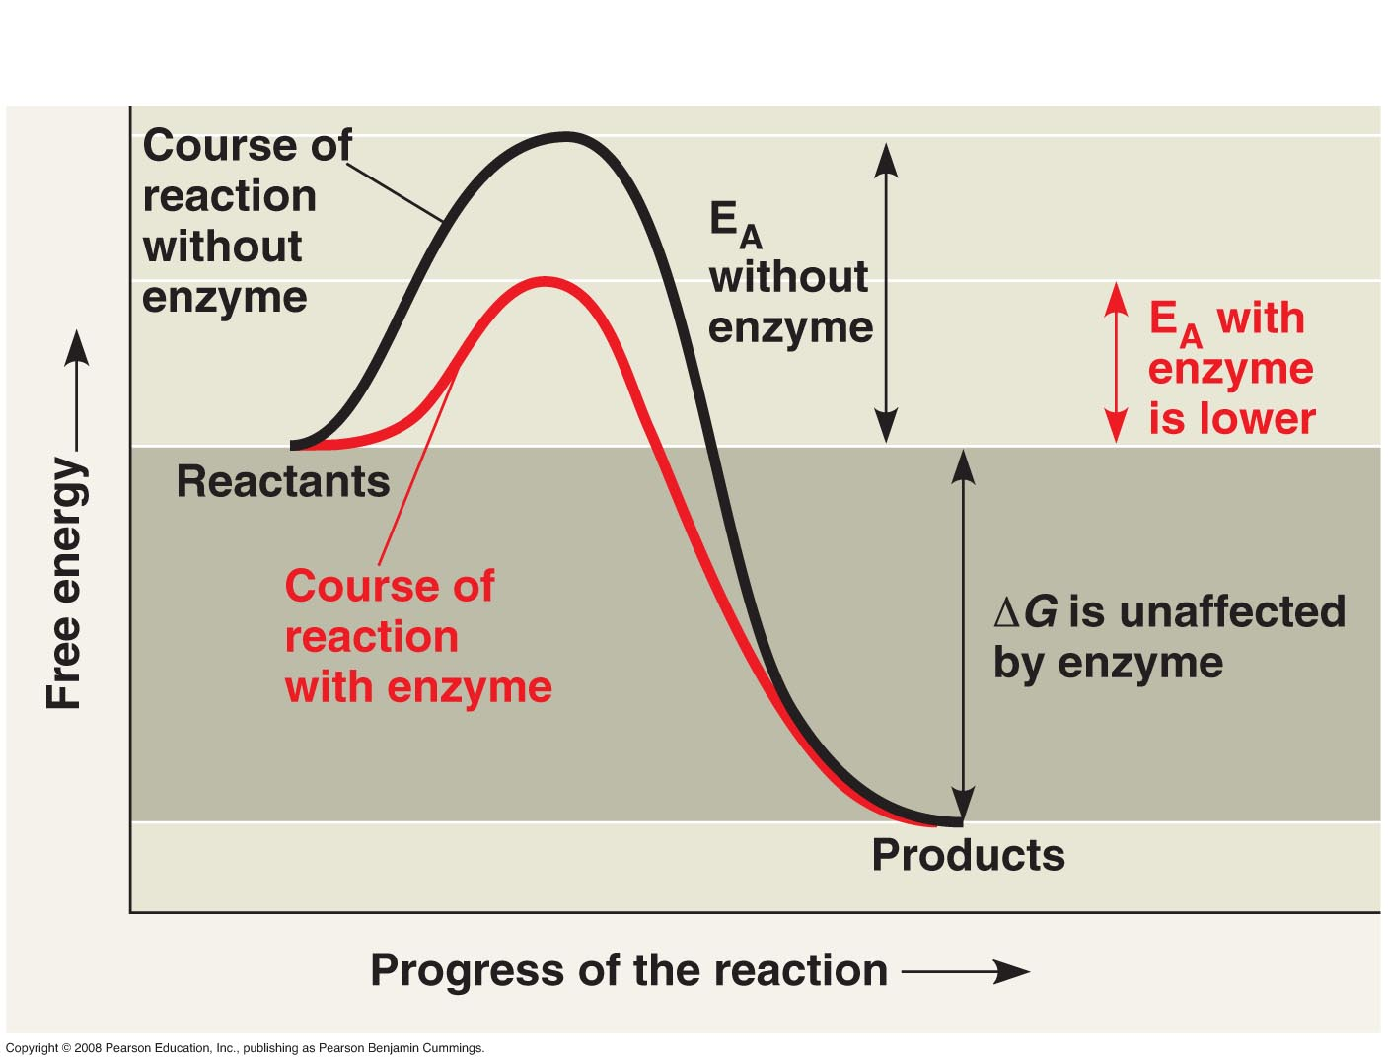
- The bonds of the reactants break only when the molecules have absorbed enough energy to become unstable and, therefore, more reactive.
- The absorption of thermal energy increases the speed of the reactant molecules so that they collide more often and more forcefully.
- Thermal agitation of the atoms in the molecules makes bonds more likely to break.
- As the molecules settle into new, stable bonding arrangements, energy is released to the surroundings.
- In exergonic reactions, the activation energy is released back to the surroundings, and additional energy is released with the formation of new bonds.
- For some processes, E_{A} is not high, and the thermal energy provided by room temperature is sufficient for many reactants to reach the transition state.
- In most cases, E_{A} is high enough that the transition state is rarely reached and the reaction hardly proceeds at all. In these cases, the reaction will occur at a noticeable rate only if the reactants are heated.
- A spark plug provides the activation energy to energize a gasoline-oxygen mixture and cause combustion.
- Without a spark, the hydrocarbons of gasoline are too stable to react with oxygen.
- Proteins, DNA, and other complex organic molecules are rich in free energy. Their hydrolysis is spontaneous, with the release of large amounts of energy.
- However, there is not enough energy at the temperatures typical of the cell for the vast majority of organic molecules to make it over the hump of activation energy.
- How are the barriers for selected reactions surmounted to allow cells to carry out the processes of life?
- Heat would speed up reactions, but it would also denature proteins and kill cells.
- Enzymes speed reactions by lowering E_{A}. The transition state can then be reached even at moderate temperatures.
- Enzymes do not change ΔG; they hasten reactions that would occur eventually.
- Because enzymes are so selective, they determine which chemical processes will occur at any time.
Enzymes are substrate specific.
- The reactant that an enzyme acts on is the substrate.
- The enzyme binds to a substrate, or substrates, forming an enzyme-substrate complex.
- While the enzyme and substrate are bound, the catalytic action of the enzyme converts the substrate to the product or products.
- The reaction catalyzed by each enzyme is very specific.
- What accounts for this molecular recognition? The specificity of an enzyme results from its three-dimensional shape, which is a consequence of its amino acid sequence.
- Only a restricted region of the enzyme binds to the substrate.
- The active site of an enzyme is typically a pocket or groove on the surface of the protein where catalysis occurs.
- The active site is usually formed by only a few amino acids.
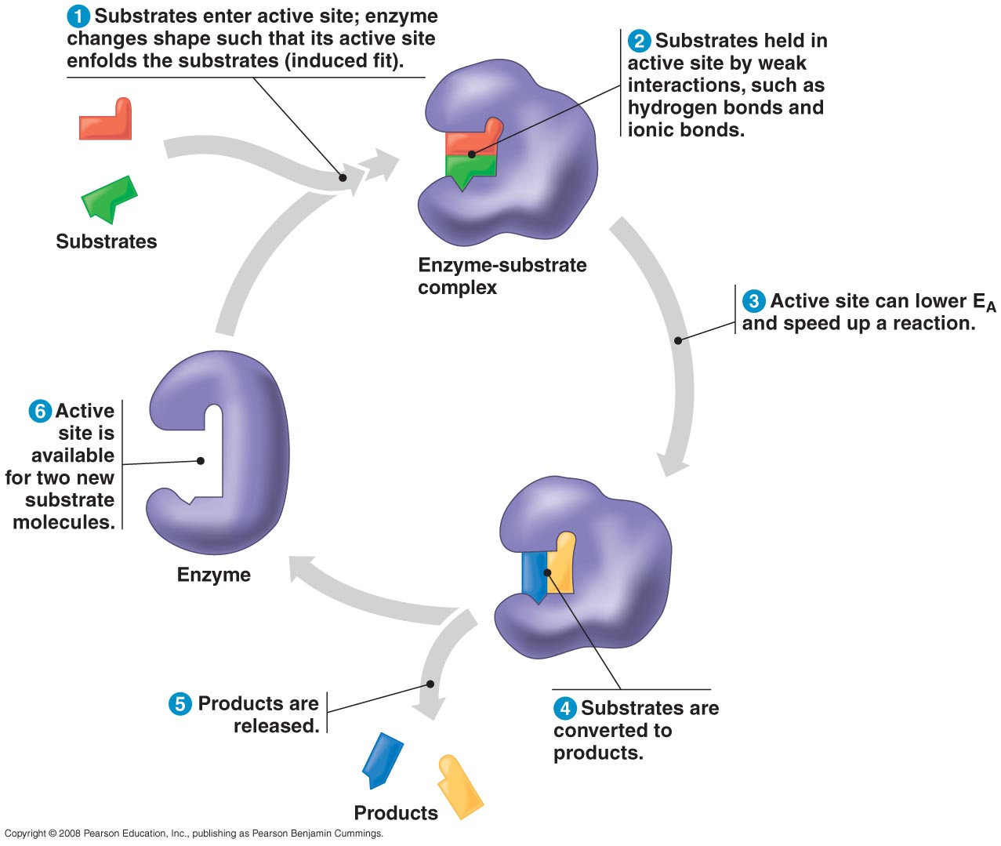
- The rest of the protein molecule provides a framework that determines the configuration of the active site.
- The specificity of an enzyme is due to the fit between the active site and the substrate.
- The active site is not a rigid receptacle for the substrate.
- As the substrate enters the active site, interactions between the chemical groups on the substrate and those on the R groups (side chains) of the amino acids of the protein cause the enzyme to change shape slightly.
- This change leads to an induced fit that brings the chemical groups of the active site into position to catalyze the reaction.
The active site is an enzyme’s catalytic center.
- In most cases, substrates are held in the active site by weak interactions, such as hydrogen bonds and ionic bonds.
- The R groups of a few amino acids on the active site catalyze the conversion of substrate to product.
- The product then leaves the active site.
- A single enzyme molecule can catalyze thousands of reactions a second.
- Enzymes are unaffected by the reaction and are reusable.
- Most metabolic enzymes can catalyze a reaction in both the forward and reverse directions.
- The actual direction depends on the relative concentrations of products and reactants.
- Enzymes catalyze reactions in the direction of equilibrium.
- Enzymes use a variety of mechanisms to lower the activation energy and speed up a reaction.
- In reactions involving more than one reactant, the active site brings substrates together in the correct orientation for the reaction to proceed.
- As the active site binds the substrate, the enzyme may stretch the substrate molecules toward their transition-state form, stressing and bending critical chemical bonds that must be broken during the reaction.
- The R groups at the active site may create a microenvironment that is conducive to a specific reaction.
- An active site may be a pocket of low pH, facilitating H⁺ transfer to the substrate as a key step in catalyzing the reaction.
- Enzymes may briefly bind covalently to substrates.
- Subsequent steps of the reaction restore the R groups within the active site to their original state.
- The rate at which a specific number of enzymes convert substrates to products depends in part on substrate concentrations.
- At low substrate concentrations, an increase in substrate concentration speeds binding to available active sites.
- There is a limit to how fast a reaction can occur, however.
- At high substrate concentrations, the active sites on all enzymes are engaged.
- The enzyme is saturated, and the rate of the reaction is determined by the speed at which the active site can convert substrate to product.
- The only way to increase productivity at this point is to add more enzyme molecules.
A cell’s physical and chemical environment affects enzyme activity.
- The activity of an enzyme is affected by general environmental conditions, such as temperature and pH.
- Each enzyme works best at certain optimal conditions, which favor the most active conformation for the enzyme molecule.
- Temperature has a major impact on reaction rate.
- As temperature increases, collisions between substrates and active sites occur more frequently as molecules move more rapidly.
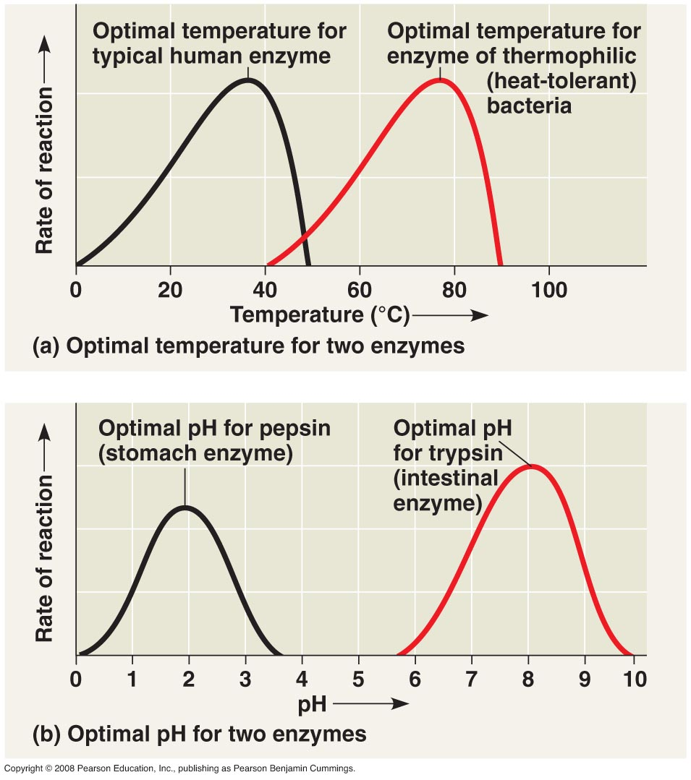
- As temperature increases further, thermal agitation begins to disrupt the weak bonds that stabilize the protein’s active conformation, and the protein denatures.
- Each enzyme has an optimal temperature that allows the greatest number of molecular collisions and the fastest conversion of the reactants to product molecules.
- Most human enzymes have optimal temperatures of about 35–40°C.
- The thermophilic bacteria that live in hot springs contain enzymes with optimal temperatures of 70°C or higher.
- Each enzyme also has an optimal pH.
- Maintenance of the active conformation of the enzyme requires a particular pH.
- This optimal pH falls between 6 and 8 for most enzymes.
- However, digestive enzymes in the stomach are designed to work best at pH 2, whereas those in the intestine have an optimal pH of 8.
- Many enzymes require nonprotein helpers, called cofactors, for catalytic activity.
- Cofactors bind permanently or reversibly to the enzyme.
- Some inorganic cofactors are zinc, iron, and copper in ionic form.
- Organic cofactors are called coenzymes.
- Most vitamins are coenzymes or the raw materials from which coenzymes are made.
Binding by inhibitors prevents enzymes from catalyzing reactions.
- Certain chemicals selectively inhibit the action of specific enzymes.
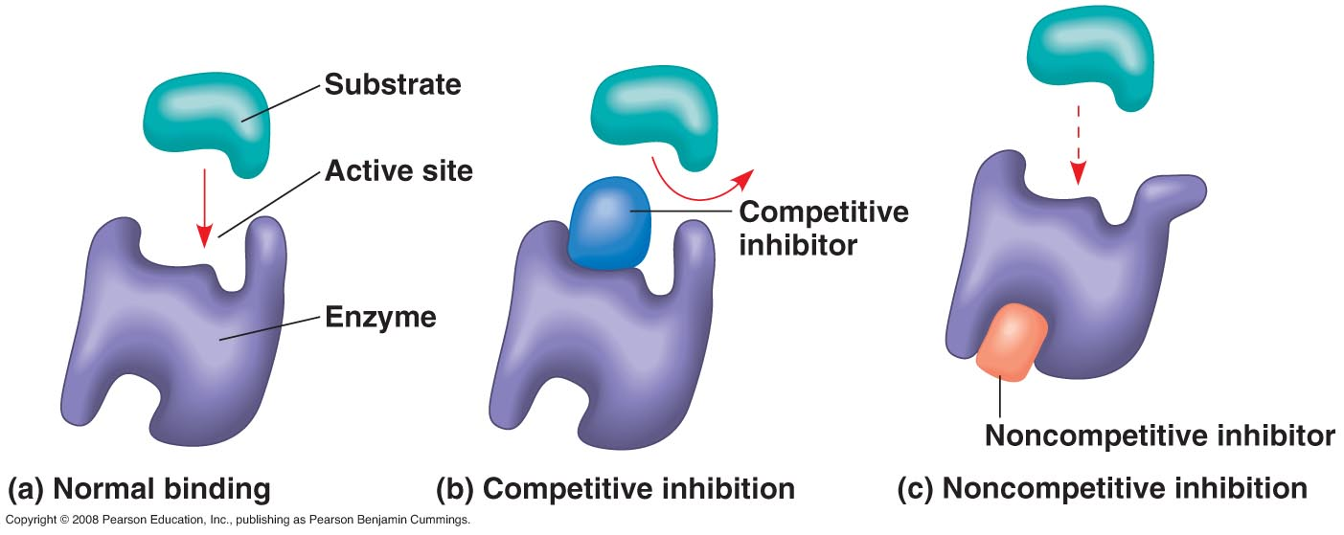
- If inhibitors attach to the enzyme by covalent bonds, inhibition may be irreversible.
- If inhibitors bind by weak bonds, inhibition may be reversible.
- Some reversible inhibitors resemble the substrate and compete for binding to the active site. These molecules are called competitive inhibitors.
- Competitive inhibition can be overcome by increasing the concentration of the substrate.
- Noncompetitive inhibitors impede enzymatic reactions by binding to another part of the molecule.
- Binding by the inhibitor causes the enzyme to change shape, rendering the active site less effective at catalyzing the reaction.
- Toxins and poisons are often irreversible enzyme inhibitors.
- Sarin, the nerve gas that was released by terrorists in the Tokyo subway in 1995, binds covalently to the R group on the amino acid serine.
- Serine is found in the active site of acetylcholinesterase, an important nervous system enzyme.
- DDT acts as a pesticide by inhibiting key enzymes in the nervous system of insects.
- Many antibiotics are inhibitors of specific enzymes in bacteria.
- Penicillin blocks the active site of an enzyme that many bacteria use to make their cell walls.
- Not all enzyme inhibitors are metabolic poisons.
- Molecules naturally present in the cell often regulate enzyme activity by acting as inhibitors.
- Such regulation—selective inhibition—is essential to the control of cellular metabolism.

Concept 8.5 Regulation of enzyme activity helps control metabolism.
Metabolic control often depends on allosteric regulation.
- Many molecules that naturally regulate enzyme activity behave like reversible noncompetitive inhibitors.
- In allosteric regulation, a protein’s function at one site is affected by the binding of a regulatory molecule to a separate site.
- This regulation may result in either inhibition or stimulation of an enzyme’s activity.
- Most allosterically regulated enzymes are constructed of two or more polypeptide chains.
- Each subunit has its own active site.
- The complex oscillates between two shapes, one catalytically active and the other inactive.
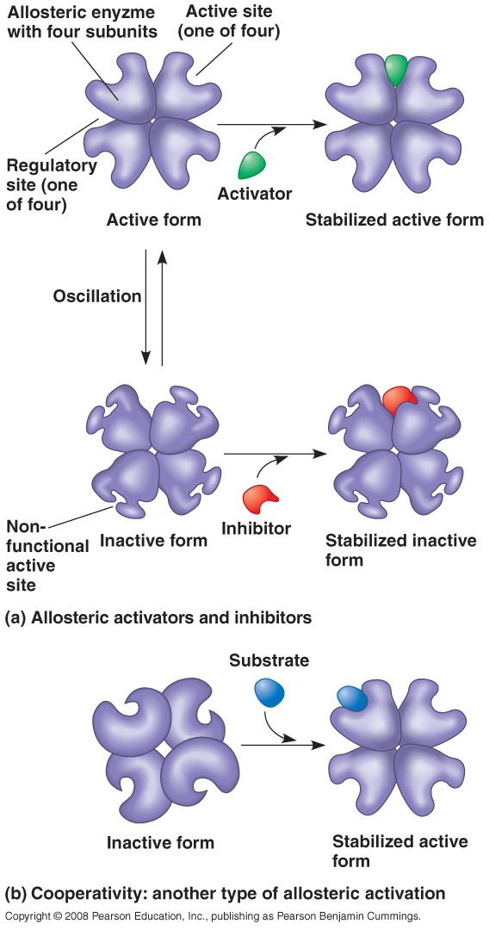
- In the simplest case of allosteric regulation, an activating or inhibiting regulatory molecule binds to a regulatory site (sometimes called an allosteric site), often located where subunits join.
- The binding of an activator stabilizes the conformation that has functional active sites, whereas the binding of an inhibitor stabilizes the inactive form of the enzyme.
- As the chemical conditions in the cell shift, the pattern of allosteric regulation may shift as well.
- By binding to key enzymes, the reactants and products of ATP hydrolysis may play a major role in balancing the flow of traffic between anabolic and catabolic pathways.
- For example, ATP binds to several catabolic enzymes allosterically, inhibiting their activity by lowering their affinity for substrate.
- ADP functions as an activator of the same enzymes.
- ATP and ADP also affect key enzymes in anabolic pathways.
- In this way, allosteric enzymes control the rates of key reactions in metabolic pathways.
- In enzymes with multiple catalytic subunits, binding by a substrate to one active site by induced fit triggers the same favorable conformational changes at all other subunits.
- This mechanism, called cooperativity, amplifies the response of enzymes to substrates, priming the enzyme to accept additional substrates.
- The vertebrate oxygen-transport protein hemoglobin is a classic example of cooperativity.
- Hemoglobin is made up of four subunits, each with an oxygen-binding site.
- The binding of an oxygen molecule to each binding site increases the affinity for oxygen of the remaining binding sites.
- Under conditions of low oxygen, as in oxygen-deprived tissues, hemoglobin is less likely to bind oxygen and releases it where it is needed.
- When oxygen is at higher levels, as in the lungs or gills, the protein has a greater affinity for oxygen as more binding sites are filled.
- Although allosteric regulation is probably widespread, relatively few of the many known metabolic enzymes are known to be regulated in this way.
- Allosteric regulatory molecules tend to bind the enzyme at low affinity and are thus hard to isolate.
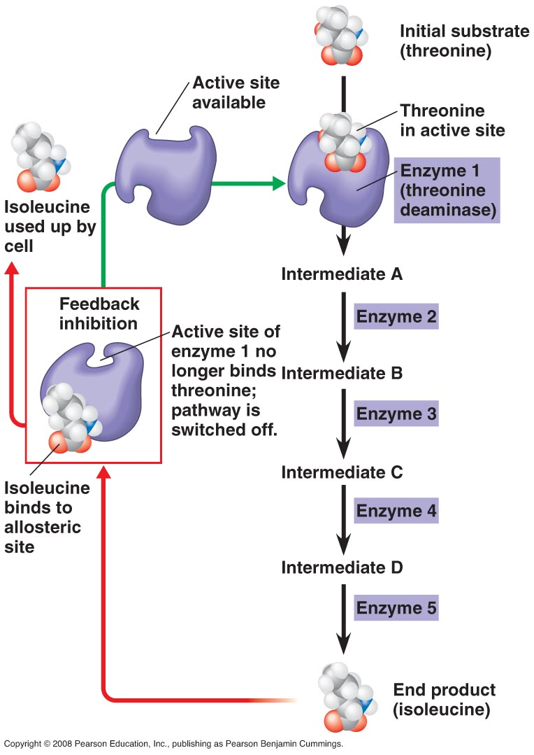
- Pharmaceutical companies are turning their attention to allosteric regulators.
- Allosteric regulators exhibit higher specificity for particular enzymes than do inhibitors that bind to the active site.
- An active site may be similar to that in another, related enzyme, whereas allosteric regulatory sites appear to be quite distinct between enzymes.
- A common method of metabolic control is feedback inhibition.
- An early step in a metabolic pathway is switched off by inhibitory binding of the pathway’s final product to an enzyme acting early in the pathway.
- Feedback inhibition prevents a cell from wasting chemical resources by synthesizing more product than is needed.
The localization of enzymes within a cell helps order metabolism.
- The cell is compartmentalized: The organization of cellular structures helps bring order to metabolic pathways.
- A team of enzymes for several steps of a metabolic pathway may be assembled as a multienzyme complex.
- The product from the first reaction becomes the substrate for an adjacent enzyme in the complex until the final product is released.
- Some enzymes and enzyme complexes have fixed locations within the cells as structural components of particular membranes.
- Others are confined within membrane-enclosed eukaryotic organelles.
- Metabolism, the intersecting set of chemical pathways characteristic of life, is a choreographed interplay of thousands of different kinds of cellular molecules.

