 | Parent Function
Standard Form:  *A, B and C must be integers  *A must be positive  Point Slope Form:  Slope Intercept Form:  y-intercept:  substitute zero for x, and solve for y.  x-intercepts:  Substitute zero for y, solve for x.  Range:  Domain:  Slope Formula:  Midpoint Formula:  Distance Formula: | 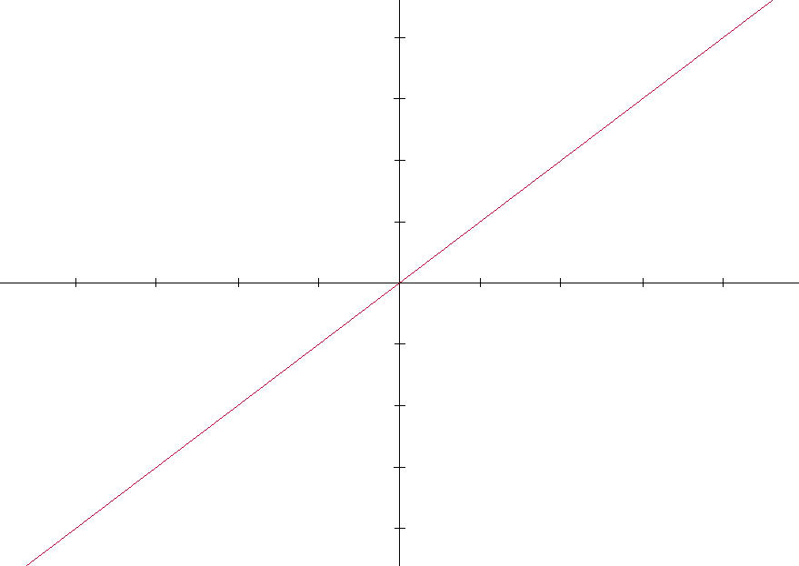
Special Cases

The equation for a vertical line looks like :
Slope of a vertical line is undefined

The equation for a horizontal line looks like:
Slope of a horizontal line is 0
LINEAR FUNCTIONS

