Vertex Form: | Parent Function
Opens:  If a > 0, the function opens up.  If a < 0, the function opens down.  Vertex: (h,k)  y-intercept:  If the function is written in general form , the y-intercept is (0,c). Otherwise, substitute zero for x, and solve for y.  x-intercepts:  Substitute zero for y, solve for x. Solve by factoring, using the quadratic formula, or by completing the square.  Range:  If a > 0, the range is .  If a < 0, the range is  Domain: | 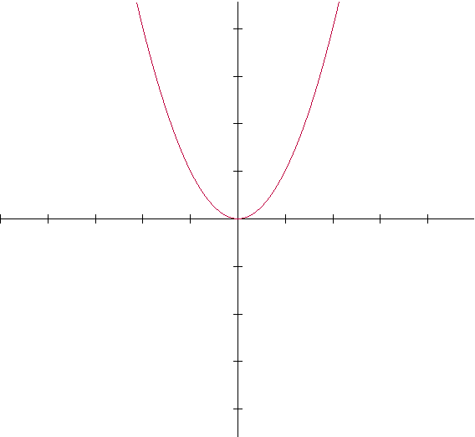
Quadratic Formula

Axis of Symmetry

Maximum or Minimum Value
is the y-value of the vertex.
QUADRATIC FUNCTIONS

