Standard Form: | Parent Function
Behavior of Curve: If a>0, moves upward  If a<0, moves downward  Point of Origin: (h,k) *There are special  cases, in that case, find the  domain of the function first.  y-intercept: Substitute zero for x, solve for y.  x-intercept: Substitute zero for y, solve for x.  Range: If a>0, the range is .  If a<0, the range is  Domain: If the x term has a coefficient of 1,  the domain is . Otherwise,  find the domain by solving an  inequality. Set the radicand  to zero and solve. If the radicand is  a polynomial, a polynomial  inequality must be solved by  finding all critical points and  testing intervals. | 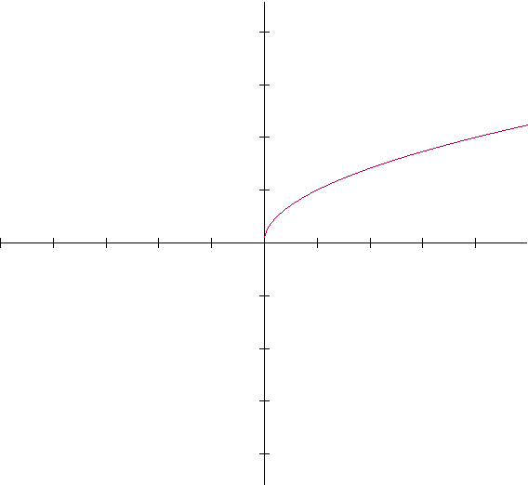
RADICAL FUNCTIONS

