Standard Form: | Parent Function
Vertex: (h,k) *if faced with , factor  out a (-1) from the radicand then  rewrite as .  y-intercept: Substitute zero for x, solve for y.  x-intercept: Substitute zero for y, solve for x.  Range:  Domain: | 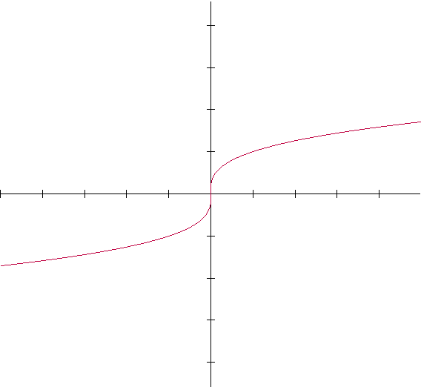
 | *You will always have exactly one y-intercept, and one x-intercept.
CUBE ROOT FUNCTIONS

