Geometric Optics Name _________________________

Ray Tracing WS ___ Date ______________ Per _______

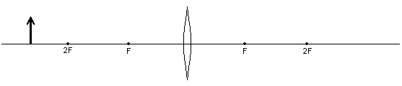
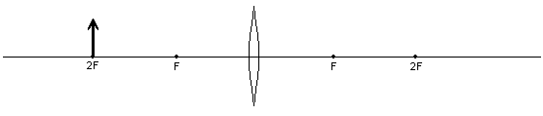
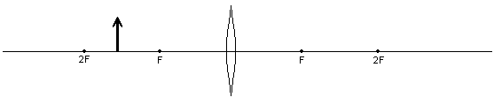

f
s_{o}
s_{i}
h_{o}
h_{i}
M

f
s_{o}
s_{i}
h_{o}
h_{i}
M

f
s_{o}
s_{i}
h_{o}
h_{i}
M

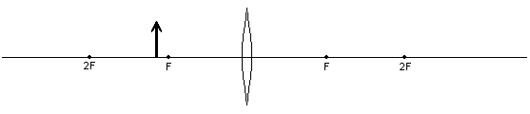
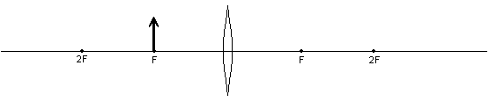
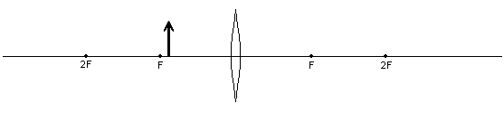

f
s_{o}
s_{i}
h_{o}
h_{i}
M

f
s_{o}
s_{i}
h_{o}
h_{i}
M

f
s_{o}
s_{i}
h_{o}
h_{i}
M

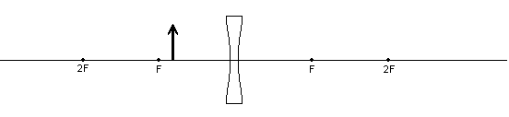
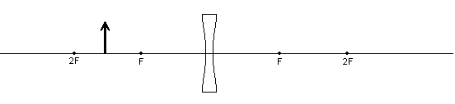
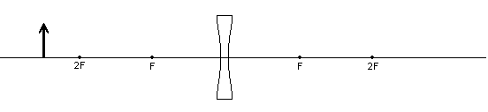

f
s_{o}
s_{i}
h_{o}
h_{i}
M

f
s_{o}
s_{i}
h_{o}
h_{i}
M

f
s_{o}
s_{i}
h_{o}
h_{i}
M

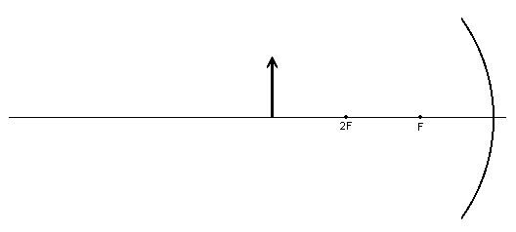
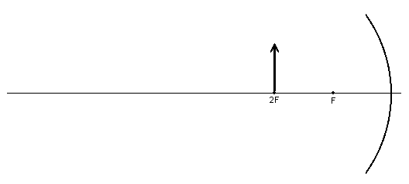
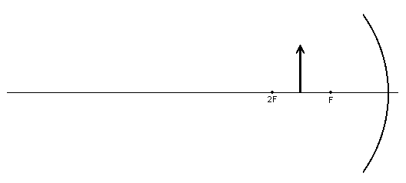

f
s_{o}
s_{i}
h_{o}
h_{i}
M

f
s_{o}
s_{i}
h_{o}
h_{i}
M

f
s_{o}
s_{i}
h_{o}
h_{i}
M

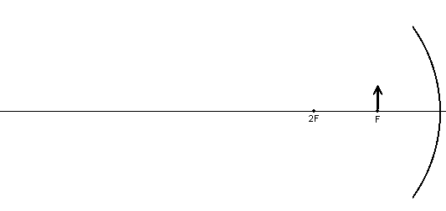
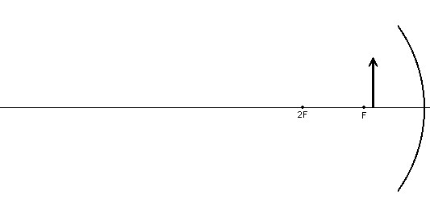
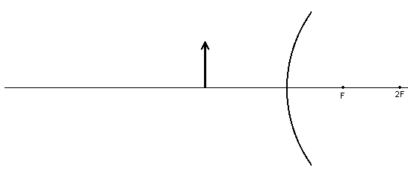

f
s_{o}
s_{i}
h_{o}
h_{i}
M

f
s_{o}
s_{i}
h_{o}
h_{i}
M

f
s_{o}
s_{i}
h_{o}
h_{i}
M

Geometric Optics Name _________________________

Ray Tracing WS ___ Date ______________ Per _______
- Complete the tables below with the correct signs, + or – , and choose the correct terms.
 | f | s_{o} | s_{i} | h_{o} | h_{i} | M | Converging or Diverging | Real or  Virtual | Convex or Concave
Converging Lens, Object outside f
Converging Lens, Object at f
Converging Lens, Object inside f
Converging Mirror, Object outside f
Converging Mirror, Object at f
Converging Mirror,
Object inside f
Diverging Lens, Object outside f
Diverging Lens, Object inside f
Diverging Mirror, Object outside f
Diverging Mirror, Object inside f

- Which variables have the same sign in all cases above?
- What does the sign of the focal point depend on?
- When an image is real, what else can be said about it? (There are quite a few)
- When an image is virtual, what else can be said about it? (There are quite a few)
- What are the main differences between converging and diverging?
- What are the differences between lenses and mirrors?

