CHAPTER 10
PHOTOSYNTHESIS

Introduction
- Life on Earth is solar powered.
- The chloroplasts of plants use a process called photosynthesis to capture light energy from the sun and convert it to chemical energy stored in sugars and other organic molecules.

A. Photosynthesis in Nature
1. Plants and other autotrophs are the producers of the biosphere
- Photosynthesis nourishes almost all of the living world directly or indirectly.
- All organisms require organic compounds for energy and for carbon skeletons.
- Autotrophs produce their organic molecules from CO₂ and other inorganic raw materials obtained from the environment.
- Autotrophs are the ultimate sources of organic compounds for all nonautotrophic organisms.
- Autotrophs are the producers of the biosphere.
- Autotrophs can be separated by the source of energy that drives their metabolism.
- Photoautotrophs use light as the energy source.
- Photosynthesis occurs in plants, algae, some other protists, and some prokaryotes.
- Chemoautotrophs harvest energy from oxidizing inorganic substances, including sulfur and ammonia.
- Chemoautotrophy is unique to bacteria.
- Heterotrophs live on organic compounds produced by other organisms.
- These organisms are the consumers of the biosphere.
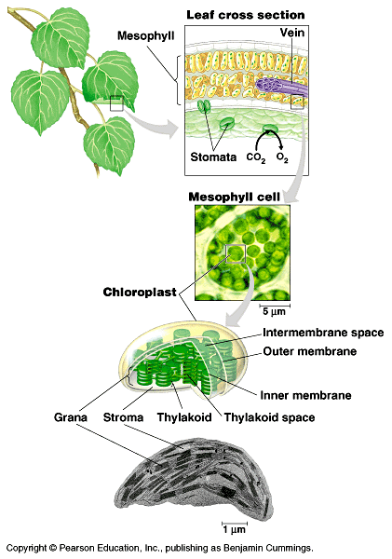
- The most obvious type of heterotrophs feed on plants and other animals.
- Other heterotrophs decompose and feed on dead organisms and on organic litter, like feces and fallen leaves.
- Almost all heterotrophs are completely dependent on photoautotrophs for food and for oxygen, a byproduct of photosynthesis.
2. Chloroplasts are the sites of photosynthesis in plants
- Any green part of a plant has chloroplasts.
- However, the leaves are the major site of photosynthesis for most plants.
- There are about half a million chloroplasts per square millimeter of leaf surface.
- The color of a leaf comes from chlorophyll, the green pigment in the chloroplasts.
- Chlorophyll plays an important role in the absorption of light energy during photosynthesis.
- Chloroplasts are found mainly in mesophyll cells forming the tissues in the interior of the leaf.
- O₂ exits and CO₂ enters the leaf through microscopic pores, stomata, in the leaf.
- Veins deliver water from the roots and carry off sugar from mesophyll cells to other plant areas.
- A typical mesophyll cell has 30-40 chloroplasts, each about 2-4 microns by 4-7 microns long.
- Each chloroplast has two membranes around a central aqueous space, the stroma.
- In the stroma aremembranous sacs, the thylakoids.
- These have an internal aqueous space, the thylakoid lumen or thylakoid space.
- Thylakoids may be stacked into columns called grana.

B. The Pathways of Photosynthesis
1. Evidence that chloroplasts split water molecules enabled researchers to track atoms through photosynthesis
- Powered by light, the green parts of plants produce organic compounds and O₂ from CO₂ and H₂O.
- Using glucose as our target product, the equation describing the net process of photosynthesis is:
- 6CO₂ + 6H₂O + light energy -> C₆H₁₂O₆ + 6O₂
- In reality, photosynthesis adds one CO₂ at a time:
- CO₂ + H₂O + light energy -> CH₂O + O₂
- CH₂O represents the general formula for a sugar.
- One of the first clues to the mechanism of photosynthesis came from the discovery that the O₂ given off by plants comes from H₂O, not CO₂.
- He generalized this idea and applied it to plants, proposing this reaction for their photosynthesis.
- CO₂ + 2H₂O -> CH₂O + H₂O + O₂
- Other scientists confirmed van Niel’s hypothesis.
- They used ¹⁸O, a heavy isotope, as a tracer.
- They could label either CO₂ or H₂O.
- They found that the ¹⁸O label only appeared if water was the source of the tracer.
- Essentially, hydrogen extracted from water is incorporated into sugar and the oxygen is released to the atmosphere (where it will be used in respiration).
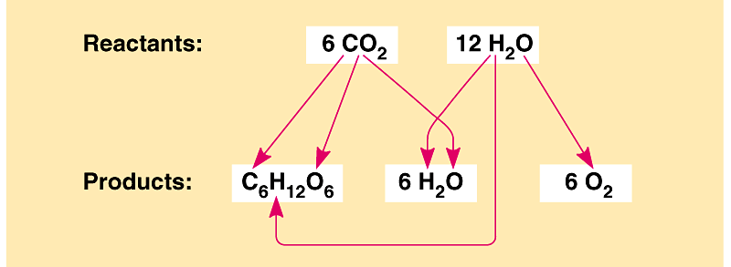
- Photosynthesis is a redox reaction.
- It reverses the direction of electron flow in respiration.
- Water is split and electrons transferred with H⁺ from water to CO₂, reducing it to sugar.
- Polar covalent bonds (unequal sharing) are converted to nonpolar covalent bonds (equal sharing).
- Light boosts the potential energy of electrons as they move from water to sugar.

2. The light reactions and the Calvin cycle cooperate in converting light energy to chemical energy of food: an overview
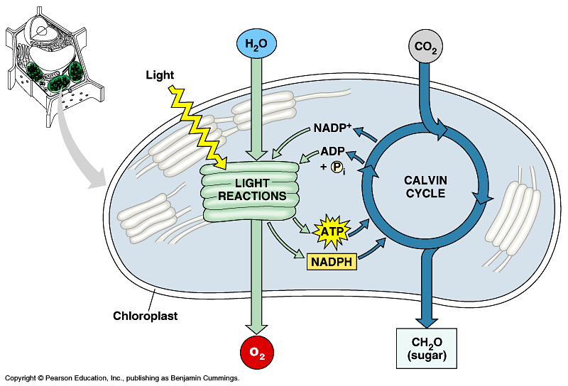
- Photosynthesis is two processes, each with multiple stages.
- The light reactions convert solar energy to chemical energy.
- The Calvin cycle incorporates CO₂ from the atmosphere into an organic molecule and uses energy from the light reaction to reduce the new carbon piece to sugar.
- In the light reaction light energy absorbed by chlorophyll in the thylakoids drives the transfer of electrons and hydrogen from water to NADP⁺ (nicotinamide adenine dinucleotide phosphate), forming NADPH.
- NADPH, an electron acceptor, provides energized electrons, reducing power, to the Calvin cycle.
- The light reaction also generates ATP by photophosphorylation for the Calvin cycle.
- The Calvin cycle is named for Melvin Calvin who, with his colleagues, worked out many of its steps in the 1940s.
- It begins with the incorporation of CO₂ int o an organic molecule via carbon fixation.
- This new piece of carbon backbone is reduced with electrons provided by NADPH.
- ATP from the light reaction also powers parts of the Calvin cycle.
- While the light reactions occur at the thylakoids, the Calvin cycle occurs in the stroma.

3. The light reactions convert solar energy to the chemical energy of ATP and NADPH: a closer look
- The thylakoids convert light energy into the chemical energy of ATP and NADPH.
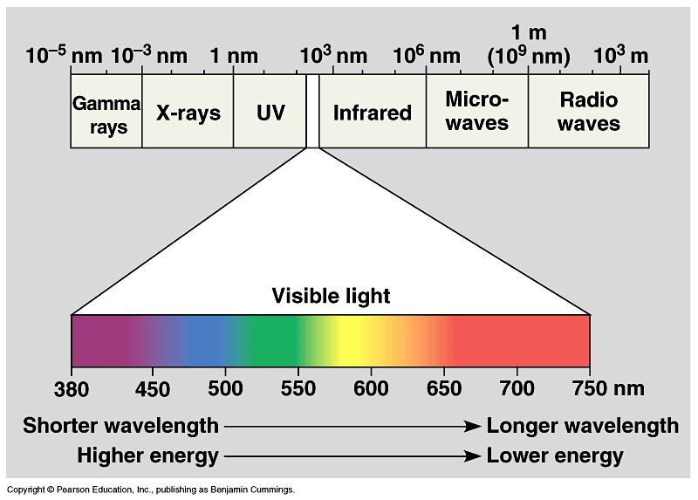
- Light, like other forms of electromagnetic energy, travels in rhythmic waves.
- The distance between crests of electromagnetic waves is called the wavelength.
- Wavelengths of electromagnetic radiation range from less than a nanometer (gamma rays) to over a kilometer (radio waves).
- The entire range of electromagnetic radiation is the electromagnetic spectrum.
- The most important segment for life is a narrow band between 380 to 750 nm, visible light.
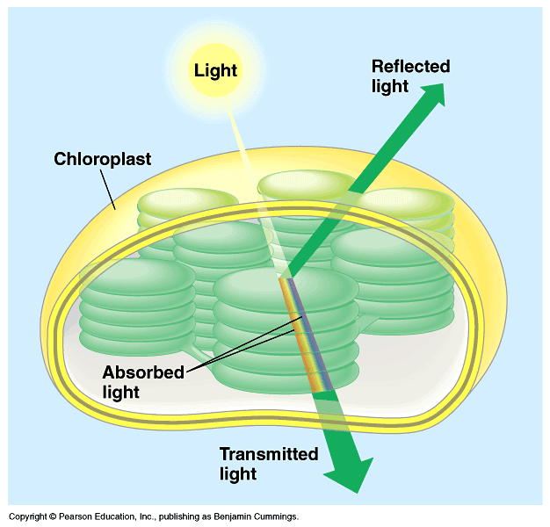
- While light travels as a wave, many of its properties are those of a discrete particle, the photon.
- Photons are not tangible objects, but they do have fixed quantities of energy.
- The amount of energy packaged in a photon is inversely related to its wavelength.
- Photons with shorter wavelengths pack more energy.
- While the sun radiates a full electromagnetic spectrum, the atmosphere selectively screens out most wavelengths, permitting only visible light to pass in significant quantities.
- When light meets matter, it may be reflected, transmitted, or absorbed.
- Different pigments absorb photons of different wavelengths.
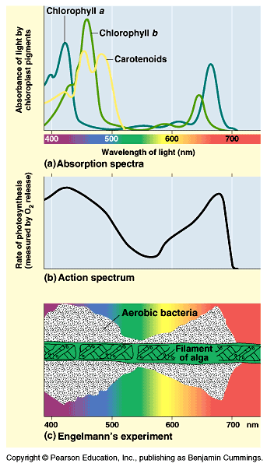
- A leaf looks green because chlorophyll, the dominant pigment, absorbs red and blue light, while transmitting and reflecting green light.
- A spectrophotometer measures the ability of a pigment to absorb various wavelengths of light.
- It beams narrow wavelengths of light through a solution containing a pigment and measures the fraction of light transmitted at each wavelength.
- An absorption spectrum plots a pigment’s light absorption versus wavelength.
- The light reaction can perform work with those wavelengths of light that are absorbed.
- In the thylakoid are several pigments that differ in their absorption spectrum.
- Chlorophyll a, the dominant pigment, absorbs best in the red and blue wavelengths, and least in the green.
- Other pigments with different structures have different absorption spectra.
- Collectively, these photosynthetic pigments determine an overall action spectrum for photosynhesis.
- An action spectrum measures changes in some measure of photosynthetic activity (for example, O₂ release) as the wavelength is varied.
- The action spectrum of photosynthesis was first demonstrated in 1883 by an elegant experiment by Thomas Engelmann.
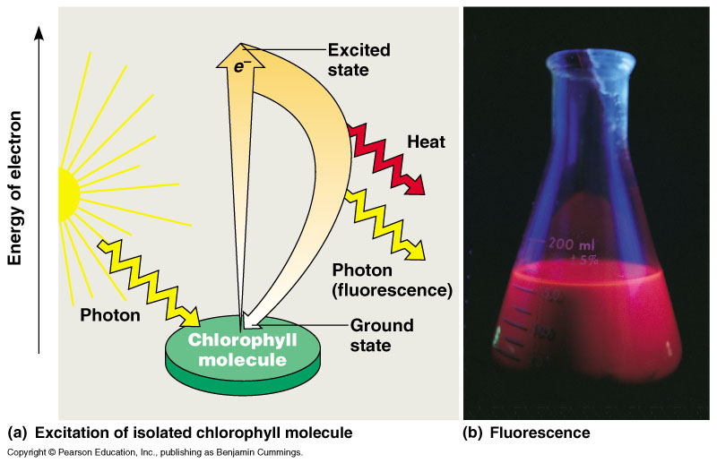
- In this experiment, different segments of a filamentous alga were exposed to different wavelengths of light.
- Areas receiving wavelengths favorable to photosynthesis should produce excess O₂.
- Engelmann used the abundance of aerobicbacteria clustered along the alga as a measure of O₂ production.
- The action spectrum of photosynthesis does not match exactly the absorption spectrum of any one photosynthetic pigment, including chlorophyll a.
- Only chlorophyll a participates directly in the light reactions but accessory photosynthetic pigments absorb light and transfer energy to chlorophyll a.
- Chlorophyll b, with a slightly different structure than chlorophyll a, has a slightly different absorption spectrum and funnels the energy from these wavelengths to chlorophyll a.
- Carotenoids can funnel the energy from other wavelengths to chlorophyll a and also participate in photoprotection against excessive light.
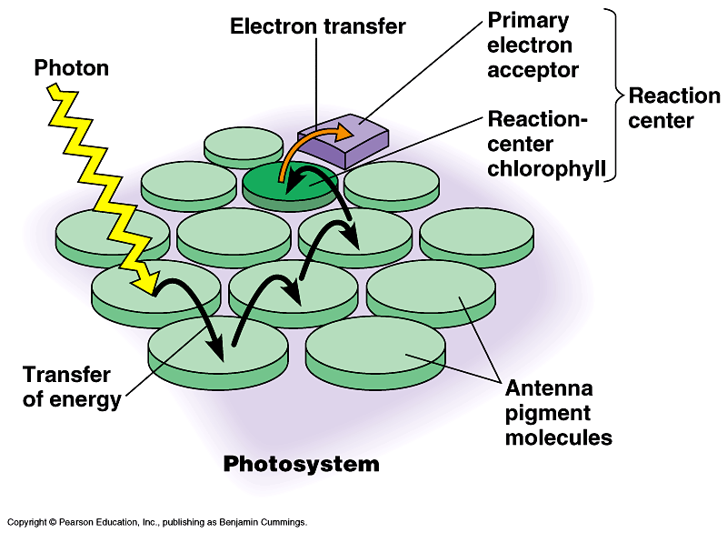
- When a molecule absorbs a photon, one of that molecule’s electrons is elevated to an orbital with more potential energy.
- The electron moves from its ground state to an excited state.
- The only photons that a molecule can absorb are those whose energy matches exactly the energy difference between the ground state and excited state of this electron.
- Because this energy difference varies among atoms and molecules, a particular compound absorbs only photons corresponding to specific wavelengths.
- Thus, each pigment has a unique absorption spectrum.
- Photons are absorbed by clusters of pigment molecules in the thylakoid membranes.
- The energy of the photon is converted to the potential energy of an electron raised from its ground state to an excited state.
- In chlorophyll a and b, it is an electron from magnesium in the porphyrin ring that is excited.
- Excited electrons are unstable.
- Generally, they drop to their ground state in a billionth of a second, releasing heat energy.
- Some pigments, including chlorophyll, release a photon of light, in a process called fluorescence, as well as heat.
- In the thylakoid membrane, chlorophyll is organized along with proteins and smaller organic molecules into photosystems.
- A photosystem acts like a light-gathering “antenna complex” consisting of a few hundred chlorophyll a, chlorophyll b,and carotenoid molecules.
- When any antenna molecule absorbs a photon, it is transmitted from molecule to molecule until it reaches a particular chlorophyll a molecule, the reaction center.
- At the reaction center is a primary electron acceptor which removes an excited electron from the reaction center chlorophyll a.
- This starts the light reactions.
- Each photosystem— reaction-center chlorophyll and primary electron acceptor surrounded by an antenna complex — functions in the chloroplast as a light-harvesting unit.
- There are two types of photosystems.
- Photosystem I has a reaction center chlorophyll, the P700 center, that has an absorption peak at 700nm.
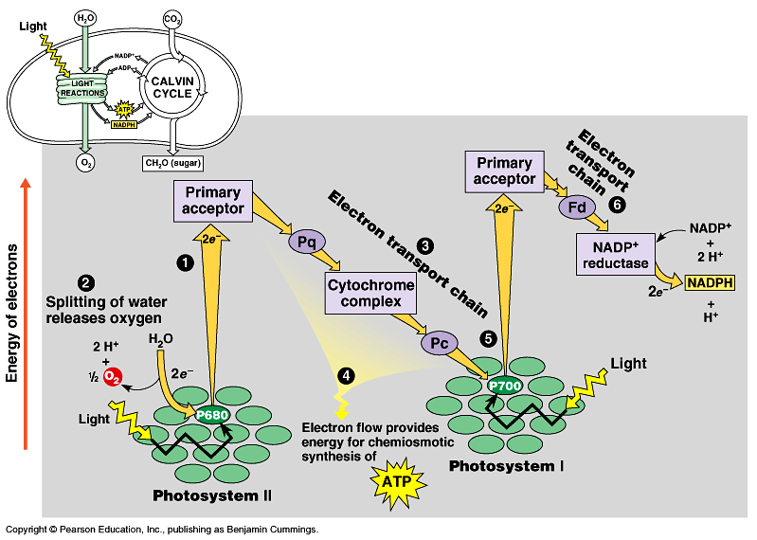
- Photosystem II has a reaction center with a peak at 680nm.
- The differences between these reaction centers (and their absorption spectra) lie not in the chlorophyll molecules, but in the proteins associated with each reaction center.
- These two photosystems work together to use light energy to generate ATP and NADPH.
- During the light reactions, there are two possible routes for electron flow: cyclic and noncyclic.
- Noncyclic electron flow, the predominant route, produces both ATP and NADPH.
• 1) When photosystem II absorbs light, an excited electron is captured by the primary electron acceptor, leaving the reaction center oxidized.
• 2) An enzyme extracts electrons from water and supplies them to the oxidized reaction center.
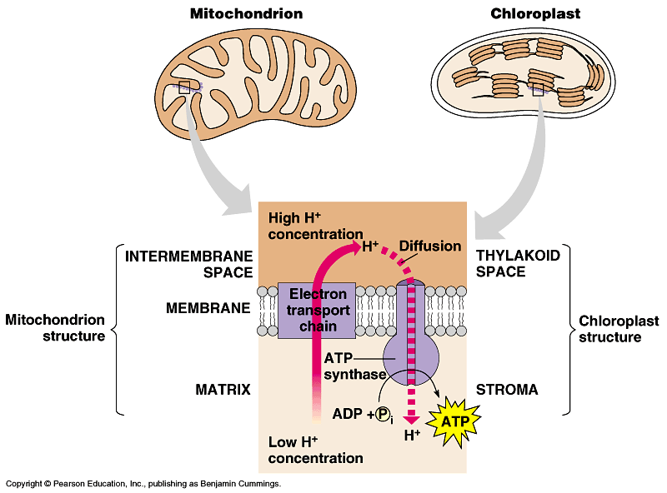
- This reaction splits water into two hydrogen ions and an oxygen atom, which combines with another to form O₂.

• 3) Photoexcited electrons pass along an electron transport chain before ending up at an oxidized photosystem I reaction center.
• 4) As these electrons pass along the transport chain, their energy is harnessed to produce ATP.
- The mechanism of noncyclic photophosphorylation is similar to the process on oxidative phosphorylation.
• 5) At the bottom of this electron transport chain, the electrons fill an electron “hole” in an oxidized P700 center.
• 6) This hole is created when photons excite electrons on the photosystem I complex.
- The excited electrons are captured by a second primary electron acceptor, which transmits them to a second electron transport chain.
- Ultimately, these electrons are passed from the transport chain to NADP⁺, creating NADPH.
- NADPH will carry the reducing power of these high-energy electrons to the Calvin cycle.
- The light reactions use the solar power of photons absorbed by both photosystem I and photosystem II to provide chemical energy in the form of ATP and reducing power in the form of the electrons carried by NADPH.
- Under certain conditions, photoexcited electrons from photosystem I, but not photosystem II, can take an alternative pathway, cyclic electron flow.
- Excited electrons cycle from their reaction center to a primary acceptor, along an electron transport chain, and return to the oxidized P700 chlorophyll.
- As electrons flow along the electron transport chain, they generate ATP by cyclic photophosphorylation.
- Noncyclic electron flow produces ATP and NADPH in roughly equal quantities.
- However, the Calvin cycle consumes more ATP than NADPH.
- Cyclic electron flow allows the chloroplast to generate enough surplus ATP to satisfy the higher demand for ATP in the Calvin cycle.
- Chloroplasts and mitochondria generate ATP by the same mechanism: chemiosmosis.
- An electron transport chain pumps protons across a membrane as electrons are passed along a series of more electronegative carriers.
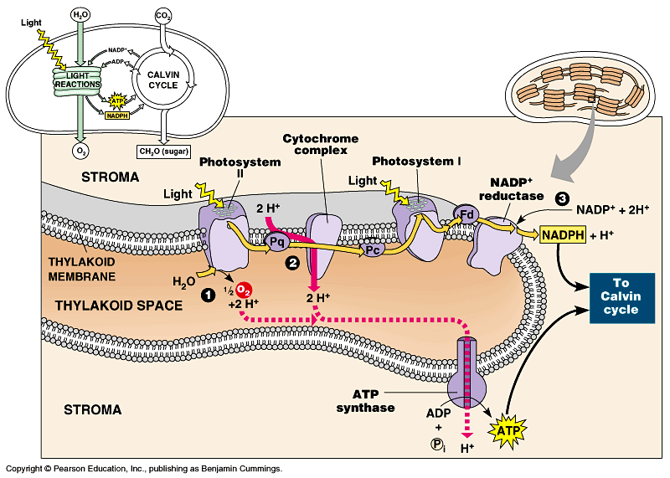
- This builds the proton-motive force in the form of an H+ gradient across the membrane.
- ATP synthase molecules harness the proton-motive force to generate ATP as H+ diffuses back across the membrane.
- Mitochondria transfer chemical energy from food molecules to ATP and chloroplasts transform light energy into the chemical energy of ATP.
- The proton gradient, or pH gradient, across the thylakoid membrane is substantial.
- When illuminated, the pH in the thylakoid space drops to about 5 and the pH in the stroma increases to about 8, a thousandfold different in H⁺ concentration.
- The light-reaction “machinery” produces ATP and NADPH on the stroma side of the thylakoid.
- Noncyclic electron flow pushes electrons from water, where they are at low potential energy, to NADPH, where they have high potential energy.
- This process also produces ATP.
- Oxygen is a byproduct.
- Cyclic electron flow converts light energy to chemical energy in the form of ATP.

4. The Calvin cycle uses ATP and NADPH to convert CO₂ to sugar: a closer look
- The Calvin cycle regenerates its starting material after molecules enter and leave the cycle.
- CO₂ enters the cycle and leaves as sugar.
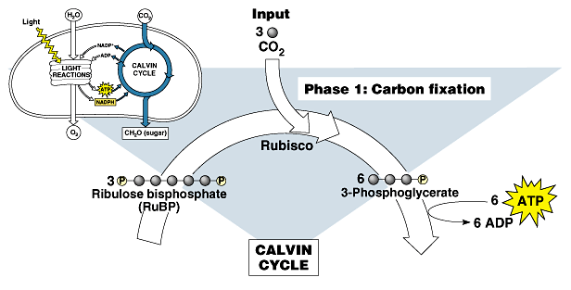
- The cycle spends the energy of ATP and the reducing power of electrons carried by NADPH to make the sugar.
- The actual sugar product of the Calvin cycle is not glucose, but a three-carbon sugar, glyceraldehyde-3-phosphate (G3P).
- Each turn of the Calvin cycle fixes one carbon.
- For the net synthesis of one G3P molecule, the cycle must take place three times, fixing three molecules of CO₂.
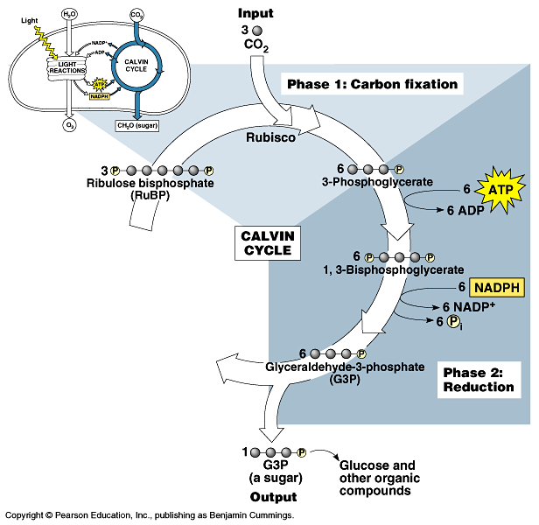
- To make one glucose molecule would require six cycles and the fixation of six CO₂ molecules.
- The Calvin cycle has three phases.
- In the carbon fixation phase, each CO₂ molecule is attached to a five-carbon sugar, ribulose bisphosphate (RuBP).
- This is catalyzed by RuBP carboxylase or rubisco.
- The six-carbon intermediate splits in half to form two molecules of 3-phosphoglycerate per CO₂.
- During reduction, each 3-phosphoglycerate receives another phosphate group from ATP to form 1,3-bisphosphoglycerate.
- A pair of electrons from NADPH reduces each 1,3-bisphosphoglycerate to G3P.
- The electrons reduce a carboxyl group to a carbonyl group.
- If our goal was to produce one G3P net, we would start with 3CO₂ (3C) and three RuBP (15C).
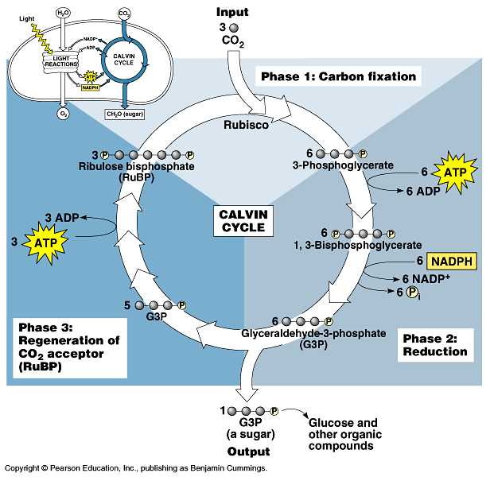
- After fixation and reduction we would have six molecules of G3P (18C).
- One of these six G3P (3C) is a net gain of carbohydrate.
- This molecule can exit the cycle to be used by the plant cell.
- The other five (15C) must remain in the cycle to regenerate three RuBP.
- For the net synthesis of one G3P molecule, the Calvin recycle consumes nine ATP and six NAPDH.
- It “costs” three ATP and two NADPH per CO₂.
- The G3P from the Calvin cycle is the starting material for metabolic pathways that synthesize other organic compounds, including glucose and other carbohydrates.

5. Alternative mechanisms of carbon fixation have evolved in hot, arid climates
- One of the major problems facing terrestrial plants is dehydration.
- At times, solutions to this problem conflict with other metabolic processes, especially photosynthesis.
- The stomata are not only the major route for gas exchange (CO₂ in and O₂ out), but also for the evaporative loss of water.
- On hot, dry days plants close the stomata to conserve water, but this causes problems for photosynthesis.
- In most plants (C₃ plants) initial fixation of CO₂ occurs via rubisco and results in a three-carbon compound, 3-phosphoglycerate.
- These plants include rice, wheat, and soybeans.
- When their stomata are closed on a hot, dry day, CO₂ levels drop as CO₂ is consumed in the Calvin cycle.
- At the same time, O₂ levels rise as the light reaction converts light to chemical energy.
- While rubisco normally accepts CO₂, when the O₂/CO₂ ratio increases (on a hot, dry day with closed stomata), rubisco can add O₂ to RuBP.
- When rubisco adds O₂ to RuBP, RuBP splits into a three-carbon piece and a two-carbon piece in a process called photorespiration.
- The two-carbon fragment is exported from the chloroplast and degraded to CO₂ by mitochondria and peroxisomes.
- Unlike normal respiration, this process produces no ATP, nor additional organic molecules.
- Photorespiration decreases photosynthetic output by siphoning organic material from the Calvin cycle.
- A hypothesis for the existence of photorespiraton (a inexact requirement for CO₂ versus O₂ by rubisco) is that it is evolutionary baggage.
- When rubisco first evolved, the atmosphere had far less O₂ and more CO₂ than it does today.
- The inability of the active site of rubisco to exclude O₂ would have made little difference.
- Today it does make a difference.
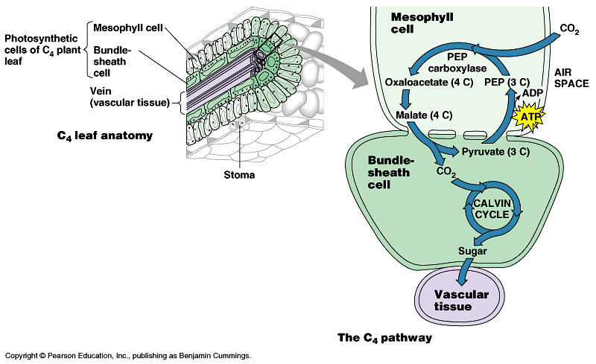
- Photorespiration can drain away as much as 50% of the carbon fixed by the Calvin cycle on a hot, dry day.
- Certain plant species have evolved alternate modes of carbon fixation to minimize photorespiration.
- The C₄ plants fix CO₂ first in a four-carbon compound.
- Several thousand plants, including sugercane and corn, use this pathway.
- In C₄ plants, mesophyll cells incorporate CO₂ into organic molecules.
- The key enzyme, phosphoenolpyruvate carboxylase, adds CO₂ to phosphoenolpyruvate (PEP) to form oxaloacetetate.
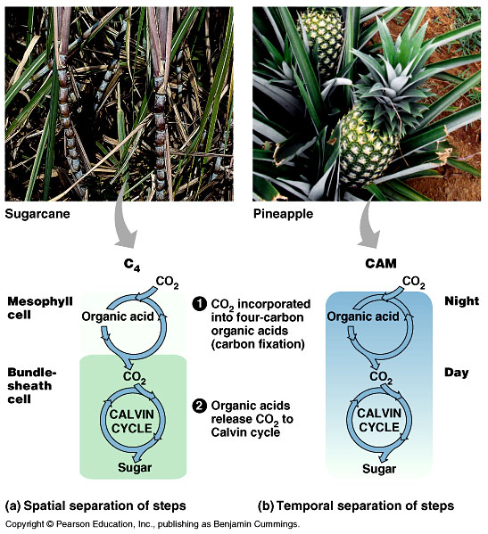
- PEP carboxylase has a very high affinity for CO₂and can fix CO₂ efficiently when rubisco cannot, i.e. on hot, dry days when the stomata are closed.
- The mesophyll cells pump these four-carbon compounds into bundle-sheath cells.
- The bundle-sheath cells strip a carbon, as CO₂, from the four-carbon compound and return the three-carbon remainder to the mesophyll cells.
- The bundle-sheath cells then use rubisco to start the Calvin cycle with an abundant supply of CO₂.
- In effect, the mesophyll cells pump CO₂ into the bundle sheath cells, keeping CO₂ levels high enough for rubisco to accept CO₂ and not O₂.
- C₄ photosynthesis minimizes photorespiration and enhances sugar production.
- C₄ plants thrive in hot regions with intense sunlight.
- A second strategy to minimize photorespiration is found in succulent plants, cacti, pineapples, and several other plant families.
- These plants, known as CAM plants for crassulacean acid metabolism (CAM), open stomata during the night and close them during the day.
- Temperatures are typically lower at night and humidity is higher.
- During the night, these plants fix CO₂ into a variety of organic acids in mesophyll cells.
- During the day, the light reactions supply ATP and NADPH to the Calvin cycle and CO₂ is released from the organic acids.
- Both C₄ and CAM plants add CO₂ into organic intermediates before it enters the Calvin cycle.
- In C₄ plants, carbon fixation and the Calvin cycle are spatially separated.
- In CAM plants, carbon fixation and the Calvin cycle are temporally separated.
- Both eventually use the Calvin cycle to incorporate light energy into the production of sugar.

6. Photosynthesis is the biosphere’s metabolic foundation: a review
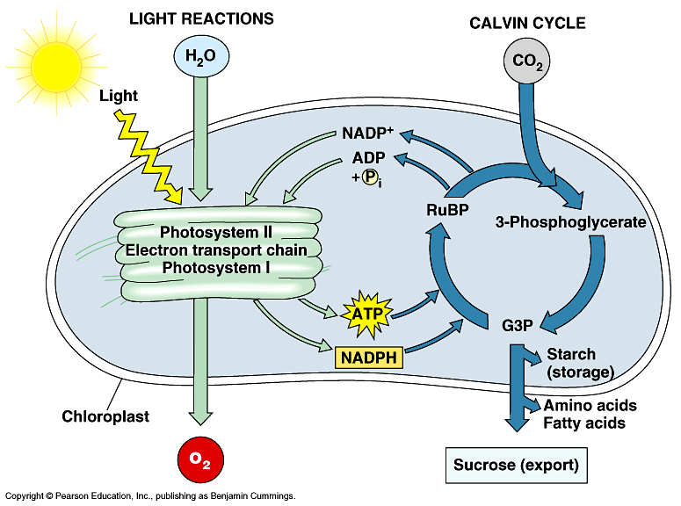
- In photosynthesis, the energy that enters the chloroplasts as sunlight becomes stored as chemical energy in organic compounds.
- Sugar made in the chloroplasts supplies the entire plant with chemical energy and carbon skeletons to synthesize all the major organic molecules of cells.
- About 50% of the organic material is consumed as fuel for cellular respiration in plant mitochondria.
- Carbohydrate in the form of the disaccharide sucrose travels via the veins to nonphotosynthetic cells.
- There, it provides fuel for respiration and the raw materials for anabolic pathways including synthesis of proteins and lipids and building the extracellular polysaccharide cellulose.
- Plants also store excess sugar by synthesizing starch.
- Some is stored as starch in chloroplasts or in storage cells in roots, tubers, seeds, and fruits.
- Heterotrophs, including humans, may completely or partially consume plants for fuel and raw materials.
- On a global scale, photosynthesis is the most important process to the welfare of life on Earth.
- Each year, photosynthesis synthesizes 160 billion metric tons of carbohydrate per year.

