Chapter 35: Plant Structure, Growth, and Development
- Describe the structure and function of these three basic plant organs:
- Roots
- Stems
- Leaves
- Describe the 3 types of plant tissues:
- Dermal
- Vascular
- Ground
- For each of the plant cell types listed below, describe the structure, function, and location.
- Parenchyma:
- Xylem cells:
- Phloem cells:
  - Sieve-tube elements:
  - Companion cells:
- What are meristems?

- Describe the location and function of:
- Apical meristems
- Lateral meristems
- Contrast primary and secondary growth. What is the relationship between the two?

- Contrast annuals, biennials, and perennials.

- Draw and label the primary growth of a root. Label the three zones of cells and what occurs at each zone.

- Beginning at the center of a tree trunk, list the layers as you proceed outward to the bark.

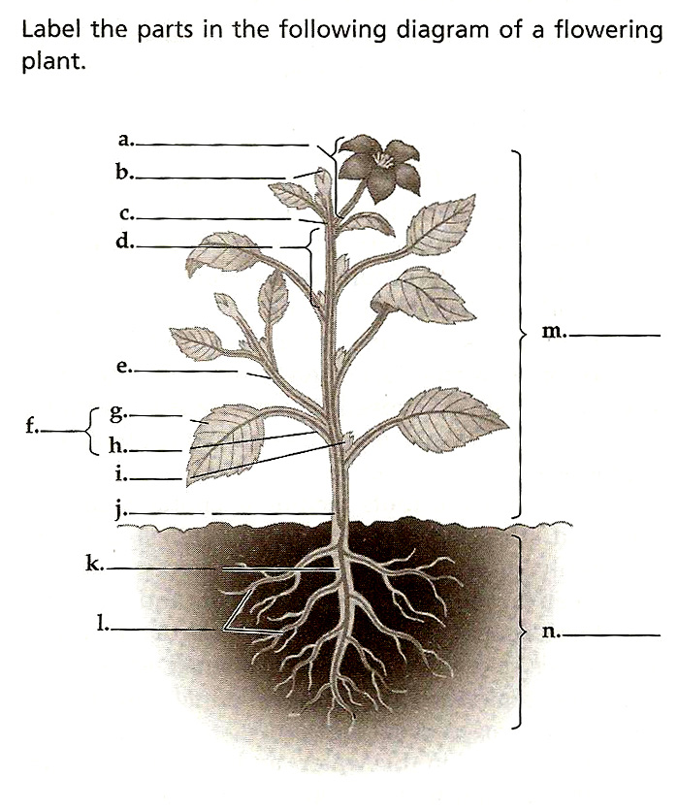
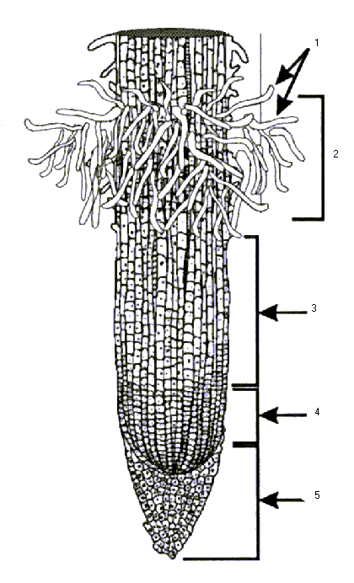
Label the following diagram of a plant root.
