Chapter 38: Angiosperm Reproduction
- Draw and label a diagram showing the alternation of generations in the angiosperm life cycle. Be sure to include: sporophyte, gametophyte, spore, sperm, egg, zygote, embryo, fertilization, meiosis, mitosis, seed.

- Explain the how a pollen grain develops from a microspore.

- Explain what occurs in an ovule to produce an egg.

- What occurs during:
  - Pollination
  - Fertilization
  - Germination
- Describe the process of double fertilization.

- What structures give rise to the:
  - Embryo
  - Seed
  - Fruit

- What are the evolutionary advantages of a seed?

- List some environmental cues that may be required to break seed dormancy.

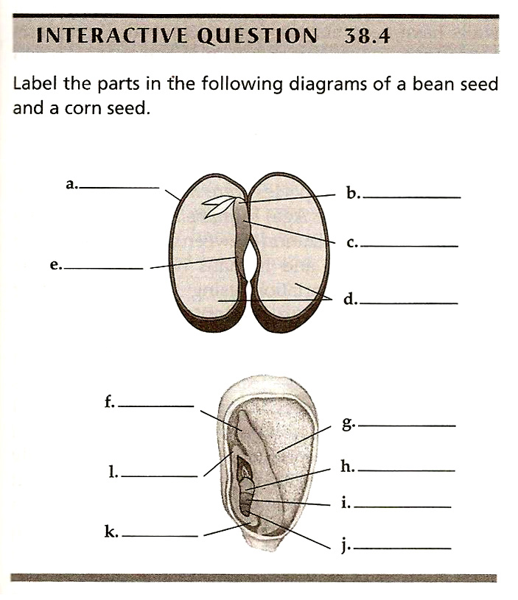

- Describe the process of seed germination.

- What is the purpose of fruit? What are the various methods of seed dispersal?

- What are the advantages and disadvantages of asexual versus sexual reproduction?

- List some mechanisms used by plants to prevent self-fertilization.

