CHAPTER 17
FROM GENE TO PROTEIN

Introduction
- The information content of DNA is in the form of specific sequences of nucleotides along the DNA strands.
- The DNA inherited by an organism leads to specific traits by dictating the synthesis of proteins.
- Proteins are the links between genotype and phenotype.
- For example, Mendel’s dwarf pea plants lack a functioning copy of the gene that specifies the synthesis of a key protein, gibberellins.
- Gibberellins stimulate the normal elongation of stems.

A. The Connection Between Genes and Proteins
1. The study of metabolic defects provided evidence that genes specify proteins
- In 1909, Archibald Gerrod was the first to suggest that genes dictate phenotype through enzymes that catalyze specific chemical reactions in the cell.
- The symptoms of an inherited disease reflect a person’s inability to synthesize a particular enzyme.
- Gerrod speculated that alkaptonuria, a hereditary disease, was caused by the absence of an enzyme that breaks down a specific substrate, alkapton.
- Research conducted several decades later supported Gerrod’s hypothesis.
- Progress in linking genes and enzymes rested on the growing understanding that cells synthesize and degrade most organic molecules in a series of steps, a metabolic pathway.
- In the 1930s, George Beadle and Boris Ephrussi speculated that each mutation affecting eye color in Drosophila blocks pigment synthesis at a specific step by preventing production of the enzyme that catalyzes that step.
- However, neither the chemical reactions nor the enzymes were known at the time.
- Beadle and Edward Tatum were finally able to establish the link between genes and enzymes in their exploration of the metabolism of a bread mold, Neurospora crassa.
- They mutated Neurospora with X-rays and screened the survivors for mutants that differed in their nutritional needs.
- Wild-type Neurospora can grow on a minimal medium of agar, inorganic salts, glucose, and the vitamin biotin.
- Most nutritional mutants can survive on a complete growth medium that includes all 20 amino acids.
- One type of mutant required only the addition of arginine to the minimal growth medium.
- Beadle and Tatum concluded that this mutant was defective somewhere in the biochemical pathway that normally synthesizes arginine.
- They identified three classes of arginine-deficient mutants, each apparently lacking a key enzyme at a different step in the synthesis of arginine.
- They demonstrated this by growing these mutant strains in media that provided different intermediate molecules.
- Their results provided strong evidence for the one gene - one enzyme hypothesis.
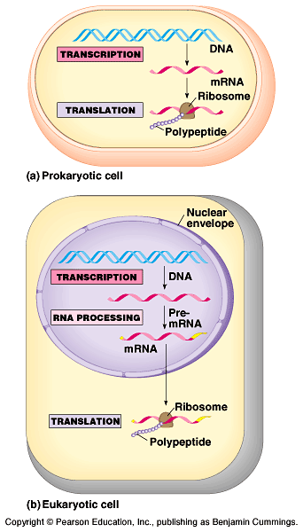
- Later research refined the one gene - one enzyme hypothesis.
- First, it became clear that not all proteins are enzymes and yet their synthesis depends on specific genes.
- This tweaked the hypothesis to one gene - one protein.
- Later research demonstrated that many proteins are composed of several polypeptides, each of which has its own gene.
- Therefore, Beadle and Tatum’s idea has been restated as the one gene - one polypeptide hypothesis.

2. Transcription and translation are the two main processes linking gene to protein: an overview
- Genes provide the instructions for making specific proteins.
- The bridge between DNA and protein synthesis is RNA.
- RNA is chemically similar to DNA, except that it contains ribose as its sugar and substitutes the nitrogenous base uracil for thymine.
- An RNA molecule almost always consists of a single strand.
- In DNA or RNA, the four nucleotide monomers act like the letters of the alphabet to communicate information.
- The specific sequence of hundreds or thousands of nucleotides in each gene carries the information for the primary structure of a protein, the linear order of the 20 possible amino acids.
- To get from DNA, written in one chemical language, to protein, written in another, requires two major stages, transcription and translation.
- During transcription, a DNA strand provides a template for the synthesis of a complementary RNA strand.
- This process is used to synthesize any type of RNA from a DNA template.
- Transcription of a gene produces a messenger RNA (mRNA) molecule.
- During translation, the information contained in the order of nucleotides in mRNA is used to determine the amino acid sequence of a polypeptide.
- Translation occurs at ribosomes.
- The basic mechanics of transcription and translation are similar in eukaryotes and prokaryotes.
- Because bacteria lack nuclei, transcription and translation are coupled.
- Ribosomes attach to the leading end of a mRNA molecule while transcription is still in progress.
- In a eukaryotic cell, almost all transcription occurs in the nucleus and translation occurs mainly at ribosomes in the cytoplasm.
- In addition, before the primary transcript can leave the nucleus it is modified in various ways during RNA processing before the finished mRNA is exported to the cytoplasm.
- To summarize, genes program protein synthesis via genetic messenger RNA.
- The molecular chain of command in a cell is:
DNA -> RNA -> protein.

3. In the genetic code, nucleotide triplets specify amino acids
- If the genetic code consisted of a single nucleotide or even pairs of nucleotides per amino acid, there would not be enough combinations (4 and 16 respectively) to code for all 20 amino acids.
- Triplets of nucleotide bases are the smallest units of uniform length that can code for all the amino acids.
- In the triplet code, three consecutive bases specify an amino acid, creating 4³ (64) possible code words.
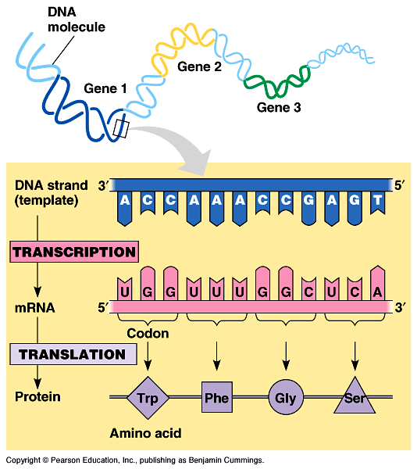
- The genetic instructions for a polypeptide chain are written in DNA as a series of three-nucleotide words.
- During transcription, one DNA strand, the template strand, provides a template for ordering the sequence of nucleotides in an RNA transcript.
- The complementary RNA molecule is synthesized according to base-pairing rules, except that uracil is the complementary base to adenine.
- During translation, blocks of three nucleotides, codons, are decoded into a sequence of amino acids.
- During translation, the codons are read in the 5’->3’ direction along the mRNA.
- Each codon specifies which one of the 20 amino acids will be incorporated at the corresponding position along a polypeptide.
- Because codons are base triplets, the number of nucleotides making up a genetic message must be three times the number of amino acids making up the protein product.
- It would take at least 300 nucleotides to code for a polypeptide that is 100 amino acids long.

- The task of matching each codon to its amino acid counterpart began in the early 1960s.
- Marshall Nirenberg determined the first match: UUU coded for the amino acid phenylalanine.
- He created an artificial mRNA molecule entirely of uracil and added it to a test tube mixture of amino acids, ribosomes, and other components for protein synthesis.
- This “poly(U)” translated into a polypeptide containing a single amino acid, phenyalanine, in a long chain.
- Other more elaborate techniques were required to decode mixed triplets such as AUA and CGA.
- By the mid-1960s the entire code was deciphered.
- 61 of 64 triplets code for amino acids.
- The codon AUG not only codes for the amino acid methionine but also indicates the start of translation.
- Three codons do not indicate amino acids but signal the termination of translation.
- To extract the message from the genetic code requires specifying the correct starting point.
- This establishes the reading frame and subsequent codons are read in groups of three nucleotides.
- The cell’s protein-synthesizing machinery reads the message as a series of nonoverlapping three-letter words.
- In summary, genetic information is encoded as a sequence of nonoverlapping base triplets, or codons, each of which is translated into a specific amino acid during protein synthesis.

4. The genetic code must have evolved very early in the history of life
- The genetic code is nearly universal, shared by organisms from the simplest bacteria to the most complex plants and animals.
- In laboratory experiments, genes can be transcribed and translated after they are transplanted from one species to another.
- This has permitted bacteria to be programmed to synthesize certain human proteins after insertion of the appropriate human genes.
- This and other similar applications are exciting developments in biotechnology.
- Exceptions to the universality of the genetic code exist in translation systems where a few codons differ from standard ones.
- These occur in certain single-celled eukaryotes like Paramecium.
- Other examples include translation in certain mitochondria and chloroplasts.
- The near universality of the genetic code must have been operating very early in the history of life.
- A shared genetic vocabulary is a reminder of the kinship that bonds all life on Earth.

B. The Synthesis and Processing of RNA
1. Transcription is the DNA-directed synthesis of RNA: a closer look
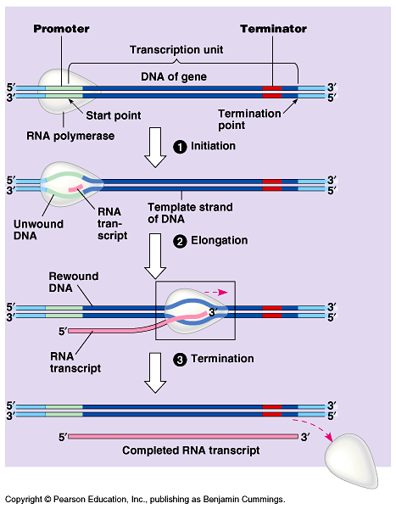
- Messenger RNA is transcribed from the template strand of a gene.
- RNA polymerase separates the DNA strands at the appropriate point and bonds the RNA nucleotides as they base-pair along the DNA template.
- Like DNA polymerases, RNA polymerases can add nucleotides only to the 3’ end of the growing polymer.
- Genes are read 3’->5’, creating a 5’->3’ RNA molecule.
- Specific sequences of nucleotides along the DNA mark where gene transcription begins and ends.
- RNA polymerase attaches and initiates transcription at the promotor, “upstream” of the information contained in the gene, the transcription unit.
- The terminator signals the end of transcription.
- Bacteria have a single type of RNA polymerase that synthesizes all RNA molecules.
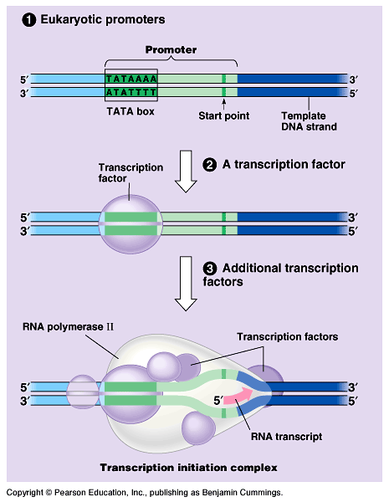
- In contrast, eukaryotes have three RNA polymerases (I, II, and III) in their nuclei.
- RNA polymerase II is used for mRNA synthesis.
- Transcription can be separated into three stages: initiation, elongation, and termination.
- The presence of a promotor sequence determines which strand of the DNA helix is the template.
- Within the promotor is the starting point for the transcription of a gene.
- The promotor also includes a binding site for RNA polymerase several dozen nucleotides upstream of the start point.
- In prokaryotes, RNA polymerase can recognize and bind directly to the promotor region.
- In eukaryotes, proteins called transcription factors recognize the promotor region, especially a TATA box, and bind to the promotor.
- After they have bound to the promotor, RNA polymerase binds to transcription factors to create a transcription initiation complex.
- RNA polymerase then starts transcription.
- As RNA polymerase moves along the DNA, it untwists the double helix, 10 to 20 bases at time.
- The enzyme adds nucleotides to the 3’ end of the growing strand.
- Behind the point of RNA synthesis, the double helix re-forms and the RNA molecule peels away.
- A single gene can be transcribed simultaneously by several RNA polymerases at a time.
- A growing strand of RNA trails off from each polymerase.
- The length of each new strand reflects how far along the template the enzyme has traveled from the start point.
- The congregation of many polymerase molecules simultaneously transcribing a single gene increases the amount of mRNA transcribed from it.
- This helps the cell make the encoded protein in large amounts.

- Transcription proceeds until after the RNA polymerase transcribes a terminator sequence in the DNA.
- In prokaryotes, RNA polymerase stops transcription right at the end of the terminator.
- Both the RNA and DNA are then released.
- In eukaryotes, the polymerase continues for hundreds of nucleotides past the terminator sequence, AAUAAA.
- At a point about 10 to 35 nucleotides past this sequence, the pre-mRNA is cut from the enzyme.

2. Eukaryotic cells modify RNA after transcription
- Enzymes in the eukaryotic nucleus modify pre-mRNA before the genetic messages are dispatched to the cytoplasm.
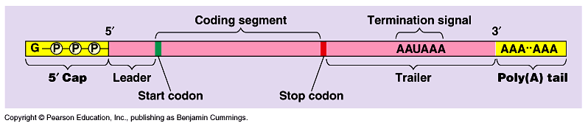
- At the 5’ end of the pre-mRNA molecule, a modified form of guanine is added, the 5’ cap.
- This helps protect mRNA from hydrolytic enzymes.
- It also functions as an “attach here” signal for ribosomes.
- At the 3’ end, an enzyme adds 50 to 250 adenine nucleotides, the poly(A) tail.
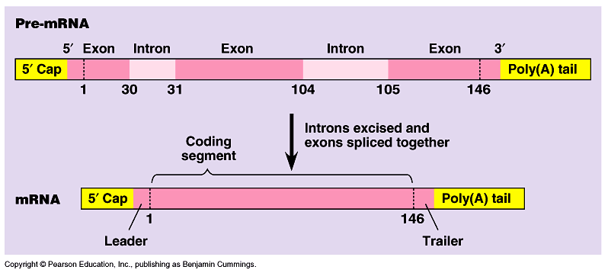
- In addition to inhibiting hydrolysis and facilitating ribosome attachment, the poly(A) tail also seems to facilitate the export of mRNA from the nucleus.
- The mRNA molecule also includes nontranslated leader and trailer segments.
- The most remarkable stage of RNA processing occurs during the removal of a large portion of the RNA molecule during RNA splicing.
- Most eukaryotic genes and their RNA transcripts have long noncoding stretches of nucleotides.
- Noncoding segments, introns, lie between coding regions.
- The final mRNA transcript includes coding regions, exons, which are translated into amino acid sequences, plus the leader and trailer sequences.
- RNA splicing removes introns and joins exons to create an mRNA molecule with a continuous coding sequence.
- This splicing is accomplished by a spliceosome.
- Spliceosomes consist of a variety of proteins and several small nuclear ribonucleoproteins (snRNPs).
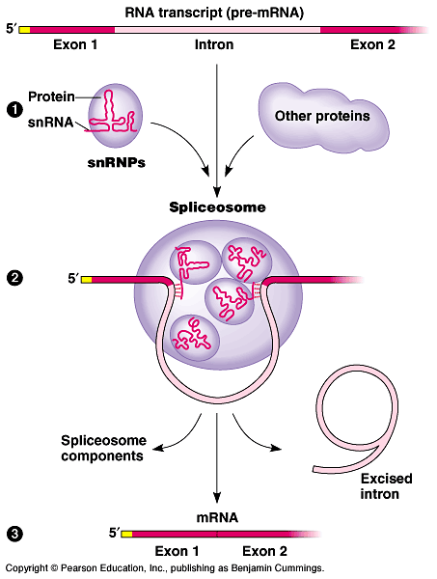
- Each snRNP has several protein molecules and a small nuclear RNA molecule (snRNA).
- Each is about 150 nucleotides long.
• 1) Pre-mRNA combines with snRNPs and other proteins to form a spliceosome.
• 2) Within the spliceosome, snRNA base-pairs with nucleotides at the ends of the intron.
• 3) The RNA transcript is cut to release the intron, and the exons are spliced together; the spliceosome then comes apart, releasing mRNA, which now contains only exons.
- In this process, the snRNA acts as a ribozyme, an RNA molecule that functions as an enzyme.
- Like pre-mRNA, other kinds of primary transcripts may also be spliced, but by diverse mechanisms that do not involve spliceosomes.
- In a few cases, intron RNA can catalyze its own excision without proteins or extra RNA molecules.
- The discovery of ribozymes rendered obsolete the statement, “All biological catalysts are proteins.”
- RNA splicing appears to have several functions.
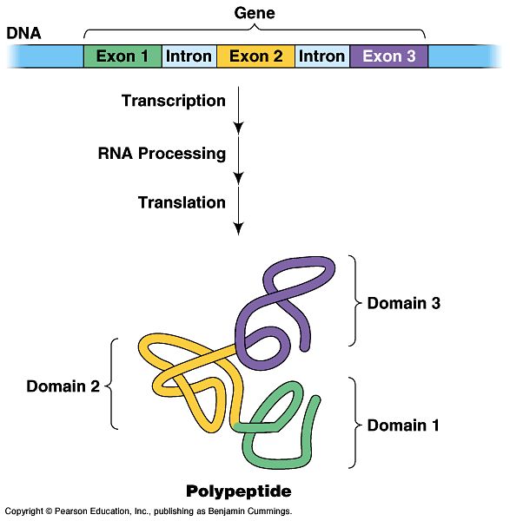
- First, at least some introns contain sequences that control gene activity in some way.
- Splicing itself may regulate the passage of mRNA from the nucleus to the cytoplasm.
- One clear benefit of split genes is to enable a one gene to encode for more than one polypeptide.
- Alternative RNA splicing gives rise to two or more different polypeptides, depending on which segments are treated as exons.
- Early results of the Human Genome Project indicate that this phenomenon may be common in humans.
- Split genes may also facilitate the evolution of new proteins.
- Proteins often have a modular architecture with discrete structural and functional regions called domains.
- In many cases, different exons code for different domains of a protein.
- The presence of introns increases the probability of potentially beneficial crossing over between genes.
- Introns increase the opportunity for recombination between two alleles of a gene.
- This raises the probability that a crossover will switch one version of an exon for another version found on the homologous chromosome.
- There may also be occasional mixing and matching of exons between completely different genes.
- Either way, exon shuffling could lead to new proteins through novel combinations of functions.

C. The Synthesis of Protein
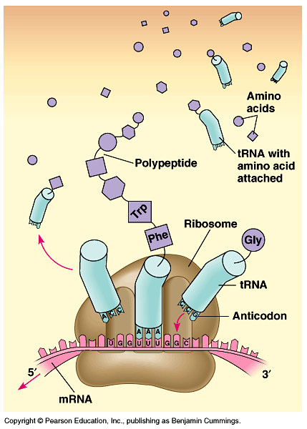
1. Translation is the RNA-directed synthesis of a polypeptide: a closer look
- In the process of translation, a cell interprets a series of codons
along a mRNA molecule.
- Transfer RNA (tRNA) transfers amino acids from the cytoplasm’s pool to a ribosome.
- The ribosome adds each amino acid carried by tRNA to the growing end of the polypeptide chain.
- During translation, each type of tRNA links a mRNA codon with the appropriate amino acid.
- Each tRNA arriving at the ribosome carries a specific amino acid at one end and has a specific nucleotide triplet, an anticodon, at the other.
- The anticodon base-pairs with a complementary codon on mRNA.
- If the codon on mRNA is UUU, a tRNA with an AAA anticodon and carrying phenyalanine will bind to it.
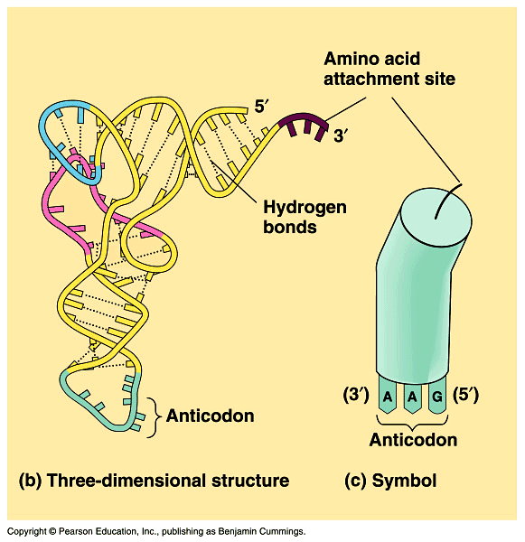
- Codon by codon, tRNAs deposit amino acids in the prescribed order and the ribosome joins them into a polypeptide chain.
- Like other types of RNA, tRNA molecules are transcribed from DNA templates in the nucleus.
- Once it reaches the cytoplasm, each tRNA is used repeatedly.
• To pick up its designated amino acid in the cytosol.
• To deposit the amino acid at the ribosome.
• To return to the cytosol to pick up another copy of that amino acid.
- A tRNA molecule consists of a strand of about 80 nucleotides that folds back on itself to form a three-dimensional structure.
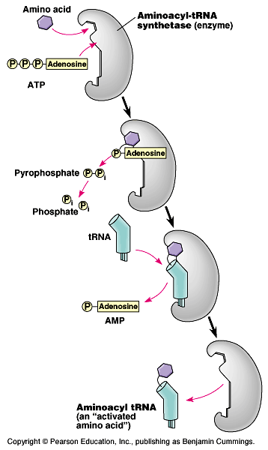
- It includes a loop containing the anticodon and an attachment site at the 3’ end for an amino acid.
- If each anticodon had to be a perfect match to each codon, we would expect to find 61 types of tRNA, but the actual number is about 45.
- The anticodons of some tRNAs recognize more than one codon.
- This is possible because the rules for base pairing between the third base of the codon and anticodon are relaxed (called wobble).
- At the wobble position, U on the anticodon can bind with A or G in the third position of a codon.
- Some tRNA anticodons include a modified form of adenine, inosine, which can hydrogen bond with U, C, or A on the codon.
- Each amino acid is joined to the correct tRNA by aminoacyl-tRNA synthetase.
- The 20 different synthetases match the 20 different amino acids.
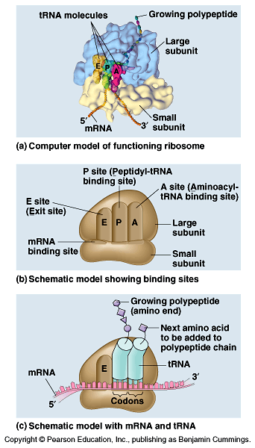
- Each has active sites for only a specific tRNA and amino acid combination.
- The synthetase catalyzes a covalent bond between them, forming aminoacyl-tRNA or activated amino acid.
- Ribosomes facilitate the specific coupling of the tRNA anticodons with mRNA codons.
- Each ribosome has a large and a small subunit.
- These are composed of proteins and ribosomal RNA (rRNA), the most abundant RNA in the cell.
- After rRNA genes are transcribed to rRNA in the nucleus, the rRNA and proteins form the subunits in the nucleolus.
- The subunits exit the nucleus via nuclear pores.
- The large and small subunits join to form a functional ribosome only when they attach to an mRNA molecule.
- While very similar in structure and function, prokaryotic and eukaryotic ribosomes have enough differences that certain antibiotic drugs (like tetracycline) can paralyze prokaryotic ribosomes without inhibiting eukaryotic ribosomes.
- Each ribosome has a binding site for mRNA and three binding sites for tRNA molecules.
- The P site holds the tRNA carrying the growing polypeptide chain.
- The A site carries the tRNA with the next amino acid.
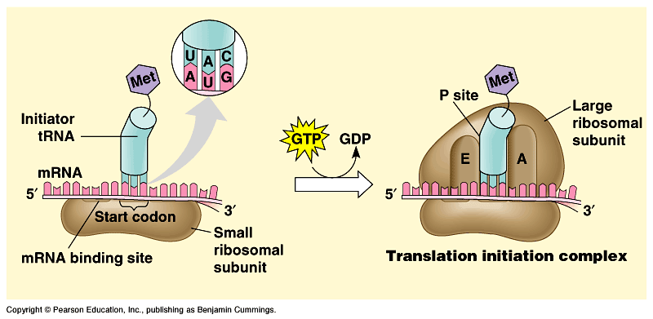
- Discharged tRNAs leave the ribosome at the E site.
- Recent advances in our understanding of the structure of the ribosome strongly support the hypothesis that rRNA, not protein, carries out the ribosome’s functions.
- RNA is the main constituent at the interphase between the two subunits and of the A and P sites.
- It is the catalyst for peptide bond formation.
- Translation can be divided into three stages
- Initiation
- Elongation
- Termination
- All three phase require protein “factors” that aid in the translation process.
- Both initiation and chain elongation require energy provided by the hydrolysis of GTP.
- Initiation brings together mRNA, a tRNA with the first amino acid, and the two ribosomal subunits.
- First, a small ribosomal subunit binds with mRNA and a special initiator tRNA, which carries methionine and attaches to the start codon.
- Initiation factors bring in the large subunit such that the initiator tRNA occupies the P site.
- Elongation consists of a series of three-step cycles as each amino acid is added to the proceeding one.
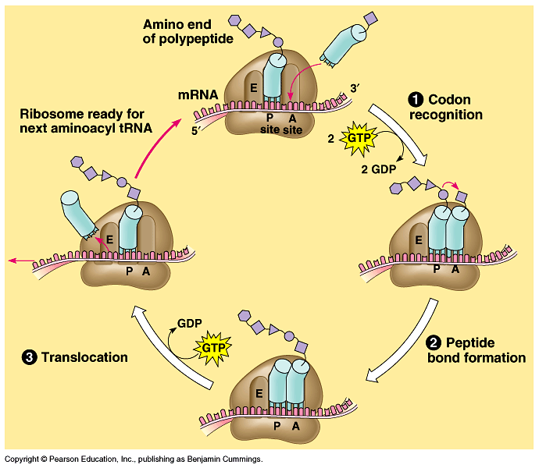
- During codon recognition, an elongation factor assists hydrogen bonding between the mRNA codon under the A site with the corresponding anticodon of tRNA carrying the appropriate
amino acid.
- This step requires the hydrolysis of two GTP.
- During peptide bond formation, an rRNA molecule catalyzes the formation of a peptide bond between the polypeptide in the P site with the new amino acid in the A site.
- This step separates the tRNA at the P site from the growing polypeptide chain and transfers the chain, now one amino acid longer, to the tRNA at the A site.
- During translocation, the ribosome moves the tRNA with the attached polypeptide from the A site to the P site.
- Because the anticodon remains bonded to the mRNA codon, the mRNA moves along with it.
- The next codon is now available at the A site.
- The tRNA that had been in the P site is moved to the E site and then leaves the ribosome.
- Translocation is fueled by the hydrolysis of GTP.
- Effectively, translocation ensures that the mRNA is “read” 5’ -> 3’ codon by codon.
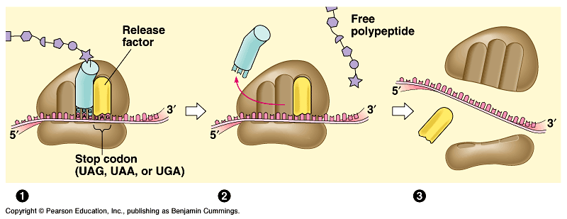
• The three steps of elongation continue codon by codon to add amino acids until the polypeptide chain is completed.

- Termination occurs when one of the three stop codons reaches the A site.
- A release factor binds to the stop codon and hydrolyzes the bond between the polypeptide and its tRNA in the P site.
- This frees the polypeptide and the translation complex disassembles.
- Typically a single mRNA is used to make many copies of a polypeptide simultaneously.
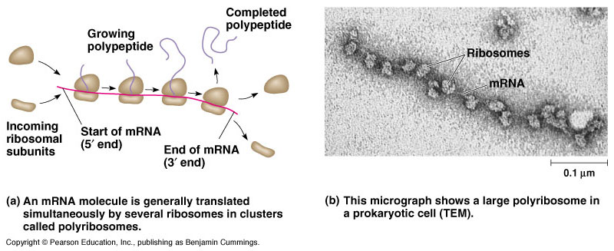
- Multiple ribosomes, polyribosomes, may trail along the same mRNA.
- A ribosome requires less than a minute to translate an average-sized mRNA into a polypeptide.
- During and after synthesis, a polypeptide coils and folds to its three-dimensional shape spontaneously.
- The primary structure, the order of amino acids, determines the secondary and tertiary structure.
- Chaperone proteins may aid correct folding.
- In addition, proteins may require posttranslational modifications before doing their particular job.
- This may require additions like sugars, lipids, or phosphate groups to amino acids.
- Enzymes may remove some amino acids or cleave whole polypeptide chains.
- Two or more polypeptides may join to form a protein.

2. Signal peptides target some eukaryotic polypeptides to specific destinations in the cell
- Two populations of ribosomes, free and bound, are active participants in protein synthesis.
- Free ribosomes are suspended in the cytosol and synthesize proteins that reside in the cytosol.
- Bound ribosomes are attached to the cytosolic side of the endoplasmic reticulum.
- They synthesize proteins of the endomembrane system as well as proteins secreted from the cell.
- While bound and free ribosomes are identical in structure, their location depends on the type of protein that they are synthesizing.
- Translation in all ribosomes begins in the cytosol, but a polypeptide destined for the endomembrane system or for export has a specific signal peptide region at or near the leading end.
- This consists of a sequence of about 20 amino acids.
- A signal recognition particle (SRP) binds to the signal peptide and attaches it and its ribosome to a receptor protein in the ER membrane.
- The SRP consists of a protein-RNA complex.
- After binding, the SRP leaves and protein synthesis resumes with the growing polypeptide snaking across the membrane into the cisternal space via a protein pore.
- An enzyme usually cleaves the signal polypeptide.
- Secretory proteins are released entirely into the cisternal space, but membrane proteins remain partially embedded in the ER membrane.
- Other kinds of signal peptides are used to target polypeptides to mitochondria, chloroplasts, the nucleus, and other organelles that are not part of the endomembrane system.
- In these cases, translation is completed in the cytosol before the polypeptide is imported into the organelle.
- While the mechanisms of translocation vary, each of these polypeptides has a “postal” code that ensures its delivery to the correct cellular location.

3. RNA plays multiple roles in the cell: a review
- The cellular machinery of protein synthesis and ER targeting is dominated by various kinds of RNA.
- The diverse functions of RNA are based, in part, on its ability to form hydrogen bonds with other nucleic acid molecules (DNA or RNA).
- It can also assume a specific three-dimensional shape by forming hydrogen bonds between bases in different parts of its polynucleotide chain.
- DNA may be the genetic material of all living cells today, but RNA is much more versatile.
- The diverse functions of RNA range from structural to informational to catalytic.

4. Comparing protein synthesis in prokaryotes and eukaryotes: a review
- Although bacteria and eukaryotes carry out transcription and translation in very similar ways, they do have differences in cellular machinery and
in details of the processes.
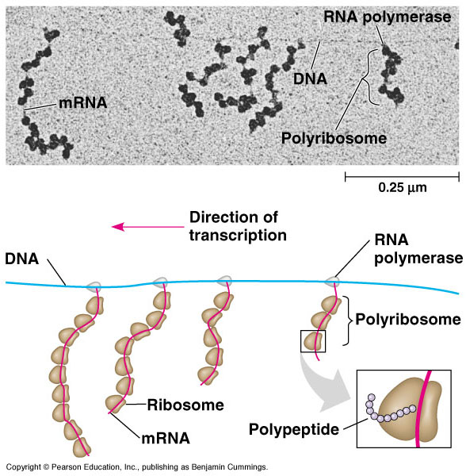
- Eukaryotic RNA polymerases differ from those of prokaryotes and require transcription factors.
- They differ in how transcription is terminated.
- Their ribosomes are also different.
- One big difference is that prokaryotes can transcribe and translate the same gene simultaneously.
- The new protein quickly diffuses to its operating site.
- In eukaryotes, the nuclear envelope segregates transcription from translation.
- In addition, extensive RNA processing is inserted between these processes.
- This provides additional steps whose regulation helps coordinate the elaborate activities of a eukaryotic cell.
- In addition, eukaryotic cells have complicated mechanisms for targeting proteins to the appropriate organelle.

5. Point mutations can affect protein structure and function
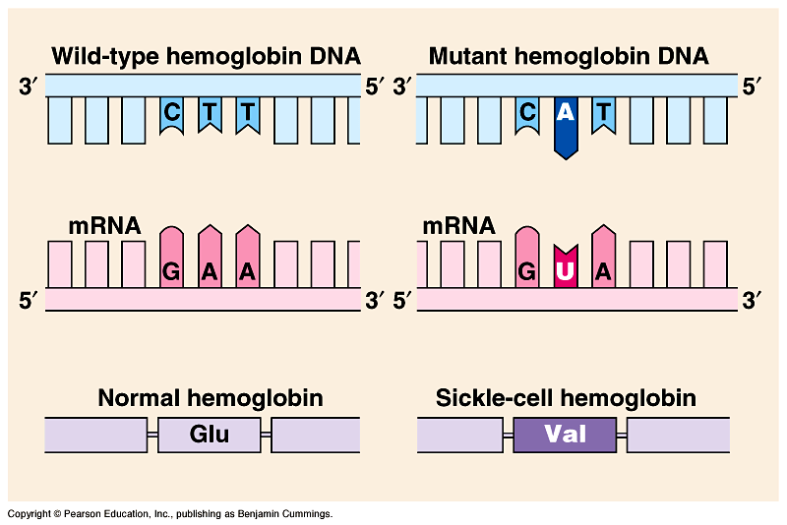
- Mutations are changes in the genetic material of a cell (or virus).
- These include large-scale mutations in which long segments of DNA are affected (for example, translocations, duplications, and inversions).
- A chemical change in just one base pair of a gene causes a point mutation.
- If these occur in gametes or cells producing gametes, they may be transmitted to future generations.
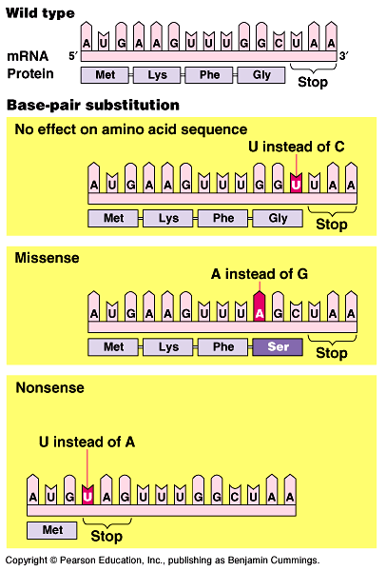
- For example, sickle-cell disease is caused by a mutation of a single base pair in the gene that codes for one of the polypeptides of hemoglobin.
- A change in a single nucleotide from T to A in the DNA template leads to an abnormal protein.
- A point mutation that results in the replacement of a pair of complementary nucleotides with another nucleotide pair is called a base-pair substitution.
- Some base-pair substitutions have little or no impact on protein function.
- In silent mutations, alterations of nucleotides still indicate the same amino acids because of redundancy in the genetic code.
- Other changes lead to switches from one amino acid to another with similar properties.
- Still other mutations may occur in a region where the exact amino acid sequence is not essential for function.
- Other base-pair substitutions cause a readily detectable change in a protein.
- These are usually detrimental but can occasionally lead to an improved protein or one with novel capabilities.
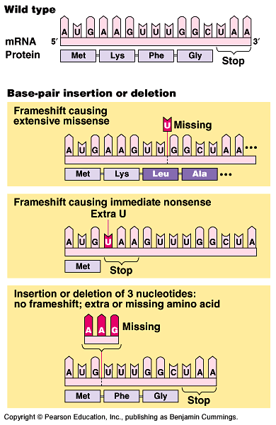
- Changes in amino acids at crucial sites, especially active sites, are likely to impact function.
- Missense mutations are those that still code for an amino acid but change the indicated amino acid.
- Nonsense mutations change an amino acid codon into a stop codon, nearly always leading to a nonfunctional protein.
- Insertions and deletions are additions or losses of nucleotide pairs in a gene.
- These have a disastrous effect on the resulting protein more often than substitutions do.
- Unless these mutations occur in multiples of three, they cause a frameshift mutation.
- All the nucleotides downstream of the deletion or insertion will be improperly grouped into codons.
- The result will be extensive missense, ending sooner or later in nonsense - premature termination.
- Mutations can occur in a number of ways.
- Errors can occur during DNA replication, DNA repair, or DNA recombination.
- These can lead to base-pair substitutions, insertions, or deletions, as well as mutations affecting longer stretches of DNA.
- These are called spontaneous mutations.
- Mutagens are chemical or physical agents that interact with DNA to cause mutations.
- Physical agents include high-energy radiation like X-rays and ultraviolet light.
- Chemical mutagens may operate in several ways.
- Some chemicals are base analogues that may be substituted into DNA, but that pair incorrectly during DNA replication.
- Other mutagens interfere with DNA replication by inserting into DNA and distorting the double helix.
- Still others cause chemical changes in bases that change their pairing properties.
- Researchers have developed various methods to test the mutagenic activity of different chemicals.
- These tests are often used as a preliminary screen of chemicals to identify those that may cause cancer.
- This makes sense because most carcinogens are mutagenic and most mutagens are carcinogenic.
6. What is a gene? revisiting the question
- The Mendelian concept of a gene views it as a discrete unit of inheritance that affects phenotype.
- Morgan and his colleagues assigned genes to specific loci on chromosomes.
- We can also view a gene as a specific nucleotide sequence along a region of a DNA molecule.
- We can define a gene functionally as a DNA sequence that codes for a specific polypeptide chain.
- Transcription, RNA processing, and translation are the processes that link DNA sequences to the synthesis of a specific polypeptide chain.
- Even the one gene-one polypeptide definition must be refined and applied selectively.
- Most eukaryotic genes contain large introns that have no corresponding segments in polypeptides.
- Promotors and other regulatory regions of DNA are not transcribed either, but they must be present for transcription to occur.
- Our definition must also include the various types of RNA that are not translated into polypeptides.
- A gene is a region of DNA whose final product is either a polypeptide or an RNA molecule.

