Chapter 14
Mendel and the Gene Idea
Lecture Outline
Overview: Drawing from the Deck of Genes
- Every day we observe heritable variations (such as brown, green, or blue eyes) among individuals in a population.
- These traits are transmitted from parents to offspring.
- One possible explanation for heredity is a “blending” hypothesis.
- This hypothesis proposes that genetic material contributed by each parent mixes in a manner analogous to the way blue and yellow paints blend to make green.
- With blending inheritance, a freely mating population would eventually give rise to a uniform population of individuals.
- Everyday observations and the results of breeding experiments tell us that heritable traits do not blend to become uniform.
- An alternative hypothesis, “particulate” inheritance, proposes that parents pass on discrete heritable units, genes, that retain their separate identities in offspring.
- Genes can be sorted and passed on, generation after generation, in undiluted form.
- Modern genetics began in an abbey garden, where a monk named Gregor Mendel documented a particulate mechanism of inheritance.

Concept 14.1 Mendel used the scientific approach to identify two laws of inheritance.
- Mendel discovered the basic principles of heredity by breeding garden peas in carefully planned experiments, carried out several decades before chromosomes were observed under the microscope.

Mendel’s Experimental, Quantitative Approach
- Mendel grew up on a small farm in what is today the Czech Republic.
- In 1843, Mendel entered an Augustinian monastery.
- Mendel studied at the University of Vienna from 1851 to 1853, where he was influenced by a physicist who encouraged experimentation and the application of mathematics to science and by a botanist who stimulated Mendel’s interest in the causes of variation in plants.
- These influences came together in Mendel’s experiments.
- After university, Mendel taught school and lived in the local monastery, where the monks had a long tradition of interest in the breeding of plants, including peas.
- Around 1857, Mendel began breeding garden peas to study inheritance.
- Pea plants have several advantages for genetic study.
- Pea plants are available in many varieties that have distinct heritable features, or characters, with different variant traits.
- Peas have a short generation time; each mating produces many offspring.
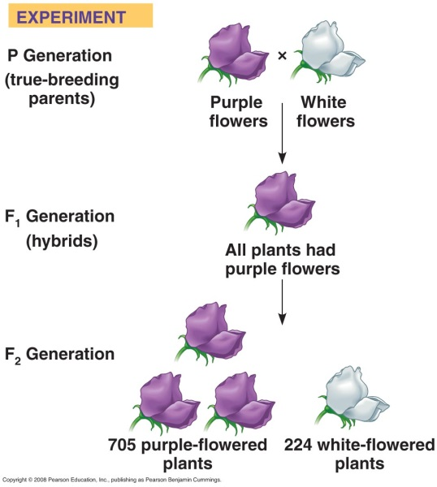
- Mendel was able to strictly control the matings of his pea plants.
- Each pea plant has male (stamens) and female (carpal) sexual organs.
- In nature, pea plants typically self-fertilize, fertilizing ova with the sperm nuclei from their own pollen.
- Mendel could also use pollen from another plant for cross-pollination.
- Mendel tracked only those characters that varied in an “either-or” manner, rather than a “more-or-less” manner.
- For example, he worked with flowers that were either purple or white.
- He avoided traits such as seed weight, which varied on a continuum.
- Mendel started his experiments with varieties that were true-breeding.
- When true-breeding plants self-pollinate, all their offspring have the same traits as their parents.
- In a typical breeding experiment, Mendel would cross-pollinate (hybridize) two contrasting, true-breeding pea varieties.
- The true-breeding parents are the P (parental) generation, and their hybrid offspring are the F₁ (first filial) generation.
- Mendel would then allow the F₁ hybrids to self-pollinate to produce an F₂ (second filial) generation.
- It was mainly Mendel’s quantitative analysis of F₂ plants that revealed two fundamental principles of heredity: the law of segregation and the law of independent assortment.

The Law of Segregation
- If the blending hypothesis were correct, the F₁ hybrids from a cross between purple-flowered and white-flowered pea plants would have pale purple flowers.
- Instead, the F₁ hybrids all have purple flowers, just as purple as their purple-flowered parents.
- When Mendel allowed the F₁ plants to self-fertilize, the F₂ generation included both purple-flowered and white-flowered plants.
- The white trait, absent in the F₁ generation, reappeared in the F₂.
- Mendel used very large sample sizes and kept accurate records of his results.
- Mendel recorded 705 purple-flowered F₂ plants and 224 white-flowered F₂ plants.
- This cross produced a ratio of three purple flowers to one white flower in the F₂ offspring.
- Mendel reasoned that the heritable factor for white flowers was present in the F₁ plants but did not affect flower color.
- Purple flower color is a dominant trait, and white flower color is a recessive trait.
- The reappearance of white-flowered plants in the F₂ generation indicated that the heritable factor for the white trait was not diluted or lost by coexisting with the purple-flower factor in F₁ hybrids.
- Mendel found similar 3:1 ratios of two traits in F₂ offspring when he conducted crosses for six other characters, each represented by two different traits.
- For example, when Mendel crossed two true-breeding varieties, one producing round seeds and the other producing wrinkled seeds, all the F₁ offspring had round seeds.
- In the F₂ plants, 75% of the seeds were round and 25% were wrinkled.
- Mendel developed a hypothesis to explain these results that consisted of four related ideas. We will explain each idea with the modern understanding of genes and chromosomes.

- Alternative versions of genes account for variations in inherited characters.
- The gene for flower color in pea plants exists in two versions, one for purple flowers and one for white flowers.
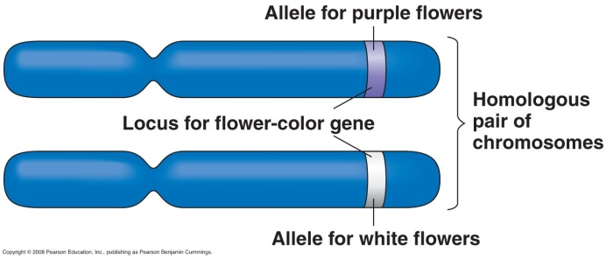
- These alternative versions of a gene are called alleles.
- Each gene resides at a specific locus on a specific chromosome.
- The DNA at that locus can vary in its sequence of nucleotides.
- The purple-flower and white-flower alleles are two DNA variations at the flower-color locus.

- For each character, an organism inherits two alleles, one from each parent.
- A diploid organism inherits one set of chromosomes from each parent.
- Each diploid organism has a pair of homologous chromosomes and, therefore, two copies of each gene.
- These homologous loci may be identical, as in the true-breeding plants of the P generation.
- Alternatively, the two alleles may differ, as in the F₁ hybrids.

- If the two alleles at a locus differ, then one, the dominant allele, determines the organism’s appearance. The other, the recessive allele, has no noticeable effect on the organism’s appearance.
- In the flower-color example, the F₁ plants inherited a purple-flower allele from one parent and a white-flower allele from the other.
- The plants had purple flowers because the allele for that trait is dominant.

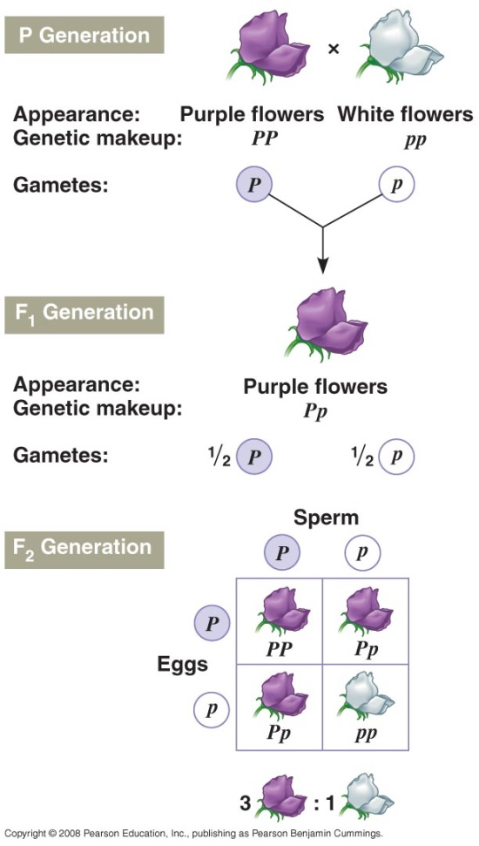
- Mendel’s law of segregation states that the two alleles for a heritable character segregate (separate) during gamete production and end up in different gametes.
- This segregation of alleles corresponds to the distribution of homologous chromosomes to different gametes in meiosis.
- If an organism has two identical alleles for a particular character, then that allele is present as a single copy in all gametes.
- If different alleles are present, then 50% of the gametes will receive one allele and 50% will receive the other.
- Mendel’s law of segregation accounts for the 3:1 ratio that he observed in the F₂ generation.
- The F₁ hybrids produce two classes of gametes, half with the purple-flower allele and half with the white-flower allele.
- During self-pollination, the gametes of these two classes unite randomly to produce four equally likely combinations of sperm and ovum.
- A Punnett square may be used to predict the results of a genetic cross between individuals of known genotype.
- For the flower-color example, we can use a capital letter to symbolize the dominant allele and a lowercase letter to symbolize the recessive allele.
- P is the purple-flower allele, and p is the white-flower allele.
- What will be the physical appearance of the F₂ offspring?
- One in four F₂ offspring will inherit two white-flower alleles and produce white flowers.
- Half of the F₂ offspring will inherit one white-flower allele and one purple-flower allele and produce purple flowers.
- One in four F₂ offspring will inherit two purple-flower alleles and produce purple flowers.
- Mendel’s model accounts for the 3:1 ratio in the F₂ generation.

Useful Genetic Vocabulary
- An organism with two identical alleles for a character is homozygous for the gene controlling that character.
- An organism with two different alleles for a gene is heterozygous for that gene.
- An organism’s observable traits are called its phenotype.
- “Phenotype” refers to physiological traits as well as traits directly related to appearance.
- An organism’s genetic makeup is called its genotype.
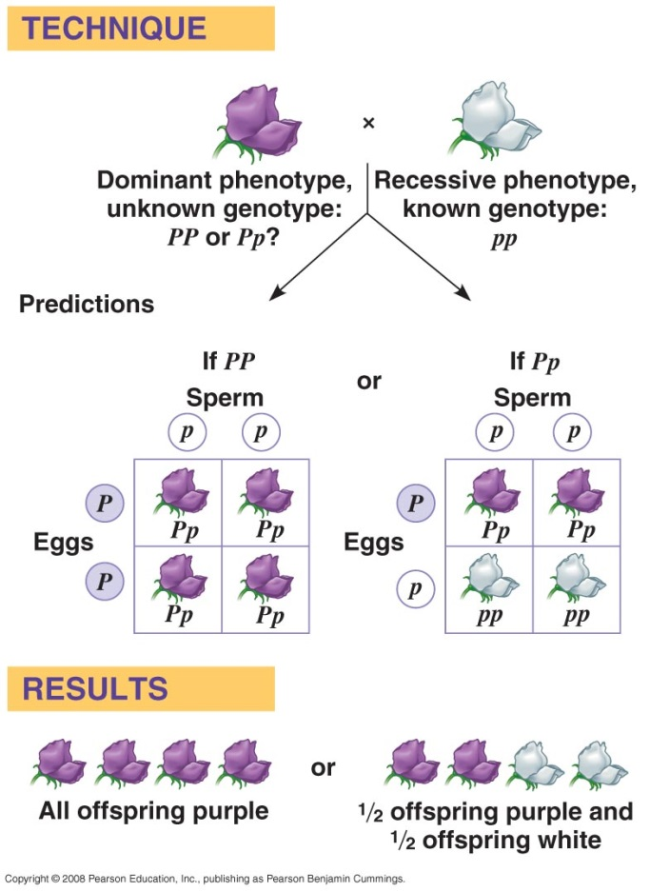
- Two organisms can have the same phenotype but different genotypes if one is homozygous dominant and the other is heterozygous.
- PP and Pp plants have the same phenotype (purple flowers) but different genotypes (homozygous dominant and heterozygous).
- For flower color in peas, the only individuals with white flowers are those that are homozygous recessive (pp) for the flower-color gene.

The Testcross
- How can we determine the genotype of an individual that has the dominant phenotype?
- The organism must have one dominant allele but could be homozygous dominant or heterozygous.
- The answer is to carry out a testcross.
- The mystery individual is bred with a homozygous recessive individual.
- If any of the offspring display the recessive phenotype, the mystery parent must be heterozygous.

The Law of Independent Assortment
- Mendel’s first experiments followed only a single character, such as flower color.
- All the F₁ progeny produced in these crosses were monohybrids, heterozygous for one character.
- A cross between two heterozygotes is a monohybrid cross.
- Mendel identified the second law of inheritance by following two characters at the same time.
- In one such dihybrid cross, Mendel studied the inheritance of seed color and seed shape.
- The allele for yellow seeds (Y) is dominant to the allele for green seeds (y).
- The allele for round seeds (R) is dominant to the allele for wrinkled seeds (r).
- Mendel crossed true-breeding plants that had yellow, round seeds (YYRR) with true-breeding plants that had green, wrinkled seeds (yyrr).
- The F₁ plants are dihybrid individuals that are heterozygous for two characters (YyRr).
- One possible hypothesis is that the two characters are transmitted from parents to offspring as a package.
- In this case, the Y and R alleles and the y and r alleles would stay together.
- If this were the case, the F₁ offspring would produce yellow, round seeds.
- The F₂ offspring would produce two phenotypes (yellow + round; green + wrinkled) in a 3:1 ratio, just like a monohybrid cross.
- This was not consistent with Mendel’s results.
- An alternative hypothesis is that the two pairs of alleles segregate independently of each other.
- The presence of a specific allele for one trait in a gamete has no impact on the presence of a specific allele for the second trait.
- In our example, the F₁ offspring would still produce yellow, round seeds.
- When the F₁ offspring produced gametes, genes would be packaged into gametes with all possible allelic combinations.
- Four classes of gametes (YR, Yr, yR, and yr) would be produced in equal amounts.
- When sperm with four classes of alleles and ova with four classes of alleles combine, there are 16 equally probable ways in which the alleles can combine in the F₂ generation.
- These combinations produce four distinct phenotypes in a 9:3:3:1 ratio.
- This was consistent with Mendel’s experimental results.
- Mendel repeated the dihybrid cross experiment for other pairs of characters and always observed a 9:3:3:1 phenotypic ratio in the F₂ generation.
- Each character appeared to be inherited independently.
- If you follow just one character in these crosses, you will observe a 3:1 F₂ ratio, just as if this were a monohybrid cross.
- The independent assortment of each pair of alleles during gamete formation is called Mendel’s law of independent assortment: Each pair of alleles segregates independently during gamete formation.
- Strictly speaking, this law applies only to genes located on different, nonhomologous chromosomes.
- Genes located near each other on the same chromosome tend to be inherited together and have more complex inheritance patterns than those predicted for the law of independent assortment.

Concept 14.2 The laws of probability govern Mendelian inheritance.
- Mendel’s laws of segregation and independent assortment reflect the same laws of probability that apply to tossing coins or rolling dice.
- Values of probability range from 0 (an event with no chance of occurring) to 1 (an event that is certain to occur).
- The probability of tossing heads with a normal coin is 1/2.
- The probability of rolling a 3 with a six-sided die is 1/6, and the probability of rolling any other number is 1 − 1/6 = 5/6.
- The outcome of one coin toss has no impact on the outcome of the next toss. Each toss is an independent event, just like the distribution of alleles into gametes.
- Like a coin toss, each ovum from a heterozygous parent has a 1/2 chance of carrying the dominant allele and a 1/2 chance of carrying the recessive allele.
- The same probabilities apply to the sperm.
- We can use the multiplication rule to determine the probability that two or more independent events will occur together in some specific combination.
- Compute the probability of each independent event.
- Multiply the individual probabilities to obtain the overall probability of these events occurring together.
- The probability that two coins tossed at the same time will both land heads up is 1/2 × 1/2 = 1/4.
- Similarly, the probability that a heterozygous pea plant (Pp) will self-fertilize to produce a white-flowered offspring (pp) is the probability that a sperm with a white allele will fertilize an ovum with a white allele. This probability is 1/2 × 1/2 = 1/4.
- We can use the addition rule to determine the probability that an F₂ plant from a monohybrid cross will be heterozygous rather than homozygous.
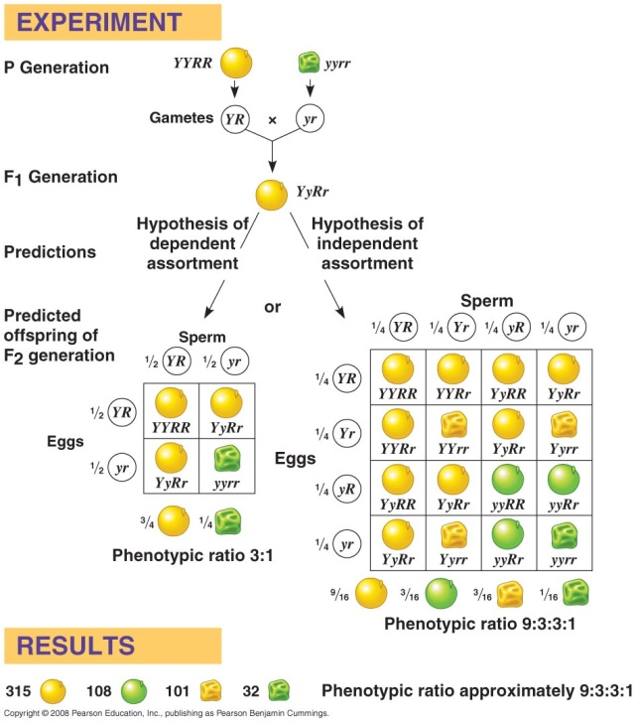
- The probability of an event that can occur in two or more different ways is the sum of the individual probabilities of those ways.
- The probability of obtaining an F₂ heterozygote by combining the dominant allele from the egg and the recessive allele from the sperm is 1⁄4.
- The probability of combining the recessive allele from the egg and the dominant allele from the sperm also 1⁄4.
- Using the rule of addition, we can calculate the probability of an F₂ heterozygote as 1⁄4 + 1⁄4 = 1⁄2.
- The rule of multiplication applies to dihybrid crosses.
- For a heterozygous parent (YyRr), the probability of producing a YR gamete is 1/2 × 1/2 = 1/4.
- We can now predict the probability of a particular F₂ genotype without constructing a 16-part Punnett square.
- The probability that an F₂ plant from heterozygous parents will have a YYRR genotype is 1/16 (1/4 chance for a YR ovum × 1/4 chance for a YR sperm).
- We can combine the rules of multiplication and addition to solve complex problems in Mendelian genetics.
- Let’s determine the probability of an offspring having two recessive phenotypes for at least two of three traits resulting from a trihybrid cross between pea plants that are PpYyRr and Ppyyrr.
- Five possible genotypes result in this condition: ppyyRr, ppYyrr, Ppyyrr, PPyyrr, and ppyyrr.
- We can use the rule of multiplication to calculate the probability for each of these genotypes and then use the rule of addition to pool the probabilities for finding at least two recessive traits.
- The probability of producing a ppyyRr offspring:
- The probability of producing pp = 1/2 × 1/2 = 1/4.
- The probability of producing yy = 1/2 × 1 = 1/2.
- The probability of producing Rr = 1/2 × 1 = 1/2.
- Therefore, the probability of all three being present (ppyyRr) in one offspring is 1/4 × 1/2 × 1/2 = 1/16.
- For ppYyrr: 1/4 × 1/2 × 1/2 = 1/16.
- For Ppyyrr: 1/2 × 1/2 × 1/2 = 1/8 or 2/16.
- For PPyyrr: 1/4 × 1/2 × 1/2 = 1/16.
- For ppyyrr: 1/4 × 1/2 × 1/2 = 1/16.
- Therefore, the chance that a given offspring will have at least two recessive traits is 1/16 + 1/16 + 2/16 + 1/16 + 1/16 = 6/16.
- Although we cannot predict with certainty the genotype or phenotype of any particular seed from the F₂ generation of a dihybrid cross, we can predict the probability that it will have a specific genotype or phenotype.
- Mendel’s experiments succeeded because he counted so many offspring, was able to discern the statistical nature of inheritance, and had a keen sense of the rules of chance.
- Mendel’s laws of independent assortment and segregation explain heritable variation in terms of alternative forms of genes that are passed along according to simple rules of probability.
- These laws apply not only to garden peas but to all diploid organisms that reproduce by sexual reproduction.
- Mendel’s studies of pea inheritance are a model not only in genetics but also as a case study of the power of scientific reasoning using the hypothetico-deductive approach.

Concept 14.3 Inheritance patterns are often more complex than predicted by simple Mendelian genetics.
- In the 20th century, geneticists extended Mendelian principles both to diverse organisms and to patterns of inheritance more complex than Mendel described.
- In fact, Mendel had the good fortune to choose a system that was relatively simple genetically.
- Each character that Mendel studied is controlled by a single gene.
- Each gene has only two alleles, one of which is completely dominant to the other.
- The heterozygous F₁ offspring of Mendel’s crosses always looked like one of the parental varieties because one allele was dominant to the other.
- The relationship between genotype and phenotype is rarely so simple.

Extending Mendelian Genetics for a Single Gene
- The inheritance of characters determined by a single gene deviates from simple Mendelian patterns when alleles are not completely dominant or recessive, when a gene has more than two alleles, or when a gene produces multiple phenotypes.
- We will consider each of these situations.

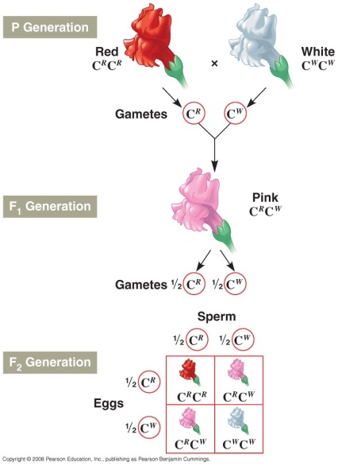
Degrees of Dominance
- Alleles show different degrees of dominance and recessiveness in relation to each other.
- One extreme is the complete dominance characteristic of Mendel’s crosses.
- Some alleles show incomplete dominance, in which heterozygotes show a distinct intermediate phenotype not seen in homozygotes.
- This is not blending inheritance because the traits are separable (particulate), as shown in further crosses.
- Offspring of a cross between heterozygotes show three phenotypes: each parental phenotype and the heterozygous phenotype.
- The phenotypic and genotypic ratios are identical: 1:2:1.
- A clear example of incomplete dominance is the flower color of snapdragons.
- A cross between a white-flowered plant and a red-flowered plant produces all pink F₁ offspring.
- Self-pollination of the F₁ offspring produces 25% white, 25% red, and 50% pink F₂ offspring.
- At the other extreme from complete dominance is codominance, in which two alleles affect the phenotype in separate, distinguishable ways.
- For example, the M, N, and MN blood groups of humans are due to the presence of two specific molecules on the surface of red blood cells.
- People of group M (genotype MM) have one type of molecule on their red blood cells, people of group N (genotype NN) have the other type, and people of group MN (genotype MN) have both molecules present.
- The MN phenotype is not intermediate between M and N phenotypes but rather exhibits both the M and the N phenotype.
- The relative effects of two alleles range from complete dominance of one allele, through incomplete dominance of either allele, to codominance of both alleles.
- It is important to recognize that a dominant allele does not somehow subdue a recessive allele.
- Alleles are simply variations in a gene’s nucleotide sequence.
- When a dominant allele coexists with a recessive allele in a heterozygote, they do not interact at all.
- To illustrate the relationship between dominance and phenotype, let’s consider Mendel’s character of round versus wrinkled pea seed shape.
- The dominant allele (round) codes for an enzyme that helps convert an unbranched form of starch to a branched form in the seed.
- The recessive allele (wrinkled) codes for a defective form of this enzyme that leads to an accumulation of unbranched starch.
- Excess water is then drawn into the seed due to osmosis.
- The seeds wrinkle when the excess water dries.
- Both homozygous dominant and heterozygous pea plants produce enough enzymes to synthesize adequate amounts of branched starch.
- As a result, they do not fill with excess water and they form smooth seeds as they dry.
- For any character, dominance/recessiveness relationships depend on the level at which we examine the phenotype.
- For example, humans with Tay-Sachs disease lack a functioning enzyme to metabolize certain lipids.
- These lipids accumulate in the brain, harming brain cells and ultimately leading to death.
- Children with two Tay-Sachs alleles (homozygotes) have the disease.
- Both heterozygotes, with one allele coding for a functional enzyme, and homozygotes, with two such alleles, are healthy and normal.
- At the organismal level, the allele for the functional enzyme is dominant to the Tay-Sachs allele.
- The activity level of the lipid-metabolizing enzyme is reduced in heterozygotes.
- At the biochemical level, the alleles show incomplete dominance.
- Heterozygous individuals produce equal numbers of normal and dysfunctional enzyme molecules.
- At the molecular level, the Tay-Sachs and functional alleles are codominant.
- A dominant allele is not necessarily more common in a population than the recessive allele.
- For example, one baby in 400 is born with polydactyly, a condition in which individuals are born with extra fingers or toes.
- Polydactyly is due to a dominant allele. Clearly, however, the recessive allele is far more prevalent than the dominant allele.
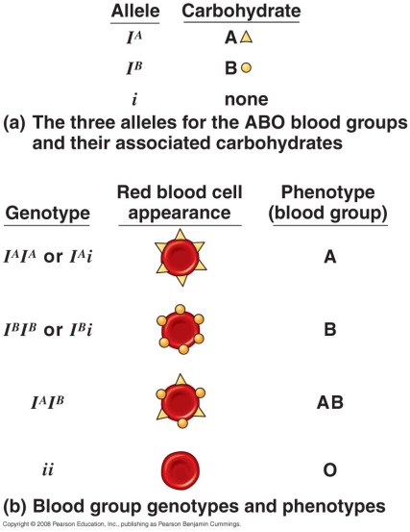
Multiple Alleles
- Many genes exist in populations in more than two allelic forms.
- The ABO blood groups in humans are determined by three alleles: I^{A}, I^{B}, and i.
- Both the I^{A} and I^{B} alleles are dominant to the i allele.
- The I^{A} and I^{B} alleles are codominant to each other.
- Because each individual carries two alleles, there are six possible genotypes and four possible blood types.
- Individuals who are I^{A}I^{A} or I^{A}i are type A and have type A carbohydrates on the surface of their red blood cells.
- Individuals who are I^{B}I^{B} or I^{B}i are type B and have type B carbohydrates on the surface of their red blood cells.
- Individuals who are I^{A}I^{B} are type AB and have both type A and type B carbohydrates on the surface of their red blood cells.
- Individuals who are ii are type O and have neither carbohydrate on the surface of their red blood cells.
- Matching compatible blood groups is critical for blood transfusions because a person produces antibodies against foreign blood factors.
- If the donor’s blood has an A or B carbohydrate that is foreign to the recipient, then antibodies in the recipient’s blood will bind to the foreign molecules, cause the donated blood cells to clump together, and can kill the recipient.

Pleiotropy
- The genes that we have covered so far affect only one phenotypic character.
- Most genes are pleiotropic, affecting more than one phenotypic character.
- For example, the wide-ranging symptoms of sickle-cell disease are due to a single gene.
- Considering the intricate molecular and cellular interactions responsible for an organism’s development, it is not surprising that a gene can affect a number of characteristics.

Extending Mendelian Genetics for Two or More Genes
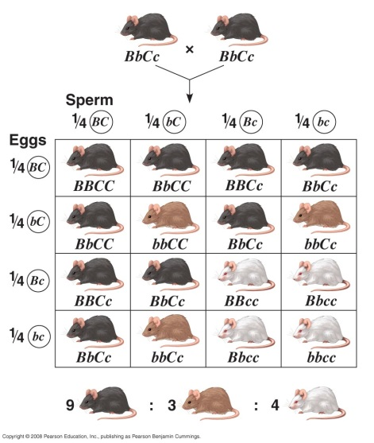
- Epistasis and polygenic inheritance are situations in which two or more genes are involved in determining phenotype.
- In epistasis, a gene at one locus alters the phenotypic expression of a gene at a second locus.
- For example, in mice and many other mammals, coat color depends on two genes.
- One, the epistatic gene, determines whether pigment is deposited in hair.
    - Presence (C) is dominant to absence (c) of pigment.
- The second gene determines whether the pigment to be deposited is black or brown.
    - The black allele (B) is dominant to the brown allele (b).
- An individual that is cc has a white (albino) coat regardless of the genotype of the second gene.
- The gene for pigment deposition is said to be epistatic to the gene for pigment color.
- A cross between two black mice that are heterozygous (BbCc) follows the law of independent assortment.
- Unlike the 9:3:3:1 offspring ratio of a normal Mendelian experiment, however, the offspring ratio is nine black, three brown, and four white.
- All cc mice are albino, regardless of the alleles they inherit at the B gene.
- Some characters cannot be classified as either-or, as Mendel’s genes were.
- Quantitative characters vary in a population along a continuum.
- Quantitative characters are usually due to polygenic inheritance, the additive effects of two or more genes on a single phenotypic character.
- For example, skin color in humans is controlled by at least three independent genes.
- Imagine that each gene has two alleles, one light and one dark, that demonstrate incomplete dominance.
- An AABBCC individual is very dark; an aabbcc individual is very light.
- A cross between two AaBbCc individuals (with intermediate skin shade) produces offspring with a wide range of shades.
- Individuals with intermediate skin shades are most common, but some very light and very dark individuals may be produced as well.
- The range of phenotypes forms a normal distribution if the number of offspring is great enough.
- Environmental factors, such as sun exposure, also affect skin color and contribute to a smooth normal distribution.

Nature and Nurture: The Environmental Impact on Phenotype
- Phenotype depends on both environment and genes.
- A single tree may have leaves that vary in size, shape, and greenness, depending on exposure to wind and sun.
- For humans, nutrition influences height, exercise alters build, sun-tanning darkens skin, and experience improves performance on intelligence tests.
- Even identical twins, who are genetically identical, accumulate phenotypic differences as a result of their unique experiences.
- The relative importance of genes and the environment in influencing human characteristics is a very old and hotly contested debate.
- The product of a genotype is generally not a rigidly defined phenotype, but a range of phenotypic possibilities, the norm of reaction, determined by the environment.
- In some cases, the norm of reaction has no breadth, and a given genotype specifies a particular phenotype (for example, blood type).
- In contrast, a person’s red and white blood cell count varies with factors such as altitude, customary amount of exercise, and presence of infection.
- Norms of reaction are broadest for polygenic characters.
- For these multifactorial characters, genes and environment influence phenotype.

Integrating a Mendelian View of Heredity and Variation
- A reductionist emphasis on single genes and single phenotypic characters presents an inadequate perspective on heredity and variation.
- A more comprehensive theory of Mendelian genetics views organisms as a whole.
- The term phenotype can refer not only to specific characters such as flower color or blood group, but also to an organism in its entirety, including all aspects of its physical appearance, internal anatomy, physiology, and behavior.
- Genotype can refer not only to a single genetic locus but also to an organism’s entire genetic makeup.
- An organism’s phenotype reflects its overall genotype and its unique environmental history.

Concept 14.4 Many human traits follow Mendelian patterns of inheritance.
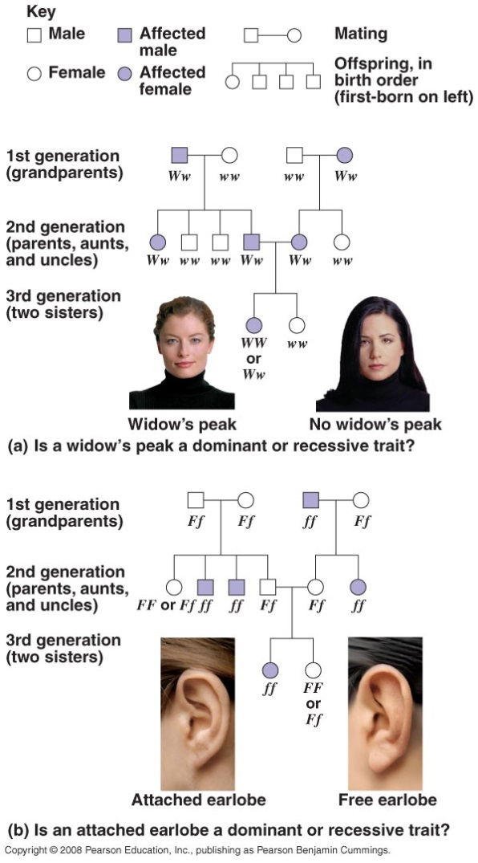
- Whereas peas are convenient subjects for genetic research, humans are not.
- The human generation time is too long, their fecundity is too low, and breeding experiments are unacceptable.
- Yet, humans are subject to the same rules governing inheritance as other organisms.
- New techniques in molecular biology have led to many breakthrough discoveries in the study of human genetics.
- In pedigree analysis, rather than manipulate mating patterns of people, geneticists analyze the results of matings that have already occurred.
- Information about the presence or absence of a particular phenotypic trait is collected from as many individuals in a family as possible, across generations.
- The distribution of these characters is then mapped on the family tree.
- For example, the occurrence of a widow’s peak (W) is dominant to a straight hairline (w).
- Phenotypes of family members and knowledge of dominance/recessiveness relationships between alleles allow researchers to predict the genotypes of members of this family.
- For example, if an individual in the third generation lacks a widow’s peak but both her parents have widow’s peaks, then her parents must be heterozygous for that gene.
- If some siblings in the second generation lack a widow’s peak and one of the grandparents (first generation) also lacks one, then we know the other grandparent must be heterozygous, and we can determine the genotype of many other individuals.
- We can use the same family tree to trace the distribution of attached earlobes (f), a recessive characteristic. Individuals with a dominant allele (F) have free earlobes.
- Some individuals may be ambiguous, especially if they have the dominant phenotype and could be heterozygous or homozygous dominant.
- A pedigree can help us understand the past and predict the future.
- We can use normal Mendelian rules, including the multiplication and addition rules of probability, to predict the probabilities of specific phenotypes.
- For example, the multiplication rule can be used to predict the probability that a child with WwFf parents will have a widow’s peak and attached earlobes.
    - The probability of having a widow’s peak is 3/4.
    - The probability of having attached earlobes is 1/4.
    - This combination has a probability of 3/4 × 1/4 = 3/16.

Recessively Inherited Disorders
- Thousands of genetic disorders, including disabling or deadly hereditary diseases, are inherited as simple recessive traits.
- These conditions range from relatively mild (albinism) to life-threatening (cystic fibrosis).

Albinism
- An allele that causes a recessive condition such as albinism codes for a malfunctioning protein or for no protein at all.
- Heterozygotes have a normal phenotype because one normal allele produces enough of the required protein.
- Albinism shows up only in homozygous individuals who inherit a recessive allele from each parent.
- Individuals who do not have the disorder are either homozygous dominant or heterozygotes.
- Although heterozygotes may lack obvious phenotypic effects, they are carriers who may transmit a recessive allele to their offspring.
- Most people with recessive disorders are born to carriers with normal phenotypes.
- In a mating between two carriers of albinism, each child has a 1/4 chance of inheriting the disorder, a 1/2 chance of being a carrier, and a 1/4 chance of being homozygous dominant.
- Genetic disorders are not evenly distributed among all groups of humans.
- This is due to the different genetic histories of the world’s people during times when populations were more geographically and genetically isolated.
- Normally, it is relatively unlikely that two carriers of the same rare, harmful allele will meet and mate.
- Consanguineous matings between close relatives increase the risk.
- Individuals who share a recent common ancestor are more likely to carry the same recessive alleles.
- Geneticists disagree about the extent to which human consanguinity increases the risk of inherited diseases.
- Most societies and cultures have laws or taboos forbidding marriages between close relatives.

Cystic Fibrosis
- Cystic fibrosis strikes one of every 2,500 whites of European descent.
- One in 25 people (4%) of European descent is a carrier for this condition.
- The normal allele at this gene codes for a membrane protein that transports chloride between cells and extracellular fluid.
- If these channels are defective or absent, abnormally high extracellular levels of chloride accumulate.
- Then the mucous coats of certain cells become thicker and stickier than normal.
- This mucous buildup in the pancreas, lungs, digestive tract, and elsewhere causes poor absorption of nutrients, chronic bronchitis, and bacterial infections.
- The extracellular chloride also contributes to infection by disabling a natural antibiotic made by some body cells.
- Without treatment, affected children die before age 5, but with treatment, they can live past their late 20s or even 30s.

Sickle-Cell Disease
- The most common inherited disease among people of African descent is sickle-cell disease, which affects one of 400 African-Americans.
- Sickle-cell disease is caused by the substitution of a single amino acid in hemoglobin.
- When oxygen levels in the blood of an affected individual are low, sickle-cell hemoglobin aggregates into long rods that deform red blood cells into a sickle shape.
- This sickling creates a cascade of symptoms, demonstrating the pleiotropic effects of this allele, as sickled cells clump and clog capillaries throughout the body.
- Doctors can use regular blood transfusions to prevent brain damage and new drugs to prevent or treat other problems.
- At the organismal level, the nonsickle allele is incompletely dominant to the sickle-cell allele.
- Carriers are said to have sickle-cell trait.
- These individuals are usually healthy, although some may suffer symptoms of sickle-cell disease under blood-oxygen stress.
- At the molecular level, the two alleles are codominant because both normal and abnormal (sickle-cell) hemoglobin molecules are synthesized.
- About one in ten African-Americans has sickle-cell trait.
- The high frequency of heterozygotes is unusual for an allele with severe detrimental effects in homozygotes.
- Individuals with one sickle-cell allele have increased resistance to the malaria parasite, which spends part of its life cycle in red blood cells.
- In tropical Africa, where malaria is common, the sickle-cell allele is both a boon and a bane.
- Homozygous normal individuals die of malaria and homozygous recessive individuals die of sickle-cell disease, while carriers are relatively free of both.
- The relatively high frequency of sickle-cell trait in African-Americans is a vestige of their African roots.

Dominantly Inherited Disorders
- Although most harmful alleles are recessive, a number of human disorders are due to dominant alleles.

Achondroplasia
- Achondroplasia, a form of dwarfism, has a prevalence of one case in 25,000 people.
- Heterozygous individuals have the dwarf phenotype.
- The 99.99% of the population who are not achondroplastic dwarfs are homozygous recessive for this trait.
- Achondroplasia is another example of a trait for which the recessive allele is far more prevalent than the dominant allele.
- Lethal dominant alleles are much less common than lethal recessive alleles.
- If a lethal dominant allele kills an offspring before he or she can mature and reproduce, the allele will not be passed on to future generations.
- In contrast, a lethal recessive allele can be passed on by heterozygous carriers who have normal phenotypes.

Huntington’s Disease
- A lethal dominant allele can escape elimination if it causes death at a relatively advanced age, after the individual has already passed on the lethal allele to his or her children.
- One example is Huntington’s disease, a degenerative disease of the nervous system.
- The dominant lethal allele has no obvious phenotypic effect until the individual is about 35 to 45 years old.
- Then the deterioration of the nervous system is irreversible and inevitably fatal.
- Any child born to a parent who has the allele for Huntington’s disease has a 50% chance of inheriting the disease and the disorder.
- In the United States, this devastating disease afflicts one in 10,000 people.
- Recently, molecular geneticists have used pedigree analysis of affected families to track the Huntington’s allele to a locus near the tip of chromosome 4.
- The gene has now been sequenced.
- This has led to the development of a test that can detect the presence of the Huntington’s allele in an individual’s genome.

Multifactorial Disorders
- While some diseases are inherited in a simple Mendelian fashion due to alleles at a single locus, many other disorders have a multifactorial basis.
- Such disorders have a genetic component plus a significant environmental influence.
- Multifactorial disorders include heart disease, diabetes, cancer, alcoholism, and certain mental illnesses, such as schizophrenia and manic-depressive disorder.
- The genetic component of such disorders is typically polygenic.
- At present, little is understood about the genetic contribution to most multifactorial diseases.
- The best public health strategy is education about relevant environmental factors and promotion of healthy behavior.

Genetic Testing and Counseling
- A preventive approach to simple Mendelian disorders is sometimes possible.
- The risk that a particular genetic disorder will occur can sometimes be assessed before a child is conceived or early in pregnancy.
- Many hospitals have genetic counselors to provide information to prospective parents who are concerned about a family history of a specific disease.

Counseling Based on Mendelian Genetics and Probability Rules
- Consider a hypothetical couple, John and Carol, who are planning to have their first child.
- Both John and Carol had brothers who died of the same recessive disease.
- John, Carol, and their parents do not have the disease.
- Their parents must have been carriers (Aa × Aa).
- John and Carol each have a 2/3 chance of being carriers and a 1/3 chance of being homozygous dominant.
- The probability that their first child will have the disease is 2/3 (chance that John is a carrier) × 2/3 (chance that Carol is a carrier) × 1/4 (chance that the offspring of two carriers is homozygous recessive) = 1/9.
- If their first child is born with the disease, we know that John and Carol’s genotype must be Aa and they are both carriers.
- In that case, the chance that their next child will also have the disease is 1/4.
- Mendel’s laws are simply the rules of probability applied to heredity.
- Because chance has no memory, the genotype of each child is unaffected by the genotypes of older siblings.
- The chance that John and Carol’s first three children will have the disorder is 1/4 × 1/4 × 1/4 = 1/64.
- Should that outcome happen, the likelihood that a fourth child will also have the disorder is still 1/4.

Tests for Identifying Carriers
- Because most children with recessive disorders are born to parents with a normal phenotype, the key to assessing risk is identifying whether prospective parents are heterozygous carriers of the recessive trait.
- Recently developed tests for many disorders can distinguish normal phenotypes in heterozygotes from homozygous dominants.
- These results allow individuals with a family history of a genetic disorder to make informed decisions about having children.
- Issues of confidentiality, discrimination, and counseling may arise.

Fetal Testing
- Tests are available to determine in utero whether a child has a particular disorder.
- One technique, amniocentesis, can be used from the 14th to 16th week of pregnancy to assess whether the fetus has a specific disease.
- Fetal cells extracted from amniotic fluid are cultured and karyotyped to identify some disorders.
- Other disorders can be identified from chemicals in the amniotic fluids.
- A second technique, chorionic villus sampling (CVS), allows faster karyotyping and can be performed as early as the eighth to tenth week of pregnancy.
- A sample of fetal tissue is extracted from the chorionic villi of the placenta.
- This technique is not suitable for tests that require amniotic fluid.
- Recently, techniques have been developed for isolating and culturing fetal cells from the mother’s blood.
- Other techniques, ultrasound and fetoscopy, allow fetal health to be assessed visually in utero.
- Ultrasound uses sound waves to produce an image of the fetus.
- In fetoscopy, a needle-thin tube containing fiber optics and a viewing scope is inserted into the uterus.
- Both fetoscopy and amniocentesis cause complications such as maternal bleeding or fetal death in about 1% of cases.
- Therefore, these techniques are usually reserved for cases in which the risk of a genetic disorder or other type of birth defect is relatively great.
- If fetal tests reveal a serious disorder, the parents face the difficult choice of terminating the pregnancy or preparing to care for a child with a genetic disorder.

Newborn Screening
- Some genetic traits can be detected at birth by simple tests that are now routinely performed in hospitals.
- One test can detect the presence of a recessively inherited disorder, phenylketonuria (PKU).
- This disorder occurs in one in 10,000 to 15,000 births.
- Individuals with this disorder accumulate the amino acid phenylalanine and its derivative phenylpyruvate in the blood to toxic levels, which leads to mental retardation.
- If the disorder is detected, a special diet low in phenylalanine usually promotes normal development.
- Unfortunately, few other genetic diseases are so treatable.

