Name:_________________________ #:_________ Week of: ________________

Reading Response

Title:____________________________________________________________________________

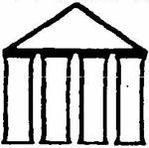  Big Idea | What is the important message or theme of this story?
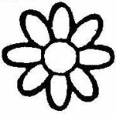  Details | What is an important detail about the character in the story?
Details | What is an important detail about the setting of the story?
Details | What are the important details about the beginning of the story?
Details | What are the important details about the middle of the story?
Details | What are the important details about the end of the story?
Unanswered  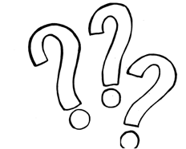  Questions | What questions do you still have that weren’t answered in the book?
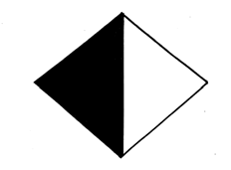  Ethics | Did a character do something good/bad? Why was it good/bad?

Making Connections:

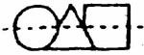  Text-to-Self | What connection can you make between this story and your own life?
Text-to-Text | What connection can you make between this story and another story you have read?
Text- to- World | What connection does this story have with something going on in the world?

Interesting words from the story:

_____________________ ______________________ _____________________

_____________________ ______________________ _____________________

_____________________ ______________________ _____________________

