Unit 1 Worksheet 16
Solving Quadratic Equations Graphically

When faced with an equations such as , you can solve for x by graphing both and on the same plane. Just find where the two graphs intersect and you will solve for x. Note in the example at the bottom, once both functions are graphed on the same plane, you can see the value of the function is 7 when and . That means the solutions of the equation are and .

 |  | and
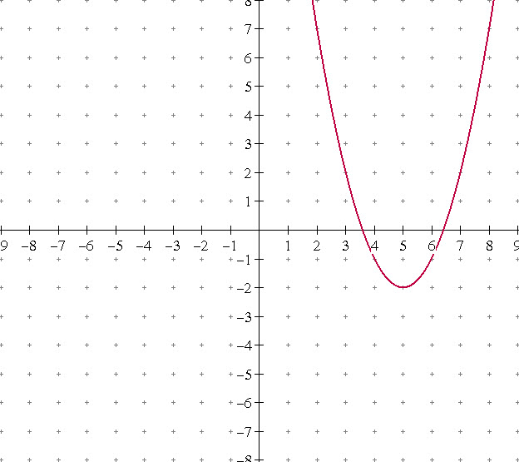 | 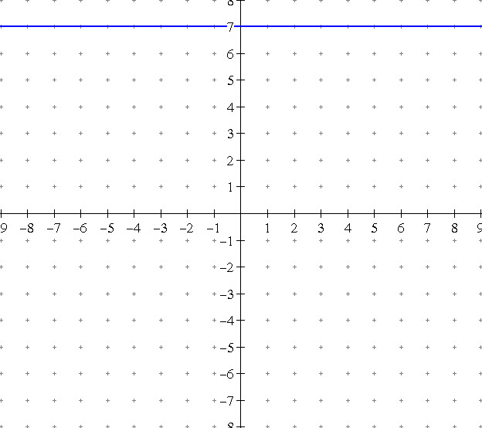 | 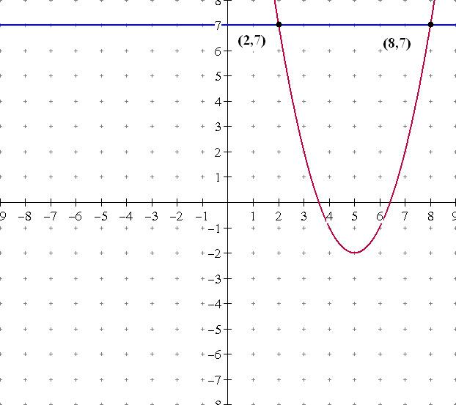

Solve each of the following by graphing.

1. 2. 3.

4. 5. 6.

7. 8. 9.

Solving Quadratic Equations by Graphing
Digital Assignment

Below is a table set up with each equation that is to be solved by graphing. Make use of Desmos to graph the two functions you create to solve the equation, then cut and paste the image of the solution graph onto this document. Be sure to use the corner of the photo to adjust the size so that the graphs fit onto the page. Use a pen or pencil to label the solutions found, or it can be done using a photo editing program as illustrated on the cover page.

Solve each of the following equations by graphing.

1. | 2.
3. | 4.

5. | 6.
7. | 8.
9.

