Using Graphing Calculator for Statistics Histograms/Box-Whisker

Editing Lists of Data

- Go to STAT → Edit
- Once you go to the list, you can get to the top of it can press clear to empty the list. DO NOT PRESS DELETE!
- Once the list is entered, quit.

STAT PLOT

- Empty the of any functions.
- Press STAT PLOT at the top of the calculator.
- Turn STAT PLOT ON and select desired display, histogram or box whisker.
- X-LIST should be (or whichever list you have stored your data). To change, press 2nd LIST.
- Frequency should be 1
- Press ZOOM 9 to see the graph.
Sample:
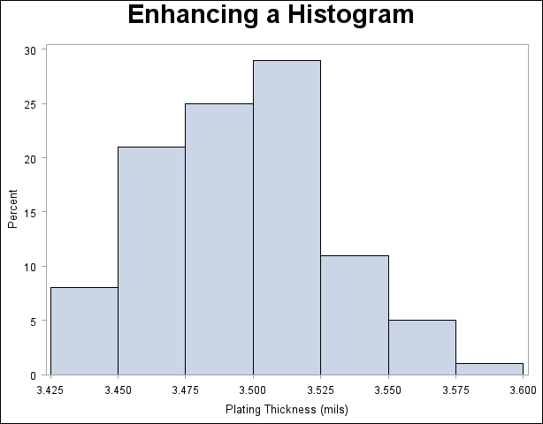

Above is the example of a histogram.
- To find the values of each section including the number of elements in each, use the trace button on the calculator. It will give you the min and max value of each section and how many elements are in each.

Standard Deviation and Mean
- STAT → CALC → 1-var stats
- Then select list one 2nd →LIST → select (or whichever list you have stored your data).
- Mean is .
- Sample Standard Deviation is .
- The number of elements being surveyed is .

The 5 Number Summary
- Once you select 1-var stats, go down to the second page of information.
- You will see:
Min
Med
Max
- These will be used for the 5 number summary.
- Follow the same procedure above to change stat plot from a histogram to box-whisker plot. Select the second box-whisker plot.

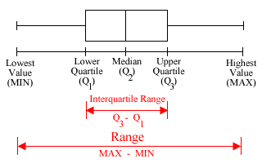
- If there is “skewness”, use the 5 number summary. Use the median as it is resistant to extreme values (outliers).
- If symmetric use mean and standard deviation.

Multiple lists
- Input lists into the calculator.
- Turn on stat plots 1 and 2 → select box-whisker for both.
- Ensure that stat plot 1’s x list is and stat plot 2’s x list is .
- Press zoom 9 and both box whisker plots will be displayed.

