Digital Photography Semester 1

Unit 2

The History of Photography

It may be hard for us to imagine life before photography. We’ve grown up in a time when photos were used to capture many different aspects of our lives. You may have baby pictures of yourself or even your grandparents, photos from trips you’ve taken, or photos of your friends. We are able to capture important moments to help us remember later and to share our lives with our friends and family through photos. In this unit, we will discuss how photos and cameras came to be a part of our lives and who made that happen.

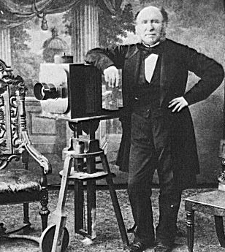  
****English Portrait Photographer in His Studio, 1850s****

The Pre-Camera History

For thousands of years, people have tried to represent the world around them. From cave drawings in ancient times to paintings throughout history, people have created representations of the world around them. The invention of photography was just one more step in our desire to capture the world and people around us in at least semi-permanence.

The term “photography” was first used in about 1839 by Sir John Herschel, a well-known English astronomer who became interested in capturing and retaining images. He used the term in a paper titled “Note on the Art of Photography, or The Application of the Chemical Rays of Light to the Purpose of Pictorial Representation,” which he presented in 1839 to the Royal Society. Herschel is also responsible for coining the use of “positive,” “negative,” and “snapshot” in relation to photography.

In some ways it is surprising that photography was not invented before the 1800s. Some of the important technology and knowledge had been around for several hundred years before the 19th century. The pinhole camera, or camera obscura, seems to have been invented several thousand years ago. A pinhole camera has no lens and is the simplest form of a camera. It consists of a light-tight box that has a single hole in one side. Light passes through the hole and creates an inverted image on the opposite side of the box. The Greek philosopher Aristotle described a pinhole camera in about 330 BC when he questioned how the image of the sun in the box remained circular even when the hole in the box was square. More recently, the pinhole camera was evidenced in a drawing by Leonardo da Vinci. The drawing shows a camera obscura. Other discussions from this time period encourages the use of a camera obscura as a drawing aid. Before chemical photographic processes, however, the only way to record the image from the pinhole camera was to draw it.

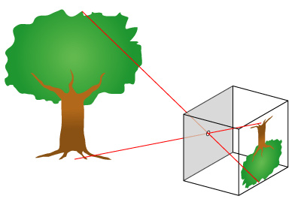  
****Pinhole Camera**** http://commons.wikimedia.org/wiki/File:Pinhole-camera.png

People were also aware of some of the chemical processes that are involved in creating a photo. The chemicals needed to create a photo were discovered centuries before. Silver nitrate, for example, was discovered by Albertus Magnus in the 13th century. In the 17th century, Robert Boyle noted that silver chloride turned darker under exposure to light, although he believed that this was due to air exposure. It was also noted by others that the sun blackened powdered nitrate of silver and that some liquids changed color when they were exposed to the sunlight.

The Development of Chemical Photography

For many years, people used the pinhole camera for drawing or viewing. They did not know how to make a more permanent representation of the image. That would change in the 19th century. In the 1820s, the first picture or photograph was produced by a French inventor, **Joseph Nicéphore Niépce** (the picture was later accidentally destroyed). Niépce used a pewter plate and a substance known as bitumen of Judea. Bituman hardens when it is exposed to light, so the unhardened parts could be washed away, leaving the negative image of the object. Once this negative image was created, ink could be applied to the image and used as a sort of stamp to produce a print of the image. This process was a prototype for modern day photos.

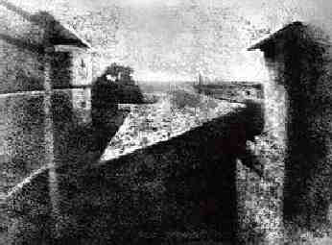  
****Joseph Niepce first photograph circa 1826****

In 1829, Niépce formed a partnership with the French artist **Louis Daguerre**. Just a few years later, Niépce died, leaving his notes to Daguerre. Although he had little scientific knowledge at the time, Daguerre used the notes and his own experiments to discover two important things. First, he found that if he exposed silver to iodine vapor before light and then to mercury, he could create an image. He also found that putting the image in a salt bath “fixes” the image. Daguerre named the process **daguerreotype** and in 1839, the French government bought the rights for the process.

The daguerreotype soon became a sensation. The ability to produce a fixed image and an exposure time that was compatible for portraits created a demand for this process, beginning the first commercial photography. The process, however, was expensive and it only created a single photo. For many of us in today’s society, the single image would be a drawback, but at the time, many regarded it as having a unique image that no one else could have. If two copies of a photo were required, two cameras were set up side by side to each take a picture. The daguerreotype was also prone to damage if handled, so most were kept behind an enclosure which had glass in front.

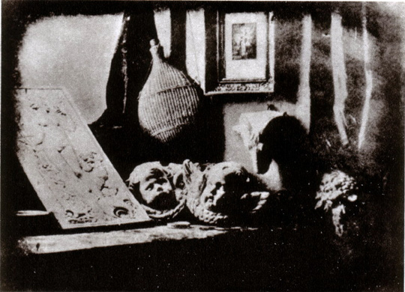  
****The Artists Studio, Louis Daguerre, 1837****

Daguerrotypes rapidly spread to other countries. In North America, Samuel Morse, inventor of the Morse code, taught several individuals the process within a couple of months. By the 1840s, a strong market had developed for portraits, and individuals trained to do them often traveled from town to town creating them. By the early 1850s, there were over 70 studios in New York City alone that used the daguerreotype process to create photos. While we’ve become rather accustomed to photos, imagine that you had never had a fixed likeness of yourself. This is the situation that people at the time found themselves in. With the daguerreotype, fixed portraits could be created of children, families, and individuals for a relatively low cost (compared to having a portrait painted). By the 1850s, daguerrotypes cost anywhere from 50 cents to 10 dollars each.

Soon, other processes and techniques began to emerge from the daguerreotype. In 1841, **William Henry Fox Talbot** created the **calotype** (also known as the Talbotype) process, which used paper coated with silver iodine. This process involved sensitizing paper with a silver salt solution and exposing it to light. This created a negative image of the object or person, which could then be used to create contact prints where the light and shadows were reversed to show the image. The calotype was named after the Greek word kalos, meaning “beautiful.”

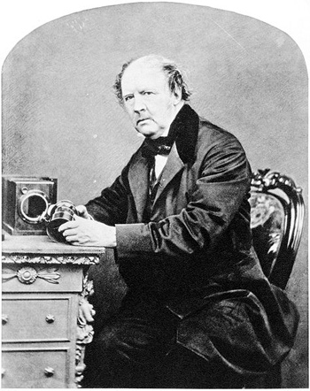  
****William Henry Fox Talbot by John Moffat, 1864****

Although the quality of calotypes was not as good as the daguerrotypes, the advantage was that multiple positive prints could be made. This process is much the same as what modern day film cameras use, and Talbot’s technology was later refined by George Eastman, who founded the Eastman Kodak Company in 1892. Talbot’s technology used paper from the images, which often showed any imperfections of the paper in the photo once the positive prints were made. However, some individuals had begun to experiment with glass negatives. John Herschel created the first glass negative in 1839, but his process was hard to reproduce. In the late 1840s, a cousin of Niepce found a way to use an albumen (egg white) emulsion on the glass slides for the negatives.

In 1851, the collodion process was invented by **Frederick Scott Archer**. The **collodion process** used wet plates, which were glass plates that had been covered with a mixture of chemicals before being placed in the camera for the exposure. This process had a number of advantages over the previous uses of paper for the negative images. First, it allowed positive prints to be created in unlimited numbers. The process was also relatively inexpensive, and the glass was more consistent and had fewer imperfections than the paper that was used for paper negatives. In addition, the collodion process needed only a few seconds for exposure, which made the process of a photo much quicker than the methods that had been available in the past. The price for a photo made through the collodion process could be less than a tenth of the cost of a daguerreotype.

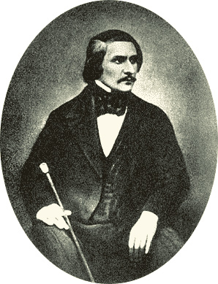  
****Daguerreotype taken by S.L. Levitsky in 1845****

With the increasing popularity of photos, other inventors and photographers looked for ways to improve the final exposures and prints. The Russian count **Sergei Lvovich Levitsky** designed a bellows camera in 1847 that made focusing on the subject easier. This adaptation would influence the design of cameras for many years (and still appears in some relatively modern examples). Levitsky also started changing the photos themselves. He was the first person to use interchangeable backgrounds in the photos that he took. He was also one of the first people to begin retouching the negatives to reduce or eliminate any imperfections that may have occurred when the photo was taken. In addition, Levitsky proposed the idea of using artificial light in the studio along with natural light.

The Modern Photographic Process

As the years passed, advances continued to happen in the area of photography. The technology that developed during the first 20 years of photography were refined and built upon. In 1871, Dr. **Richard Maddox** developed a way to use gelatin instead of glass for the negatives. This allowed photographers to develop a dry plate technique rather than the wet plates of the collodion process. This change would be a turning point in photography, as it meant that a darkroom tent did not need to be used with the camera and the process of exposure and negatives was much less cumbersome. No longer did the photographer need technical knowledge to create the negative. The dry plate would eventually open up photography to the masses.

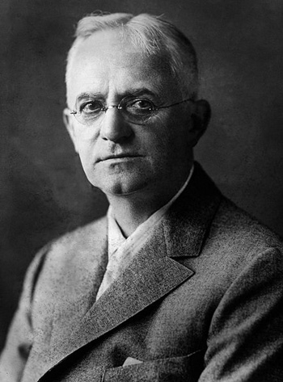  
****George Eastman****

In 1884, **George Eastman** created a dry gel on paper, or what we think of as film. This replaced the photographic plates that photographers had been using since the development of photography and eliminated the need for photographers to carry around plates and chemicals in order to take a photo. By 1888, a Kodak camera was introduced to the market. The slogan attached to the camera was, “You press the button, we do the rest.” Early Kodak cameras came with film inside, and when an individual had finished the film, the entire camera was sent to Kodak for processing. The camera was then returned to the individual with a new roll inside and the negative images. The cameras were fairly simple to operate, although not foolproof. Individuals just had to set the shutter, push the exposure button to take the picture, and then wind the film for the next photo.

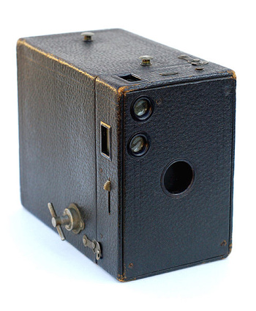  
****Kodak Brownie No. 2A, circa 1907-1933****

When the **Kodak Brownie** was introduced in 1900-1901, cameras were available to the mass market. The Kodak Brownies became a very popular camera, as they were simple to use and relatively inexpensive. This is the camera that introduced the idea of a “snapshot.” The initial price of the Brownie was one dollar, and it was intended to be a camera that could be used by anyone, not just by professionals with technical knowledge.

Although Kodak’s cameras created low-cost photography for more people, professionals and serious photographers tended to stick to dry plate cameras.

These cameras still produced the best images. Some cameras were created that could use both film and dry plates, giving photographers the ability to choose which one they preferred.

By the early 1900s, **Oskar Barnack** was thinking about another invention that would change the shape of photography: the 35mm film. Around 1913, he built his first prototype of a 35mm camera, the Ur-Leica, although it took several more years for more work to be done as World War I erupted. The Leica I started production in 1925, and a number of other competitors jumped into the market with 35mm cameras of their own. The 35mm cameras remained too expensive for most people until the 1930s. SLR cameras were also introduced to the public during this time period, with companies like Canon and Nikon entering the market during the 1950s.

A brand new type of camera entered the market in 1948: the Polaroid. You may be familiar with the instant pictures that Polaroid cameras produce. Instant cameras use self-developing film, which creates an image in a matter of minutes. The development of instant cameras is generally credited to Edwin Land, an American scientist. Polaroid cameras are still sold today, although digital cameras have taken over much of the demand for instant images.

The Color Process

Throughout the beginnings of photography, the photos that were taken were in black and white. Photographers in the 19th century experimented with adding color to photos, but the results proved to be only temporary or did not contain all colors. The emulsions used for the plates were, for example, not sensitive to green or red light until the 1870s. In the 1860s, **James Clerk Maxwell** used filters to create three monochrome images (one photo in red, blue, and green). When projected together with three different lanterns, the image would return to a more natural color image. Experiments such as this formed the basis for trichromatic color photography.

In the 1870s, photographers began to experiment with subtractive color with the use of sensitizing dyes. Subtractive color is the process of subtracting colors from white light. The process uses dyes or other chemicals to do this. Louis Ducos du Hauron, for example, experimented with subtractive color photography in the late 1870s.

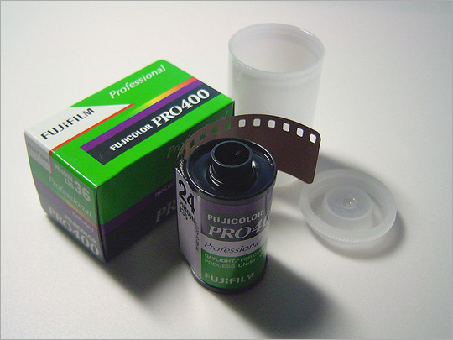During the early part of the twentieth century, **Autochrome Lumiere** was one of the color processes. It was patented in 1903 by French brothers **Auguste and Louis Lumiere**. The technology was marketed within several years and it would become the primary color photography process until the 1930s. Autochrome Lumiere involved coating a glass with microscopic grains that had been dyed colors like green, violet, and orange. These dyed grains acted as a filter for the image being photographed.

In 1935, Kodak began to produce **Kodachrome**, a color still film that used a subtractive process. It was the first successfully marketed color still film, although it was first sold as a 16mm movie film. As the processing of the film was a complex one, Kodak initially included processing in the price of the film. When someone bought the film, they would also receive an envelope in which to send the film to Kodak, who processed the film in one of several different laboratories and sent back the images in 2”x2” cardboard mounts. This practice was challenged legally in the 1950s and was found to be anticompetitive. This allowed for independent laboratories to process the film for people who used the film.

Digital Cameras

While digital cameras have become a common item in today’s world, they developed from some unexpected sources. The technology that would lead to the development of digital cameras originated with the development of television technology and the ability to capture live images from television. Other technology that contributed to digital cameras came from spy satellites used during the Cold War. Digital technology was developed that allowed spy satellites to send photos back to earth in digital form. NASA also began using the technology, working to develop ways to transmit images from space exploration back to earth. Bell Laboratories created the CCD (charge-coupled device) in 1969, which converted light into electronic signals. The first images from this device were small and of poor quality, so inventors and scientists continued to work on the technology to produce bigger and clearer images.

By the 1980s, a push began to bring digital images to the public. Newspaper publishing was one area that was interested in digital cameras. Traditional film cameras were problematic in that photographers working in remote locations had to find processing centers or darkrooms to develop the photos that they had taken. This could delay photos from being used in a newspaper article if the processing wasn’t readily available. With increasing pressure from television in reporting the news, newspaper publishers were interested in any technology that would give them faster photos.

Sony began marketing the first digital camera in 1981, which used a CCD for imaging. The camera saved images to a disk, though it was not entirely a still digital camera, but more of a digital camcorder. Some newspapers began using digital cameras in the mid 1980s. For example, USA Today first used digital images for its World Series baseball coverage. The first commercially available digital camera was the **Kodak DCS 100**, which entered the market in 1990. The images could be downloaded from the camera to a computer.

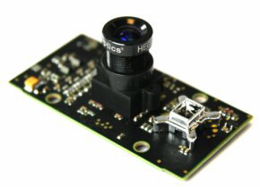  
****First Single Board 3D PMD Camera Prototype****

Throughout the next two decades, digital cameras emerged to dominate the camera market. They have become popular consumer products, showing up not only in traditional-looking cameras, but also in cellular phones and other electronic devices. Digital cameras now outsell film cameras, indeed, some manufacturers market only a few film models or none at all. Kodak no longer sells 35mm reloadable film cameras in Canada or the United States. Nikon has also reduced its film camera models to two. The marketing of digital cameras has also produced digital image printers, memory cards with increasing space for photos, and software programs to edit digital images.

Not everyone has jumped on the digital bandwagon, however. A survey in 2007 indicated that about three in four professional photographers planned to continue using film cameras exclusively or in combination with digital cameras. Many photographers believe that film cameras produce a better quality photograph. Digital technology has also increased the ethical considerations created by a more easily manipulated medium.

The Changing Professional Landscape

**Commercial photography** can be thought of as any photography in which the photographer is paid for images that were not produced as works of art. In the early days of photography, cameras were limited to professional photographers because of the knowledge needed to work the cameras and develop the images with various chemicals. Today, the boundaries dividing commercial photography, art photography, and amateur photography are increasingly being blurred. As the process of taking pictures has become easier and more accessible to a wider group of people, drawing the lines between these different groups is even more difficult.

Stock photography is one of the areas where professional, amateur, and art photography boundaries are blending. Simply put, stock photography is photography that is licensed for a particular use. For example, a website might license a stock image of something rather than paying a photographer to go out and capture a similar image. In other words, stock photography has often already been created by the photographer before it is licensed, although there are circumstances in which the photography is specifically requested.

One of the first stock photography agencies began in 1920 and was founded by H. Armstrong Roberts. For decades, stock photography consisted largely of “outtake” images that photographers had from their commercial magazine assignments. Over the decades, however, many photographers began producing images specifically for stock agencies. By the 1990s, the stock agency world was dominated by two agencies: Getty and Corbis.

With the rise of the Internet, websites, and digital cameras, stock agencies increasingly moved their operations online. Many stock agencies use only the Internet for distribution. Another major change that has occurred in stock photography industry is that many agencies are increasingly reaching out to amateur photographers. This allows the stock agencies to keep the price of the images lower while reaching a broader audience. For example, individuals may purchase inexpensive stock photography for personal or small business websites. By 2003, a number of online stock agencies were allowing anyone to upload photos and sell them, with a portion of the image fees going back to the stock agency. In general, these online stock agencies do have guidelines and criteria that images must meet before they are accepted for sale, but anyone who meets these guidelines can sell their photos on the stock sites. Some sites specialize in or have categories of editorial photos, allowing individuals to submit photos of breaking news events as well as the standard stock images.

Stock images typically use one of two license types. It is important for both photographers and those buying the images to understand what those licenses mean in terms of their use. **Royalty-free images** are those in which the user pays a one-time fee for the image. Under this license, users can use the image for as long as they like after they pay the license fee, although there may be limits to how many reproductions can be made of the image (e.g., it can only be used 50,000 times on brochures). Royalty-free images are also not exclusive images, meaning that the photographer can sell them to as many users as he or she wants to. In other words, the image may be used by multiple users at the same time. For this reason, licenses for royalty-free images tend to be less expensive.

**Rights-managed images** are those in which the price of the license is determined by the use of the image. Some of these considerations include how long the user will be using the image, the location that the image will be used in (North America, Asia, Europe, etc.), how large of an image the user requires, and the specific use of the image (such as on a billboard or in a magazine). Rights-managed licenses can include exclusivity, and the terms of the license are typically negotiated by the photographer and the user.