Digital Photography Semester 1

Course Description  
In the digital photography course, students will learn creative photographic skills and processes. They will build a portfolio of work and explore the fields of photography and graphic arts.

If you like taking pictures, you may love this class. Many students state that they learned a lot and it was fun and interesting. If photography doesn’t interest you, this may be a tough class to get through.

Course Materials

* You will need a camera: a cell phone camera is acceptable, but you will learn more if you use a camera with more settings. If your camera is not able to do what is required in a photography assignment, mention that in your notes, and do a substitute activity in order to earn the points.
* You will need access to photo editing software: this can be found online or on your own computer. It is often included on a CD that comes with a camera. If you don’t have this, you can use the computers at school.
* Optional: flash drive (also known as a thumb drive), CD, printer ink, paper. You will need to turn in your photos either electronically or on paper (which is more expensive).

How to turn in work

You can turn in work on paper, on a storage device (flash drive or CD), or via email. Work and electronic devices will be returned to you upon request.

Syllabus

Upon completion of the course, you will be able to meet the following objectives:

Unit 1: ***Introduction to Photography***

**\* Learn what happens inside the camera when you take a picture.**

**\* Investigate how an image is created by the camera.**

**\* Learn some of the basic terminology for photography and cameras.**

**\* Examine how a simple pinhole camera can be constructed at home.**

Unit 2: ***The History of Photography***

**\* Discuss the usage of pinhole cameras and how they were used before modern photography.**

**\* Discuss the development of the first camera in the early 19th century.**

**\* Investigate advances that were made to cameras and photograph production through the 19th and early 20th centuries.**

**\* Examine the development of digital cameras.**

**\* Discuss the changes in the stock image industry.**

Unit 3: ***Aperture & Shutter Speed***

**\* Understand aperture and shutter speed.**

**\* Discuss how different aperture and shutter speed settings can influence a photo.**

**\* Examine how aperture and shutter speed settings influence each other.**

**\* Investigate some of the common camera modes.**

**\* Discuss how aperture and shutter speed can be used to create nighttime photos.**

Unit 4: ***Composition***

**\* Discuss composition and how it applies to photos.**

**\* Examine some of the common “rules” of photography composition.**

**\* Investigate how the “rules” can improve photos.**

**\* Discuss how and when to break the “rules” of photography composition.**

Unit 5: ***Lighting***

**\* Discuss the importance of light when taking photos.**

**\* Examine the advantages and disadvantages of natural and artificial lighting.**

**\* Investigate some techniques for using light in outdoor photos.**

**\* Learn about the lighting equipment and accessories for studio photography.**

**\* Discuss some techniques for studio lighting.**

Unit 6: ***Special Techniques***

**\* Discuss the use of filters in photography.**

**\* Examine the fundamentals of black and white photography.**

**\* Learn some tips to help improve black and white photos.**

**\* Investigate how to create panoramic photos.**

**\* Learn techniques for capturing firework photos.**

**Unit 7: ***People*****

**\* Examine tips on taking portraits.**

**\* Learn techniques for photographing children.**

**\* Investigate how to take group photos.**

**\* Discuss some of the arrangements that can be used for large group formal photos.**

Unit 8: ***Landscapes & Places***

**\* Learn about the different types of landscape photography.**

**\* Discuss some of the challenges in taking landscape photos.**

**\* Examine some general tips for taking landscape photos.**

**\* Discuss the importance of focal points in landscape photography.**

**\* Investigate how to approach different types of landscapes.**

Unit 9: ***The Close-Up***

**\* Understand how macro photography is by photographers.**

**\* Discuss different equipment and accessory options to use in creating macro photos.**

**\* Discuss the basic techniques of macro photography.**

**\* Investigate some popular topics for macro photography.**

**\* Examine how best to take macro photos of flowers and insects.**

Unit 10: ***Documentary & Action***

**\* Discuss techniques for taking sports photos.**

**\* Understand the basics for the technique of panning moving subjects.**

**\* Discuss tips on photographing pets.**

**\* Examine wildlife photography and the basics of capturing wildlife on “film.”**

**\* Investigate documentary photography and how best to approach this area of photography.**

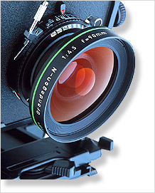**Unit 1**

Introduction to Photography

Photos are all around us. It is likely that you encounter numerous photos each day. We see them in ads, on websites, and in our homes. We use photos to remind us of people or places, to learn new techniques or activities, and to navigate our daily lives. Photos may entice us to buy something, teach us something, or warn us about something. Whatever their use, photos have become an important part of our lives, and many of us enjoy taking our own pictures to display in our homes or online.

To better understand how to improve the photos that we take, we must first understand how cameras work. This will help us make those adjustments that take our photos from ordinary snapshots to great photos.

How Cameras Work

To take great photos, it is important to have a basic understanding of how cameras work. This will help you better navigate the many features and controls of your camera because you’ll know how cameras commonly function. Surprisingly, the basic operation of a camera isn’t particularly complex or difficult. The principle of photography is actually fairly simple.

In general, all cameras work in a similar way. A photo is taken by letting light fall on a light-sensitive medium, which then records the image onto that medium. How light or dark a photo is depends on how much light was allowed to fall on the light-sensitive medium. In other words, a **camera** is a light-tight box that contains a light-sensitive material or device and a way of letting in a desired amount of light at particular times to create an image on the light-sensitive material.

A traditional still film camera has three different components. First is the mechanical element, which is the camera body and the parts associated with it. Next is an optical element. This is otherwise known as the camera lens. Finally, we have the chemical element, which is the film. These three different elements make up a film camera (we’ll discuss digital cameras a bit later).

The optical element of a camera consists of a lens. A **lens** is “a ground or molded piece of glass, plastic, or other transparent material with opposite surfaces, either or both of which are curved, by means of which light rays are refracted so that they converge or diverge to form an image.” In other words, a lens can simply be a curved piece of glass. This glass takes the light bouncing off an item and redirects the light so that it forms an image of the item. It is able to do this because light changes speed as it moves from one material to another. The glass of the lens slows the light down from its speed in air. Since the light waves enter the glass at different times, the lens will bend the light in one direction. A **converging or convex lens** will bend the light toward the center of the lens, since one or both sides of the glass curve out. It also takes the various rays of light and bends them toward the same point, which ultimately allows an image to form.

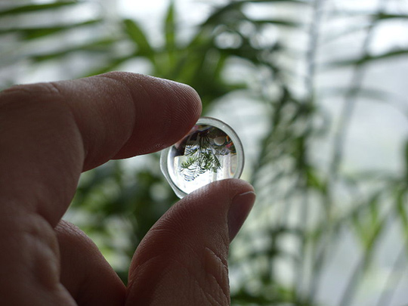

****A biconvex lens showing the inverted image.****

Not surprisingly, various factors influence how the convex lens bends the light. The distance from the object to the lens is one of these factors. As the object is moved closer to or farther away from the lens, the angle of light entry changes. When the item is close to the lens, the light enters at a sharper angle than when the item is farther away. The angle of light entry then affects the distance to the real image that is formed. If an item is farther away from the lens, the real image that forms will be closer to the lens, and vice versa. In practical terms, an item that is farther away will produce a smaller real image since the light has a more obtuse angle, as opposed to a sharp angle producing a larger real image.

To see this for yourself, you can take a lit candle and put a magnifying glass between the candle flame and the wall. The real image of the candle will appear upside down, and it will grow larger or smaller depending on how close or far away you hold the magnifying glass. This process is essentially what you do when you turn the lens of a camera.

While all of this can be done with a single piece of curved glass, camera lenses usually involve several lenses within the same unit. This is partly due to the need to exactly line up the colors of an item so that there are no issues with the real image. To compensate, cameras use multiple lenses to realign the colors of the object.

You may also be familiar with another aspect of lenses: magnification. The magnification of a lens is also called the **focal length**. This is the distance between the lens and the film, when the lens is focused at an infinite distance. So the focal length is really the distance to a far image. In theory, a 300mm lens would be 300 millimeters away from the film, if you decided to measure it. In practice, however, the lens is smaller because the multiple lenses allow the lens to act as if it were longer than it is. You may be more familiar with the term telephoto. **Telephoto lenses** are those that magnify an image or make an object seem closer than it really is. In contrast, a **wide-angle lens** shrinks the object in front of it, by way of a shorter focal length.

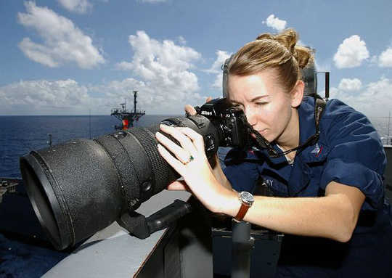**A 400mm fixed telephoto lens being used to photograph**   
**daily activity aboard an aircraft carrier.**

Creating the Image

A camera uses either a light-sensitive device (film) or a digital sensor to capture an image. In traditional film-based cameras, the film becomes a chemical record of the pattern of light on an object. Once this pattern of light has been recorded, we then need to process the film to see the image. The film is developed by exposing it to other chemicals. Color film normally has three light-sensitive layers that react to the colors blue, green, and red. In developing, the chemicals dye the film, and when the layers are combined, a full color image is the result.

For the camera to record the pattern of light on an object or scene, the camera has to have several different features that help control how much light enters the camera and when light enters the camera. Have you ever tried to create an image with film alone? If you laid film out in the sun or pointed the film at an object, you wouldn’t end up with a usable photograph because too much light would reach the film. Instead, the camera has to limit the amount of light that reaches the film, although this too can have its problems from time to time. In the case of too much light, the photo will appear washed out or have a big spot of light. If too little light enters the camera, the photo will be dark or even completely black.

[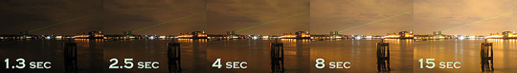](https://chino0988-chinovalleyvirtual-fps.gradpoint.com/Resource/324077,600,0,0,100/Assets/01Unit01/WEB/03Unit01/images/image004-full.jpg)  
****Shutter Speed in Greenwich****

To ensure that the right amount of light enters the camera for a particular photograph, cameras use several different mechanisms to control when and how much light enters the light-tight camera body to record the image on the film. A **shutter** opens and closes between the film and the lens, letting light in only when you have told the camera to do so. The **shutter speed** is the length of time that light is let into the camera in order to expose the film. Letting light in is only one part of the equation, though, as we also need to control how much light enters the camera. Aperture refers to the lens opening that allows us to control the amount of light that reaches the film or digital sensor. The aperture is controlled by the **iris diaphragm**, a set of overlapping metal plates that expand out to allow more light or fold in on each other to reduce the amount of light.

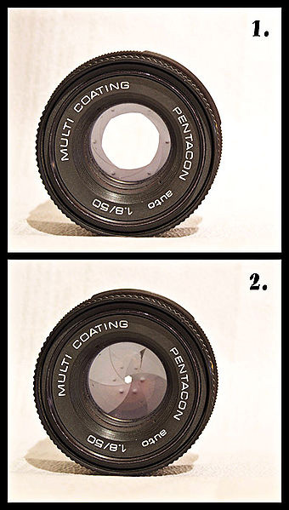

**Diaphragm giving a big (f/2.8) and a small (f/16) aperture in the camera lens**

The film itself also plays a role in how much light is needed for the ideal photo. Traditional film has light-sensitive grains in it. The larger the grain of the film, the more quickly it will absorb the light. You can tell the size of the grain in film by looking at the film’s **speed**. You may have seen canisters of film labeled as 100 ISO film or 400 ISO film. These numbers refer to the speed or size of the grain. 100 ISO film is typically used for outdoor photography where the sun is bright; 1600 ISO film, in contrast, is best suited for photography where the light is very dim. In digital cameras, you will find reference to **sensitivity** settings, which are the equivalent of film speed.

To create an optimal image, the photographer and camera have to balance the film speed, shutter speed, and aperture. This can take some practice, but it can produce images that show better lighting than simply pointing the camera and shooting.

Taking the Photograph

What happens when you push the button on the camera to take a picture? Let’s pretend that you’ve seen a bear and you want to take a picture of the bear. How does the bear go from an object in your viewfinder to an image on your film?

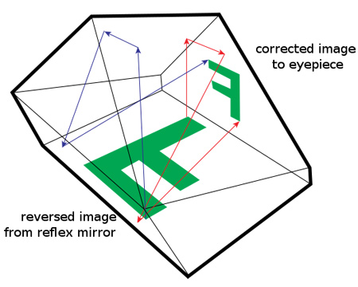  
****SLR Pentaprism****

When you point the camera at the bear, light that bounces off the bear enters the camera. The light passes through the lens and onto a mirror, which is located between the lens and the shutter. This mirror reflects the light upward to a **pentaprism**, which is a five-sided mirror. The light from the image then bounces off this mirror and into the viewfinder, where you see the image. The job of the pentaprism is to flip the light from the image so that the image appears right side up rather than shows the inverted image that first occurs. Imagine what it would be like to have to take a picture if you were looking at the object or scene upside down!

You line up your photo of the bear in just the way you want it and push the button to take the picture. When you push the button, the mirror that just gave you the image on the viewfinder moves out of the way. This allows the light bouncing off the bear to reach the film behind the open shutter. The mirror and the shutter operation are connected, so that the mirror stays out of the way for as long as the shutter is open. When the shutter closes, the mirror flips back into place. This is why your image in the viewfinder goes dark for a period of time before it reappears. As long as the viewfinder is black, you know that the shutter is open inside the camera, allowing the light to hit the film. With the shutter open, the light hits the light-sensitive film, where the image of the bear is recorded. Now you’ve taken the photo of the bear and are ready to take another.

Types of Cameras

The process that we discussed above comes from an SLR camera. An **SLR, or single lens reflex, camera** has a semiautomatic movement of the mirror, which produces an exact image in the viewfinder. SLR cameras exist in both digital and traditional film forms. Since the 1970s, most professionals use SLR cameras. We often refer to SLR cameras when we talk of cameras where we can exchange one lens for another, but not all SLR cameras have the ability to change lenses. A **dSLR** is a digital version of the traditional SLR camera.

**Point and shoot cameras** are those that use an optical viewfinder, rather than having the semiautomatic mirror. This means that the image the photographer sees through the viewfinder is not the exact same image that will be recorded. Rather than having a mirror within the camera that reflects the image, point and shoot cameras have a viewfinder that goes directly through the camera, giving the photographer a slightly different angle on the scene than what the shutter will open to capture. There are still many point and shoot cameras on the market today, most often used by casual photographers. While these cameras can still take good photos, it is important to recognize how the slightly different view from the viewfinder might affect the resulting photos. Point and shoot cameras get their name from the fact that these cameras do almost everything for the photographer, who only has to “point and shoot.”

**Large and medium format cameras** use a negative film size that is greater than the usual 35mm. These types of cameras are typically used by professionals or by enthusiastic amateurs who enjoy using different types of cameras. Hasselblad is a Swedish manufacturer of medium format cameras—these are some of the more widely used in this category.

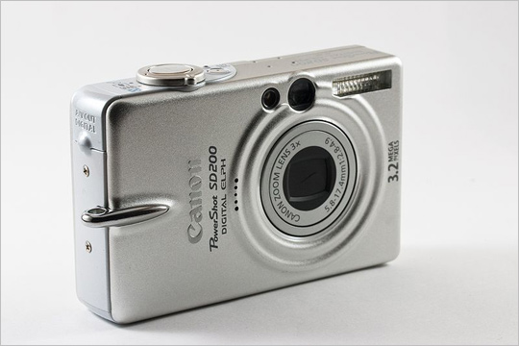

****Canon SD200 point and shoot camera****

One of the earliest cameras made was a **pinhole camera**. Pinhole cameras do not use a lens and they have a very small aperture. Essentially, pinhole cameras are light-tight boxes that have a small hole, through which light passes and creates an inverted image on the opposite side of the box as the hole. These cameras may have been used as long ago as the fourth century BC.

Digital Cameras

You may be most familiar with digital cameras. Over the last few decades, digital cameras have become the most popular choice for many people. **Digital cameras** use an electronic image sensor to digitally record an image. Some digital cameras can also be used to create video in addition to still photos. Today, the technology for digital cameras is being used not only in traditional-looking cameras but also in cellular phones and other electronic devices. Rather than storing the image taken on traditional film, digital cameras record the image to a memory device, or card. In other ways, the digital camera works in much the same way as a traditional film camera, except that it uses electronics rather than chemicals to record the image.

Digital cameras do have several differences from traditional film cameras, particularly in the recorded image. Digital cameras create photos that are made up of pixels. A **pixel** is the smallest unit of the picture that can be controlled. A single pixel would give us very little information about what a photo is about, but if we combine the pixels, we see the image that was photographed. Digital cameras in use today create pictures made up of millions of pixels. In fact, we often abbreviate the number of pixels as MP (or million pixels). In other words, a 2MP camera takes photos that contain two million pixels, and a 5MP camera takes photos that have five million pixels in each picture. We often refer to digital images by the arrangement of pixels as well. For example, a 2048x1536 display is the arrangement for a 3.1MP image. This image will have 2048 pixels from side to side on the image and 1536 pixels from top to bottom.

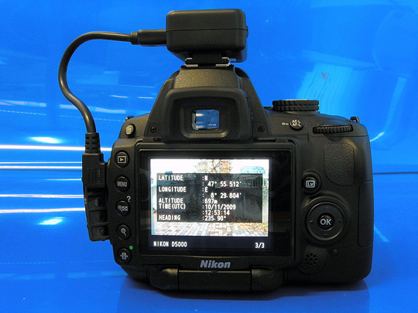  
****Nikon D5000****

Image format is another part of digital cameras that is different from traditional film. When a digital camera takes a picture, it saves the picture in a particular file format. These image file formats organize and store the information from the photo so that you can retrieve the image. Generally, each pixel in an image creates three bytes of data. So, with a 3MP camera, the image would be three million pixels and nine million bytes (9MB) of data. Let’s look at some common ways of storing this information:

• **JPEG:** (pronounced “jay-peg”) stands for “Joint Photo Experts Group.” It is the default file format in many digital cameras on the market today. This is because the file format compresses the image to decrease the size of the image. Typically, this allows you to put more images on your photo memory card. However, JPEG has an drawback to this space-saving advantage—it is compressed in a ‘lossy’ manner, which means that some of the data is lost. The more the image is compressed (the smaller the size of the file), the more information from the image is lost. With a high compression, the image may begin to look blurry and lose some of the sharp detail that was present in the full-sized version. Some cameras allow you to choose how much compression will occur to the JPEG file.

• **TIFF:** The Tagged Image File Format is a lossless file format. A lossless file format keeps all of the information in the picture, but it means a much larger file size than a compressed file. TIFF files can be compressed, but the size difference really isn’t a great one.

• **RAW** or **NEF:** this is a file format that is offered on some cameras, particularly higher-end cameras. This file saves the actual data, which are not processed by the camera. RAW files can be compressed without losing information, and their compressed size tends to be between a TIFF and a JPEG file. Many photo editing software programs can convert RAW files to TIFF or JPEG files. The advantage of RAW files is that because they retain all of the information, some aspects such as white balance can be more easily changed in editing than with other files.

Understanding these different file formats can help you determine which option you should choose for different applications. For example, if you are just taking a snapshot and don’t plan to enlarge the photo beyond a standard snapshot size, a JPEG file would probably be fine. However, if you are shooting professional images that might be blown up to larger sizes, you would probably want to choose a lossless file format like TIFF or RAW.

Camera Features and Controls

To get the most out of your camera, it is important to understand the features and controls that your particular camera has. You may find that your camera has more than what we discuss, or it may not have all of these features. Our discussion will focus primarily on digital cameras, although some of the controls can also be found on traditional film cameras.

Most digital cameras on the market today (as well as most point and shoot cameras) have a fixed zoom lens that cannot be replaced. On these digital cameras, you may find reference to optical and digital zoom. **Optical zoom** works like a telephoto lens; the image quality remains the same as the image is magnified. **Digital zoom** crops the image and enlarges the cropped image to fill the frame of the camera. This means that the digital zoom generally results in a loss of quality in the image.

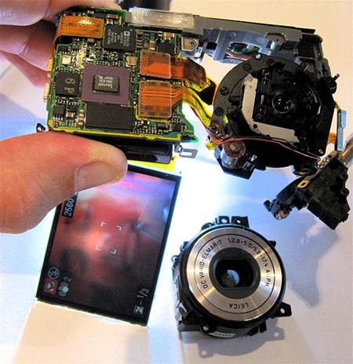  
****A partly disassembled Panasonic Lumix digital camera,****  
****with the front lens removed, but still functioning (see display).****

Another feature that appears on some cameras is the **white balance**. This is simply an adjustment that can be made to the color so that whites will appear white in the photo, and not yellow or blue. The light source for the photo is often a cue about the white balance; some cameras have settings for shade, sunlight, fluorescent lighting, and so on.

[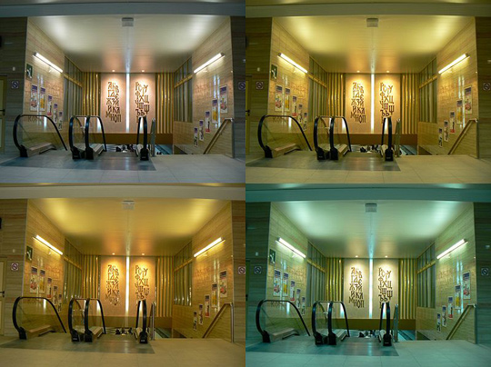](https://chino0988-chinovalleyvirtual-fps.gradpoint.com/Resource/324077,600,0,0,100/Assets/01Unit01/WEB/07Unit01/images/image010-full.jpg)  
****This illustrates the differences in the white balance setting: upper left: auto WB; upper right: sun; lower left: flash; lower right: wolfram bulb****

Some cameras also have image stabilization or vibration reduction. These features essentially adjust for any movements that the camera may make during exposure to reduce blurry images. This adjustment might include moving a lens group or the sensor in the camera if movement is detected. Although it is not foolproof, this feature can help reduce some camera movement issues.

Many digital cameras have different modes, which basically give the camera a hint about the type of picture you want to take so that it can adjust accordingly. In older cameras, manual mode, or one in which the photographer has to make all adjustments, was the only choice. Some cameras still have this option (although others are included as well). Automatic modes control the features of the camera for the photographer. For example, a camera in automatic mode will determine whether the flash is needed or if it will need to set the aperture.

Other common camera modes may be found on your camera, such as macro, action, night, portrait, and so on. These modes adjust the camera even more for the type of picture that you want to take. For example, using the portrait mode tends to result in a less-focused background, putting the emphasis on the person whose portrait you are taking. An action or sports mode will use the highest shutter speed possible to best capture movement.

Did You Know?

You can create your own simple pinhole camera using items commonly found in homes. To create a pinhole camera similar to those created before the age of modern photography, you’ll need a round oatmeal box, wax paper, and heavy tape (preferably black tape).

To start, you’ll want to cut the round oatmeal box (or other cardboard type tube or round container) in half, leaving the bottom of the container in place, so that you have two short round pieces or tubes. Place a piece of wax paper over one of the open ends of the round container and tape it in place. Once you have this done, put the oatmeal tube back together again so that the wax paper is in the middle of the tube. Wrap tape around the middle of the tube where the two pieces join together, making the tube as lightproof as possible. Finally, create a small pinhole in the bottom of the container. Now you’re ready to try out your pinhole camera.

Take your pinhole camera outside on a sunny day. Hold your eye to the open end and let some light come through the pinhole. You should see the small inverted image of what your pinhole camera is pointing at on the wax paper inside. You’ve created a pinhole camera that is fairly similar to those that were created hundreds of years ago! You can also create simple cameras that will actually record photos, although the process is slightly different and a bit more complicated than creating the simplest pinhole camera. The Kodak website has more information on creating a pinhole camera.

nit One Quizgraphy 1