UNIT FIVE: The Darkroom

“For me the printing process is part of the magic of photography. It's that magic that can be exciting, disappointing, rewarding and frustrating all in the same few moments in the darkroom.”   
–John Sexton

In many ways, darkrooms are the fundamental base for photography. Traditionally, this is where images became visible to our eyes and where photographers first saw the photograph that they might have spent hours setting up. Although fewer people use darkrooms today, they can still be part of the creative process of photography. In this unit, we will learn more about the issue of darkrooms in the field of photography.

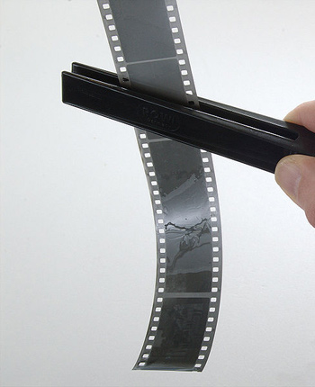  
****Film****

**Darkrooms** are light tight areas where photography processing takes place. They range from portable darkroom tents to light tight areas like an interior bathroom to dedicated lab spaces in schools and other buildings. Whatever the space that is used, they all share one thing in common—light cannot enter the space when photography processing is going on. This is because if the film were exposed to light, the images on the film would be ruined. So, however a darkroom is set up, it will always need to have light tight capabilities.

Today’s photographic film is made of plastic coated by an emulsion with light-sensitive materials. When these materials are exposed to light, by the opening of the camera shutter, an invisible image is formed on the film. Color films use at least three layers of light-sensitive materials (with some color films using a dozen or more layers), while black and white film uses one layer. For the image to be made visible, the film must be developed

Before delving into the darkroom, it is useful to investigate why you would need to know about darkrooms in the first place. With more people using digital cameras and the availability of film processing labs, why would someone want to go through the trouble of developing their own film? The answer is often twofold for those who choose to use traditional film cameras rather than digital ones. Although darkrooms cost money to set up, they can actually be less expensive in the long run than using a professional lab. When you develop your own photographs, you can choose which images to print versus having a lab print all of the images from the negatives. If you use rolls and rolls of film, the cost grows even higher. Processing costs are also increasing as fewer people are using labs to process film. However, darkrooms do carry their own share of costs so photographers do need to be aware of the costs of purchasing equipment and chemicals for their darkrooms.

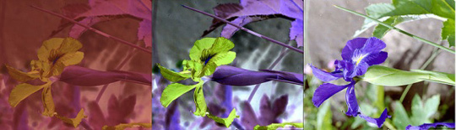  
****The same image as seen through the negative film,****  
****the real negative image once the orange mask is removed, and as a positive color image.****

The second reason individuals may choose to do their own processing with the help of a darkroom is that it offers the film photographer the greatest amount of control. Photographers have control over taking the actual photo, but if a lab is used for the processing, they lose control over the final piece of the puzzle. This means that someone else will make the final decisions on what the photograph will ultimately look like. By using a darkroom, the photographer can maintain control over this aspect as well. Many photographers, including the famous photographer Ansel Adams, saw the darkroom as part of the creative process of photography.

The History of Film Development

For over a century, photographers have been creating images with the use of a camera and film. The film that we place in traditional cameras is photosensitive. In other words, when light hits the film, its properties change, creating the image. Through a series of chemical processes, a print can be created from the original film.

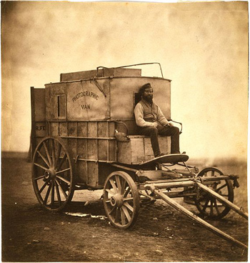  
****Marcus Sparling, full-length portrait, seated on Roger Fenton's photographic van, 1855.****

In the 1720s, **Johann Heinrich Schulze,** a German scientist, discovered that exposing silver nitrate to light made it turn purple. The areas that he exposed to light changed, while the areas that were not exposed to light remained the same. Although he didn’t set out to discover this, it would help encourage the development of photography as we now know it. Other scientists used the information that Schulze had discovered to experiment more with silver nitrate and the changes that occurred with light. Some began to dip paper into the silver nitrate, using it as an early form of photographic film. By using early cameras and other devices, they were able to create images on the paper. The problem, however, was that the paper would lose the image as soon as the whole paper was exposed to light.

About one hundred years after Schulze’s first discovery of the effects of silver nitrate, scientists discovered that by using sodium hyposulfite, they could eliminate the remaining silver nitrate on the piece of paper. This meant that the whole paper would not turn black if it was exposed to light. In other words, sodium hyposulfite allowed scientists to keep the image that they had created by exposing some of the paper to the light. This would be a major step in the technology of photography.

Early cameras did not use film at all. The first flexible photographic film was developed by Kodak Eastman in the 1880s. The first versions were made of paper, but plastic soon became the base for the film. Color film became useable in the 1930s and quickly became popular, particularly for amateur photographers.

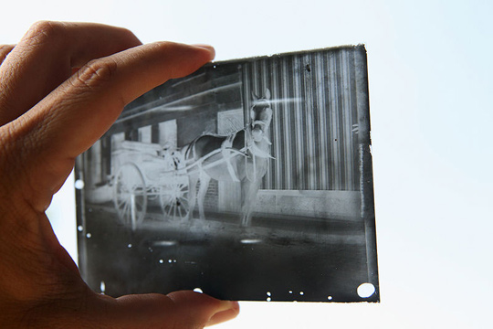  
****Glass plate negative****

The Process of Film Development

To develop a roll of film, a basic process is followed that will develop the images on the roll of film and create a negative of the image. With a negative, a photographer can then create a print or what we would typically think of as a photo. Following the process carefully is important in developing film, as changes can result in a ruined roll of film.

If you’ve worked with a film camera before, you know that a roll of film that has been used for photographs will be in a small canister that you can take out of the camera. This canister protects the film from light. Before removing that film from the canister, you will need to be in the darkroom, as any light that hits the film will cause exposure.

To begin the process of developing your film and creating negatives, make sure that your developing tank is clean, and then place the developing chemicals into the developing tank. Once this is complete, you may begin to take the film out of the canister and wind it onto a reel. Many people find it helpful to practice loading an old roll of film onto the reel in the light to get the feel for doing this. With an old roll of film, you can practice as many times as you need to until you can load the reel with your eyes closed. Some reels have clips to hold the film in place as you wind the film, but others will not.

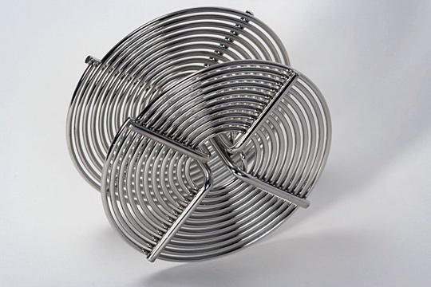  
****A 35mm stainless steel film reel****

To load the reel, open the film canister, but leave the film in a roll so that it does not get dust on it. The best way to load the film onto the reel is to cut the edge of the film so that it is straight. This end will be inserted into the center of the reel. You’ll want to gently curve the film as you rotate the reel so that the film fits onto the reel. This helps the film fit into the spiral grooves on the reel which prevent the film from coming into contact with itself (which might create a situation where the chemicals can’t reach a particular part of the film during the developing process). At the end of the film spool, you’ll find that the film and the spool are attached by a piece of tape. Here, you’ll cut the film again to release it from the spool and finish winding it onto the reel. Now the film (on the reel) is ready to be placed into the developing tank.

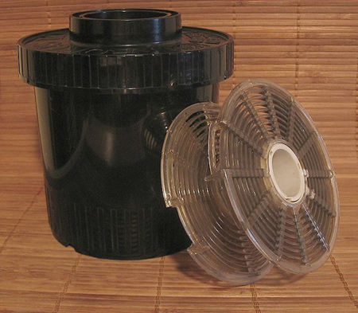  
****Photo tank for developing film****

The key to developing film is adjusting the time that the film is in the tank by the temperature of the chemicals. Usually, the optimum developer temperature is 68 degrees F. There is a range of ways that you can get your developer to this temperature, including putting the chemicals into bottles and placing both the bottles and the developing tank into water that is the right temperature.

After inserting your film (on the reel) into the **developing tank,** you’ll first presoak the film with water. The water may turn green or blue from the paper backing on the film. The presoak will also help get the film to the same temperature as the **developer.** Check on the developing time for your film before putting the developer in with the film. Now you are ready to add the developer and shut the outer lid. Make sure to use a timer, as you’ll need to be precise in the time that the film is exposed to the various chemicals. With the developer and film in the developing tank, you will need to agitate the tank so that the developer gets to all parts of the film. For example, you might move the tank from side to side, flip it upside down and then right side up, or hit the tank on a surface (which helps to get rid of air bubbles). There are also machines that you can buy that will do the agitating for you. You’ll want to be consistent in agitating and do it at regular intervals during the process. It is also important to keep an eye on the temperature of the water that the developing tank is in to keep it at the optimum temperature.

At the end of the recommended time for the developer, open the outer cap on the developing tank and pour out the developer. Next, pour in the **acid stop bath** and close the developing tank back up. The tank will still be in the water bath and you’ll want to agitate the tank as well. When the recommended time is up, pour out the acid stop bath and pour in the **fixer** to the developing tank. With the tank closed, alternate agitating the tank and letting the tank sit in the water bath to maintain the correct temperature. At the end of the recommended time, you can pour out the fixer. It is now fine to take the lid completely off the developing tank, if you’d like.

The next step is to wash the film. To do this, run water into the developing tank for the recommended amount of time. You can also buy a film washer that will move water over the film in order to rinse the chemicals off of it. After the recommended time is up, it’s time to dry out the film (or negatives) before you make a contact print or prints of one of the actual pictures. First, you’ll empty the tank of water and put in a wetting agent (leaving it on for often about thirty seconds, although it may differ depending on the brand that you are using). When the time is up, remove the film from the tank and slowly take the film off of the reel that it has been on. You can clip the film to an overhead wire or cord with a clothespin, film clip, or other device. Once you have all of the film off of the reel and hanging from the cord, place another clip at the bottom of the film. This will act as a weight, keeping the film straight as it dries. Gently remove any water spots on the film with a damp sponge, but be careful not to scratch the film as you do this. Then leave the film alone for a few hours (around three to four hours is often recommended). Some darkrooms have a heated drying cabinet, which will reduce drying times. Be sure that any fans or other air sources have been stopped and try to leave the room without stirring up any dust or dirt that might stick to the film.

Once the film is dry, you can cut the film into more manageable-sized pieces. Often, photographers will cut the film after every fifth frame. One reason for this is that this size will fit easily into a negative sleeve, which will protect the negatives until you are ready to make a print from them.

Creating a Print from the Negative

Before beginning the actual process of creating a photo from the negative, you have to gather the necessary materials. This includes the chemicals for the developer, the stop bath, and the fixer. In addition, trays, paper for the prints, tongs to handle the prints, and other items need to be on hand. You will want to mix the chemicals for the developer, stop bath, and fixer according to the manufacturers’ instructions and place the chemicals in trays large enough to hold the paper.

Before creating a print from a negative, most photographers will create a contact sheet or a **contact print.** This involves creating a print of all of your negatives or one strip of your negatives onto a sheet of photography paper, allowing you to see what the photograph looks like. The contact sheets can also give you information about any prints that you might want to make, including whether you’ll want to crop a photo or whether the print will require a different exposure time than what you are used to. Let’s assume that you’ve made a contact print and are ready to create an actual photograph from a negative.

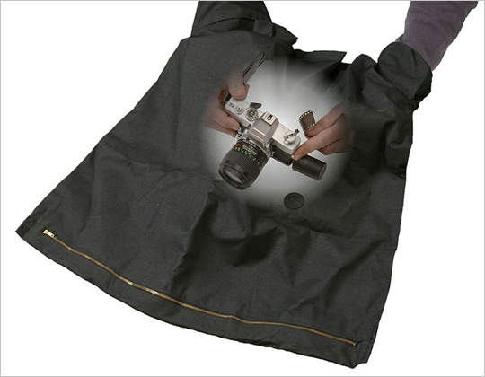  
****Darkroom Bag****

The first part of the process involves using an **enlarger.** If you plan to do a lot of your own developing in a home darkroom, you may want to purchase a new or used enlarger. You can also rent them, and most darkrooms in schools or arts centers have them as well. First, you need to adjust the enlarger so that you get the photograph the right size. To do so, place the negative (emulsion side up) in the negative carrier, and place a used piece of paper in the spot for the paper (an easel or flat surface generally). Turning the lamp on, you can lower or raise the enlarger head to give you an image in the size that you want. Adjust the focus so that it is right where you want it, turn the lamp off, and take the used paper off the enlarger.

Next, you’ll want to make a test print to determine the time that you’ll need to expose the negative to the photography paper. To do so, turn off any lights in the darkroom, except for lights safe for the developing process. Take a sheet of photography paper and place it on the enlarger. Expose the paper to the light from the enlarger for the recommended amount of time, after which you’ll develop the print (which we will discuss below). This will allow you to have information necessary to create a great print once you are ready to do so. It will tell you whether you need to make any adjustments to the exposure time or other areas of the photo. Just be sure to record the information on the exposure time, type of photography paper, the negative number, and any other relevant information so that you can duplicate the effort the next time.

Let’s assume that you have a negative image that you are ready to develop into a photo. You’ve exposed your photography paper to the negative using the enlarger. However, at this point, the paper will still not appear to have an image on it. You need to take that paper and develop the photo. At this point, it is helpful if you’ve prepared in advance, as you’ll need four trays (or tubes) of chemicals, including one tray of developer, one tray of a stop bath, one tray of a fixer, and one tray of wash. Many photographers find it helpful to always put these trays in the same order, such as left to right. Mixing up the order can ruin your photograph.

As with developing your film, the temperature of the chemicals is important. Generally, the manufacturer will have a range of temperature that the chemicals should be kept at while you develop. There are a number of different ways that you can adjust the chemical temperature, including putting the tray into a larger tray of water to heat it or cool it. You can also put something into the tray, such as a balloon or a container that has been filled with warmer or cooler water.

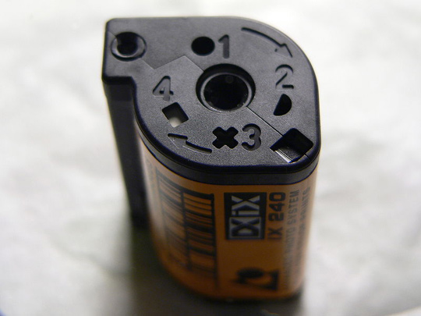  
****APS Film****

To develop your print, you will expose the print on the enlarger and then put the print paper into the trays, following the order from developer to wash at the prescribed times that the manufacturer recommends. Use tongs on the edges of the print to move the paper from one tray to the next when the time is complete. You should also agitate each tray during the process (at intervals) by slightly rocking the tray. This will help ensure that all parts of the paper come into contact with the chemicals needed to develop the print.

As your print develops, you’ll see the image appear. Once you’ve made it through all four trays for the recommended amount of time, your print will be ready to dry. Some darkrooms have drying racks for prints, which speeds up the time needed. Otherwise, remove as much of the water from the print as possible and hang it up with clips to a wire or cord. The drying process can take several hours, but you can continue to work in the darkroom while a print is drying. Some papers may curl a bit at the edges while drying, but you can always place additional clips at the bottom to help weigh down the paper and keep it straight.

Now you have a print that you’ve developed from start to finish. The process may seem a bit intimidating at first, but with practice and some knowledge of what to do, you can make the darkroom part of the creative process with photography. Once you have the basics down, you can learn to adjust and even do some editing within the darkroom to improve the photos that you’ve taken.

Darkroom Safety

While we normally don’t think of photography as a dangerous hobby or profession, the darkroom can pose some risks that photographers need to be aware of. Darkrooms carry not only the risk of tripping or falling in the low light levels, but processing film also involves the use of chemicals that can be potentially dangerous. In addition, these chemicals and other substances used for photo developing and printing can be dangerous to the environment.

One reason darkrooms pose a threat is that photographers may not always receive the proper training in working within a darkroom. As all of the materials are available either locally or through online businesses, photographers can set up a darkroom with no real experience in one at all. If you are thinking of creating a darkroom in your home, make sure that you receive the proper training in processing film and handling the chemicals. Many universities and local arts centers offer courses in darkroom processes where you can receive actual hands-on training in the darkroom environment.

Some of the potential risks of using photo developing chemicals include burns, vomiting, skin issues, central nervous system failure, and asphyxiation in cases where a sudden, acute reaction occurs. The chemicals can also have potential effects with long-term use, including chronic headaches, lung problems, and cancer.

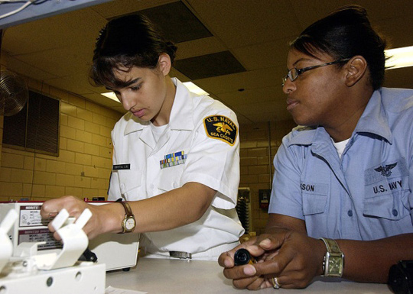  
****Photographer's Mate 1st Class Aviation Warfare Toiete Jackson, right, instructs****  
****U.S. Naval Sea Cadet Seaman Callista Espitia as she learns the basics of developing photographic film.****

Why do darkroom chemicals present a problem? There are several reasons, including the risk of inhalation or breathing in the chemicals. Darkrooms are by nature closed spaces and often have poor ventilation, since ventilation that is light tight can be expensive. Photographers also often spend long hours in the darkrooms developing film and using these chemicals. The handling of materials such as negatives and prints, which have been exposed to chemicals, also increases the risk of chemical absorption by the skin. Another issue is that most of the work done in darkrooms happens in low light conditions, which can increase the risk of mistakes and accidents with chemicals. Mixing the wrong chemicals or accidentally coming into contact with a chemical while it is in an open tray can be all it takes for a problem to develop.

In addition to human risks, darkroom chemicals can also pose a threat to the environment. Individuals may dump chemicals into waste water, releasing them into the environment. In some cases, the fumes from the chemicals can pose a danger as well. One of the problems with combating the threat of environmental damage is the common practice of pouring chemicals down the sink with large amounts of water. While the risk may be small, it does still represent a possible threat to the environment.

What can you do to remain safe in a darkroom? One of the first steps that you can take happens before you even enter the darkroom. Try to anticipate any risks that you might have in the particular darkroom you are working in. Familiarize yourself with where things are kept and the layout of the room. You can also buy chemicals that you feel are safe. If you question the safety of a chemical, it is better not to buy it and look for an alternative. Mixing your own chemicals, rather than buying a pre-made mix, can also give you greater control over what you are using.

In the darkroom, make sure to wear protective gear, including gloves, eye protection, and other clothing to help keep you safe from the chemicals. You should also make sure to have a water source close by so that you are in a position to quickly rinse off any chemical that you might come into contact with. Using the highest amount of light (red or orange) that you can and keeping electrical cords tucked away can also help prevent situations where a trip or fall could result in electrocution, shock, or other injury. You should also try to introduce as much ventilation into the darkroom as you can. When dealing with the chemicals, some photographers feel that tubes are easier to work with than the traditional trays for holding the chemicals. Tubes often reduce the amount of chemicals needed as well as reduce the vapors released during the developing process. In addition, they are less likely to spill than open trays.

In this unit, we examined darkrooms and what advantages they can offer a photographer. We briefly discussed the developing process for both photographic film and for creating a print from a negative. We learned some of the history of film and film development and learned about some of the safety issues in the darkroom. Although darkrooms are becoming less commonly used as more photographers are using digital cameras, darkrooms can be a creative space for photographers who wish to use traditional methods or who prefer to use film cameras.