**How to Write a Resume In 2018 – Extensive Resume Guide (+Examples)**

Whether you are looking for your first job or trying to make a career change, the process starts with your resume. This one document can make or break your chances of getting a [job interview](https://novoresume.com/career-blog/interview-questions-and-best-answers-guide).

So, what is it that recruiters want to see? This comprehensive guide will cover all the resume rules and tips you need to write a [professional resume for 2018](https://novoresume.com/resume-templates), including several [resume examples](https://novoresume.com/career-blog/resume-examples).

**On average, recruiters spend**[**only 6 seconds**](https://cdn.theladders.net/static/images/basicSite/pdfs/TheLadders-EyeTracking-StudyC2.pdf)**reviewing an individual resume, therefore focus more on the quality and relevancy of your content rather than the length.**

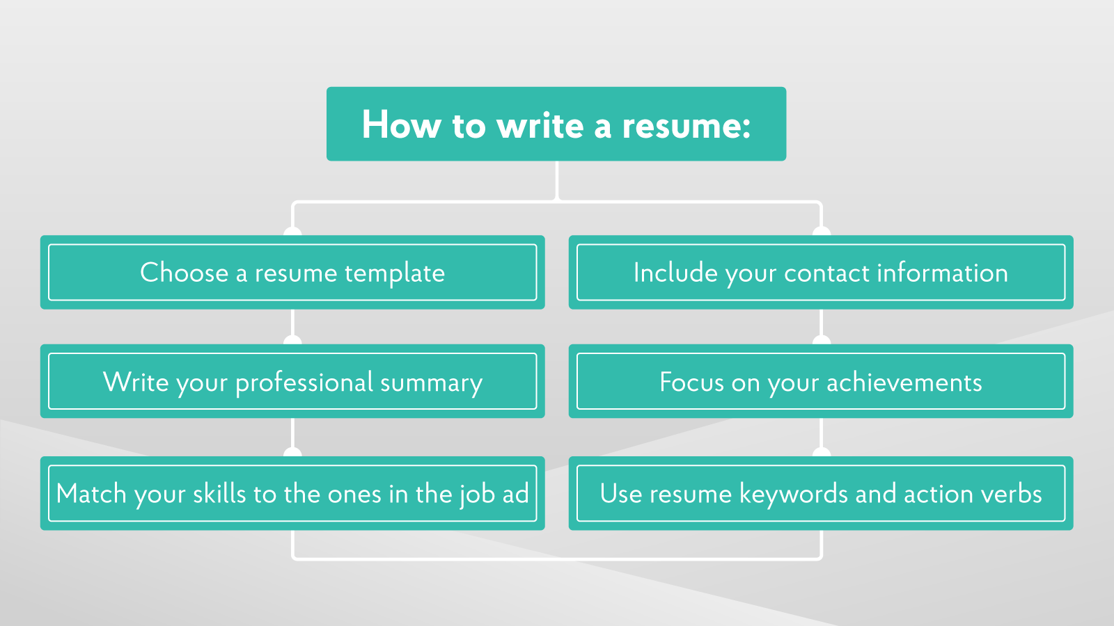

By reading this resume help guide, you will learn…

* How to write a resume
* What is a resume? And, what is a CV?
* How to choose the [best resume format](https://novoresume.com/career-blog/resume-formats)
* What content to include, such as [skills to put on your resume](https://novoresume.com/career-blog/most-important-skills-to-put-on-your-resume)
* Tricks for how to write an effective resume like the one in the following example
* Additional [job search advice](https://novoresume.com/career-blog/find-a-job)

**How to Write a Resume - Basic Steps**

1. Review [professional resume examples](https://novoresume.com/career-blog/resume-examples)
2. Choose a [resume template](https://novoresume.com/resume-templates)
3. Write your professional title and [resume summary](https://novoresume.com/career-blog/resume-summary)
4. Include your contact information
5. Match [your skills](https://novoresume.com/career-blog/most-important-skills-to-put-on-your-resume) to the ones in the job ad
6. Use [resume keywords and action verbs](https://novoresume.com/career-blog/resume-keywords-how-to-use-them)
7. [Focus on your achievements](https://novoresume.com/career-blog/how-to-write-your-achievements-in-your-resume)
8. Select the right font and color theme
9. Proofread before sending

Keep in mind that you don’t have to build your resume from scratch. A [resume builder](https://novoresume.com/) can provide you with a [free resume template](https://novoresume.com/resume-templates) to work with, so all you have to focus on is resume writing.

Let’s get started...

**Resume Writing Basics**

**What is a Resume?**

* A resume is a brief summary of personal, educational, professional experiences used for job applications.

**What Is a CV?**

* A Curriculum Vitae (CV) is a detailed summary of professional and educational histories used for job applications.

**What Is the Difference Between a Resume And a CV?**

We hear this question all the time. And based on how similar the above definitions above are, it’s easy to see why there might be some confusion.

The [main difference between a resume and CV](https://novoresume.com/career-blog/cv-vs-resume-what-is-the-difference) is the length and amount of detail. A resume layout and its content is meant to be selective and concise. That means one page (maximum three for senior roles). By contrast, a CV outlines your entire educational and professional history, along with major accomplishments, publications, and other credentials, so it is almost always more than two pages in length.

In general, a resume is used when applying for jobs in the private sector, whereas a CV is used for jobs in the public sector, especially academia. We’ve developed a separate guide so you can learn more about the differences and see a comparison of [resume samples and CV samples](https://novoresume.com/career-blog/cv-vs-resume-what-is-the-difference).

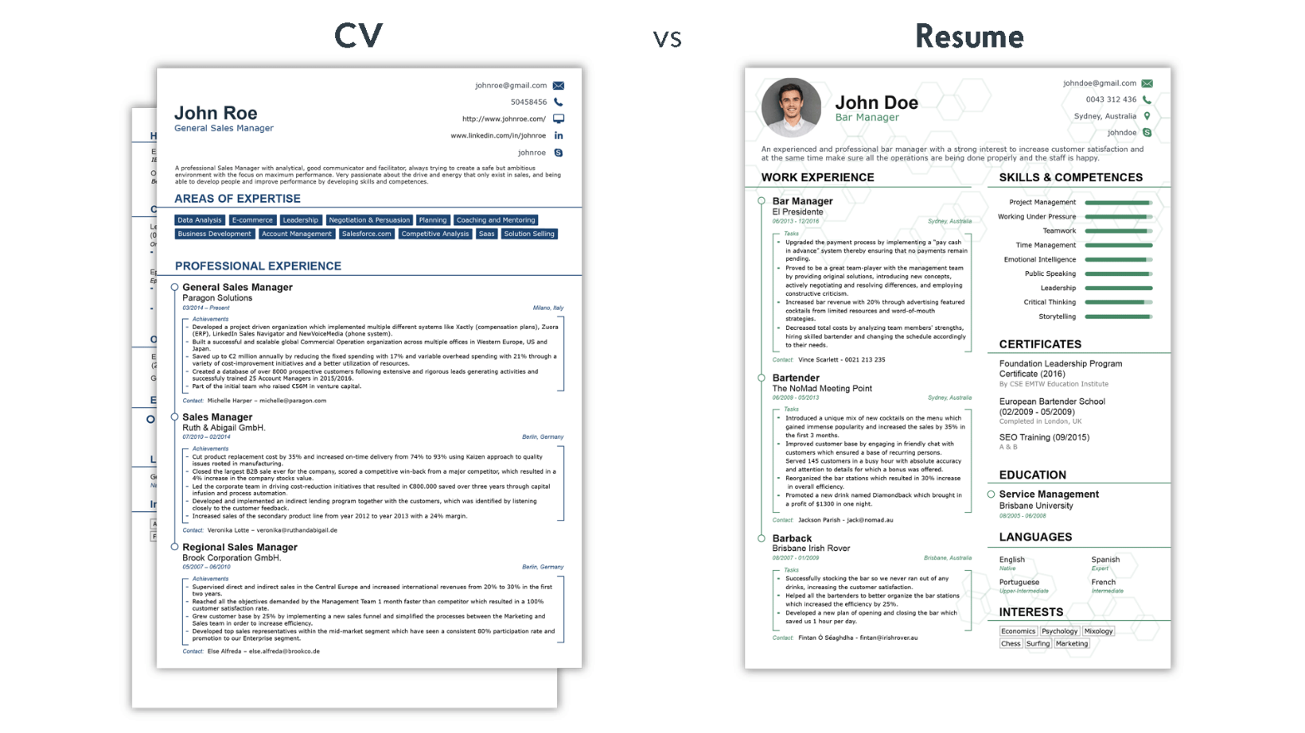

**Resume Layout and Format**

**What Are the Different Resume Formats?**

There are three types of [resume formats](https://novoresume.com/career-blog/resume-formats): reverse chronological, functional or skills-based, and a combination of the two. Choosing which one to use depends on the type of job you are applying for and your level of experience.

**Best Resume Formats**

1. **Reverse chronological resume format** - this is the [most popular resume format](https://novoresume.com/career-blog/resume-formats) and is ideal for people with plenty of work experience that is relevant to the role which they are seeking.
2. **Functional/skills-based resume format** – if you lack relevant work experience because you are a student/recent graduate, or you are looking to make a career change, the [skills-based format](https://novoresume.com/career-blog/resume-formats) is a good choice.
3. **Combination resume format**– this is a great choice if you have a diverse set of skills and work experiences that you feel are relevant to the desired role.

Still not sure which format to go with? The [combination resume format](https://novoresume.com/career-blog/resume-formats) is becoming very popular and can look great when you use a [free resume builder](https://novoresume.com/).

**What Is The Best Resume Layout?**

The first thing a job recruiter notices about any [resume is the layout](https://novoresume.com/career-blog/resume-formats). Does it look organized or cluttered? Is it too short or too long? Is it boring and ignorable, or does it scream out “Read me!”?

This is what you have to consider when choosing a resume layout. There are some general layout principles that apply no matter where and with whom you are applying for work.

**Resume Layout Must Haves**

1. One page in length (max three).

2. Clear section headings.

3. Ample white-space, especially around the margins.

4. Easy-to-read font.

Following you can see a [professional resume layout](https://novoresume.com/resume-templates) created with the functional resume template:

The ideal resume layout also depends on the company and role you are pursuing. For example, if you are applying for a marketing job with a cool new startup, you will want to use a [modern resume template](https://novoresume.com/resume-templates). Looking for a job with an investment bank? A [simple resume template](https://novoresume.com/resume-templates) will be your best bet.

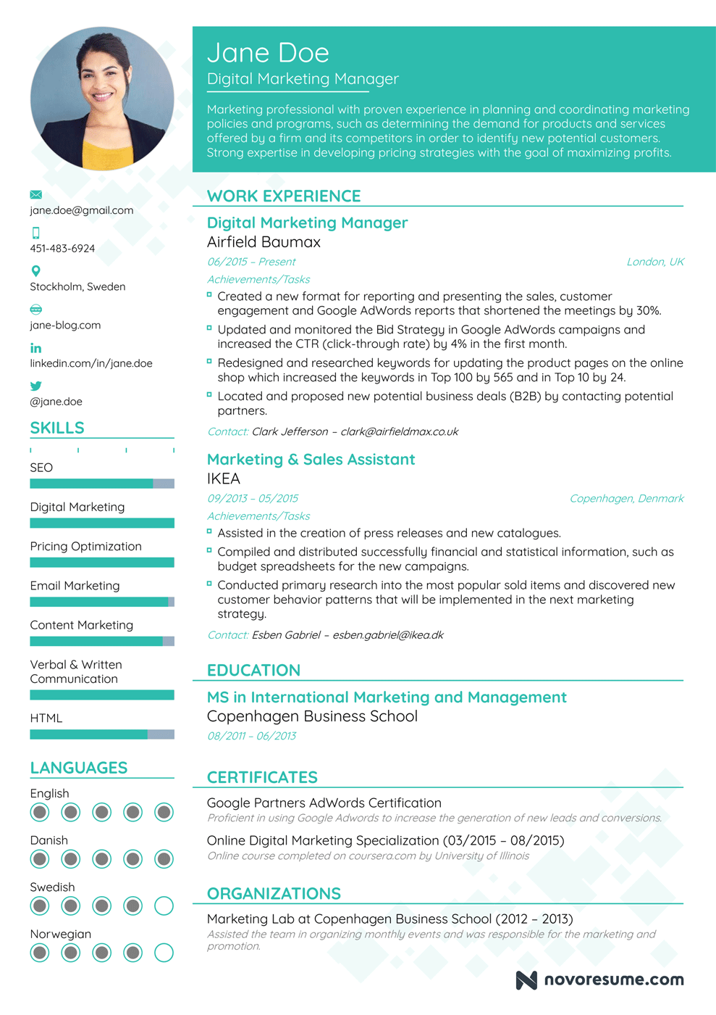

**Resume Content**

**What Sections to Include On a Resume?**

The most important sections for a resume are:

* Contact Information
* [Professional Resume Summary](https://novoresume.com/career-blog/resume-summary)
* Professional Title
* Work Experience
* Skills
* Education

**Using a Resume Builder**

[A resume builder](https://novoresume.com/) will make it easy to fill in these sections, and will normally include additional sections for organizations you are involved with, volunteer work or languages you speak.

[The advantage of using a resume builder](https://novoresume.com/career-blog/using-a-resume-builder-advantages-and-disadvantages) is that these must-haves are done automatically. You don’t have to invent an entirely new layout. Instead, you can make use of a [professional resume template](https://novoresume.com/resume-templates) and customize it to your needs.

All of the templates on [novoresume.com](https://novoresume.com/) have been carefully prepared by a professional graphic designer together with recruiters and employers, making sure our templates meet all the standards and demands.

**Hobbies and Interests**

Many people wonder if they should include a [list of interests or hobbies](https://novoresume.com/career-blog/hobbies-and-interests-to-put-on-a-resume) on their resume. The answer is that it depends.

You can either [incorporate the skills](https://novoresume.com/career-blog/most-important-skills-to-put-on-your-resume) and experiences gained through these pursuits into other sections, such as Organizations or if your hobbies are highly relevant to the position, you can give them their own section. There can be great value in showing your diverse interests to a potential employer.

**Resume Objective vs. Professional Resume Summary**

Which is most common in 2018, an objective for a resume vs. professional summary? Well, the objective statement is going out of fashion.

**What is a Professional Resume Summary?**

* A professional resume summary provides a convincing snapshot of your skills and experience is favored by recruiters. The [best resume templates](https://novoresume.com/resume-templates) will have space for two or three lines of text at the very top of the page for a summary of what follows.

The main goal of the summary is to ‘hook’ the reader, providing encouragement to keep reading. Here is a good resume summary example:

*“An independent and self-motivated graduate with proven and tested business, procurement, sales, and marketing skills. A strong link between theoretical knowledge from an MSc, practical internships and a part-time job.”*

**Which Contact Information to Include On a Resume**

Some of the most common mistakes in resume writing are related to contact information, so pay close attention to this section.

Here are some dos and don’ts of resumes to keep in mind:

**DOs**

* As a minimum, include your name, phone number, email address, and the current location of residence.
* Consider including social media profiles that are relevant to the position, such as a detailed LinkedIn profile. Other profiles like Twitter, Medium and Instagram, may be valuable for certain roles.
* Include a professional headshot if you are applying for a job in Continental Europe, Asia, South America, Africa or the Middle East.

**DON'Ts**

* Use an unprofessional email address, like CoolCanadian86@hotmail.com. Create a separate professional email if you don’t already have one.
* Include personal information, such as marital status, nationality or religious affiliation.
* Include a professional headshot if you are applying for a job in the United Kingdom or North America.

**What to Include In the Work Experience Section Of a Resume**

* This section is your opportunity to showcase how your experience is aligned with the position you want. The best way to do this is through bullets, with each point providing examples of past [responsibilities and accomplishments](https://novoresume.com/career-blog/how-to-write-your-achievements-in-your-resume) based on what the potential employer is asking for in the job description.

Keep in mind that you have limited space on a resume, so you will need to be selective about what you want to emphasize. The easiest way to decide what to include is to base the content of your resume off of [keywords the recruiter wants to see](https://novoresume.com/career-blog/resume-keywords-how-to-use-them).

Your ability to use these strategic keywords will determine whether or not you are invited for an interview. Our [guide to resume keywords](https://novoresume.com/career-blog/resume-keywords-how-to-use-them) offers plenty of examples to follow.

One more consideration is that you want to avoid leaving any gaps in employment on your resume. If one of your previous jobs doesn’t seem applicable and it came between two relevant roles, you still need to list it. But you don’t have to describe it in great detail.

If you’re still wondering how to write the work experience section, take a look at these [resume examples](https://novoresume.com/career-blog/resume-examples).

**How to Write Achievements In a Resume (for Work Experience Section)**

**IDEAL**

1. In charge of the full renovation of the hotel with a $5M budget. Completed the project 3 months before the deadline and respecting the budget.
2. Revamped the business page on Facebook that now reached over 95.000 followers (up 38% in just 2 months); which generated over 1.200 customer leads resulting in over 4% increase in bottom line profitability.

**NOT IDEAL**

1. Completed the renovation of the hotel before the deadline and within the budget limit.
2. Redesigned the Facebook business page which generated new customer leads resulting in increased profitability.

**What to Include In the Education Section Of a Resume**

The content under this section depends on where you are at in your career. If you’ve been working for 20 years, you are best keeping the education section brief by listing your completed academic degrees and institutions attended from most recent to oldest.

For students or recent graduates, the education section has added importance. Here you can include sub-sections for relevant courses taken, research/course projects, and academic achievements. This is [how to create a resume without a lot of work experience](https://novoresume.com/career-blog/resume-advice-for-students-with-no-experience).

**What Skills to List on a Job Application?**

* The [skills section of your resume](https://novoresume.com/career-blog/most-important-skills-to-put-on-your-resume) should include a combination of hard skills and soft skills. With a typical resume template, you have limited space, so you should only list the skills that are A) mentioned in the job description, and B) skills that you can qualify you have.

**Here are some examples of skills for a resume:**

**Hards Skills Examples For a Resume**

* Financial ratio analysis
* Proficiency with specific software
* Written or verbal communication
* Negotiation
* Equipment operation

**Soft Skills Examples For Resume**

* Emotional intelligence
* Active listener
* Service orientated
* Mentoring towards others
* Critical thinker

There are hundreds of possible skills to consider using. We’ve also developed a guide on which [skills to put on a resume](https://novoresume.com/career-blog/most-important-skills-to-put-on-your-resume).

**Additional Sections for a Professional Resume Format**

Extra sections to consider include

* Achievements (E.g.: scholarships or industry awards).
* Organizations (E.g.: memberships in professional associations).
* Certifications (E.g.: professional designations).
* Conferences/Courses attended
* Languages spoken.

These sections aren’t necessarily black and white in terms of their labeling and usage. For example, your personal situation might be perfect for a “Certifications and Courses Completed” section.

As part of choosing the [best resume builder](https://novoresume.com/), consider whether it gives you the flexibility to change section headings.

**Resume Writing and Editing Advice**

Resume writing and editing tip #1: *One resume DOES NOT fit all job applications*

Resist the urge to create one resume and use it for multiple jobs. This is a lazy approach that will significantly reduce your chances of [getting an interview](https://novoresume.com/career-blog/interview-questions-and-best-answers-guide). There’s a good chance it won’t include all the keywords outlined in the job description.

Keywords are just one part of customizing your resume to a specific job. Here are some other [resume elements employers want to see](https://novoresume.com/career-blog/what-recruiters-want-in-a-resume).

Resume writing and editing tip #2: *Be selective with what you include*

Since your resume should be customized to each job opportunity, you need to be precise with the information you include and exclude. You also only have one page to capture all of the attributes you want to share.

The [best examples of resumes](https://novoresume.com/career-blog/resume-examples) avoid emphasizing the same skills or experiences multiple times. Especially under the Work Experience section, each bullet should provide a new insight into your capabilities, even if you’ve done similar tasks for multiple companies.

Resume writing and editing tip #3: *Illustrate your achievements, not responsibilities*

One of the best pieces of resume writing advice for getting job interviews is to [focus on accomplishments](https://novoresume.com/career-blog/how-to-write-your-achievements-in-your-resume), not responsibilities. The goal of a resume is to persuade, and simply listing the tasks or types of work you’ve completed does little to impress.

When you are outlining your previous work experience, explain what tasks you did and the RESULT of the work.

Here are a few [examples of accomplishments](https://novoresume.com/career-blog/how-to-write-your-achievements-in-your-resume) you can list:

* Improved efficiency of X system in the organization
* Grew customer base with %
* Trained X employees/students/volunteers
* Launched X campaigns/products/services

See more ideas for [how to focus your resume on your achievements](https://novoresume.com/career-blog/how-to-write-your-achievements-in-your-resume).

Resume writing and editing tip #4: *Follow a proofreading checklist*

There are plenty of [mistakes you can make on a resume](https://novoresume.com/career-blog/common-mistakes-when-writing-a-resume), ranging from poor choices of content to the smallest of typos. Many of the mistakes can be avoided by following the advice in this guide. But even after you’ve given close consideration to the content of your resume, your work isn’t finished.

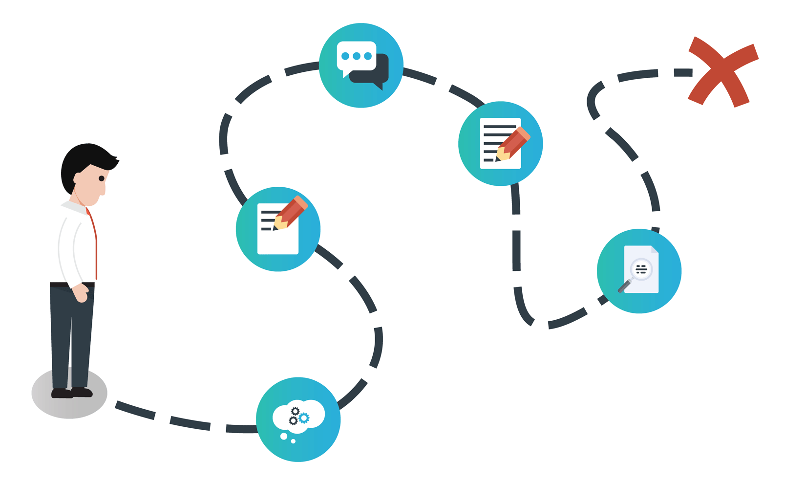

Proofreading is an essential final step to developing a resume. Here is a proofreading checklist to help guide you through this stage.

**Proofreading checklist**

1. **Have I used consistent tense throughout?** Use past tense to describe previous roles, and present tense to describe current roles.
2. **Have I used a variety of action verbs?** Describe experiences with verbs that convey action. E.g.: Coordinated, Developed, Achieved, Launched, etc.
3. **Have I used too much jargon?** Assume your resume will be read both by technical experts and a non-technical layperson.
4. **Have I included personal pronouns?** Avoid using I, me, we, us.
5. **Have I included superfluous words?** Save space and get your points across efficiently by eliminating unnecessary words (E.g.: adverbs, such as greatly, fairly, creatively)
6. **Have I used a simple, clear font?** An [online resume builder](https://novoresume.com/) will automatically use a common, easy-to-read font.
7. **Have I given my resume a professional file name?** Make sure to include at least your surname in the file name of the version you will submit (E.g.: Smith Resume ABC Corporation)
8. **Have I had someone else proofread my resume?** There’s a good chance you’ve still overlooked a spelling or grammar error, so have a trusted friend give your resume one last proofread before hitting send.

**What Are Action Verbs And How Can I Use Them In a Resume?**

If you are in doubt what the action verbs are, they are verbs that precisely and vividly demonstrate an action.

**Action Verbs to Use in a Resume**

* Coordinated
* Organized
* Programmed
* Operated
* Built
* Formalized
* Launched
* Introduced
* Developed
* Reduced
* Decreased
* Achieved

**How Long Should a Resume Be?**

* From our research, it was concluded that the best length for your resume depends on your career stage and experience:
* One-page resume: [Ideal for students/graduates](https://novoresume.com/career-blog/students-graduates-resume-example) and for everyone that has less than 5 years of relevant work experience for the job they are applying for.
* Up to 3 pages resume: For seniors and professionals having 5+ years of relevant work experience for the job they are applying for.

Remember the concept of “[Less Is More](http://www.businessinsider.com/elons-musk-resume-all-on-one-page-2016-4?r=UK&IR=T&IR=T)” and filter the information you include in your job application, only including the relevant details.

**On average, recruiters spend**[**only 6 seconds**](https://cdn.theladders.net/static/images/basicSite/pdfs/TheLadders-EyeTracking-StudyC2.pdf)**reviewing an individual resume, therefore focus more on the quality and relevancy of your content rather than the length.**