UNIT THREE: Photographers and Critiques

“You know, so often it's just sticking around and being there, remaining there, not swooping out in a cloud of dust: sitting down on the ground with people, letting children look at your camera with their dirty, grimy little hands, and putting their fingers on the lens, and you just let them, because you know that if you will behave in a generous manner, you are apt to receive it,  
you know?” –Dorothea Lange

Since the beginning of photography, individuals have shaped the technology, images, and inspiration involved in photographing people, places, and events. Through their innovation and creativity, the photographers of today have works to model, emulate, and build from. Individuals such as Ansel Adams, Edward Weston, Dorothea Lange, and Alfred Eisenstaedt helped to develop the field of professional photography and gave us some of the iconic images of events such as World War II and the Great Depression that helped modern individuals understand those events.

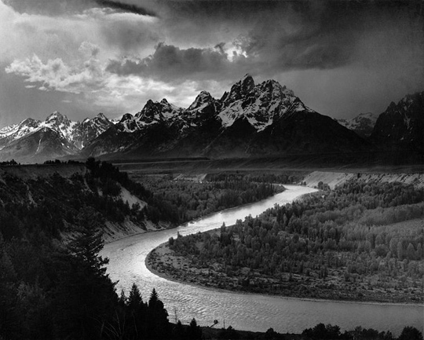  
The Tetons and the Snake River**, Ansel Adams (1942)**

The photographers that we will consider in this unit are just a handful of those who shaped and influenced the area of photography since it began. Many others have made technological and artistic advances in photography, beyond the individuals that we will learn about. As you continue to learn about photography, you’ll want to continue to explore the photography of others. Photographers who have achieved recognition in the field can help us understand how to improve our photographs and inspire us to try new ways of creating photographs.

Ansel Adams

Perhaps the most well-known photographer in North America, **Ansel Adams** is best known for his black and white photographs of the western United States, particularly national parks such as Yosemite National Park. Adams made a mark not only on the world of photography, but also on the national park system during his fifty plus year career. His landscape photographs brought individuals to places in the days before the average tourist began to travel to them, and brought to the forefront environmental concerns. His photographs also helped to move photography into consideration as art, comparable to other artistic forms such as music and painting.

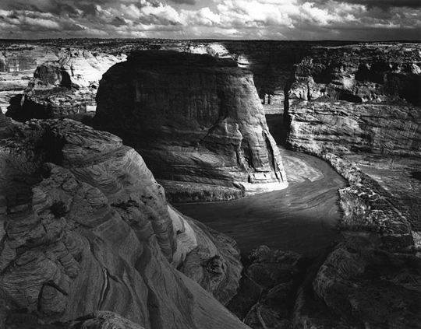  
Canyon de Chelly**, Ansel Adams (1941)**

Ansel Adams was born in February 1902 in San Francisco, California. An only child, Adams was drawn to nature at an early age, exploring the sea coast and collecting insects. He was also trained as a concert pianist. During a family trip to Yosemite National Park, his father gave Adams a Kodak Brownie camera, beginning his love for photography. Adams would return the following year to do more photography within the park. He also learned darkroom techniques by working part time for a photo finisher. At the age of seventeen, Adams joined the Sierra Club, a group dedicated to preserving natural spaces, and spent several summers as the caretaker for their lodge in the Yosemite Valley.

In 1921, Adams sold his first photographs, although he still planned to pursue music as a career. While he experimented with a range of different photograph techniques during this period, he preferred a realistic approach for his photographs. In 1927, Adams completed his first portfolio, which earned about $3,900. He soon began to get commercial assignments for portraits. By the 1930s, Adams was focusing on photography as his work matured. His first solo museum exhibition took place in 1931 at the Smithsonian Institution and featured sixty photographs he had taken of the Sierra Mountains.

With Edward Weston, M. H. de Young Museum, and Imogen Cunningham, Adams formed **Group f/64,** with the group committed to “straight” photography rather than artistic renditions of a scene. The name came from the small aperture setting (f/64) which gave the greatest depth of field for a photo. Adams also opened his own photography gallery in San Francisco. In the years that followed, Adams continued to photograph the West, publishing numerous books with his photographs and displaying his photographs in photography shows.

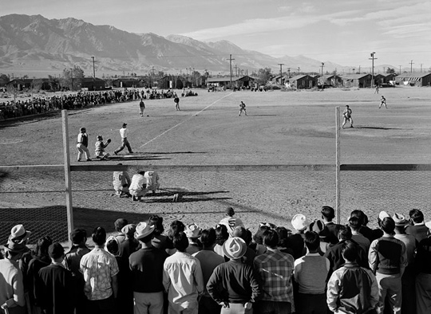  
**Baseball game at Manzanar War Relocation Center, Owens Valley, California, Ansel Adams (1942)**

One of Adams’ contributions to the area of photography was in the development of his Zone System. **The Zone System** was a way of adjusting the exposure in a photo to make the most of the shadows and highlights. Looking at Adams’ work, it is clear that the manipulation of light was one of his strengths. The Zone System developed by Adams separated the tones between white and black into eleven different zones, with middle gray at the center. Each of these zones corresponded to an f/stop. The system helped to make sure that a photo was exposed correctly, rather than being under- or overexposed. To use the system, a photographer would choose a particular area of the photo, meter the area, and then adjust the exposure using the system to put the area of the photograph into the exposure that best measures the area. For example, let’s say that you are photographing a mountain scene. Bright snow might be metered at a zone V (5), but you want it at a zone IX (9). Using the system, you would know to increase the f/stop by four f/stops to get the exposure that you want for the photo. The Zone System was first used with black and white film, but the principle also worked for color film and with digital images.

Edward Weston

Another influential photographer from the early twentieth century was **Edward Weston.** His photographs are among the most expensive ever sold. As a photographer, Weston often emphasized the beauty of natural form, whether it was a seashell or a vegetable. Often taken in black and white, his photographs reveal and focus on the natural form of a single item, taken in sharp detail.

Edward Weston was born in Highland Park, Illinois, in 1886. He received his first camera, a Kodak Bulls-Eye No. 2, as a present for his sixteenth birthday. He took the camera on a family vacation in the Midwest before buying a 5 x 7 camera and beginning to learn darkroom techniques. Soon, he was photographing Chicago parks and the areas around his aunt’s farm. In 1906, he submitted a photo to Camera and Darkroom, which published the photograph in a full-page reproduction.

In 1906, Weston moved to California, but moved back to Illinois a year later to attend the Illinois School of Photography. After finishing the coursework, Weston again moved to California and began work in several photographers’ studios, learning the business. In 1911, he opened “The Little Studio” and took photographs of children and friends, gaining recognition for his work. In the 1920s, Weston turned his attention to the everyday objects that he saw around him, although he continued to take portraits as well. Among the everyday objects that would capture Weston’s attention over the years were seashells, fruits, and vegetables.

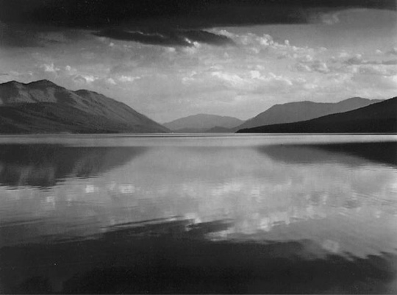  
Evening, McDonald Lake, Glacier National Park, **Ansel Adams (1942)**

Needing to raise money to support himself and his family, but not wanting to go back to taking portraits, Weston began the “Edward Weston Print of the Month.” For five dollars a month, subscribers received a limited edition print from his work. The idea, however, was not a large success. It is estimated that he had only about eleven subscribers to the program. In 1937, Weston received the first ever Guggenheim Foundation grant for a photographer, which allowed Weston to travel and photograph. He arranged to sell some of his prints to a magazine for publication. The following year, he received another grant and published Seeing California with Edward Weston in 1939. The book contained photographs of his travels. The following year California and the West was published. He contributed to several other books, exhibits, and programs around this time as well.

In 1945, Weston began to exhibit signs of Parkinson’s disease. By 1948, he was no longer physically able to use a camera, although he continued to be active in other aspects of photography. He continued to exhibit his work and publish some of the photos that he had taken earlier in his life. He died in 1958. One of his favorite beaches, and the subject of many photographs in Point Lobos, California, was later renamed Weston Beach, in his honor.

Dorothea Lange

Best remembered for her images of the Southern poor and those starting over in the West, **Dorothea Lange** sought to photograph the hard times of the Depression era and reveal the social difficulties that individuals and families faced. Those iconic images have come to be the face of the Depression for those of us living in subsequent generations, and it is likely that you have seen at least one of Lange’s images.

Lange was born in 1895 in Hoboken, New Jersey. After a childhood marked by polio, Lange became an informal apprentice in several New York photography studios. She moved to San Francisco in 1918 and opened her own studio. When the Great Depression hit the United States in the late 1920s, Lange was moved to document the people hardest hit by the financial crisis. She was hired by the Resettlement Administration (which was later renamed the Farm Security Administration).

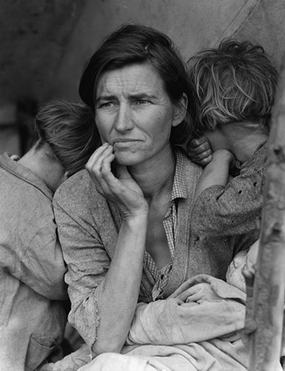  
Migrant Mother**, Dorothea Lange**

Many of Lange’s photographs from this time focus on the unemployed and the homeless. Perhaps her most famous image is of a migrant mother and her two children. During the 1930s, Lange’s photographs of the poor in the United States were distributed to newspapers across the country. Important and inspiring in their day, these photographs became iconic images of the Great Depression as the years passed.

In 1941, Lange worked for the War Relocation Authority to document the forced evacuation of Japanese Americans on the West Coast to relocation camps. She photographed everything from the process of relocation to the lives of the Japanese Americans in the camps, focusing most of her attention on Manzanar, one of the first permanent relocation camps that housed the relocated Japanese Americans in California. Her photographs of the camp and the relocated Japanese Americans were deemed too critical of the relocation by the government, who impounded the photos (although they are now available for viewing through the National Archives).

After WWII, Lange continued with her work in photography, although from a slightly different position than her earlier social commentary work. Ansel Adams offered Lange a faculty position at the California School of Fine Arts, which had the first fine arts photography department. Lange also helped to co-found the photography magazine Aperture.

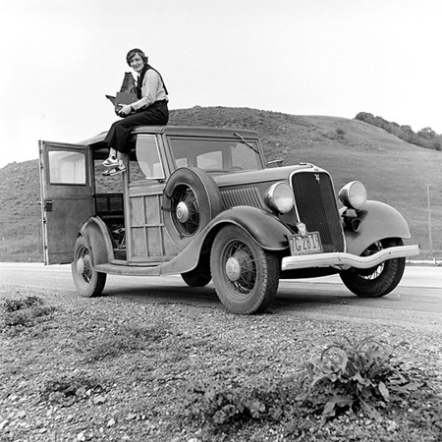  
**Ford Model V8 (AKA "Model 68"), Dorothea Lange**

In 1965, at the age of 70, Dorothea Lange died of esophageal cancer. Her photographs of individuals living through the Great Depression and in the Japanese American internment camps have become iconic images of the time periods. Her images have helped countless people better understand these time periods and the events in them. As a woman, Lange also served as an inspiration for other female photographers, working in a field that was at that time dominated by men.

Alfred Eisenstaedt

Called the “father of photojournalism,” **Alfred Eisenstaedt** is famous for the candid photographs that he took. He captured spontaneous moments, forever recording these moments. You may have seen one of Eisenstaedt’s famous images of a United States sailor in uniform kissing a woman in a white dress, taken on the day that World War II ended.

Eisenstaedt was born in Germany in 1898. His interest in photography began when he was given a Kodak camera at the age of fourteen. After serving in the German army during World War I, Eisenstaedt began working as a freelance photographer. He sold his first photograph in the 1920s and began taking photographs for the agency that would become the Associated Press in 1928. In 1935, Eisenstaedt immigrated to the United States, as Germany became more and more oppressive towards Jewish individuals. He would reside in New York for the rest of his life and work for Life magazine for more than thirty-five years.

During his career, Eisenstaedt photographed musicians, politicians, writers, and even royalty. Yet, it is his candid photographs, often of unknown people, that became his most famous images. His work in this area illustrates the need for photographers to be ready for those perfect spontaneous moments that create great photographs. Eisenstaedt once said, “I still use, most of the time, existing light and try not to push people around. I have to be as much a diplomat as a photographer. People often don't take me seriously because I carry so little equipment and make so little fuss.” His approach to photojournalism and photography offers others a good lesson in not missing that great shot.

Annie Leibovitz

If you look at portraits of modern celebrities, you are likely to come across the name **Annie Leibovitz.** She has taken portraits of everyone from John Lennon (taken on the day that he was killed) and Queen Elizabeth II to Michael Jackson and Bill Gates. Her photographs have appeared in a number of different fashion and music magazines over the course of her career.

Leibovitz was born Waterbury, Connecticut, in 1949. Her father was a member of the United States Air Force and the family moved frequently around the world. It was in the Philippines that Leibovitz took some of her first photographs. She would continue her interest in the arts, including photography and music, through high school. Returning to the United States after living in Israel, Leibovitz took a job with Rolling Stone magazine. Her first cover image appeared on January 12, 1971, and she became the chief photographer for the magazine in 1973.

For the next ten years, her style of photographing celebrities helped to define not only the magazine that she worked for, but also the style of portraits that appeared in other magazines and mediums. In the 1980s, Leibovitz left Rolling Stone and went to work for Vanity Fair, continuing to photograph celebrities for the magazine. Leibovitz continues to photograph celebrities, producing often talked about portraits.

Critiquing Photographs

The idea of critiquing someone else’s art, including photographs, can leave even the most talkative person a little tongue-tied. The idea of having someone else critique your own photographs can strike fear into the hearts of even the bravest photographers. Yet, critiquing photographs is one of the best ways not only to learn the craft of photography, but also to improve your own work. While it is not always an easy or pleasant task, it is one that is worthwhile for photographers to engage in.

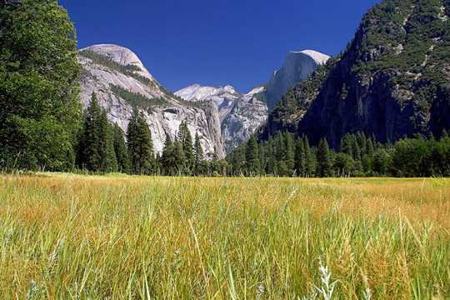  
**Yosemite Meadows**

We often think of criticism as a negative activity, or finding what is wrong with an image and pointing out its faults. This is true, to a degree. When we critique a photo, we are looking for aspects of the photograph that could have been improved. However, we are also looking at the aspects that the photographer did well. If we think of critiquing photographs as exploring both the good elements and those that could be improved, we are looking at photographs from a position of constructive criticism rather than one of trying to tear the image down. In other words, critiquing a photo (or another work of art) is merely critically analyzing the photograph in its various elements.

One of the first steps in critiquing a photo is to determine the purpose of the photo. Photographs might be created for commercial use, social commentary, to illustrate something, to document an event, or for another purpose. Understanding the purpose of a photo can help us better understand what elements benefit the photograph and which elements could be improved to better meet the purpose of the image. For example, if an image is created to be commentary on a social issue, but the image composition doesn’t highlight the element that would best demonstrate the social issue, the image isn’t fulfilling that purpose in the best way.

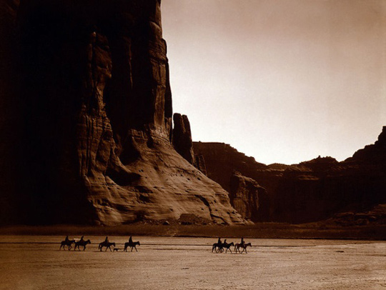  
**Canyon de Chelly**

When critiquing a photo, you can look at several different aspects: technical aspects, composition, and emotional elements. Your critique may focus on one area or you may examine some or all of the different aspects of the photo, depending on your purpose in doing the critique and what you hope to gain from it.

The technical aspects of a photo include exposure, lighting, focus, and depth of field. As you critique a photo, think about some of the following questions:

• Is the photograph properly exposed? Are there any areas of the photograph that are underexposed or overexposed?

• Is the main subject of the photograph in proper focus? Is the right subject focused on?

• What is the depth of field like in the photograph? Does the photograph have a shallow or deep depth of field?

• Does the lighting in the photograph enhance it? Is the lighting too soft or too harsh? Is the white balance in the photograph correct? Does the photograph have any tints or colors that are not correct?

In addition to assessing the technical aspects of a photo, you can also use your knowledge of composition to help you examine the compositional elements in the photo. You have probably learned about many of the “rules” of composition already, such as the Rule of Thirds, using leading lines, and framing. You may remember that there are times when breaking the rules is beneficial for a photo, but some of the following questions can help you as you examine composition:

• Does the photograph exhibit simplicity or is there too much going on in the photograph? Is there empty space in the photograph? Should the photograph be cropped or expanded?

• Where is the main subject of the photograph? Does the photograph use the Rule of Thirds?

• Does the photograph have elements in the foreground, middle, and background? If not, would adding elements to the photograph improve it?

• Does the photographer use any lines in the photograph to draw the viewer into the image? What part of the photograph is your eye drawn to?

• Is the arrangement of the photograph or the objects in the photograph pleasing? Are there any ways that this could be improved?

Finally, in addition to the technical aspects and the composition of the photo, we can also turn our attention to the emotional aspect of the photo. As you’ve probably learned already, good photographs elicit an emotional response from us. We connect with some aspect of the photo, whether it is an appreciation of the beauty shown or finding a sense of power and strength in a photo of an ocean wave. As you assess the emotional response of a photo, you can think about some of the following questions:

• Do you like the photograph? Why do you like it? What aspects of the photograph make it appealing (for example, is it the colors, the subject, the composition, etc.)?

• How does the photograph make you feel? Does it remind you of anything (a place, a feeling, a concept)?

• Does the photograph have a mood? If so, what mood does the photograph exhibit? If not, what could be added or changed to give the photograph more of an emotional response?

• Is the photograph successful in telling a story or illustrating a concept? Does the photograph meet the purpose or goal of the photographer?

• Does the photograph grab your attention? Is it creative, dynamic, or unusual in some way?

Depending on the photo, you may also want to consider darkroom techniques or photo editing and its effect on the photo. For example, you may note that an image appears to have been digitally edited. In this case, you may want to consider whether the editing enhances an image or whether the photographer went too far with the image editing.

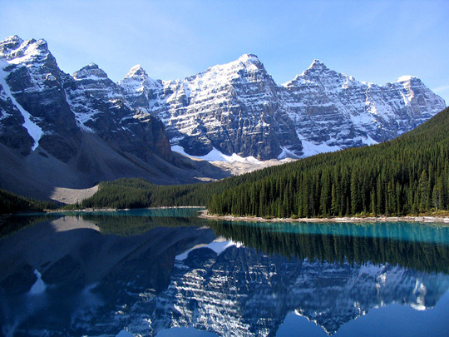  
**Moraine Lake**

Critiquing photographs happens after the fact. In other words, the photograph has already been taken. The process of critique, then, is not only about this one photograph, since it may not ever be replicated by the photographer, but rather about seeing elements that the photographer did well or could improve on in future work. As the person giving the critique, we can learn more about what elements, compositions, and emotions make good photographs, which can help us improve on our own work. As with any art, there are no right or wrong answers when doing a critique. Even the “rules” of composition are broken at times in order to experiment or produce a different type of photograph. The photographer’s natural preferences will also enter into the critiquing process. You may prefer black and white landscapes with high contrast. Someone else might prefer that a macro image be taken of one element in that landscape.

As you work on developing your photographic eye, one thing to keep in mind is to be as specific as possible. Saying, “I like this photograph. I think it’s cool,” doesn’t really help the photographer and it doesn’t really help you develop your sense of what makes a good photograph. Instead, push yourself to think about the elements that you like about the photo. For example, you might say, “I like this photograph because the diagonal lines draw my eye into the photograph and the colors of the flowers offer a nice contrast to the texture of the stone.”

The way that you go about a critique will be unique to you. Some photographers prefer to first just look at the photograph before trying to make any assessments. Some prefer to look at the emotional elements of a photo in the beginning while those impressions are fresh in their minds, before dissecting some of the more technical elements of the photo. How you go about a photo critique really depends on what works best for you. Just remember to have someplace to write down your thoughts about the photograph before you forget!

In this unit, we learned more about some of the people who have shaped and influenced the field of photography. These individuals influenced not only the craft of photography, but also its growth and acceptance as a profession. We also examined how to critique a photo. In doing so, we discussed some of the technical aspects, compositional elements, and emotional aspects that can be looked at for an image critique.