Basketball: How it Began-Facts and Information About the Game

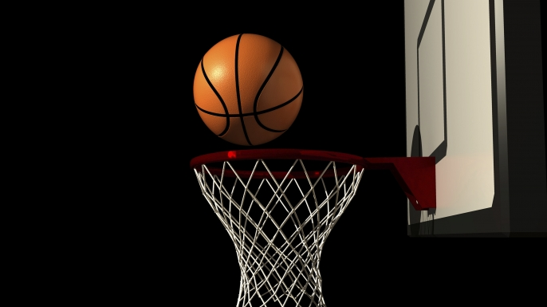

Basketball is the only major American sport with a clearly identifiable inventor. James Naismith wrote the sport’s original 13 rules as part of a December 21, 1891 class assignment at a Young Men’s Christian Association (YMCA) training school in Springfield, Massachusetts. Born and educated in Canada, Naismith came south to pursue his interests of physical education and Christian ministry. Naismith expanded on an assignment to create a game that could be played in YMCA gyms during the winter.

The first games featured nine players a side, attempting to toss a soccer ball into peach baskets nailed to the balconies at the ends of a gymnasium (when a basket was made, the game paused while a man with a ladder retrieved the ball). After its first public match in 1892, Naismith’s game spread quickly through the global network of YMCAs. The first intercollegiate match, between the Minnesota School of Agriculture and Hamline College, was played in 1895. The earliest women’s match, in which Stanford beat U.C. Berkeley, took place a year later. Basketball’s first professional league was founded in 1898, seven years before nets finally replaced the sport’s original peach baskets.

James Naismith devoted little effort to shaping the evolution of the game he invented, although he spent a decade as the University of Kansas’s founding basketball coach, losing more games than he won. Today the sport’s leading historic organization, the Naismith Memorial Basketball Hall of Fame in Springfield, Mass., stands not far from where the first peach baskets were nailed up.

The 13 Original Rules of Basketball

1. The ball can be thrown in any direction with one or both hands.

2. The ball can be batted in any direction with one or both hands, but never with the fist.

3. A player cannot run with the ball. The player must throw it from the spot on where he catches it.

4. The ball must be held in or between the hands. The arms or body must not be used for holding it.

5. No shouldering, holding, pushing, striking, or tripping an opponent.

6. A foul is striking the ball with the fist.

7. If a side makes three consecutive fouls, it counts as a goal for the opponents.

8. A goal shall be made when the ball is thrown or batted from the ground into the basket and stays there.

9. When the ball goes out of bounds, it shall be thrown into the field and played by the first person touching it.

10. The umpire shall be the judge of the men and shall note the fouls and notify the referee when three consecutive fouls have been made.

11. The referee shall be the judge of the ball and decide when it is in play in bounds, to which side it belongs, and shall keep the time.

12. The time shall be two 15-minute halves with a five-minute rest between.

13. The side scoring the most goals in that time shall be declared the winner.

In the history of basketball, the highest-rated college basketball game seen on U.S. television was the 1979 NCAA tournament championship game of Michigan State vs. Indiana State, which featured Magic Johnson and Larry Bird. This was one of the best-rated basketball games in basketball history.