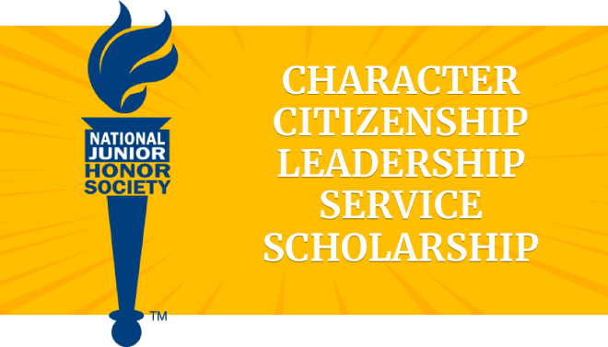

Canyon Hills Junior High School NJHS

Service Hours Log

Name___________________________________

Grade __________ Year 2022-2023

|  |  |  |  |  |
| --- | --- | --- | --- | --- |
| Service Hours Log | | | | |
| Date | **Start time** | **End time** | **Event/Action** | **Adult signature** |
|  |  |  |  |  |
|  |  |  |  |  |
|  |  |  |  |  |
|  |  |  |  |  |
|  |  |  |  |  |
|  |  |  |  |  |
|  |  |  |  |  |
|  |  |  |  |  |
|  |  |  |  |  |
|  |  |  |  |  |
|  |  |  |  |  |
|  |  |  |  |  |
|  |  |  |  |  |
|  |  |  |  |  |
|  |  |  |  |  |
|  |  |  |  |  |
|  |  |  |  |  |
|  |  |  |  |  |
|  |  |  |  |  |
|  |  |  |  |  |
|  |  |  |  |  |
|  |  |  |  |  |