UNIT SIX: Art, Product, and Stock Photography

***“Photography is more than a medium for factual communication of ideas. It is a creative art.” –Ansel Adams***

Photography is all around us. We see it on our walls, on websites, in advertisements, and in the catalogs that we pick up. This unit will focus on three types of photography that we see often in modern society: fine art photography, product photography, and stock photography. Many photographers take these three types of photographs, largely because each is in large demand.

Although these types of photographs are all around us, most of us don’t stop to consider the technical aspects of these photographs or think about how they are created. To do these types of photography well, photographers need to keep in mind certain guidelines and work to create images that will be popular choices for consumers, advertising agencies, and web designers.

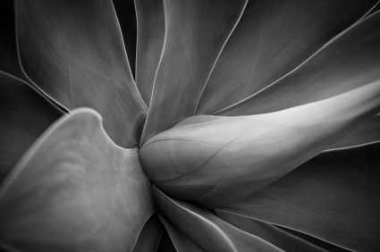

**Art Photography**

To define what fine art photography is, we first need to examine fine art. **Fine art** can be defined as including “those artworks that are created primarily for aesthetic reasons (‘art for art's sake’) rather than for commercial or functional use.” However, it should be noted that there are many different definitions for what fine art is. In reality the line between fine art and art for commercial or functional use can be a blurry one, even more so in the area of photography than some other forms of art. Fine art may be bought and sold, and in some cases may have some functional purposes. Thus, the distinctions between fine art and other “art” may be more subjective than objective.

Given this definition, what is fine art photography? One way of thinking about **fine art photography** is to think about it as photography that is created especially for the expression of beauty, contemplation, or commentary. In other words, it is photography that is created to record not only a moment, but also the emotion and beauty of that moment. We might think of fine art photography as the creation of a photo that captures the way the photographer sees a particular scene or item. As with general fine art, it is also usually produced just for art’s sake, although prints may be sold. You may be most familiar with the fine art photography that you encountered in a museum, art gallery, art fair, or even on the walls of your home. Many of the images that you would see in these places would be considered fine art photography.

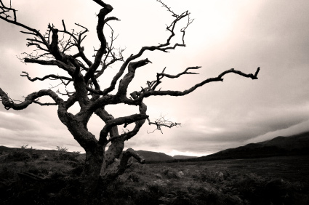

With modern technology, the distinction between fine art photography and mass-produced commercial photography is a slim one. For example, you might buy a photo in a store that has been mass produced, meaning that there are many copies of this print available for people to buy. Does a photo that is mass produced and marketed still qualify as fine art photography? Other photographers may produce a photo in a limited edition, meaning that only a certain number of the image will be produced so only a limited number of people could buy the photo. Does this make the image more of a fine art photograph than something that is mass produced?

In addition to the overlap between fine art photography and mass produced commercial photography, fine art photography also overlaps with other genres of photography. Fashion photography, nature photography, portrait photography, photojournalism, and black and white photography all overlap with fine art photography. These types of photographs may also be displayed in galleries and museums or sold in limited editions.

The beginnings of fine art photography can be dated back to the Victorian era. John Jabez Edwin Mayall is sometimes credited with being the first person to display fine art photography with his 1851 daguerreotypes illustrating the Lord’s Prayer. Other photographers helped to introduce photography to fine art museums. Today, thousands of fine art photographs are sold through auction houses, and the Internet has opened up opportunities for other photographers. There is a strong market for photographers who produce high-quality, limited edition photographs, although the number of individuals who fall into this category is small.

Since fine art photography can involve so many different subjects and styles, it is difficult to come to a precise set of guidelines. Instead, fine art photographers must know about the particular genres of photography that they practice. A strong interest in an area is often the foundation for strong fine art photography. In many cases, fine art photography is about capturing a particular moment in time. This can often involve waiting at a location and being ready to take that perfect photograph. At the same time, these images are often planned in the sense that the photographer carefully composes and plans for the photograph that he or she wants. Whatever the topic, fine art photography tends toward a dramatic, breathtaking image.

**The Presentation of Art Photography**

Museums and galleries are common spots for art photography exhibitions and presentations. While our focus is often on the photos themselves, the presentation of photography, whether on a gallery wall or in our homes, can enhance or detract from the photo. Perhaps you’ve seen this yourself in a photo that is overwhelmed by the frame that has been placed around it or a photo that is placed at an odd height on the wall. We may not pay attention to the presentation until it is problematic, but paying close attention to how we present photographs can help avoid situations where the presentation takes away from the impact of the photo.

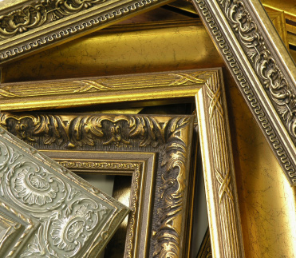

Before the mid-twentieth century, photographs displayed in galleries or museums were not framed. They were often mounted onto plywood or another backing, or they were printed with a white border and pinned at the corners to the display area. Due to these display practices, early photographs were rarely displayed behind glass. This can seem a little odd to us today since placing a photo under glass or other see-through material has become quite common in our homes, galleries, and museums. In the last decade, however, some photographers and sites have been going back to the traditional practice of displaying photographs without glass.

Art photographers often sign their prints, which helps to authenticate them and serves as an identifier for the photo. The signature may also be accompanied by the year that the photograph was taken and the number of the print, if it is a limited edition photograph. Each photographer has a different preferred method of signing, but there are some common patterns. Many photographers choose to create a print that is slightly larger than the actual photograph, particularly at the bottom of the photo. This creates a space for the photographer’s signature, which is usually found in the lower right-hand corner under the photo. The signature is often written in pencil, as ink can fade or change color over time. In addition or in place of a front signature, many photographers sign and date the back of their photographs. Some photographers add more information on the back of the print, such as the negative number or edition information.



Photographs for display purposes are generally printed on high-quality papers. Mounting and framing a photo often depends on the photographer’s preferences. Some choose to mount photographs behind glass, while others do not use glass, for example. The mats used should also be of a high quality and are generally matted to museum quality standards. Many photographers use temporary measures to attach a photo to a mat board, recognizing that the frame may need to be replaced or changed at some point in the future. Simple frames often work best for displaying photographs, and if more than one photograph is going to be displayed, matching frames can create a uniform look.

When displaying photographs in a gallery, museum, or other location, photographers should check with the location itself about any presentation guidelines that the location has. They may have guidelines on how many photographs can be displayed, the size of the photos, and the lighting that will be used. Generally, a simple, uncluttered display of the photos is often best. Many galleries feature photographs similarly mounted and framed in a single line, evenly spaced, at about eye level on the wall.

**Product Photography**

**Product photography** involves taking photographs of various products to be used for advertising purposes. This can include photographs of everything from grocery items to electronics to jewelry. Imagine if you were a businessperson with a product to sell. Regardless of whether you were a large company or a small home business, you’d need some way to show your product to potential customers, particularly if you are selling online. In these cases, companies and individuals often take product photographs to showcase the item that they are trying to sell. You’ve undoubtedly seen a product photograph, whether you were looking at an mp3 player online, a toy in a catalog, or a homemade scarf on a website. The picture below is a product photograph.

With so many items for sale globally and so many different ways of showcasing a product, product photography is in demand. However, the scale of product photography differs. Individuals handcrafting jewelry in their own home may learn to take their own product photographs for use on a website. Large companies may hire photographers either on a full-time or freelance basis to photograph products. In between these extremes are a wide variety of other situations for photographers. In some cases, product photographers may use their skills at photographing items for stock photography as well. For example, many of the same principles would be used to photograph food arrangements or individual items for stock photography.



To take good product photographs for advertisements or catalogs, there are a few things that photographers need to keep in mind. While many of the basic techniques and aspects of photography remain the same, product photography does involve a few aspects that you’ll want to pay special attention to in order to get the best photographs possible.

One aspect of product photography that is very important is the product itself. When photographing a product, it is important for the product to be presented in the best light possible. In other words, the product should be free of any defects and in good condition. In addition, you’ll want to make sure that the image is clear and uncluttered. Most product photographers use a tripod to ensure that the product images will be in focus and not blurry at all.

The background for product photography is often quite important. If you think about this for a moment, it makes perfect sense. The focus of the photograph should be on the item itself. A distracting background can distract from the product. The specific company that you are taking photographs for may have guidelines on the background that they want used, but a solid background is typically best. In fact, a great deal of product photography will take place with a white background, although there may be exceptions. Some jewelry, for example, is photographed on black backgrounds rather than white. One reason that white is often used for product photography is that it is easier to “cut” the item out in photo editing software such as Photoshop.

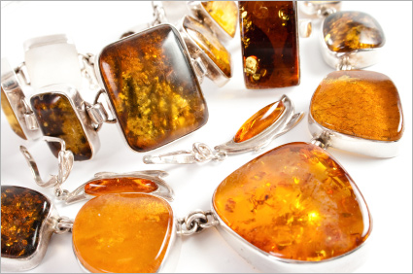

There are many ways to set up the background and display for the product. Some photographers use simple items such as white poster board or a white sheet. Other photographers build their own displays out of more permanent materials. Regardless of the material used (cardboard, fabric, foam, etc.), many photographers construct light boxes or light tents. **Light boxes or tents** are essentially three-sided boxes, with a top and a bottom, leaving one side open. The inside is often a uniform white color that will reflect the light and help reduce harsh shadows on the product. You can buy a premade light tent (some even fold up when you are done with them) or you can construct your own.

Lighting is another area of concern for product photographers. Harsh shadows or unevenly lit products are best avoided. Some photographers may make use of the natural light from windows, but most photographers use artificial lighting for product photography. The exact set-up will differ depending on the size of the object and the specific product. A light on each side of the product can help distribute the light, and some photographers use a third light in front of or behind the item as well. Some areas of product photography may use specially designed lights or set-ups to best represent the product. For example, jewelry photographers may use extra lights specifically designed to add luster and sparkle to gemstones.

To photograph the product, place the item several inches in front of the background. This helps to ensure that the product will not create harsh shadows on the background and allows you to place the background out of focus. Choosing to manually focus your camera on the product, particularly when dealing with small items, can help you get crisp, clear images. While a clear focus is important in many types of photography, it is especially important when dealing with product photography, where images may be used in different media and in different sizes. Imagine if you were buying an item out of a catalog or from an online site and the image was a little burry. You might overlook the item or you might go with a different product altogether if you couldn’t clearly see what the product looked like or what features it had.

**Stock Photography**

While product photography focuses on a particular brand or specific product, **stock photography** includes images that can be licensed for particular uses. Stock photography is used by web designers, advertisers, graphic artists, magazine editors, and others, particularly those working with online sites. When someone wishes to use a stock photograph, they generally pay a fee to license the image for a particular product, such as a brochure, for a particular amount of time. If they wish to use the image again in a different project, they may need to re-license the image for this different use.

Traditional stock photographs are often taken by professional photographers in studios. These photographers are generally well versed in the types of photographs that graphic artists and advertising agencies are looking for. They may use models posing as businesspeople and families or use them to illustrate a particular idea or emotion, such as freedom or anger. More than likely, you have seen images produced by a stock photographer online or in magazines.

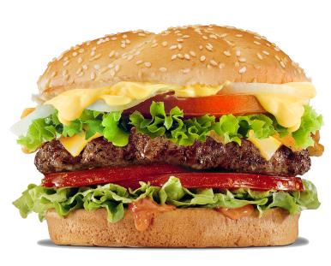

In addition to the traditional stock photographs, some photographers also produce what are known as microstock images. **Microstock agencies** are typically exclusively online, use a wider range of photographers, and use lower resolution images for much lower rates than traditional stock agencies. Whereas traditional stock agencies showcase the work of professional photographers, anyone can submit to microstock agencies, provided that their images meet the criteria that the microstock agency has set up. The area of microstock is a controversial one in photography. Some professional photographers feel that microstock images devalue the images that professional photographers produce, since they are offered at such a low price and can be submitted by anyone.

For photographers to be successful in stock photography, it is necessary for them to understand what stock agencies and the companies that buy the photos are looking for. Vacation pictures or snapshots taken on the fly generally are not good subjects for stock images. Stock photographers need to spend time learning what photographs are most popular. There are many books on stock photography, which is one way to learn more, and photographers can also look through the stock agency sites to see what the most popular images are. While you want to produce your own unique images, looking at examples can help you get a feel for the types of photographs that those buying the licenses are looking for.

Stock photographers generally spend a great deal of time planning and thinking about the photos that they make. Many stock photographs are meant to convey a particular concept, whether that concept is family, happiness, the first day of school, a job promotion, or something else. Each stock photograph has to convey the concept clearly so that viewers do not have to guess what the photograph is meant to convey. The process of creating a photo that conveys a concept clearly can take some practice and thought. Think about a photo that you’ve seen online or in a magazine. What concept or idea did the photograph convey? How do you think the photographer composed the photograph to convey this concept? One way to learn more about how to do this is to study examples of stock photography so that you can learn how to compose your own images.



While the concept is perhaps the most important aspect of a stock photograph, there are other aspects that photographers need to keep in mind for the photos. In general, colorful, bright images sell better than those that are less vibrant. Think about the photos that you see online or in magazines; not only do they have a concept, but they also grab the viewers’ attention. Attractive, well-composed images are valued by those buying the images. One difference between photojournalism and stock photography is that stock photography does not seek to show reality, but an ideal version of reality. For example, consider a first day of school photograph. Stock photography might show excited children in pressed school uniforms, eager to get to their first day of class. Photojournalism, in contrast, might capture anxious children, hurried parents, children who are wearing ill-fitting hand-me-downs, and school buildings in need of repair. While photojournalism may capture the reality of the situation, this image might not help sell a tutoring service, for example, or the concept of education that web designers and advertisers are looking for.

The technical aspects of stock photographs are important as well. Stock agencies are often concerned about the issue of noise. **Noise** is essentially the presence of color specks in areas where there should be none. For example, in a photo of blue water, colored specks of pink, purple, and so on might be present where they shouldn’t be. Noise can appear for different reasons, including using a high ISO, using a long exposure, or heat in the image generator itself. Stock agencies pay close attention to noise because if the photograph were to be enlarged, the noise would show in the enlargement. Higher-end cameras are usually better about eliminating noise from the beginning, although it does depend on the ISO and lighting conditions used. Noise reduction software can be used to help reduce the noise in an image.



Due to the high quality of images needed in stock photography, most stock photographers use a RAW file format to save their photographs. This ensures that if they need to do some image editing after taking the photo, they won’t lose any of the photograph elements that they might if they use a JPEG file format. In general, you’ll want to compose your photographs carefully to avoid drastic photo editing (unless you aim to do this from the beginning for a specific reason, such as creating an image using two different images).

Another issue to keep in mind when creating stock images is that you’ll need to obtain model releases from people who appear in the photos. If a person is recognizable in a photo that you plan to license, you’ll need to make sure that you have their consent to license their image. As discussed in a previous unit, individuals have the right to protect their own image, which is why you’ll need to obtain their permission to use the image commercially. In addition, it is important to remember that trademarks are generally excluded from stock photography. When photographing objects, then, you’ll need to make sure that the brand name or trademark does not appear. For example, you would need to be sure that people in a photo are not wearing a T-shirt or hat with a company name or trademark on it.

In this unit, we examined three different areas of photography: fine art photography, product photography, and stock photography. In doing so, we discussed some of the tips and techniques that photographers use in each of these areas, including how fine art photographs are often displayed, why a clear focus is important for product photography, and what are some of the guidelines for stock photography.