**Name:**

**Lab Partner:**

**Course: AP Physics**

**Instructor: Mr. Fallon**

**Period:**

**Date:**

**AP Lab #2- Acceleration of Gravity**

**Purpose/Problem:** To analyze the motion of a freely falling object and therefore determine its acceleration due to gravity.

**Hypothesis:** The acceleration of gravity will be determined to be ________ m/s2 (fill in the blank with the accepted value found in your text for the acceleration of gravity).

**Materials:** Photogate timers, Physics Stand, metal or plastic marble, marble dropping mechanism, ball catcher, meter stick

**Experimental Design & Procedure:** Two photogate timers that can be adjusted to fit along the vertical length of the Physics Stand and a marble dropping mechanism and ball catcher will be attached to a Physics Stand. Set up the timers, Physics Stand, and marble dropping mechanism as modeled by Mr. Fallon. Do NOT include, “as modeled by Mr. Fallon” in your formal lab write-up; rather your write-up needs to explain the details of your set-up as well as thoroughly explaining your procedure (such that a reasonably intelligent sophomore in Mrs. Wendling’s class could do EXACTLY the same thing as you using only your lab write-up and your equipment WITHOUT having to talk to you).

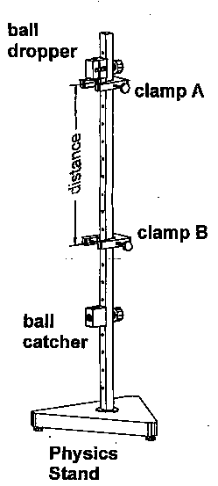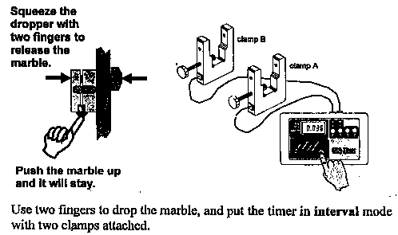

**Observations & Data:**

|  |  |  |  |  |  |
| --- | --- | --- | --- | --- | --- |
| Interval # | Displacement during current one interval (m) | Time duration for current one interval (s) | Average velolcity during interval (m/s) | Position at the beginning of each interval  (m) | Total Time  (s) |
| 1 |  |  |  |  |  |
| 2 |  |  |  |  |  |
| 3 |  |  |  |  |  |
| 4 |  |  |  |  |  |
| 5 |  |  |  |  |  |
| 6 |  |  |  |  |  |
| 7 |  |  |  |  |  |
| 8 |  |  |  |  |  |
| 9 |  |  |  |  |  |
| 10 |  |  |  |  |  |

**Analysis:  
NOTE**

Besides the other analysis elements you might include in this lab and write-up, be sure to compare your experimentally determined value for the acceleration of gravity to the accepted value (in Analysis #7). This is our first lab with an accepted "right" answer. In physics, when you are asked to "compare" two values or to find the relative error or the percent difference between the experimental result and the accepted answer, please calculate it in the following way (note the absolute value symbols—in physics relative error is typically reported as a positive value):

Relative Error = ׀ Experimental Result – Accepted Value׀ 100% X

Accepted Value

**The calculation should be shown in the Analysis section (not in the Conclusion). It should be referenced in the Conclusion.  
  
Analysis:**

1. Calculate the magnitude of the average velocity for each interval (show your work **here** in the analysis section not in the data table – if all calculations are the same, one sample calculation is enough, although more calculations are acceptable) and record the results in the data table above. Show all of your work for the calculation (you must write the equation EVERY time used, plug in values with units, and show answers for each calculation).

1. Calculate the position for the beginning of each interval. The position is determined relative to a point you define as the “zero” position. Be careful to reference all positions from that point. Also explicitly define the positive direction.

Record these values in the table (you do not need to show the work for this calculation).

1. On graph paper and in pencil, plot the positions at the end of each interval

(y-axis) versus time (x-axis). Again, make sure the graph has an appropriate title and that both axes begin at (0,0), have continuous and even scales, and are properly labeled (including units).

1. Draw the best-fit line or curve for the data on your graph. Describe the shape of the best-fit line for this graph. What quantity does the slope of the best-fit represent/indicate?
2. Linearize any curve found on your graph. Show both the original graph and the linearized graph. **(**Remember: DON’T connect the data points!)
3. Find the equation of your best-fit line and write it here. What is the value of the slope (include units)? S**how the slope calculation including both points from the best-fit line that were chosen.** What physical quantity does the slope represent? (Hint: Think of how this relates to the acceleration due to gravity.)
4. Calculate the percent error for the position versus time graph data. Use this to compare your experimental value for the acceleration due to gravity (obtained from the best-fit line on the graph) to the accepted value (from the book).
5. How could you use the velocity values in the table to determine the acceleration?

**Conclusion (Use the hints below but do NOT include them in your write-up):**

1. Remember, make sure that this is **at least** a six sentence, well-developed paragraph regarding what you conclude and have learned (or should have learned) from doing the lab. In this particular lab, it will definitely include a discussion about graphs and graph shapes and slope.
2. Always relate the conclusion to the purpose/problem and/or hypothesis (as appropriate/relevant). List all assumptions you made in determining the validity of your information.
3. Do **not** repeat procedure, observations, or data; rather, **conclude** (hint: look at your answers to analysis questions for good concluding thoughts; i.e., what did you learn from doing this lab)!
4. Do **not** include any "fluff" statements (if you want full credit) regarding your emotional responses to the lab or your lab partner. Do **not** tell me **that** you learned; rather, tell me **what** you learned!
5. Include, but do not ever limit your conclusion to, an error analysis. **Never** say, "Our error was probably due to 'human' error." **Never** say, "Our error was due to faulty equipment or using it incorrectly." These statements do **not** relate to error but rather incompetence and no one on my team is incompetent!
6. For each item listed in your error analysis, estimate how much the measurement varies because of it (the goal is to *quantify*). Your error analysis should allow the reader to redesign the experiment to be more precise/accurate based on your error analysis.
7. Use the passive voice. Never use the first person ("I") or the second person (“you”) or casual or flippant language in a lab write-up. These are formal write-ups of which you should be proud at the end.