**History of the Atom Project**

The atomic theory of matter is an excellent illustration of the process of science. Our understanding of the world around us is reshaped and refined with each scientific experiment. The first recorded idea of the atom comes from the ancient Greeks in the 400’s B.C. Over the millennia, scientific experimentation has added to our knowledge of the atom, redefining what it is and what its structure is like. In this project, your goal will be to learn about some of the highlights in the history of atomic theory to gain an appreciation of how we know what we know about atoms.

**Step 1:** This process involves research. Listed below are 14 scientists who all contributed to our current understanding of the atom. You need to find out who these people were and what they contributed to atomic theory.

Democritus Antoine Lavoisier John Dalton

J. J. Thomson Ernest Rutherford Robert Millikan Marie Curie

James Chadwick Max Planck Albert Einstein Niels Bohr

Louis De Broglie

Erwin Schrödinger

Werner Heisenberg

# Questions to answer in your research

1. When did they live? Where did they live?
2. What new information did they contribute to the understanding of the atom?
3. How did they find this new information? (What experiments did they do?)
4. Interesting facts – other accomplishments, personal information, famous historical events at the time, etc..

# Cite Your Sources!

You must hand in a bibliography with your project. This must be in proper works cited/bibliography format. (See the example shown below.) There are lots of websites that can help you make a correctly formatted citation. One good one is <http://www.easybib.com/>

Sample Citation (for an online source):

"A Science Odyssey: You Try It: Atom Builder." *PBS*. PBS, 1998. Web. 04 Nov. 2009.

[<http://www.pbs.org/wgbh/aso/tryit/atom/](http://www.pbs.org/wgbh/aso/tryit/atom/)>.

# Research Tips

Some of these scientists did experiments not related to atomic theory as well. If you search on the web form information, you might include searches about history of atomic theory, or “Niels Bohr atomic

theory” to help get fewer broad results. You can of course get good information by searching each name as well, but don’t forget to find out about their contributions to the atomic theory. Your textbook also has useful information about some of these scientists.

Here are a few useful websites to get things going.

<http://www.pbs.org/wgbh/aso/tryit/atom/>- scroll down to the bottom for links to scientists <http://www.ausetute.com.au/atomichist.html>

<http://chemistry.learnhub.com/lesson/3663-history-of-the-atomic-theory-i-ancient-times> <http://chemistry.learnhub.com/lesson/3687-history-of-the-atomic-theory-part-3> <http://www.visionlearning.com/library/module_viewer.php?mid=50>

**Step 2-T**his project is turning your research into a creative and informative project. This is the part where you use the information, making sure to avoid plagiarism by putting things into your own words. The type of project you will complete is called a RAFT (R = role, A = audience, F = Format, T = Topic). You choose one horizontal row from the choices below to complete. If you don’t see any options that appeal to you, talk to your teacher about designing your own. (A self-designed option must be approved by your teacher.)

# Role Audience Format Topic – Have fun and be CREATIVE!!!

|  |  |  |  |
| --- | --- | --- | --- |
| **Role** | **Audience** | **Format** | **Topic** |
| Science Writer at the New  York Times | Reader of the New York  Times Science Section | Series of Newspaper Articles | The ongoing discovery of  the atom |
| Science Historian | Students studying atomic history | Detailed Timeline | Important Figures and Events in the History of Atomic Structure |
| Author | Students in your high school chemistry class | Graphic Novel | Adventures of 2 or more Scientists listed above that includes their contribution  to atomic development |
| Video-Game Developer | Head Game Developers of Nintendo or Sony | Illustrated proposal for a new video game  (don’t forget to name your game) | A video game that will teach high school students about atomic  theory |
| Actors putting on a performance for the scientists at Fermilab | Scientists in the research community who are currently doing research on subatomic particles | Role-Playing | You will take on the persona of at least two of the scientists who contributed to the  development of the atom |

**Read the rubric carefully** to understand what content needs to be included in your project and how your project will be graded.

Newspaper articles – You could write one article per scientist, but it might be better to write fewer articles, each one focusing on a different time period. Make sure your writing is interesting; your reader shouldn’t want to put the newspaper down after the first few sentences. Make sure to use newspaper article format and be creative. (Read a science article perhaps for a better understanding of this.)

Timelines – Your timeline should be visually attractive and include pictures of each scientist as well as descriptions of their contributions to atomic theory. Organization and attractive layout are key.

Graphic Novel – You should write an illustrated story. Don’t forget a cover with the title of your novel. Remember, you need to make an interesting narrative that students would like to read that still includes all the required content. Turn your research into a story!

Video Game Proposal – Imagine you have to pitch a new video game to Nintendo or Sony. This is the proposal you would bring with you. It should outline the type of game, the objective of the game, and describe how the game is played. It should include some illustrated frames of what the game will look like on screen. Be creative about how you can incorporate learning atomic theory into a game! Remember, your proposal should make Nintendo or Sony want to make and sell your game.

Role Playing – Take on the persona of the scientists. You will give your performance to the scientists in our class. Be creative and fully take on the role of the scientists you have chosen. Limit the performance to 3-5 minutes and turn in a bibliography with the sources you used to research your scientist(s).

Name: Date:

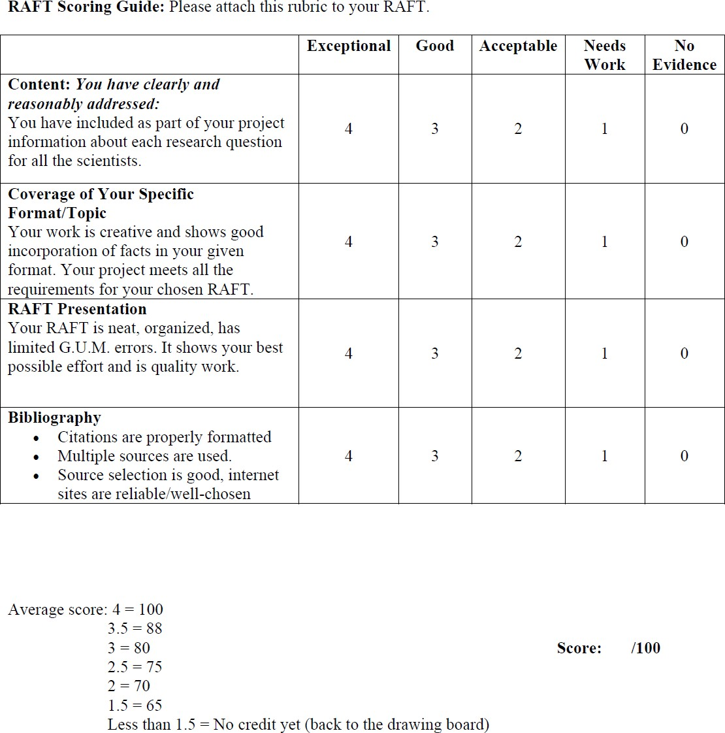

**/32**

**Various Graphic Novel Websites**

<http://www.collectionscanada.gc.ca/comics/027002-6000-e.html>

[http://www.getgraphic.org](http://www.getgraphic.org/)

<http://www.video.aol.com/video-detail/pixton-presentation-on-the-showroom-floor/107411>

[http://www.toondoo.com](http://www.toondoo.com/)

[http://www.pixton.com](http://www.pixton.com/)

[http://getgraphic.org](http://getgraphic.org/)

<http://www.wikihow.com/create-a-graphic-novel>

<http://comic-book-and-strip-service.com/creating-comics-2.html>

<http://www.graphicnovels.brodart.com/links.htm>

<http://blogs.sun.com/martinhardee/entry/design_comics_templates_1_0>

<http://www.cincinnatilibrary.org/spotlight/sp200601/websites.html>