RACE Graphic Organizer
Writing Prompt Question: 
R | Restate the Question  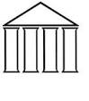 | * Did you restate the question in your own words?
A | Answer the Question   | * Does your answer to the question express a main idea (a point you are going to prove)?
C | Cite Evidence  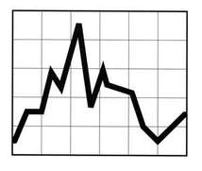 | *Identify Evidence from the text or an exact quote using the following sentence starters:  **According to the text, it states, “______________.”  **In paragraph__, it expresses, “__________”.  **In the text, it states, “_____.”  **On page__, it expresses, “___________.”
E | Explain the evidence and your thinking  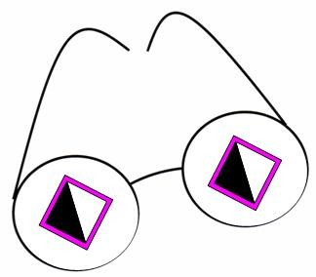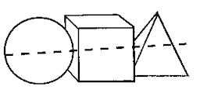   | Choose one of the following sentence starters:  - This evidence demonstrates…  - This evidence proves…  - This evidence tells me…  - This quote reminds me of…  Then provide 2-3 additional statements expressing connections, thoughts, and summarizing ideas together.

