You're about to learn how to write a great

Cover Letter.

But first, think about this:

It took weeks to find *this* job. It took hours to get your resume right.

Almost there. You just need a cover letter.

The problem?

You only get one shot.

You can’t just write a cover letter. It has to be perfect.

But… How do you write the perfect cover letter?

You know—the kind of letter that will make the employer call you up in the middle of the night?

Give us 10 minutes and you’ll know how to write a cover letter like that.

**This guide will show you:**

* How to write a cover letter better than 9 out of 10 others.
* A sample cover letter that will get you more interviews (and why).
* Cover letter writing tips and hacks to boost your chances of landing a job.
* Actionable ideas on how to start and end a cover letter, plus how to address it.

Ready? Take a look at this basic cover letter sample. What do you think makes it so special?

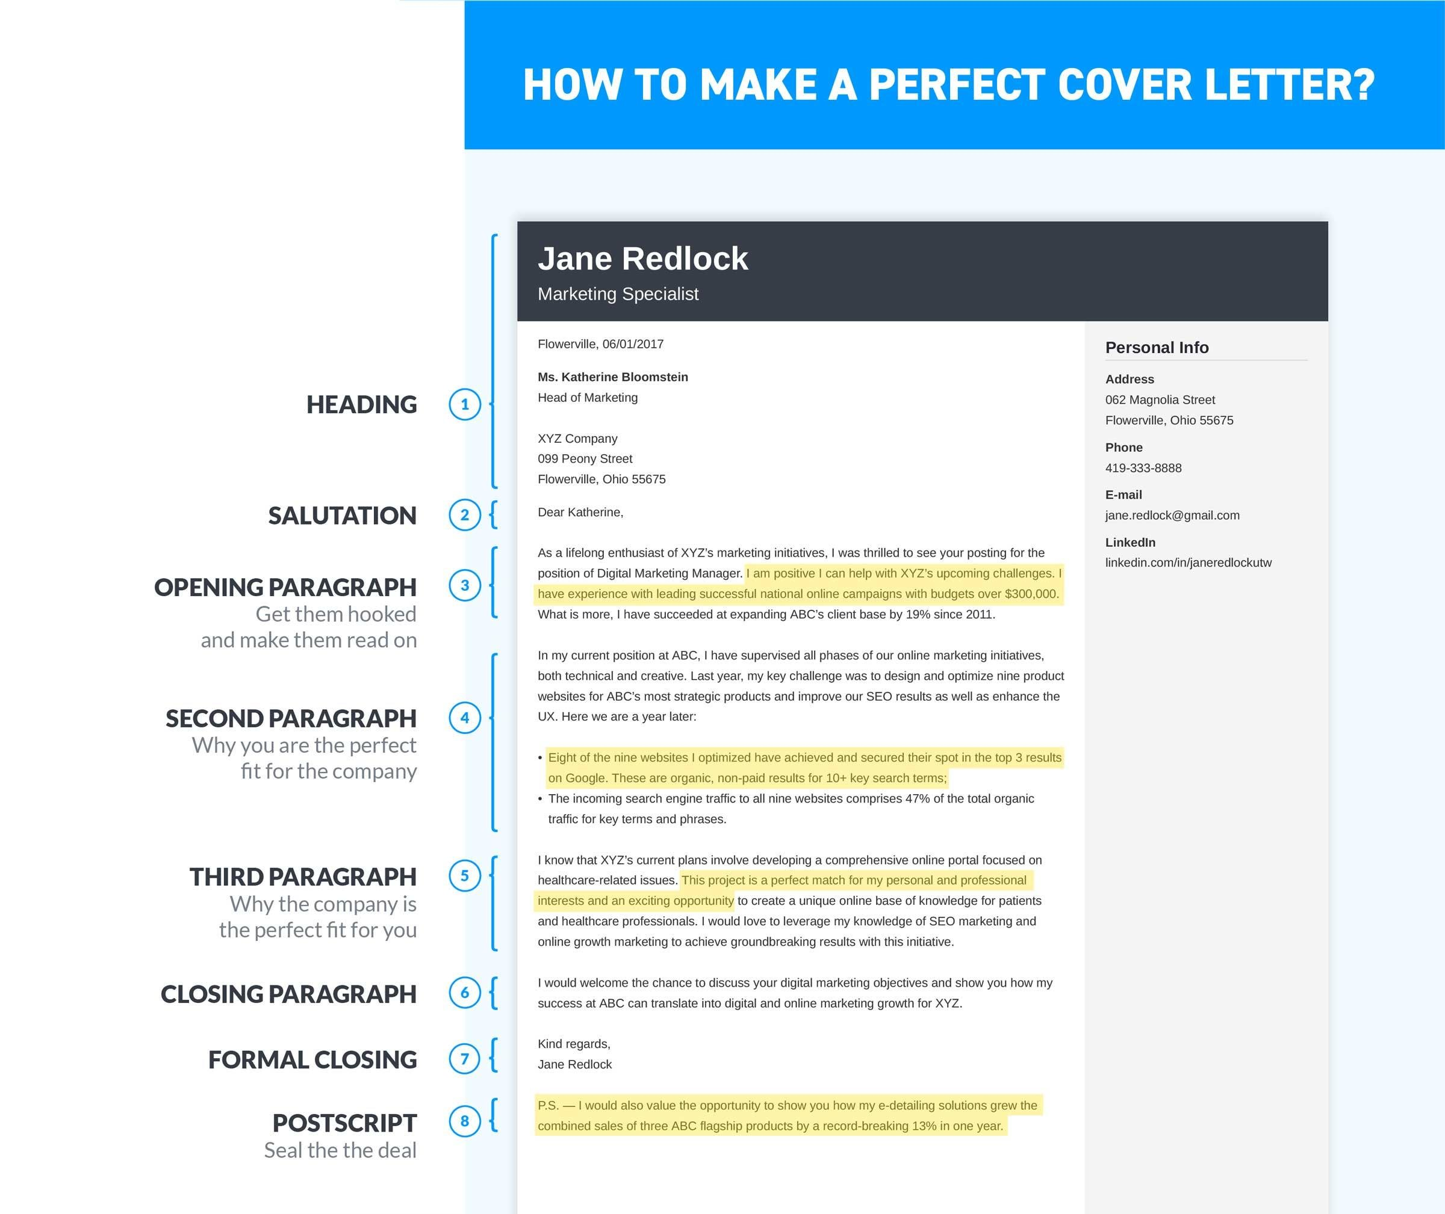

Read on! We’ll break down the formula in 8 simple steps.

Let's begin with the basics.

A cover letter (also known as an application letter or motivational letter) is a document which explains why you're sending in the resume and adds extra information. It used to literally serve as a cover for a resume (in a time when people still used paper and hunted mammoths).

Now—

All great cover letters have something in common: they’re based on a proven, effective template. Here’s what I mean:

Meet Jane, the candidate who wrote the cover letter above. She’s applying for a digital marketing manager position with a pharmaceutical company, XYZ Corp. The company is planning to launch a new flagship website.

Jane’s experience and knowledge make her a perfect candidate for this role. The purpose of her cover letter is to prove that she’ll be able to replicate her past success in the new position.

Right, so you’ve seen a perfect example of a cover letter for a job.

Now, let me explain what makes this sample cover letter great and how you can use this cover letter outline to make the most of each section.

Yup, the basics first. The header of every professional cover letter for a job application should include the following:

* Your name
* Your telephone number
* Your email address
* The date
* The name of the hiring manager and their professional title
* The name and address of the company to which you’re applying

Optionally, you can add:

* Your professional title
* Your home address
* Links to your professional websites
* Your social media accounts (applicable only for LinkedIn and Twitter)
* Your city of residence (it’s not mandatory but adds a professional touch—include it if your cover letter is highly official)

Just remember to keep it professional:

* Use an email address from a respected provider—that means either Gmail or your personal domain (if you have one.)
* Your email address should only include your first and last name—sexyvanessa@gmail.com or johnlikesgoats@hotmail.com will be deal-breakers.
* Don’t use your current work email. It’s impolite to both your current and potential future employer.
* Make sure your contact information is consistent across your resume, cover letter, and social media profiles.

**Pro Tip:** Writing a cover letter with no name of the hiring manager available? In the addressee section include only the name of the department: for example, “XYZ Sales Department.”

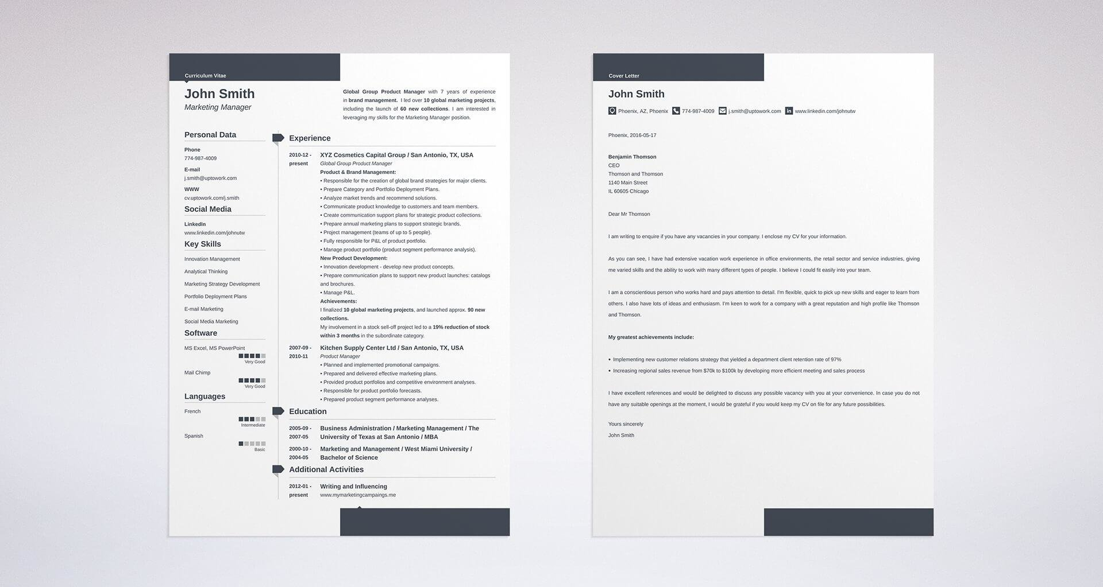

Resume and a sample cover letter for a job application

**Who do you address a cover letter to?**

Directly to the hiring manager who’ll read it.

The greeting of your cover letter (i.e., the salutation) might be the very first thing the hiring manager sees. There’s one great, foolproof strategy to make your greeting catch her attention:

Dear **Katherine**,

That’s right. Her name.

If we hear or see our name, we react. Focus on what comes next. There’s a lot of science behind this:

Once the hiring manager sees her name in the greeting of your application letter, she’s going to feel like she’s found something tailored specifically for her. It will feel personal, she’ll know whatever comes next might just be the exact information she’s been looking for.

All of the following are good examples of professional cover letter greetings.

**Sample cover letter greetings:**

* Dear Katherine,
* Dear Miss Jones,
* Dear Ms. Smith,
* Dear Mrs. Ford,
* Dear Mr. McConnor,

**Pro Tip:** Wondering whether you should use the hiring manager’s first or last name? That depends on the company culture. If you’re applying for a position with a relaxed, casual company, use the first name. For corporate cover letters, it’s safer to go with the addressee's last name.

**How do you find out the hiring manager’s name?**

Do some research!

There are multiple ways to find out who your hiring manager is.

If you’re unable to find the name by any means possible, you’ll need to write a cover letter to whom it may concern.

**Who to address a cover letter to if there’s no name of the hiring manager provided?**

Have a look at those sample cover letter to whom it may concern greetings:

* Dear Sales Team Hiring Manager,
* Dear Hiring Manager,
* Dear [XYZ Company] Team,
* To Whom It May Concern

**Pro Tip:** If you’re not living in Victorian England, don’t start a cover letter with “Dear Sir or Madam.”

Done with the header and greeting? Now it’s time for the meat and potatoes. The central paragraphs of your cover letter.

How to get them right?

**Go for the three paragraph cover letter format:**

* The first paragraph to grab the hiring manager’s attention
* The second to show what you’ve got to offer
* The third to prove that you’ll fit in

Want to learn more about best professional cover letter formats?

Now, have a look at a quick breakdown of the cover letter main body.

Here’s the brutal truth:

These few sentences at the beginning of your cover letter will determine whether the hiring manager will read on.

You need to make your cover letter introduction attract and hold the hiring manager’s interest.

**Have a look at these two sample cover letter opening paragraphs:**

### ****How To Make a Cover Letter—Opening Paragraph****

| **WRONG** |
| --- |
| In response to your posting for the Digital Marketing Manager, I would like to express my interest in taking part in the recruitment process. As a digital marketing manager with 8+ years of experience, I am positive that I would be successful at this role. |

Why is it so bad?

Because it provides no value and no details. The bottom line is basically “I’ve already done this job so I think I’d fit in.” That’s not what the hiring manager is looking for.

Now, see a properly written cover letter opening example:

| **RIGHT** |
| --- |
| As a lifelong enthusiast of XYZ’s marketing initiatives, I was thrilled to see your posting for the position of Digital Marketing Manager. I am positive I can help with XYZ’s upcoming challenges. I have experience with leading successful national online campaigns with budgets over $300,000. What is more, I have succeeded at expanding ABC’s client base by 19% since 2011. |

“Wow, I’d have to be a lunatic not to hire her!”

That’s the response this cover letter first paragraph will bring.

There are a few different, effective strategies for your cover letter opening. You can highlight your achievements, show how well you know your prospective employer’s needs, or base the intro on your enthusiasm.

Even professional writers struggle to make a perfect intro to their pieces. We know that starting a cover letter can be daunting, that’s why we’ve put together a dedicated guide for you. Give it a read:

You see a job posting from your dream employer. The name of the job is the same as your current position. You’ve been a very successful professional so far.

This means, to get that job you just have to show off your best assets in your application letter, right?

**Wrong!**

Your cover letter is not a trophy case.

So—

**What to write in a cover letter’s second paragraph?**

You need to get the hiring manager exactly what she’s looking for. You have to show that you’re going to satisfy the company’s specific needs.

Remember Jane, our digital marketing manager candidate? The XYZ company to which she’s applying needs:

* First of all, **a savvy digital marketing manager (1).**
* And, on top of that, **someone who will supervise the development of their new online portal (2).**

Let’s have a look at how Jane managed to show that she’s both **(1)** and **(2)**.

### ****How To Make a Cover Letter—Second Paragraph****

**Sample cover letter for a job application in digital marketing:**

In my current position at ABC,**I have supervised all phases of our online marketing initiatives, both technical and creative (1)**. Last year, **my key challenge was to design and optimize nine product websites for ABC’s most strategic products and improve our SEO results as well as enhance the UX (2)**. Here we are a year later:

* **Eight of the nine websites I optimized have achieved and secured their spot in the top 3 results on Google (2)**. These are organic, non-paid results for 10+ key search terms;

* **The incoming search engine traffic to all nine websites comprises 47% of the total organic traffic (2)** for key terms and phrases.

See how it’s done?

In the first sentence, show that you’re an expert in your field. But don’t keep on bragging. The remaining part of your cover letter’s second paragraph should be all about how your previous experiences will help your future employer press ahead with their plans.

*Job seekers impress employers by identifying transferable skills related to new positions. People often apply to new positions, so it’s likely you’ll not have the exact experience requested. But employers would rather know how your past experiences will inform future decisions. You were a hostess? Relate those management and organizational skills to the Executive Assistant position.*

***Lauren Little***

*Career Coach*

What if you’re creating a cover letter for an internship and don’t have a wealth of professional experience to present? Don’t worry, we’ve got a dedicated guide to show you how to write a good cover letter and land your dream internship:

Your future employers have needs. If they’re willing to hire you, it’s because they think you’ll satisfy those needs.

But what they also want is for you to actually enjoy working with them. They want your future job to feel rewarding to you—that way, they know you’re more likely to stay with them for a longer period of time.

The key to writing a perfect cover letter third paragraph is showing the hiring manager why you want this job, not just any job.

**Here’s the easiest way to do it:**

* Start with a company fact—for instance, an upcoming project **(1)**
* Say why you find it interesting **(2)**
* Reiterate that your experience and knowledge will let you succeed with the project **(3)**

Have a look at this cover letter example:

### ****How To Make a Cover Letter—Third Paragraph****

I know that XYZ’s current plans involve **developing a comprehensive online portal focused on healthcare-related issues (1)**. This project is a perfect match for my personal and professional interests and an **exciting opportunity to create a unique online base of knowledge for patients and healthcare professionals (2)**. I would love to leverage my **knowledge of SEO marketing and online growth marketing to achieve groundbreaking results with this initiative (3)**.

Pro Tip: [How long should a cover letter be?](https://zety.com/blog/how-long-should-a-cover-letter-be) In general, relevant and short cover letters are best. Three paragraph tops. Your go-to word count shouldn’t exceed 300 words.

Wondering how to write a good cover letter for a job application when there’s no job offer? Want to see some general cover letter writing tips? Read our handy guide, and find out about effective cover letter strategies for different types of cover letters!

So far so good:

Your cover letter shows that you have relevant skills. You’ve explained your motivation. What could possibly go wrong?

Actually, a lot.

You still have a cover letter ending to write. And it’s the decisive part.

It has to amplify the general impression you’ve made with the previous paragraphs. It has to make the hiring manager excited as she starts reading your resume.

How to make the best cover letter ending?

Long story short: by providing value.

Tell the hiring manager that you’re looking forward to meeting in person and discussing **how your experience and knowledge can help your future employer in fulfilling their goals**.

Like in this cover letter example:

### ****How To Make a Cover Letter—Closing Paragraph****

Two worst cover letter mistakes you can make in the final paragraph are:

1. Coming off needy—focusing on how much you want the job, not on what you have to offer.
2. Repeating the cliched phrase “Thank you for your consideration and your time.”

 There are some easy tricks you can use to write an effective cover letter closing paragraph. Make sure to read our guide and check them out!

Once you’ve written the body of your cover letter, you just need to put a formal closing at the very end.

Write “sincerely” and follow it with your full name. Adding your handwritten signature is optional, but it’s recommended for more formal cover letters.

If you’re not a fan of the well-worn, “sincerely,” feel free to use any of the following synonyms:

**Sample cover letter sign-offs:**

* **Thank you,**
* **Best regards,**
* **Kind regards,**
* **Sincerely,**
* **With best regards.**

The ones listed above are going to be your safest bets. Still not what you’re looking for?

**Have a look at some alternative cover letter sample salutations:**

* Thank you for your consideration,
* Regards,
* Sincerely yours,
* Yours truly,
* Respectfully yours.

**Pro Tip:** It’s a good idea to repeat your basic contact information, such as your LinkedIn profile, email address and telephone number below your sign-off.

All of the above sections are must-haves in a good cover letter format.

But there’s one special trick you can use:

The postscript.

Why is the “P.S.” so important?

Because it’s like a magnet for the hiring manager’s eyes. It screams: “you cannot miss this information.”

Use the postscript to**tell the hiring manager about something impressive about your career (1)**, even if it’s not strictly related to the job opening.

**And say that you’d be happy to provide them with more details (2)** if they find it interesting.

Like in our cover letter example:

## ****Takeaway****

All good cover letters are based on a similar, proven template. To write a cover letter that gets you the job, follow the 8 steps we covered:

1. Create a professional header with your info.
2. Address the hiring manager by name.
3. Show relevant achievements to introduce yourself in the first paragraph.
4. Target the employer’s needs and prove you can help in the second paragraph.
5. Explain why you want to join and convince the employer you want to stay in the third paragraph.
6. Reiterate your offer and make a call to action in the final paragraph.
7. Sign off with a proper formal closing and your full name.
8. Include one more achievement in the postscript to stand out.

And for the final advice:

Keep it short.