**Chino High School**





CHOMP is actively looking for contacts in the areas of culinary, hospitality, and tourism. Students within our academy explore various career opportunities and we are looking for contacts that can provide students with real-life experiences. Industry contacts can help to provide students with guest speakers, demonstrations, and field trips. Furthermore, any industry contacts that can help to provide our upperclassmen with job shadowing and internship opportunities are greatly needed and highly appreciated.

We Can Use Your Help!

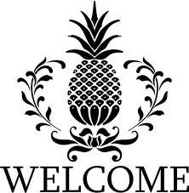

MAIN OFFICE: (909) 627-7351

5472 PARK PLACE

CHINO, CA 91710

http://www.chino.k12.ca.us/chinohigh

**CHOMP** is a member of



Linked Learning is an approach that is transforming education for California students by integrating rigorous academics with career based learning and working experiences. Linked Learning ignites high school students’ passions by creating meaningful learning experiences through career-oriented pathways in fields such as engineering, healthcare, hospitality, performing arts, law and more. When students love what they are learning, they work harder, dream bigger, and learn more.

Chino High School does not discriminate on the basis of race, color, national origin, age, religion, political affiliation, gender, mental or physical disability, sexual orientation, or any other basis protected by federal, state or local law, ordinance or regulation, in its educational program(s) or employment.



The culinary and hospitality sectors provide students with the academic and technical preparation to pursue high-demand and high-skill careers in these related and growing industries. The foundation standards, along with the common core state standards, include core, comprehensive technical knowledge and skills that prepare students for learning in the food service and hospitality pathway. In addition, these standards are designed to prepare students for technical training, postsecondary education, and entry to a career.

Mission Statement

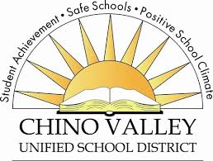

Academy of Culinary, Hospitality, and Tourism

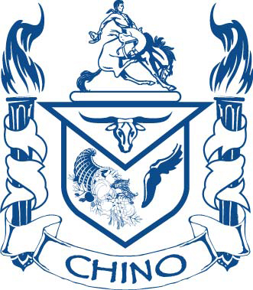

An Academy Preparing Students to Enter the 21st Century Work Force