Digital Photography Semester 1

**Unit 5**

Lighting

“Photography is all about light, composition and, most importantly, emotion.” ***–Larry Wilder***

Photography is all about light, as without light, we would not be able to take a photo. Every photo is essentially a record of the pattern of light in an image. Even on the darkest night, a photo is created by the light available. For photographers, working with light and adapting it in a variety of ways is what helps them produce the images that capture our imagination and show us places that we’ve been. Lighting can make or break a photo; thus, understanding light is the key to strong photography. In this unit, we will explore the different elements of lighting.

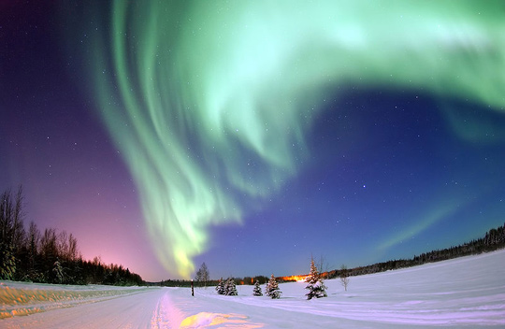  
****Eielson Air Force Base, Alaska—The Aurora Borealis, or Northern Lights, shines above Bear Lake****

As you work with lighting, you’ll find that the type of light on the subject can have a large effect on the photo. The direction, quality, color, and amount of light all influence the photo. We may be tempted to think of light as something we either have or don’t have, but the reality is that natural light changes each hour, from season to season, with the weather, and in different parts of the world. All of these factors influence the direction of the sun, its intensity, and the color.

In terms of lighting, three common terms are used to identify the direction of the light on the subject. Each of these directions creates a different effect on the subject, in both positive and negative ways. **Frontlighting** occurs when the sun is at the back of the photographer. In other words, the light is directed toward the side of the object that the photographer is taking the picture of. Putting the sun at your back to take a photo is a common piece of advice. However, it does not always produce the best photo. Using frontlighting can create a photo with a flattened appearance. This means that the details and depth of the photo are obscured due to the direction of the light. The 2-dimensional image that is created tends not to be a great photo for these reasons. Putting even a little bit of an angle in the sun on the subject will often create a more 3-dimensional image with more detail and depth.

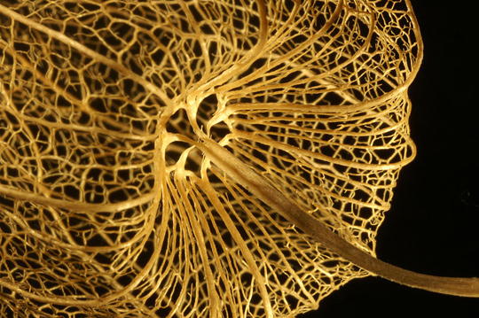  
****Sidelighting of a Physalis****

**Backlighting** occurs when the light source is behind the subject. This can be used to create a silhouette effect. In some cases, it can be useful for portraits, as it reduces the need for the person to squint. However, if the subject is backlit, a fill-in flash or reflector is often needed to eliminate the shadows on the person’s face. It is also important to make sure that the light doesn’t fall directly onto the lens. Some photographers use lens hoods to shield the lens from the sun.

**Sidelighting** happens when the light source is at an angle to the subject. This can create some interesting shadows and effects in the photo, and the technique is often used in black and white photography. Sidelighting can be particularly useful in situations where you want to highlight the details in something.

Existing Light Photography

**Existing light photography** is photography that only uses light already present in the scene. This can include light from the sun, lamps, candles, or neon lights. In other words, it is photography in which the photographer does not add any additional light to the scene through flashes or other types of light. Using natural or existing light tends to create more natural-looking photos. It is also beneficial because it allows you the greatest amount of freedom. If you are using artificial lights, you are constrained by the lights. In other words, you need to rearrange the lights if you want to shoot from a different angle or change the photo. Existing light gives you the ability to move around. Not all positions will be the best for the photo, but you’ll have more options when shooting in existing light. For example, you can shoot subjects farther away, such as landscapes, since you don’t need to worry about the artificial lights illuminating the scene.

  
****A storm at Pors-Loubous, France****

When taking photos indoors with existing lighting, such as fluorescent lights, it is important to keep in mind that the colors may not come out as you see them. To our eyes, the scene may seem fine. However, fluorescent lights tend to emit less red right, which can give the photo an unnatural greenish tint. The lights can also cause dark shadows under people’s eyes in photos. With film cameras, using filters can correct the color. For digital cameras, adjusting the white balance can often correct these issues.

Photographing in Natural Light Outdoors

Taking photos outside means that you’ll generally be using natural light. Although natural light can create some breathtaking photos, it does have its challenges. To take good photos outdoors, you’ll need to keep in mind the time of day, the direction of the sun in relation to your subject, when to use flash, and how to take advantage of “bad” weather days.

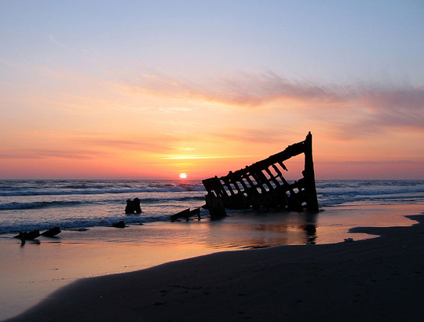  
****The wreck of the Peter Iredale in the Fort Stevens State Park, Oregon. Ran aground in 1906.****

While the bright noonday sun seems as though it would be the perfect lighting condition for photos, it is often one of the worst. At midday, there are very few shadows, and those that do exist are often quite harsh. The light at midday also tends to be a harder, harsher light as well, creating unflattering shadows in the picture. As the day goes on, the light usually becomes softer and warmer. Taking portraits, then, is often best accomplished later in the day, as this light will add warmth to the photo. The “color” of the light will also change throughout the day. Early in the day, the light tends to be yellow, turning bluer toward midday. By later in the evening, the light has a more orange tone before becoming a dark blue in the overnight hours. Typically, the best times for photography are early morning and late afternoon.

It may be tempting to head inside if the weather is cloudy and overcast. However, these days can be some of the best for taking outdoor photos. An overcast day is often a great day to take a portrait, as there will be fewer harsh shadows and the individual will not need to squint during the photo. Similarly, photos of flowers often turn out well on overcast days, particularly lighter colored flowers. Even if it is raining, you can still take some interesting photos, as the water will highlight the light around it. You can also gain a different feeling in the photo from rainy days than you would from sunny days. Between the rain, puddles, umbrellas, and other signs of a rainy day, you can create a different mood. One thing to keep in mind when taking photos on a wet day, however, is to protect your camera from the water.

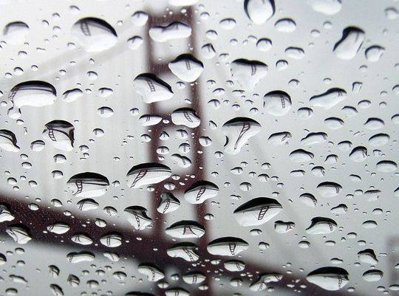  
****The Golden Gate Bridge refracted in rain drops acting as lenses****

Many times, though, you will not have the choice of when to take a photo. This means that you’ll have to make do with the light that is available to you. The more you practice taking photos at different times of day and in different conditions, the more you’ll be able to see the difference in the light. The particular position of your subject will also depend on the type of photo that you are taking. For example, a photographer may choose to use sidelighting for a portrait of a person, but may use frontlighting for a picture of an animal or a building to show more detail. In time, you’ll learn to make decisions about the light and the placement of your subject in relationship to the light.

If you do have the option to plan when you will take a photo of a particular subject, you may want to keep some of the following in mind:

• A calm day is better for capturing reflections on bodies of water such as lakes or ponds. Windy days will create more waves or ripples, which will reduce the effect of the reflection.

• The late afternoon or early evening sun can create softer light that is great for photos. The late afternoon light can also create a more romantic mood and feeling in a photo.

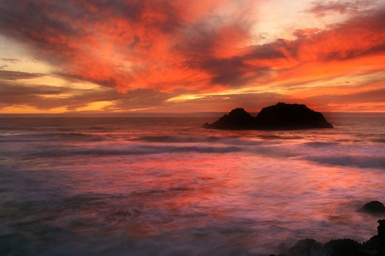  
****Sunset from Sutro Bath at Land's End in San Francisco****

• If you need to backlight an item or a person, get as close as you can to the subject to minimize the background. You may also need to use the fill-flash on your camera to light up the front of the person or item in relation to the brighter background.

• If you are photographing an item with texture and you want this to stand out, try taking the photo in the late afternoon with sidelighting. This will tend to highlight the texture and make it more noticeable.

• Use elements within the environment to reflect light to the subject. White buildings, cement, and other lighter colored objects can act as reflectors to direct some light toward your subject. This can create more light and help eliminate shadows. You can also create your own reflectors, such as a white bed sheet or aluminum foil, or you can buy reflectors to help direct the light to your subject.

• Try turning off the auto mode if you aren’t getting the quality of photograph that you want in terms of light. Switching from auto mode to one in which you can control the aperture and/or the shutter speed can help prevent an over- or underexposed photo due to the lighting conditions.

Photographing in natural light can create some beautiful photos of people, landscapes, and other objects. Practicing with different lighting conditions can help you learn to best use natural lighting in a variety of settings and photos.

Studio Lighting

Dealing with artificial lighting can be overwhelming for beginners. Not only are there questions about what types of lights to use, but there are also decisions to be made about where best to position the lights. As with natural lighting, the wrong lighting angle or position can create unwanted shadows or give the photo a feel that you don’t want.

Imagine for a minute that you are preparing to take a portrait of someone indoors and have only your camera flash for the lighting. What kind of picture do you think you’d get? Since flash lighting on its own can be somewhat harsh and bright, you would probably wind up with shadows on the wall or background behind the person. You may also find that the person’s eyes are red. Finally, the image is likely to be rather flat and two-dimensional. For these reasons, photographers working in a studio typically use artificial lights to help eliminate these problems and create more pleasing portraits and photos of objects.

Why is it important to use lights in a studio for portraits or taking pictures of specific objects? The best answer is that using artificial lights in the studio setting allows more control and flexibility than trying to use the light through a window or other source of sunlight. With artificial lights, the photographer can adjust the lighting to eliminate shadows or to create various effects within the photo. This lighting also means that a subject can be moved around and placed in different positions for the portrait.

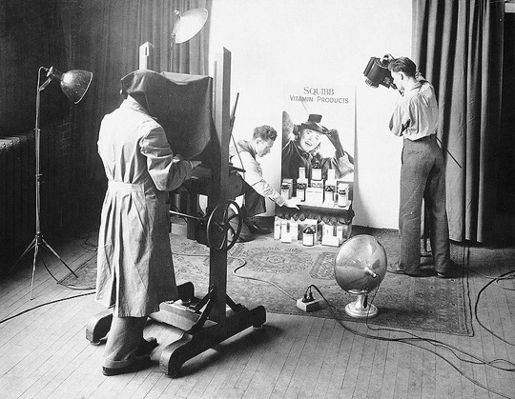  
****The Peake & Whittingham photography studio at 159 Elm Street,****  
****just west of University Avenue in Toronto, Ontario, Canada****

At the basic level, there are two different types of artificial or studio lights: continuous and flash lights. **Continuous or constant source lights** are those that remain on. They include lamps, fluorescent lights, and other lights that remain constantly on, like the lights in your home that remain on until you turn them off. Continuous lights are relatively inexpensive to use, and you can see the shadows and highlights that they will make on the subject of the photo before you take the photo. However, continuous or constant source lights also have several drawbacks. One is that the light is not balanced to daylight, so you need to adjust the white balance on your camera to correct the colors in the photo. Another problem is that these lights tend to become warm, which can be uncomfortable for both you and the person that you are photographing. While continuous lights can be used within a studio, most photographers choose alternative lighting.

The second main type of studio lights is **flash lights**. These are lights, like the flash on your camera, that only emit light when you tell them to. Flash lighting is also known as **strobe lighting**. In fact, many photographers use flash lighting to refer to smaller, battery-operated flash lights and strobe lighting to refer to the larger units in the studio that are plugged in. There are several different advantages to using flash lighting indoors:

• Strobe lighting tends to be consistent. In other words, the light that is produced from flash lighting will be the same on the first photo as it is on the thousandth photo. Unlike natural light that can change throughout the day or continuous lights, which can become more yellow as they age, flash lighting remains consistent.

• Strobe lighting can give you a great deal of light, without getting hot, and without needing a lot of lights. Imagine trying to light a room for a photo with just floor lamps. It would probably take several to get enough light to take a good photograph. Flash lighting produces more light in just a fraction of a second.

• Strobe lighting can be controlled and adjusted. Even inexpensive units generally have some variance in the amount of light that is emitted, allowing you to adjust the light for your needs.

Due to these advantages, most photographers choose to use strobe lighting within studios. These lights usually offer photographers the best lighting conditions for portraits and other studio work.

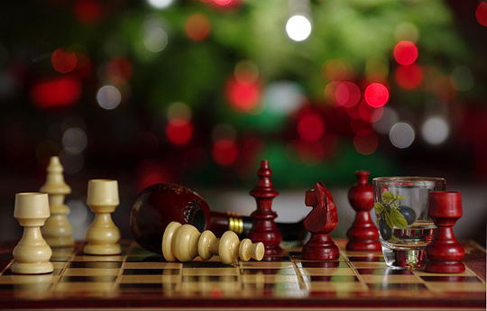  
****Strobe 540FGZ full manual mode at 1/32 coming from top camera right in a large white umbrella****

One type of light that can be either continuous or a strobe is a softbox. **Softboxes** are lighting devices that enclose the lighting source in a “box” with reflective back and side walls and a front diffusing material, where the light passes through. Some softboxes also have a layer of diffusing material inside. These devices come in a range of different shapes, including square and rectangular. Although rectangular ones are the common, most smaller softboxes are square-shaped. Other shapes are possible as well, including an eight-sided box called an octabox. Softboxes create a soft light on the subject of the photo, since the light is diffused through the diffusing material. By angling the softbox slightly away from the subject of the photo, which is known as feathering, you can create an even softer light on the subject. Small softboxes can generally be purchased for under $100; larger units are more expensive.

The light that comes from strobe lights can create strong shadows, and without other accessories, it is often too strong. To compensate for this, most photographers use accessories like umbrellas to help control and soften the light. A photography umbrella looks exactly like an umbrella that you’d use to keep you dry in the rain. In general, the larger area that a light is spread out over, the softer it will be. Attaching an umbrella to the strobe light makes the light bigger when it flashes, which softens the overall effect. There are two different types of umbrellas: shoot through and bounce. With a shoot through umbrella, the light is aimed through the umbrella at the subject, as with a softbox. With a bounce umbrella, the light is aimed into the umbrella, but the umbrella bounces the light back toward the camera and the subject behind it.

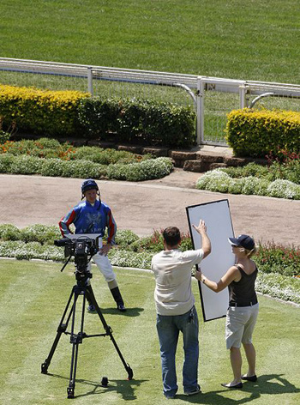  
****Videographer placing a fill reflector with assistant****

Umbrellas generally come in several different colors. Silver umbrellas create a sparkly type of light that work well for portraits of younger individuals. These also tend to be the most reflective. White umbrellas with black backs create a soft light for portraits of babies and are also good for general use. The black backs keep any light from passing through the umbrella so all of the light comes back toward the subject of the photo. Finally, translucent umbrellas create a soft light when used in the regular way and can be turned around, with the light passing through the umbrella, to diffuse the light, such as a window might.

Reflectors are another useful photography accessory. A **reflector** is any object that reflects light back toward the subject of your photo. Reflectors can be used with any camera in order to get a more professional look, even by cameras that do not have a flash on the camera. Typically, reflectors are either held in place by an assistant or attached to a stationary object, such as a stand. They are often placed at an angle about the same distance from the camera and the subject. The idea behind a reflector is simply to reflect some light into areas of a photo that are in shadow or are darker than desired.

Reflectors come in a wide range of shapes and sizes and many can be folded up when not in use. The size and shape differences affect the amount of light that is directed toward the subject. Although you can buy reflectors specifically designed for studio photography, many photographers use various items that are commonly available as reflectors, such as poster boards or white walls. It is important to note that the color of the reflector will influence the light sent to the subject. For example, using a gold reflector will create a warmer light, while a blue reflector will have cooler tones. White is neutral and doesn’t affect the color of the light; silver is also neutral, although the light will be brighter than with a white reflector.

If you think back to the earlier discussion of taking a photo in a studio without any external lights, imagine the photo with its harsh shadows and red eye. Using the equipment and accessories that we’ve discussed, you can take that photo and turn it into a beautiful portrait of someone. Let’s take a few minutes to discuss how you might do this.

When setting up a studio, you will probably have some sort of backdrop behind the person whose photo you are taking. Although you can buy professional backdrops, you can also create your own out of fabric, sheets, or other items. In front of the backdrop will be the person that you are taking the portrait of. In front of the portrait subject is the photographer. With this lineup, where do the lights and other accessories go?

The first item that you’ll want for the portrait is a light to help light the person without having to use the camera flash, which can create the harsh shadows. By placing the light off to one side and angled at the person, you’ve created softer shadows and more of a 3-dimensional image of the person. While this is a good start, the angle of the light will mean that one side of the person’s face will receive more light than the other. In some cases, this may be the look that you are going for with the photo. In other situations, however, you’ll want to have both sides of the person’s face lit up.

One easy solution to this problem of having one side lighter than the other is to put a reflector on the other side of the person, opposite the light. You will want to adjust the reflector until you get just the right amount of light reflected back at the person. You can move the reflector forward and backward to vary the amount of light and move it sideways to find the right angle for the light on the person. Alternatively, you might place another light on the opposite side of the person, although you will need to make sure that there is not too much light coming from the two sides of the person. Using softboxes on each side would diffuse some of the light, but regardless of what you do, you want to control the amount of light. One way to do this is to use an umbrella and bounce the light off the umbrella toward the person. This will spread the light out and soften it, which is often desirable for portraits.

This set-up is a great start for creating a studio photo. From here, you can play around with more lights and other arrangements to light your subject. For example, you might place a light that is directed toward the person’s back. This will help create an even more 3-dimensional look in the photo and will help distinguish the subject from the background. This also helps to make the background look more dynamic and interesting behind your subject. This light can also be placed directly behind the person to give hair a softened look and to show even more the form of the individual.

Another way to arrange the lights is to place one light off to the side with an umbrella and have another light near the camera in the front. With a front camera, you will want to use a shoot through umbrella or another way of diffusing some of the light. For example, a softbox would also work in this circumstance.

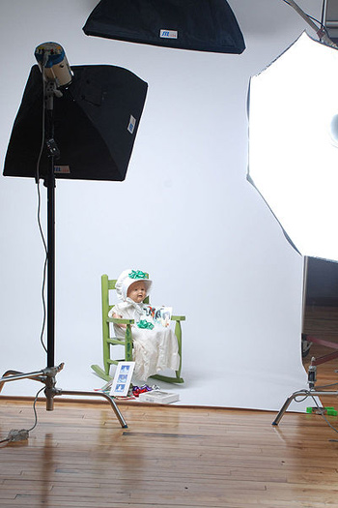  
****Example of a photographic studio setup: main through a dark umbrella 45 degrees from subject.****  
****Fill, using a soft box, almost straight on. Hairlight (softbox) lighting the back of the screen for definition.****

When working with studio lighting, you will want to make sure to turn off your camera flash. The other lights that you’ve set up will be what you will use. In addition, you will want to set the white balance to the tungsten light setting and set the ISO a bit higher than what you would for outdoor photos. Another tip is to use a tripod for the camera. This will eliminate a great deal of the possible camera movement and increase your chances of getting a clear photo. Once you begin using studio lighting, you’ll also want to begin learning to use a light meter, which will help you determine whether you have the right amount of light and also help you set the controls on your camera with this information.

Studio photographers often spend more time arranging their lights and looking for the best lighting situation than they do adjusting their camera. Why? Light is so important for each photo. You may find that the lighting on one portrait will be different from the light that you want on another portrait. Over time and with practice, you can learn to adjust the lighting and find arrangements that work for you and the people that you are photographing.