**Name Period**

**Chapter 23: The Evolution of Populations**

This chapter begins with the idea that we focused on as we closed the last chapter: Individuals do not evolve! *Populations* evolve. The Overview looks at the work of Peter and Rosemary Grant with Galápagos finches to illustrate this point, and the rest of the chapter examines the change in populations over time. As in the last chapter, first read each concept to get the big picture and then go back to work on the details presented by our questions. Don’t lose sight of the conceptual understanding by getting lost in the details!

***Overview***

1. What is *microevolution*?

2. What are the three main mechanisms that can cause changes in allele frequency?

3. Which is the only mechanism that is adaptive, or improves the match between organisms and their environment?

***Concept 23.1 Mutation and sexual reproduction produce the genetic variation that makes evolution possible***

5. Using the techniques of molecular biology, what are the two ways of measuring genetic variation in a population?

6. *Geographic variation* may be shown in a graded manner along a geographic axis known as a *cline*. What external factors might produce a *cline*? Why does the existence of a cline suggest naturalselection?

7. What is the ultimate source of new alleles?

8. *Mutations* are any change in the nucleotide sequence of an organism’s DNA. These mutations provide the raw material from which new traits may arise and be selected. What occurs in a *point mutation*?

11. Much of the genetic variation that makes evolution possible comes through sexual reproduction. What are the three mechanisms by which sexual reproduction shuffles existing alleles?

***Concept 23.2 The Hardy-Weinberg equation can be used to test whether a population is evolving***

14. The greater the number of *fixed* alleles, the lower the species’ diversity. What does it mean to say that an allele is *fixed*?

15. The *Hardy-Weinberg principle* is used to describe a population that is *not* evolving.What does this principle state?

16. If the frequency of alleles in a population remains constant, the population is at *Hardy- Weinberg equilibrium*. There are five conditions for *Hardy-Weinberg equilibrium*. It is very important for you to know these conditions, so enter them neatly into the box below.

**CONDITIONS FOR HARDY-WEINBERG EQUILIBRIUM**

|  |  |
| --- | --- |
| 1. |  |
| 2. |  |
| 3. |  |
| 4. |  |
| 5. |  |

`

17. So, here is a problem to try. Suppose in a plant population that red flowers (*R*) are dominant to white flowers (*r*). In a population of 500 individuals, 25% show the recessive phenotype. How many individuals would you expect to be homozygous dominant and heterozygous for this trait? (A complete solution for this problem is at the end of this *Reading Guide*.)

18. In a population of plants, 64% exhibit the dominant flower color (red), and 36% of the plants have white flowers. What is the frequency of the dominant allele? (There are a couple of twists in this problem, so read and think carefully. A complete solution for this problem is at the end of this *Reading Guide*.)

***Concept 23.3 Natural selection, genetic drift, and gene flow can alter allele frequencies in a population***

19. First, let’s try to summarize the big idea from this section. Scan through the entire concept to pull out this information. Three major factors alter allelic frequency and bring about evolutionary change. List each factor, and give an explanation.

|  |  |
| --- | --- |
| **Factor** | **Explanation** |
|  |  |
|  |  |
|  |  |

20. Which of the factors above results in a random, nonadaptive change in allelic frequencies?

21. Which of the factors above tends to reduce the genetic differences between populations and make populations more similar?

22. Of the three factors you listed above, only one results in individuals that are better suited to their environment. Which is it?

23. Explain what happens in each of these examples of *genetic drift*:

**founder effect bottleneck effect**

***Concept 23.4 Natural selection is the only mechanism that consistently causes adaptive evolution***

24. In evolutionary terms, *fitness* refers only to the ability to leave offspring and contribute to the gene pool of the next generation. It may have nothing to do with being big, or strong, or aggressive. Define *relative fitness*.

25. What is the *relative fitness* of a sterile mule?

26. Figure 23.13 is important because it helps explain the three modes of selection. Label each type of selection, and fill in the chart to explain what is occurring.

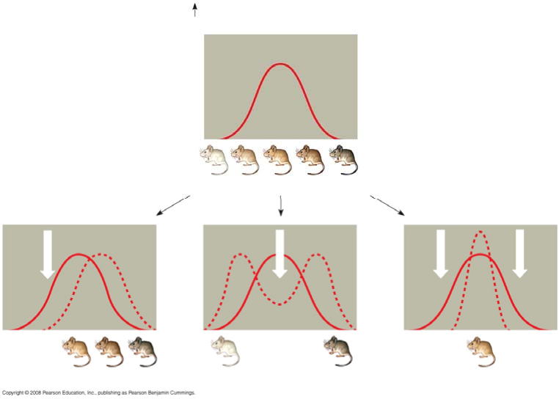

|  |  |
| --- | --- |
| **Type of Selection** | **How It Works** |
| *Stabilizing* |  |
| *Directional* |  |
| *Disruptive* |  |

27. What is often the result of *sexual selection*?

29. Explain two ways in which genetic variation is preserved in a population.

30. Discuss what is meant by *heterozygote advantage*, and use sickle-cell anemia as an example.

31. Finally, give four reasons why natural selection cannot produce perfect organisms