UNIT EIGHT: Wedding Photography

***“I love spontaneous nature of weddings—that things aren't always perfect. I also get to see the tender side of people, which is rare. It's all about capturing the human spirit that is unique to each individual….” –Bambi Cantrell***

Since the development of photography, we have used photographs to capture the special moments in our lives. This is nowhere more true than with wedding photography. Wedding photographers help to capture wedding moments for the bridal couple and their families and friends. They create photographs that will forever remind the couple of this important day in their lives. In this unit, we will consider the different aspects of wedding photography and the ways that photographers can help capture those special moments.

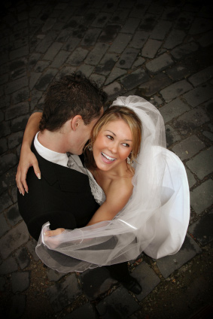

**Types of Wedding Photography**

Although wedding photography is a common part of most weddings in our culture, it is a relatively recent addition in the history of weddings. Wedding photography, of course, was dependent on the development of photography, and that development has shaped wedding photographs in a variety of ways. Today, there are several different types of wedding photography that are commonly used to capture the big day.

Wedding photography began as early as the 1840s. Due to the limitations of photography at that time, only a few photographs likely were taken, often posed photographs of the couple or families. Posing was necessary because of the long exposure times. Wedding portraits continued to be the common type of photograph through the mid-twentieth century. Gradually, the idea of capturing the wedding itself became popular after World War II. The ability to do so was dependent on the development of film cameras that were more portable and were capable of shorter exposure times. Film and developing costs were still expensive, however, and although some photographs were taken during the wedding, most of them were still posed shots of the bridal party and family using studio lights.

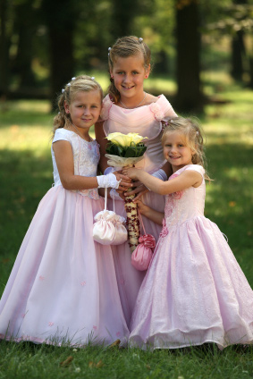

**Traditional wedding photography**

generally consists of posed portraits. The photos are often pre-arranged by the photographer and the couple before the wedding. Typically, the photos consist of photographs of the bridal couple, the bridal party, and the couple’s families. The photos are typically formal in style, with a concentration on good lighting and a pleasing arrangement of people within the photo. The advantages of this type of wedding photography are that it typically results in good photographs. Often a number of photographs are taken of each pose, which increases the chances of getting a great shot. In addition, the photographer can manipulate the lighting or poses to make people look their best and reduce distracting elements in the photo. Traditional portraits are often classically beautiful images that many families treasure. There is a reason this type of photograph has remained popular for weddings.

As film and developing became less expensive, and particularly as digital cameras came on the market, another type of wedding photography developed. **Wedding photojournalism** seeks to document the events of the wedding day with little interference from the photographer. Photographers practicing this style seek to capture the emotion of the day, rather than focusing on the technical aspects of lighting and posing. That is not to say that they do not pay attention to lighting or the way that individuals are arranged, but they are more likely to move themselves to adjust these elements than to move the people they are photographing.

There are several reasons wedding photojournalism has increased in popularity over the last several decades. First, this type of photography mirrors what is seen in the editorial content of contemporary bridal magazines, making it familiar to the bridal couple. This type of wedding photography also provides more unique images than the posed images of the past. The photos often better highlight the personalities and relationships of the people at the wedding. In addition, wedding photojournalism can combine to tell the story of the day. Each photograph contains one piece of that story, from beginning to end, but combining to illustrate the whole. Wedding photojournalism can also take some of the pressure off of the bridal party and help move things along more quickly. Rather than having to take a significant portion out of the day for posed photographs, wedding photojournalism allows bridal parties and families to simply enjoy the day, while the photographer captures the moments.

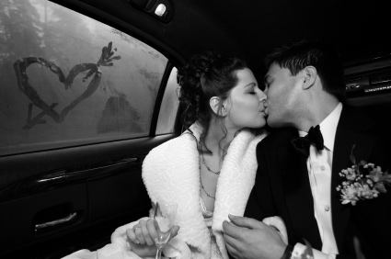

Today, some photographers take a combination approach to photographing a wedding by using some posed shots and some candid, photojournalistic shots. In this case, the photographer will often work in the background, while occasionally setting up a particular photograph with the people and backgrounds on hand. They may also ask individuals to repeat a particular expression or action in order to get the shot or take an insurance photograph in case the original doesn’t turn out. The blend of the two styles can also create posed photographs, but in more relaxed settings such as a park or the beach.

The growth of digital camera use among wedding photographers is also changing the way weddings are photographed. Digital images can be edited and manipulated in photo editing software programs, creating unique effects or covering up blemishes and distracting elements. Photographers now spend time after the wedding enhancing the photos that they took and using filters and other special effects to create new looks. A single color photograph can be turned into a black and white image, have a single element be left in color to highlight it, or be turned into a “painted” image, all with just a few keystrokes.

**The Business Aspect**

At the end of the day, even if the photographer greatly enjoys photographing weddings, wedding photography is still a challenging job with many tasks that go beyond the day of the wedding. Photographers who expect to make money photographing weddings need to seek out business, and they are responsible for other aspects of the business. It is often the case that wedding photographers who are just starting out or who are trying to do wedding photography as a side job will underestimate the costs involved with doing this work, such as insurance, equipment costs, and the time it takes to prepare and edit photographs. If a good estimate isn’t made, the photographer may end up quoting too low of a price for their services, creating a situation where they earn much less than they think they will.

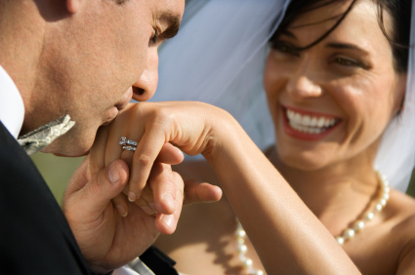

A good way to begin learning the business of wedding photography is to work as an assistant to a wedding photographer. Many wedding photographers hire other individuals to help them handle different aspects of the job, whether it is assisting with lighting or helping to work with the bridal party for posed shots. In addition, some wedding photographers will use a second photographer to help catch different aspects of the wedding and reception.

Photographers starting out will want to create a portfolio that showcases their wedding-related photography. This could include not only actual wedding photographs, but also engagement photographs and bridal portraits. In the beginning, you may not have many wedding photographs, and the photographers that you assist may or may not be willing to let you use some of the photos that you took for them in your portfolio. One way you can build up your portfolio is to take your camera to every wedding that you are invited to as a guest, although you’ll want to ask permission from the bridal couple and make sure that you don’t intrude on the professional photographer. If these options aren’t available, you can also fake a wedding to get photographs. Rent a tux and gown, invite several friends to help you out, and take “wedding” photographs.

As you gain more photographs in the different wedding-related areas, you can divide them into separate portfolios that highlight the particular areas. A strong portfolio illustrates to prospective clients that you have experience photographing weddings, and it helps them get a sense of the quality of your work. Most people are not going to hire someone to photograph one of the most important days of their lives without having some indication that the photographer can deliver good photographs.

One of the most important aspects of running a wedding photography business is marketing. After all, bridal couples have to come across your name as a potential candidate for the job in order for you to actually get the job. In today’s world, marketing is becoming easier in some respects. Social media sites such as Facebook are places where wedding photographers can set up a page and showcase some of their work. This allows potential clients to see your work and consider hiring you to photograph their wedding. Other common locations for marketing include newspapers, online ads (particularly on wedding sites), bridal magazines, and bridal fairs. In addition, wedding photographers should not overlook the power of word-of-mouth advertising. If you do a great job for one client, they may mention your name to someone they know who is getting married. Likewise, the photos that you take serve as a marketing tool to attract clients so it’s important that each wedding produce high-quality images.

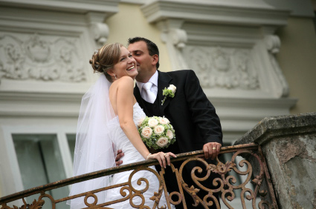

**Pricing the wedding**

One of the challenges of starting a wedding photography business is coming up with a fee to charge for photographing a wedding. Novice wedding photographers might base the price solely on their time, but after the other costs add up, they will earn substantially less than they thought they would. The net cost of photographing a wedding includes the cost of not only your time, but also travel, clothing, taxes, equipment, studio overhead (if you have one), insurance, processing, batteries, film, and so on. You’ll also need to factor in the time that you spend before and after the wedding, including meeting with the bridal couple, editing photographs, sorting photographs, and creating prints. An average wedding often takes between six and eight hours to photograph, and the post-wedding work will often be at least that much as well.

Wedding photographers may structure their fees in different ways. Many offer packages to bridal couples. These packages include the fees for photographing the wedding and include a particular number of prints in particular sizes. Most also offer the option for the bridal couple to purchase additional photographs at set prices. Packages should be priced so that you are making a profit. Any additional sales above that package will earn you a greater profit, but by earning profit on the package, you have already taken care of the necessities in case the couple doesn’t buy any more images.

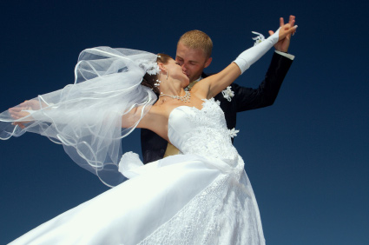

One way to gauge package prices is to check out the competition. Knowing what other wedding photographers charge and how much someone is getting for that price can help keep you competitively priced. At the same time, you’ll also want to factor in the competition’s reputation and their business history. Someone who has been taking wedding photographs for many years and has an excellent reputation will generally be able to charge a higher fee than someone who is just starting out with little reputation. This doesn’t mean that you have to sell yourself short, but it does mean that you should be realistic in creating your pricing. In part, your fees will determine the type of clientele that you attract, as higher-end clients will expect to pay higher-end prices (although they’ll also expect higher-end photographs).

Whatever prices or packages you choose, you should always have a signed contract for each job that you accept. The contract will spell out the work terms, the package terms, how much everything will cost, when payments have to be made, and liability limits. Looking at examples from other wedding photographers can help you determine what should be included in your contract. It is also a good idea to have a lawyer look over the contract for any potential problems or areas of concern. The contract should establish your copyright over the images that you take. It cover information about your liability in case something damages the film or digital images. In addition to other areas, the contract should also spell out the price of the package and when you expect to be paid. Most wedding photographers will ask for a particular portion of the package cost to be paid upfront and will specify that the upfront fee will not be returned in case the wedding is cancelled or postponed.

**What Does It Take to Be a Wedding Photographer?**

Wedding photography continues to be a popular area of work for professional photographers. Not only do wedding photographers gain the satisfaction and reward of recording a happy moment for two individuals, but photographing weddings can also be regular work that pays fairly well. Yet, wedding photography isn’t for everyone. With that in mind, what are some of the characteristics that a good wedding photographer should have?

Perhaps the greatest skill that a wedding photographer needs to have, in addition to being able to take good photographs, is the ability to work with people. Weddings are all about people and their relationships. Photographers will need to work and interact with many different people over the course of a single wedding, from the bridal couple, to the families and guests, to the minister, caterers, and others. Being able to interact positively with a wide range of personalities and people will make photographing a wedding easier.

One of the biggest challenges for wedding photographers is that they work under a great deal of stress. The couple has often spent months planning their wedding and possibly even years thinking about it. For some individuals, this will be a once in a lifetime event. A wedding photographer, then, is under pressure to produce beautiful images of the event for the bridal couple. There are no chances to redo the photos at a later date or to make it up to a couple if the photos do not turn out well or if technical difficulties wipe the images out. Wedding photographers have to be able to adapt to the situation, have patience, and be able to deal constructively with the stress of capturing those images.

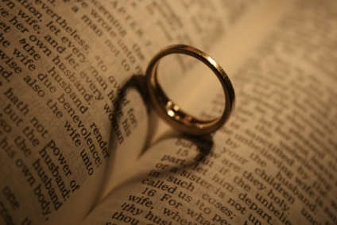

Wedding photographers must also be skilled at producing photographs that capture the best in each person. A great wedding photographer consistently produces images in which people look their best. The ability to make adjustments to hide a few pounds, a blemish, or other imperfection can create photographs that individuals feel good about. In addition, the photographer needs to be able to create the impression of a perfect event even when it is not. In some cases, this may mean taking photographs in such a way that it hides the stress and frayed nerves that might be present during particular times of the day. In other cases, it may mean taking a challenging situation, such as a sudden rainstorm, and turning it into something beautiful that will give the couple and family members fond memories rather than unpleasant memories of the things that often go wrong.

One goal of wedding photographers should be consistency in their photographs. It’s great if a photographer can create a beautiful image, but having only one great image will not be enough for a photographer to be successful and keep couples happy with their photographs. Instead, wedding photographers have to produce consistent images at every wedding. There cannot be just one great image; there must be many great images for each wedding.

Part of capturing great images is learning to anticipate and see those moments. Most weddings will have some predictable times for great photographs. It may be the first dance for the couple at their reception or the moment when they exit the church or other location after the ceremony. Learning which moments produce great shots that are full of emotion and capture the moment will help you photograph these moments. However, photographers also need to pay attention to the unique moments at each wedding whenever the unexpected happens.

**Before the Wedding**

Although we tend to focus on the wedding day events when thinking about wedding photography, a great deal of planning and preparation come before the big day. In fact, the pre-wedding planning can have a large impact on the wedding photographs that will be taken. By engaging in that preparation, the photographer helps to ensure that the couple’s wedding photographs are what they want, and it will help ensure that the process will run more smoothly and be less stressful for everyone involved.

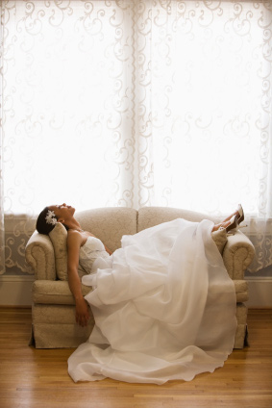

One of the best ways to prepare for photographing a wedding is to have a **pre-wedding consultation** with the couple. During the consultation, you can get an idea about the types of photographs that the couple wants. For example, do they want more posed photos or are they looking for a blend of posed and candid photographs? Is there a specific location for the photos that they want taken, such as a park or public garden? It is also a time for you to convey to the couple what you’ll need in order to get the photos that they want. For example, you may have a general time frame that you’ll need to take the photos of the wedding party.

During the consultation, it can also be helpful to have examples of your previous work to show the couple. This can do several things. First, it creates a degree of professionalism and helps to establish trust between you and the couple. They are able to see that you’ve created images during other weddings that they like and this can help reassure them that you’ll do a good job on their wedding as well. After all, for many people, a wedding is a big deal, and they want someone they can trust to capture those moments. Second, showing your previous work can help the couple decide on particular shots or poses that they’d like to have done. You may not exactly copy the previous photograph, but it can help you get ideas about what type of photographs they are looking for.

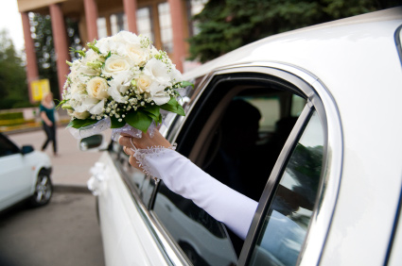

**The Wedding and Reception**

Ideally, before the wedding even starts, the photographer has prepared him- or herself for the particular needs of the specific wedding. Some wedding photographers, particularly those who are new to photographing weddings, will find it helpful to scout the location. This can give the photographer information about where the he or she can photograph from, where the good backgrounds are, and the specifics about where the wedding will be taking place.

Photographers who are used to working in a particular area will gradually accumulate knowledge about the venues and locations that they’ll work in. It is often a good idea as you begin working in wedding photography to take notes on locations and interesting places that you find. For example, you may discover that there is a nice park just a block from a particular church that is a great option for some outdoor pictures. Or you might find that a particular area of town has interesting architecture, such as covered walkways fountains or even graffiti, that might work for the type of photographs that your clients are looking for. Experienced photographers will gradually learn which locations are best in particular seasons and at particular times of day, and that will help them in suggesting alternative locations for wedding photographs beyond the actual wedding location.

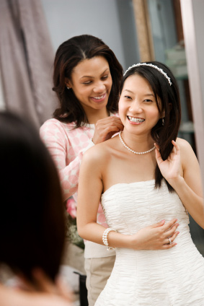

When photographing a wedding, photographers generally follow the rules of composition and their knowledge of lighting and exposure to set up the photos. The Rule of Thirds, for example, can be used to compose a photo for dramatic effect. Arched doorways, garden arbors, or other architectural details can be used to create a frame within the photograph to highlight the bridal couple or a flower girl. Simplicity in a photo is also a good aim. The focus of many photographs will be on the bridal couple or one member of it. Getting in closer and simplifying the background can help keep the focus on the individuals. For example, in some cases, it may be possible to use the bride’s veil or the train from her dress (held up by assistants) for the background of a close-up on her face.

Traditional wedding photographers will often have an agreed-upon set of photographs that they will take, after meeting with the bridal couple, along with other photo opportunities that may happen during the wedding and reception. For example, there may be photographs on the entire bridal party, with the parents of the bridal party, of the procession of the bride down the aisle, the exchange of rings, and the first dance at the reception, just to name a few of the more common ones. The photos taken may vary depending on the bridal couple’s preferences as well as on other factors, such as the size of the wedding party and the location of the wedding. Some churches, for example, may restrict photography during the wedding ceremony itself, which would eliminate those photographs from the list.

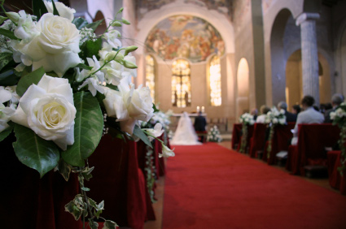

Photographers who use a more photojournalistic approach to wedding photography may still have some general guidelines on the types of photographs that they will be taking. For example, the bridal couple may want photographs taken as they get ready for the wedding, and they may want some photographs with the bridal party or their families. In some cases, they may request candid photographs of these, or they may request more posed photographs. Talking about these issues during the pre-wedding consultation can help the photographer learn what the bridal couple is looking for.

In this unit, we examined the area of professional wedding photography. As we’ve learned, this area consists of more than just taking photographs at a wedding and reception; there is a great deal of work that goes into preparing for and completing a wedding photography job. We’ve also learned about the two most common types of wedding photography and how photographers in these areas may photograph a wedding differently. A career in wedding photography can be a rewarding one as photographers work with couples and families on an important day of their lives, but there are also pressures and challenges that come with that work, such as making sure to shoot consistently good photographs and working with individuals who are under stress themselves.