Chapter 3

Water and the Fitness of the Environment

Overview: The Molecule That Supports All of Life

* Because water is the substance that makes life possible on Earth, astronomers hope to find evidence of water on newly discovered planets orbiting distant stars.
  + Water is the substance that makes life on Earth possible.
  + 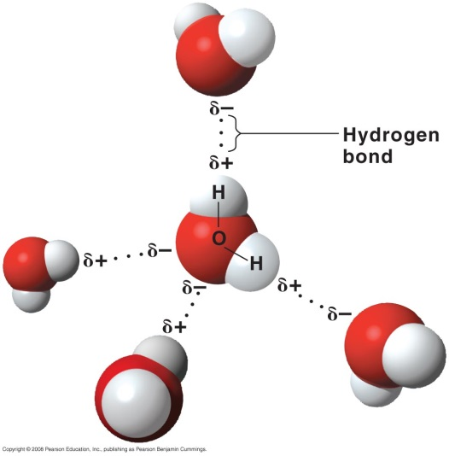All organisms are made of mostly water and live in an environment dominated by water.
  + Water is the only common substance in the natural environment that exists in all three physical states of matter: solid, liquid, and gas.
* Three-quarters of Earth’s surface is submerged in water.
* Life on Earth began in water and evolved there for 3 billion years before spreading onto land.
* Even terrestrial organisms are tied to water.
  + Most cells are surrounded by water.
  + Cells are 70–95% water.
  + Water is a reactant in many of the chemical reactions of life.

Concept 3.1 The polarity of water molecules results in hydrogen bonding.

* A water molecule is shaped like a wide V, with two hydrogen atoms joined to an oxygen atom by single polar covalent bonds.
* Because oxygen is more electronegative than hydrogen, a water molecule is a **polar molecule** in which opposite ends of the molecule have opposite charges.
  + The oxygen region of the molecule has a partial negative charge (δ-), and the hydrogen regions have a partial positive charge (δ+).
* Water has a variety of unusual properties because of the attraction between polar water molecules.
  + The slightly negative regions of one water molecule are attracted to the slightly positive regions of nearby water molecules, forming hydrogen bonds.
  + Each water molecule can form hydrogen bonds with as many as four neighbors.
  + When water is in its liquid form, its hydrogen bonds are very fragile, about one-twentieth as strong as covalent bonds.
  + Hydrogen bonds form, break, and re-form with great frequency.
  + Each hydrogen bond lasts only a few trillionths of a second, but the molecules continuously form new hydrogen bonds with a succession of partners.
  + At any given instant, a substantial percentage of all water molecules are hydrogen-bonded to their neighbors.

**Concept 3.2 Four emergent properties of water make Earth fit for life: cohesive behavior, ability to moderate temperature, expansion upon freezing, and versatility as a solvent**

Organisms depend on the cohesion of water molecules.

* Collectively, hydrogen bonds hold water together, a phenomenon called **cohesion.**
* Cohesion among water molecules plays a key role in transporting water and dissolved nutrients against gravity in plants.
  + 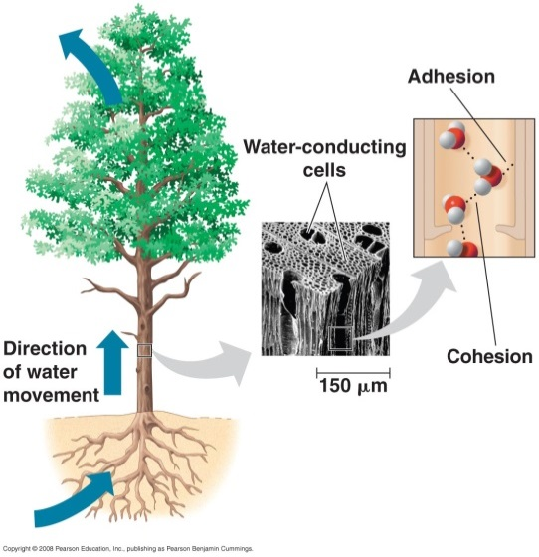Water molecules move up from the roots to the leaves of a plant through water-conducting vessels.
  + As water molecules evaporate from a leaf, other water molecules from vessels in the leaf replace them.
  + Hydrogen bonds cause water molecules leaving the vessels to tug on molecules farther down.
  + This upward pull is transmitted down to the roots.
  + **Adhesion**, the clinging of one substance to another, also contributes, as water adheres to the walls of the vessels.
* **Surface tension,** a measure of the force necessary to stretch or break the surface of a liquid, is related to cohesion.
  + Water has a greater surface tension than most other liquids because hydrogen bonds among surface water molecules resist stretching or breaking the surface.
  + Water behaves as if covered by an invisible film.
  + Some animals can stand, walk, or run on water without breaking the surface.

Water moderates temperatures on Earth.

* Water moderates air temperatures by absorbing heat from warmer air and releasing heat to cooler air.
* Water can absorb or release relatively large amounts of heat with only a slight change in its own temperature.
* Atoms and molecules have **kinetic energy,** the energy of motion, because they are always moving.
  + The faster a molecule moves, the more kinetic energy it has.
* **Heat** is a measure of the *total* quantity of kinetic energy due to molecular motion in a body of matter.
* **Temperature** measures the intensity of heat in a body of matter due to the *average* kinetic energy of molecules.
  + As the average speed of molecules increases, a thermometer records an increase in temperature.
* Heat and temperature are related but not identical.
* When two objects of different temperatures come together, heat passes from the warmer object to the cooler object until the two are the same temperature.
  + Molecules in the cooler object speed up at the expense of the kinetic energy of the warmer object.
  + Ice cubes cool a glass of soda by absorbing heat from the soda as the ice melts.
* In most biological settings, temperature is measured on the **Celsius scale** (°C).
  + At sea level, water freezes at 0°C and boils at 100°C.
  + Human body temperature is typically 37°C.
* Although there are several ways to measure heat energy, one convenient unit is the **calorie (cal).**
  + One calorie is the amount of heat energy necessary to raise the temperature of 1 g of water by 1°C.
  + A calorie is released when 1 g of water cools by 1°C.
* In many biological processes, the **kilocalorie (kcal)** is a more convenient unit.
  + One kilocalorie is the amount of heat energy necessary to raise the temperature of 1000 g of water by 1°C.
* Another common energy unit, the **joule (J),** is equivalent to 0.239 cal.

***Water has a high specific heat.***

* Water stabilizes temperature because it has a high specific heat.
* The **specific heat** of a substance is the amount of heat that must be absorbed or lost for 1 g of that substance to change its temperature by 1°C.
  + By definition, the specific heat of water is 1 cal per gram per degree Celsius, or 1 cal/g/°C.
* Water has an unusually high specific heat compared to other substances.
  + For example, ethyl alcohol has a specific heat of 0.6 cal/g/°C.
  + The specific heat of iron is one-tenth that of water.
* Water resists changes in temperature because of its high specific heat.
  + In other words, water absorbs or releases a relatively large quantity of heat for each degree of temperature change.
* Water’s high specific heat is due to hydrogen bonding.
  + Heat must be absorbed to break hydrogen bonds, and heat is released when hydrogen bonds form.
  + The investment of 1 calorie of heat causes relatively little change in the temperature of water because much of the energy is used to disrupt hydrogen bonds, not speed up the movement of water molecules.
* Water’s high specific heat affects Earth as a whole as well as individual organisms.
  + A large body of water can absorb a large amount of heat from the sun during the daytime in the summer and yet warm only a few degrees.
  + At night and during the winter, the warm water heats the cooler air.
  + Therefore, the oceans and coastal land areas have more stable temperatures than inland areas.
  + Living things are made of primarily water, so they resist changes in temperature better than they would if composed of a liquid with a lower specific heat.

***Water’s high heat of vaporization has many effects.***

* The transformation of a molecule from a liquid to a gas is called **vaporization** or **evaporation**.
  + Vaporization occurs when a molecule moves fast enough to overcome the attraction of other molecules in the liquid.
  + The speed of molecular movement varies; temperature is the *average* kinetic energy of molecules.
  + Even in a low-temperature liquid (with low average kinetic energy), some molecules move fast enough to evaporate.
  + Heating a liquid increases the average kinetic energy and increases the rate of evaporation.
* **Heat of vaporization** is the quantity of heat that a liquid must absorb for 1 g of it to be converted from liquid to gas.
  + Water has a relatively high heat of vaporization, with about 580 cal of heat required to evaporate 1 g of water at room temperature.
  + This is double the amount of heat required to vaporize the same quantity of alcohol or ammonia.
  + The heat of vaporization is high because hydrogen bonds must be broken before a water molecule can evaporate from the liquid.
* The large amount of energy required to vaporize water has a wide range of effects.
  + Water’s high heat of vaporization moderates climate.
  + Much of the sun’s heat absorbed by tropical oceans is used for the evaporation of surface water.
  + As moist tropical air moves to the poles, water vapor condenses to form rain, releasing heat.
* At the level of the organism, water’s high heat of vaporization accounts for the severity of steam burns.
  + Steam burns are caused by the heat energy released when steam condenses to liquid on the skin.
* As a liquid evaporates, the surface of the liquid that remains behind cools, a phenomenon called **evaporative cooling**.
  + The most energetic molecules are the most likely to evaporate, leaving the lower–kinetic energy molecules behind.
  + Evaporative cooling moderates temperature in lakes and ponds.
* Evaporation of sweat in mammals or evaporation of water from the leaves of plants prevents terrestrial organisms from overheating.
  + Evaporation of water from the leaves of plants or the skin of humans removes excess heat.

Oceans and lakes don’t freeze solid because ice floats.

* Water is unusual because it is less dense as a solid than as a cold liquid.
  + Most materials contract as they solidify, but water expands.
  + At temperatures higher than 4°C, water behaves like other liquids, expanding as it warms and contracting as it cools.
* Water begins to freeze when its molecules are no longer moving vigorously enough to break their hydrogen bonds.
* When water reaches 0°C, it becomes locked into a crystalline lattice, with each water molecule bonded to a maximum of four partners.
* As ice starts to melt, some of the hydrogen bonds break, and water molecules can slip closer together than they can while in the ice state.
* Ice is about 10% less dense than water at 4°C. Therefore, ice floats on the cool water below.
* Ice floating on water has important consequences for life.
  + If ice sank, eventually all ponds, lakes, and even oceans would freeze solid.
  + During the summer, only the upper few centimeters of oceans would thaw.
  + Instead, the surface layer of ice insulates the liquid water below, preventing it from freezing and allowing life to exist under the frozen surface.

Water is the solvent of life.

* A liquid that is a completely homogeneous mixture of two or more substances is called a **solution.**
  + A sugar cube in a glass of water eventually dissolves to form a uniform solution of sugar and water.
* The dissolving agent is the **solvent,** and the substance that is dissolved is the **solute.**
  + In our example, water is the solvent and sugar is the solute.
* In an **aqueous solution,** water is the solvent.
* Water is not a universal solvent, but it is very versatile because of the polarity of water molecules.
  + Water is an effective solvent because it readily forms hydrogen bonds with charged and polar covalent molecules.
  + For example, when a crystal of salt (NaCl) is placed in water, the Na+ cations interact with the partial negative charges of the oxygen regions of water molecules.
  + The Cl− anions interact with the partial positive charges of the hydrogen regions of water molecules.
  + Each dissolved ion is surrounded by a sphere of water molecules, a **hydration shell.**
  + Eventually, water dissolves all the ions, resulting in a solution with two solutes: sodium and chloride ions.
* Polar molecules are also soluble in water because they form hydrogen bonds with water.
* Even large molecules, like proteins, can dissolve in water if they have ionic and polar regions.
* A substance that has an affinity for water is **hydrophilic** *(water-loving).*
  + Hydrophilic substances are dominated by ionic or polar bonds.
* Some hydrophilic substances do not dissolve because their molecules are too large.
  + For example, cotton is hydrophilic because cellulose, its major constituent, has numerous polar covalent bonds. However, its giant cellulose molecules are too large to dissolve in water.
  + Water molecules form hydrogen bonds with the cellulose fibers of cotton. When you dry yourself with a cotton towel, the water is pulled into the towel.
* Substances that have no affinity for water are **hydrophobic** *(water-fearing).*
  + Hydrophobic substances are nonionic and have nonpolar covalent bonds.
  + Because no regions consistently have partial or full charges, water molecules cannot form hydrogen bonds with hydrophobic molecules.
  + Oils such as vegetable oil are hydrophobic because the dominant bonds, carbon-carbon and carbon-hydrogen, share electrons equally.
  + Hydrophobic molecules are major ingredients of cell membranes.
* Biological chemistry is “wet” chemistry, with most reactions involving solutes dissolved in water.
* Chemical reactions depend on collisions of molecules and therefore on the concentrations of solutes in aqueous solution.
* When carrying out experiments, we use mass to calculate the number of molecules.
  + We know the mass of each atom in a given molecule, so we can calculate its **molecular mass,** which is the sum of the masses of all the atoms in a molecule.
  + We measure the number of molecules in units called moles**.**
* The actual number of molecules in a mole is called Avogadro’s number, 6.02 × 1023.
  + A **mole (mol)** is equal to the molecular weight of a substance but scaled up from daltons to grams.
* To illustrate, how can we measure 1 mole of table sugar—sucrose (C12H22O11)?
  + A carbon atom weighs 12 daltons, hydrogen 1 dalton, and oxygen 16 daltons.
  + One molecule of sucrose weighs 342 daltons, the sum of the weights of all the atoms in sucrose, or the **molecular weight** of sucrose.
  + To get 1 mole of sucrose, we would weigh out 342 g.
* The advantage of using a mole as a unit of measure is that a mole of one substance has the same number of molecules as a mole of any other substance.
  + If substance A has a molecular weight of 10 daltons and substance B has a molecular weight of 100 daltons, then we know that 10 g of substance A has the same number of molecules as 100 g of substance B.
  + A mole of sucrose contains 6.02 × 1023 molecules and weighs 342 g, while a mole of ethyl alcohol (C2H6O) also contains 6.02 × 1023 molecules but weighs only 46 g because the molecules are smaller.
  + Measuring in moles allows scientists to combine substances in fixed ratios of molecules.
* In “wet” chemistry, we typically combine solutions or measure the quantities of materials in aqueous solutions.
  + The concentration of a material in solution is called its **molarity.**
  + Aone-molar (1 *M*) solution has 1 mole of a substance dissolved in 1 liter of a solvent, typically water.
  + To make a 1 *M* solution of sucrose, we would slowly add water to 342 g of sucrose until the total volume was 1 liter and all the sugar was dissolved.

Concept 3.3 Acidic and basic conditions affect living organisms.

* Occasionally, a hydrogen atom participating in a hydrogen bond between two water molecules shifts from one molecule to the other.
  + 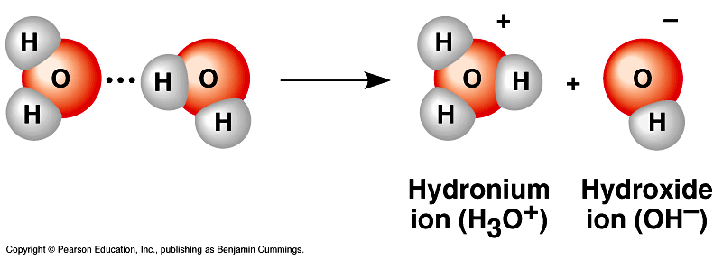The hydrogen atom leaves its electron behind and is transferred as a single proton—a **hydrogen ion** (H+).
  + The water molecule that lost the proton is now a **hydroxide ion** (OH−).
  + The water molecule with the extra proton is now a **hydronium ion** (H3O+).
* A simplified way to view this process is to say that a water molecule dissociates into a hydrogen ion and a hydroxide ion: H2O ⇔ H+ + OH−.
  + This reaction is reversible.
* 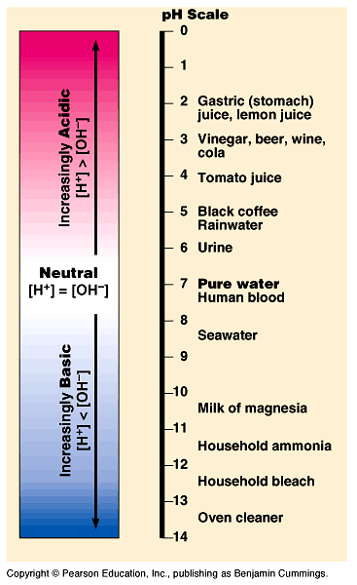At equilibrium, the concentration of water molecules greatly exceeds the concentration of H+ and OH−.
  + In pure water, only one water molecule in every 554 million is dissociated.
  + At equilibrium, the concentration of H+ or OH− is 10−7 *M* (at 25°C).
* Although the dissociation of water is reversible and statistically rare, it is very important in the chemistry of life.
  + Because hydrogen and hydroxide ions are very reactive, changes in their concentrations can drastically affect the chemistry of a cell.
* Adding certain solutes, called acids and bases, disrupts the equilibrium and modifies the concentrations of hydrogen and hydroxide ions.
* The pH scale is used to describe how acidic or basic a solution is.
* An **acid** is a substance that increases the hydrogen ion concentration in a solution.
  + When hydrochloric acid is added to water, hydrogen ions dissociate from chloride ions: HCl 🡪 H+ + Cl−.
  + The addition of an acid makes a solution more acidic.
* Any substance that reduces the hydrogen ion concentration in a solution is a **base.**
* Some bases reduce the H+ concentration directly by accepting hydrogen ions.
  + Ammonia (NH3) acts as a base when the nitrogen’s unshared electron pair attracts a hydrogen ion from the solution, creating an ammonium ion (NH4+): NH3 + H+ ⇔ NH4+.
* Other bases reduce the H+ concentration indirectly by dissociating to OH−, which then combines with H+ to form water.
  + NaOH 🡪 Na+ + OH−
  + OH− + H+ 🡪 H2O
* HCl and NaOH dissociate completely when mixed with water.
  + Hydrochloric acid is a strong acid, and sodium hydroxide is a strong base.
* In contrast, ammonia is a relatively weak base.
  + The double arrows in the reaction for ammonia indicate that the binding and release of hydrogen ions are reversible reactions.
  + At equilibrium, there is a fixed ratio of products to reactants.
* Carbonic acid is a weak acid, which reversibly releases and accepts hydrogen ions.
  + H2CO3 🡨🡪 HCO3- + H+

Carbonic Bicarbonate Hydrogen

acid ion ion

***The pH scale measures the H+ concentration of a solution.***

* In any aqueous solution at 25°C, the *product* of the H+ and OH- concentrations is constant at 10-14.
* Brackets ([H+] and [OH−]) indicate the molar concentration of the enclosed substance.
  + [H+] [OH−] = 10−14
  + In a neutral solution, [H+] = 10−7 *M* and [OH−] = 10−7 *M.*
* Solutions with more OH− than H+ are basic solutions; solutions with more H+ than OH- are acidic; solutions in which the concentrations of OH- and H+ are equal are neutral.
* Adding an acid to a solution shifts the balance between H+ and OH− toward H+ and leads to a decrease in the OH− concentration.
  + If [H+] = 10−5 *M*, then [OH−] = 10−9 *M.*
  + Hydroxide concentrations decrease because some of the additional acid combines with hydroxide to form water.
* Adding a base does the opposite, increasing the OH− concentration and lowering the H+ concentration.
* The H+ and OH− concentrations of solutions can vary by a factor of 100 trillion or more.
* To express this variation more conveniently, the H+ and OH− concentrations are typically expressed with the pH scale.
  + The pH scale, ranging from 1 to 14, compresses the range of concentrations by employing logarithms.
  + The **pH** of a solution is defined as the negative logarithm (base 10) of the hydrogen ion concentration.
  + pH = −log [H+] or [H+] = 10−pH
  + In a neutral solution, [H+] = 10−7 *M* and pH = 7.
* The pH *decreases* as the H+ concentration *increases*.
* Although the pH scale is based on [H+], values for [OH−] can be easily calculated from the product relationship.
* The pH of a neutral solution is 7.
* Acidic solutions have pH values less than 7, and basic solutions have pH values greater than 7.
* Most biological fluids have pH values in the range 6–8.
  + However, the human stomach has strongly acidic digestive juice with a pH of about 2.
* Each pH unit represents a tenfold difference in H+ and OH− concentrations.
  + A small change in pH indicates a substantial change in H+ and OH− concentrations.
  + A solution of pH 3 is not twice as acidic as a solution of pH 6 but 1,000 times more acidic.

Organisms are sensitive to changes in pH.

* The chemical processes in the cell can be disrupted by changes in the H+ and OH− concentrations away from their normal values, usually near pH 7.
* To maintain cellular pH values at a constant level, biological fluids have **buffers.**
* Buffers resist changes in the pH of a solution when H+ or OH− is added to the solution.
  + Buffers accept hydrogen ions from the solution when they are in excess and donate hydrogen ions when they have been depleted.
  + Buffers typically consist of a weak acid and its corresponding base.
  + One important buffer in human blood and other biological solutions is carbonic acid (H2CO3), formed when CO2 reacts with water in blood plasma.
    - Carbonic acid dissociates to yield a bicarbonate ion (HCO3-) and a hydrogen ion (H+).
    - The chemical equilibrium between carbonic acid and bicarbonate acts as a pH regulator.
    - The equilibrium shifts left or right as other metabolic processes add or remove H+ from the solution.

Contamination of rivers, lakes, seas, and rain threatens the environment.

* Human activities, including the burning of fossil fuels, threaten water quality.
  + The release of prodigious amounts of CO­2 into the atmosphere alters the delicate balance of conditions for life on Earth by affecting water’s pH and temperature.
* The burning of fossil fuels is a major source of sulfur oxides and nitrous oxides.
  + These oxides react with water to form strong acids, which fall to earth with rain or snow.
* **Acid precipitation** occurs when rain, snow, or fog has a pH that is higher than 5.6.
  + Uncontaminated rain has a slightly acidic pH of 5.6, owing to the formation of carbonic acid from carbon dioxide and water.
* Electrical power plants that produce coal create more of these oxides than any other single source.
  + Winds carry this pollution from its site of origin to contaminate relatively pristine areas hundreds of kilometers away.
  + In 2001, rain in certain sites in Pennsylvania and New York had an average pH of 4.3, 20 times more acidic than normal rain.
* Acid precipitation can damage life in lakes and streams, adversely affect soil chemistry, and damage forests.
  + Currently, most North American forests are not suffering substantially from acid precipitation, in large part due to 1990 amendments made to the Clean Air Act.
* CO2 is a major product of fossil fuel combustion.
  + The release of CO2 into the atmosphere has been increasing steadily and is expected to double by 2065, relative to the year 1880.
  + About half of the CO2 stays in the atmosphere, acting like a reflective blanket over Earth that prevents heat from radiating into outer space.
* A portion of the CO2 is taken up by trees and other organisms during photosynthesis.
  + The remainder—about 30%—is absorbed by the oceans.
  + In spite of the huge volume of water in the oceans, scientists worry that this absorption of so much CO2 will harm marine life and ecosystems.
* When CO2 dissolves in seawater, it can react with water (H20) to form carbonic acid (H2CO3).
  + This weak acid lowers the pH of seawater and causes a decrease in the concentration of CO32-, the carbonate ion.
  + Many studies have shown that calcification, the production of calcium carbonate (CaCO3) by corals and other organisms, is directly affected by the concentration of CO32-.
* Perhaps one of the best-known and longest-term studies on coral reef calcification was carried out by scientists at the ecosystem center known as Biosphere-2.
  + The center includes an artificial coral reef system in which the temperature and chemistry of the seawater can be controlled and manipulated.
  + Chris Langdon and colleagues used this system to test the effects of varying the concentration of CO32- on the rate of calcification in the coral reef.
  + Together with conclusions from other studies, their results led them to predict that the doubling of CO2 emissions by 2065 could lead to a 40% decrease in coral reef calcification.
* If there is reason for optimism about the future quality of water resources on our planet, it is because we have made progress in learning about the delicate chemical balances in oceans and other bodies of water.
  + Continued progress can come only from the actions of people who are concerned about environmental quality.
  + We must all understand the crucial role that water plays in the environment’s fitness for continued life on Earth.