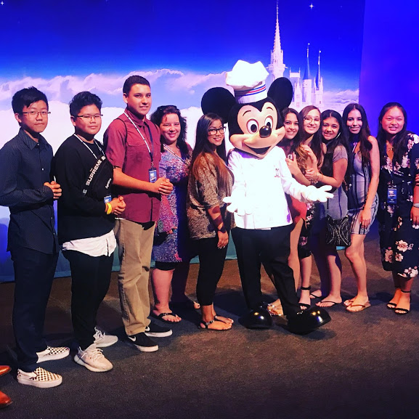  Exciting Career Opportunities  - Business Management  - Financial Management  - Food Service Management  - Lodging Management  - Travel and Tourism Management  - Recreation Management | Who We Are  About Us  The Chino Hills High School Business Academy of Hospitality and Tourism will provide students with the business, leadership, and industry standard skills necessary to pursue careers in this multifaceted industry. The students will be prepared to enter the industry and continue studies at a 4-year university  Contact Us  Jennell Acker-Lead BAHT Teacher  Email: Jennell_Acker@chino.k12.ca.us  Business Academy of Hospitality and Tourism B.A.H.T.  16150 Pomona Rincon Rd Chino Hills CA 91709 | Careers in Business And Hospitality Manangement  Business Academy of Hospitality and Tourism B.A.H.T.  - Chino Hills High School
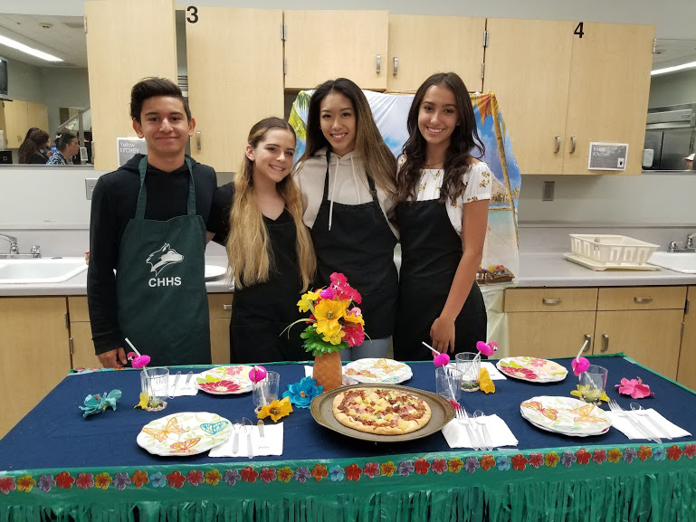  Program of Study  9th Grade  Intro to Business Hospitality/Health  10th Grade  Management of Hospitality and Tourism  11th Grade  Hospitality Economics (Econ Credit)  12th Grade  Internships/Work Experience/School Based Enterprise | In wisdom gathered over time I have found that every experience is a form of exploration.”  Ansel Adams  Opportunities for Students  - Professional guest speakers  - Industry specific site visits  - College tours  - Industry certifications  - Scholarship opportunities  - Competition opportunities for completing business plans  - Job shadowing/Internships/ work experience  - College credit for over 50 universities throughout the country  - Work based learning opportunities  - Certifications from National Restaurant Association | 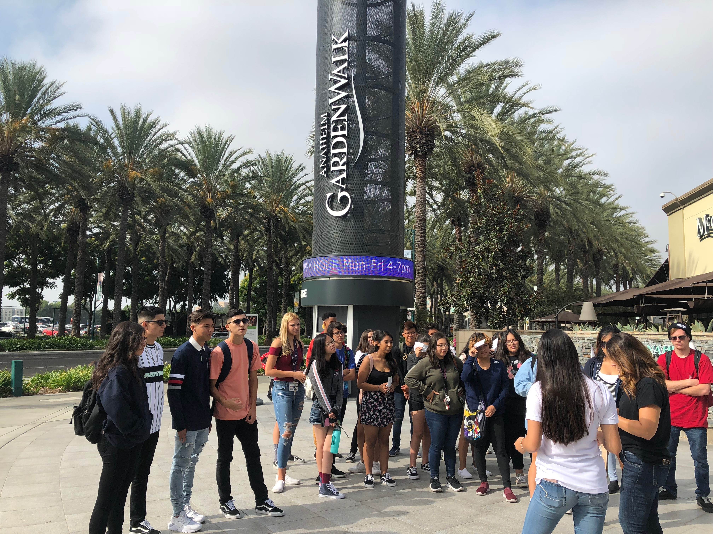  Hospitality & Tourism Management…. A Hot Career Field  Currently, the Hospitality and Tourism industry maintains the largest national employment base in the Southern California’s private sector  The leisure and hospitality sector in California supports a significant tourism industry  Leisure and hospitality companies employ 13.6% of the total private workforce and generate 4% of gross state product.  The industry is growing just over 4% annually due to improving consumer sentiment and growing disposable income.  The largest subcategories are accommodations, full-service restaurants and limited-service eating places.

