Digital Photography Semester 1

**Unit 4**

Composition

“There are no rules for good photos, there are only good photos.” ***-Ansel Adams***

Have you ever wondered why a particular photo catches your eye? What makes some photos stand out from others? While a number of factors, including lighting and color, play a role in creating a great photo, the composition of the photo can mean the difference between a good photo and a great one. **Composition** is the visual arrangement or placement of the elements in a photo. While some great photos may happen accidentally, more often they are carefully planned and thought out.

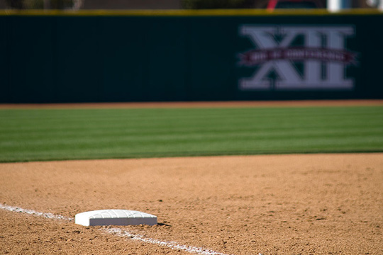  
****Olsen Field Third Base****

In this unit, we will discuss some of the composition guidelines and “rules” that can help you create pleasing photos. We’ll also discuss some of the reasons behind these rules and why they help improve photos. However, the “rules” don’t always produce the best photos. Sometimes breaking the “rules” will produce a different or even better photo. We’ll also discuss some of the situations in which you’ll want to break the “rules.”

Keep It Simple

One of the easiest ways to compose a photo is to focus on the object or person that you want as the center of attention while simplifying the background around that object or person. For example, let’s say that you want to photo a bird. You see a bird sitting on a fence post and you snap a picture. When you look at the picture, you find that there are tree branches, electrical wires, and a building in the background. While the photo shows the bird, it also has a lot of other things going on. Now imagine that you change the angle of the photo so that the only thing behind the bird is sky. Suddenly, you’ve eliminated the parts of the photo that might distract from the bird itself and put the focus clearly on the bird.

  
****Baby bell pepper**** capsicum annuum

Keeping it simple means that the reason for your photo is clear. Instead of having many things in the photo, the picture focuses on the reason for the photo, such as a particular building, person, or object. Uncomplicated backgrounds will often take a good photo and make it even better by introducing more of a dynamic feel to it. Combined with other composition guidelines, simplicity can work wonders for a photo.

The Rule of Thirds

One of the best known composition guidelines is the “Rule of Thirds.” The **Rule of Thirds** involves imagining that your photo is split into thirds both horizontally and vertically. This produces 9 squares in the photo and 4 points of intersection within the photo. This grid helps to identify 4 good places to position points of interest in the photo (the 4 intersecting points) and 6 different lines that you can also use to position elements.

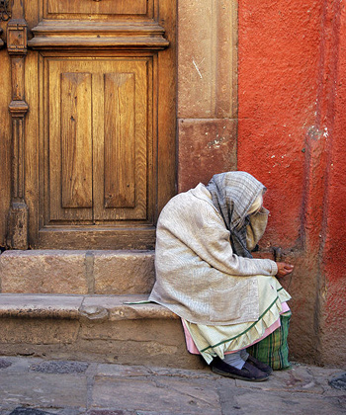  
****Old lady at San Miguel Allende, Guanajuato, Mexico****

The theory behind the Rule of Thirds is that by placing items of interest in the photo at these 4 intersecting points or along the grid lines, the photo will become more balanced and dynamic. Studies done on how individuals view photos have shown that our eyes are naturally drawn to the four sites of intersection. We often assume that our eyes are drawn first to the center of the photo (hence why so many photos involve a centered object or person), but these studies indicate that in many cases the four points of intersection may be better position points for items.

So, how do we use the Rule of Thirds to create better photos? Let’s say that you have a person that you want to photo. You might place the person along one of the vertical grid lines, or you might place the person’s head at one of the two top intersecting positions. Before you compose an image with the Rule of Thirds, ask yourself two questions: What are the points of interest in the photo? Where should I intentionally place those points of interest?

Another way to use the Rule of Thirds is to position vertical or horizontal lines along the grid lines. For example, you may have the horizon between land and sky in your photo. Try placing the horizon at either the top or bottom horizontal grid lines. It is also common to place vertical lines off-center, or along one of the vertical grid lines. If you happen to miss the imaginary grid lines with the Rule of Thirds, you can often crop and adjust the photo with photo editing software later on. However, you’re usually in a better position if you begin with that great photograph rather than finding it through editing.

Framing

What do you do with the photos that you take? For many people, at least some of their photos end up in frames. The composition technique of framing works in much the same way that a frame on your wall works. **Framing** involves blocking some elements within the photo in order to show off other elements. In other words, it involves creating a “frame” around the objects or persons that you want to showcase in the photo.

“Framing” within a photo can help add various elements to a photo. By including objects in the foreground, the photographer can create greater depth in the photo. The “frame” can also help give context to a photo. For example, if you include a tree branch as part of a frame, it conveys to the viewer that the picture is taken outside in a natural setting. Including a building or archway as the frame might convey a more urban setting. Including a frame also draws the viewer’s eyes to the subject of the photo. For example, imagine that you take a photo out of a window, including some of the window and inside wall to frame the view outside. The focus of your photo automatically becomes what is outside the window.

  
****Jerusalem, Dominus flevit, view to the Mount Moriah****

Shooting a picture out a window is the most obvious way to create a frame in a photo, but there are other ways that you can include a frame as well. Frames do not need to go all the way around the photo, but can exist in just one area of a photo. For example, a tree branch or the lines of a building can help frame a scene. Tunnels, archways, and even shooting over someone’s shoulder can also form a frame within the photo. Frames will not work in all cases, however, and you will have to determine whether the frame benefits the image or just adds distraction. You’ll also need to decide whether to have the framing objects in focus or to blur them a bit with a shallower depth of field.

Using Lines

Horizontal, vertical, and diagonal lines can create a great deal of dynamics and interest in a photo if they are used well. Lines exist all around us, from the lines of roads and buildings to the lines of trees and flower stems. Using lines to create a great picture takes some practice, but we can start by examining what lines are present in the photo that we are thinking about taking. Analyzing the lines before taking the picture helps us identify which lines are present and gives us the chance to adjust the photo to make the best use of the lines.

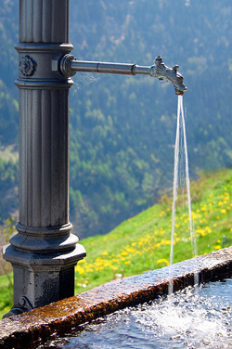  
****Water fountain found in a small Swiss village****

Vertical lines can convey power and strength in a photo. From tall buildings to trees, adding a vertical orientation to the photo tends to further highlight the height of the vertical object. When photographing a vertical line, it is often best to avoid placing it in the center of the photo. While there may be exceptions to this, you will often find a better photo by using the Rule of Thirds.

Horizontal lines appear in the horizons, fallen trees, across roadways and bodies of water, and even people lying down. On the one hand, horizontal lines can convey a sense of stability and peace. On the other hand, horizontal lines can make the photo appear dull if not used right. Generally, you’ll want to avoid placing horizontal lines in the middle of the photo. Using the Rule of Thirds can help give the photo more stability and interest. Using a landscape orientation for the picture can emphasize this stability, while a vertical orientation can draw attention to the horizontal lines. One thing you’ll want to keep in mind is to try to keep the horizontal lines horizontal in the photo. Otherwise, your picture may look off center or tilted.

Diagonal lines offer yet another potential impact in your photos. These lines are often dynamic and tend to create a feeling of action. Diagonal lines can draw the viewer’s attention to something within the photo, and they can also draw the viewer’s eye through the photo. Some studies have indicated that our eyes naturally travel from bottom left to top right, so putting the diagonal along that path can take advantage of our eye patterns. Positioning the diagonal line(s) a bit above or below the actual corner will help keep the photo from appearing split.

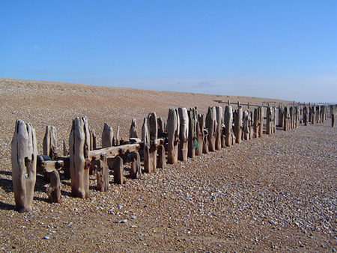  
****Sea defences on the South Coast (UK) near Winchelsea****

Finally, curved lines can also add dramatic interest to a photo. “S” curves, for example, tend to convey a sense of elegance and serenity. The lines themselves do not need to form a perfect “S”; any type of winding or curved line will work. Curved lines include things such as rivers, paths, roads, or fences. A curved line can draw the viewer’s eye into the photo as the line trails off into the distance.

Filling the Frame

A common mistake that people make when taking photos is to allow too much empty space in their photos. They may not realize the background will be distracting, or they simply don’t consider how the photo might change with a different view. Often this happens from not getting close enough to the subject of the photo. For example, you may have seen a picture where the people in it are very small parts of the overall picture. Unless there is a specific reason for doing so, the photo would probably be improved if the subject of the photo was closer, filling more of the frame.

When setting up your photograph, think about what you are trying to convey with the photo. If you are taking a picture of someone, think about whether you need to include much background or even whether you need to include the whole person. While you may want to include some background in a travel photo to convey the location, this probably isn’t necessary for many other photos. For example, imagine that you are trying to illustrate a person’s happiness. Including the person’s whole body can take the focus off of your goal of showing happiness, since other aspects in the photo might distract from your goal. Focusing on the person’s face, in contrast, will capture the happiness of the person with fewer distracting elements. Filling the photo with your subject can add dramatic interest to the photo, as well. Try taking close-up photos of individuals, where only their heads and shoulders (or even less) are shown. Children’s eyes or smiles can be the subject of a photo all by themselves, for example.

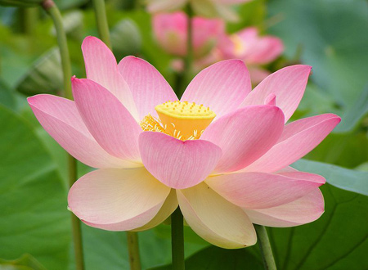  
****Flower of**** Nelumbo nucifera ****at Botanic Garden, Adelaide, South Australia****

One way to get closer to your subject is to use your zoom lens to help fill the frame. This is probably the first instinct of most photographers when they begin to practice filling the frame. There may be times when this is your only option, as well. Another alternative is to crop your photo with a software editing program. While this can be useful, getting a great photo in the first place is usually a better choice. You can also get physically closer to the subject by moving toward it. Before snapping the picture, ask yourself whether it is possible to move closer to the person or object. If you can, try it. Moving closer will often give you more angles and perspectives to choose from in constructing your photo.

New Perspectives

We see much of our world from a straightforward perspective. After all, our eyes are on the front of our faces, and we often approach things from the same perspective as we see them. We tend to take photos from our eye level, and we often take photos that show our subject from a straightforward perspective.

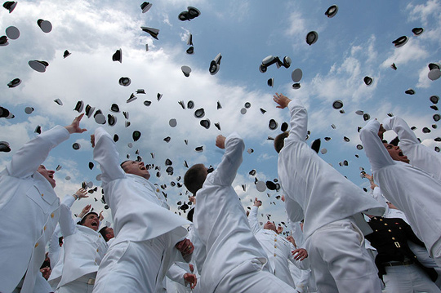  
****Newly commissioned officers celebrate their new positions by throwing their midshipmen covers****  
****into the air as part of the U.S. Naval Academy graduation and commissioning ceremony.****

One of the most effective and easiest ways to create more interesting photos is to change the perspectives and angles that you are shooting your pictures from. Changing the angle or perspective of the photo can better convey how you actually see the object or person. For example, you can illustrate the height of a building by having the photo angled up toward the top of the building. This can convey strength and power to the building.

How can you find different angles to shoot from? Move around. Try lying on the ground, climbing above your subject, or crouching in front of a small object—anything that takes you from the traditional standing, straight-in-front position will give you new angles to explore. Think about how you can convey the feeling of the subject better by using a different angle or perspective.

Active Space

Have you ever seen a photo of a person or animal moving in a particular direction, but it appears that they are ready to move right out of the photograph? While filling the frame is an important technique, in some cases you can also take it too far. Leaving **active space** is typically done where you have movement or when the subject is looking off into space. Centering these subjects or putting them on the Rule of Thirds grid line closest to the direction they are going in can create an off-balance photo. It will make the object appear as if it has no place to go.

A common solution to this problem is to create active space within the photo. In other words, active space gives the object room to move in the photo before the object would move out of the photo. For example, say you are taking a photo of two people walking in the sunset. If they are moving to the left, you can place the individuals to the right of the photo. This will create active space for the individuals and give the illusion that the individuals will continue to move through the photo.

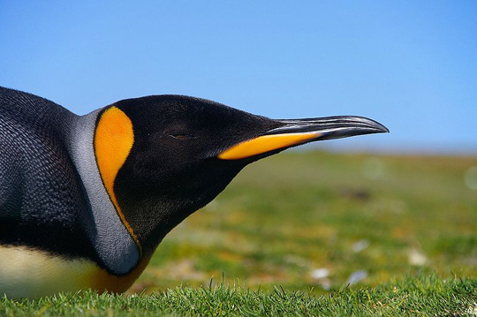  
****King Penguin****

When you take a photo of a person or animal looking to one side of the photo, it is also often a good idea to include active space in front of the person or animal. Although there is no movement in this instance, it gives the subject space to gaze, rather than having his gaze be directly out of the photo. The amount of space will depend on the subject and the photo itself. You may want to try different amounts of active space to see what difference these spaces would make in the overall photo.

There are circumstances in which you would want to eliminate some of the active space in favor of the dead space behind the subject. For example, imagine that you are taking a picture of a race. If you use the active space, you’ll put the individual on one side of the photo with room in front of her. However, this will eliminate her competitors behind her. In this circumstance, you may decide to trade the active space in front of the person for the dead space behind her to show that she is in the lead of the race. In cases like this, you’ll need to make a judgment call about what you want to include in the image and what the different compositions will mean for the photo. The composition of the photos will have benefits and disadvantages either way, but you can choose which advantages and messages you’d like the photo to have.

Keeping Things Straight

Have you ever taken a photo only to realize that you weren’t holding your camera straight? Not getting an image straight is a common problem and one that you can often avoid, giving you better photos. There will be times when you’ll want your photo not to be straight for artistic purposes, but it’s important to practice so that you’ll know how to create straight images.

One practice that you should get into the habit of doing is to check what lines will be in the photo that you are taking. By knowing what lines are present, you can make sure to check whether they are straight or not. If they are not, you’ll want to make an adjustment. If you are opting for a photo in which the lines will not be straight, you’ll generally want to move the camera so that it is obvious that you are not aiming for straight horizontal and vertical lines in the photo. In most cases, lines that are just a bit off will appear to be accidental and will often create a less than desirable look.

One line that you may not consider checking, since it is a natural line, is the horizon. If you miss getting the horizon (the place where sky and land meet) level, your photo may appear to be at an angle, and any other lines in the photo, such as a roof of a building, may also appear to be sloping.

So how do you get your horizons straight? Some cameras have grid marks in the viewfinder to help photographers straighten lines or to position items in the photo. Using these lines can help you make sure that the horizon is straight. You can also buy a small level, like those used in construction or building, to place on your camera. The level will tell you whether your camera is straight or not. This can be a useful option if you continue to have problems keeping your camera level for shots. If you do find that some of your photos are not quite level after you take them, many photo editing software programs have ways of fixing the problem after the fact. These features are often called “straighten” or “rotate.”

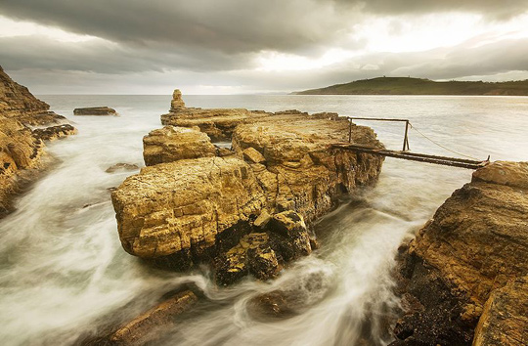  
****Clifton Beach, Tasmania, Australia****

It is worth noting that if you are taking a photo of a building and aiming the camera straight up, the vertical lines will move to the center the higher they go. The perspective of the photo will create this effect. In this case, you’ll want to make sure that the lines at the bottom of the photo are straight. This will create the straight lines that you want and still capture the height of the building.

Breaking the Rules

Now that you’ve learned a bit about some of the “rules” of photography, let’s talk a little bit about breaking those rules. Although the rules we’ve discussed will create great pictures, there will be times when you will want to break them to create an even better photo. You’ll want to be deliberate about breaking the rules. In other words, before breaking one of the rules, you’ll want to have a specific purpose in mind for doing so.

For example, imagine that you are confronted by a straight road with fields on each side. Putting that road in the center of the camera (breaking the Rule of Thirds) can create a dramatic photo. A railroad line can produce a similar effect with the down-the-center approach. In some cases, you may be able to take the same scene and create very different (but equally good) photos both by following the rules and breaking them.

Breaking the rule of keeping lines straight can give you a dramatic and energy-filled photo, if you remember to obviously break the rule. Likewise, breaking the rule about active space in front of a moving object can show you where something has come from, or it can give a greater sense of movement.

  
****HDR of the interior of Église Saint-Maimbœuf in Montbéliard, France****  
****Photo : Bresson Thomas****

You can also create some interesting effects by breaking the rules without the use of photo editing software or any special tricks. For example, you might want to create a dreamy feel to a photo, where the main subject is a bit out of focus. You can do this by using a large aperture and then either focusing on an unimportant piece of the photo or focusing well in front of or behind your main subject. You will probably need to use a manual setting, as your camera will want to focus on something, but the outcome can be a nice change of pace from the normal, totally in-focus photos. Getting just the right amount of fuzziness can be tricky, since you want the main subject to be recognizable, even if slightly out of focus.

Another technique that can create interesting photos is to add noise or grain to a photo. This is becoming a bit harder to do with today’s digital cameras, which try to eliminate as much noise as possible from the photos. However, the results, when accomplished, are reminders of old photos and films from days gone by. To get a grainy image, try setting your ISO at a higher number than what would be called for under the lighting conditions. This can work in some situations, although you may have better luck adding in grain and noise in a photo editing software program after you have the image.