UNIT SEVEN: Photojournalism

“We photographers deal in things which are continually vanishing, and when they have vanished there is no contrivance on earth can make them come back again. We cannot develop and print a memory.” –Henri Cartier-Bresson

Think about a historical event during your lifetime that you were not physically present for. Maybe it is the Oklahoma City bombing, the fall of the Berlin Wall, the tsunami in Southeast Asia, or the collapse of the Twin Towers in New York City on 9/11. How do you know about these events? What mental pictures do you have of the event?

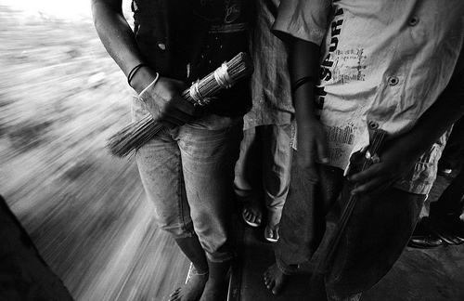  
**Tool of the Trade**

Most likely, your understanding of these events has been influenced by the media, and more specifically, by photojournalism. During each of these events, photojournalists captured photographs of the action and people that made up these events. The same is true for events further back in history, such as World War II. While we can read about these events and watch video of them, it is often the iconic images captured by the click of a camera shutter that remain with us as memorials of the events. In this unit, we will discuss the area of photojournalism and the role that it plays in capturing the newsworthy events in our world.

**Photojournalism** can be defined as the reporting of visual information. We typically think of photojournalism as the production of still photographs that are used in print and online media such as newspapers, magazines, and news websites. However, photojournalism can also appear as the photos used in television news broadcasts or other areas. One of the key underlying aspects in defining photojournalism is that it is a form of reporting. Photojournalism helps to gather and record information. Whereas journalism records written information, photojournalism records visual information.

Over the years, some commentators have argued that photojournalism would decline. The death of photojournalism had been declared when magazines such as Life stopped publishing weekly and when traditional newspapers began closing their doors. Some argued that photojournalism would need to combine with video in order to provide streaming content for websites. Yet, despite all of these death tolls, photojournalism continues to contribute still photographs to news outlets and online websites. The Internet has contributed greatly to the strength of photojournalism. News sites require photographs to add a visual element to the news stories that they cover. In addition, many traditional news outlets, including national newspapers, now have content online. Not only do these outlets need photographs for their print newspapers, but they also need photographs for their online content.

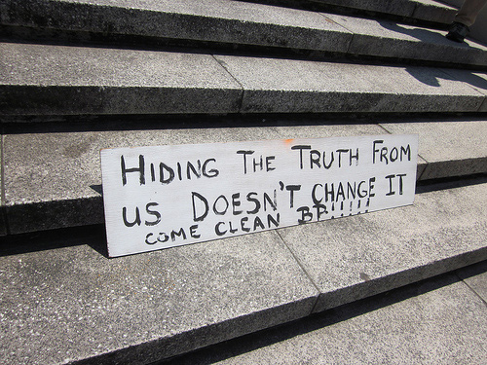  
**BP Oil Disaster protest, French Quarter, New Orleans**

At the same time, photojournalism does find itself at a bit of a crossroads. In the past, photographs were often viewed as evidence of what happened. A photojournalist captured a moment and the moment was accepted as having happened in the way that the photograph shows. However, in today’s world, most people are well aware that photographs can be edited, manipulated, and changed. With simple actions, we can delete part of a photo, change something in the photo, or even add something to the photo. We can make it look as though people were present at an event or situation even when they weren’t, and vice versa. We can also change elements in the photograph by making an item a different color, airbrushing weight from a model, or erasing the wrinkles from an old man’s face.

All of this has led to a greater distrust in photographs. We no longer believe without question that what we see in photographs is the truth. Yet, photojournalism still has the ability to capture moments in time honestly and accurately. It is up to the photojournalists today to strive for the highest ethical and professional standards in order to increase trust in the photos taken.

Why Become a Photojournalist?

Many people look at photojournalism as an exotic career choice. They envision traveling around the globe, photographing important and exciting events. They may want to photograph wars or see their name in print in glossy magazines or national newspapers. While photojournalism can be a rewarding, interesting career, it can also be a tough, challenging career.

Photojournalists, regardless of where they are based, often must work under pressure to deliver photographs of an event or situation. The hours may be long and irregular and the conditions may be poor. Photojournalists must be able to carry heavy equipment for long periods or over long distances. It is also important that they be knowledgeable about various topics and world events. This helps photojournalists prepare for an assignment and have the knowledge needed to anticipate the moments for great photographs. Experts also note that for those individuals who hope to make an above average income, advertising, fashion, and other types of photography are often better bets for a higher income.

At the same time, photojournalism plays an important role in the world today by documenting events and situations. Photojournalists help individuals and societies better understand these events, even when they occur around the world. For individuals who enjoy taking candid photographs and prefer a flexible working environment, photojournalism can be a great career choice. Many photographers see the challenges of photojournalism, including extensive travel, varied working situations, and challenging shots, as advantages. While the career may not be right for everyone, some individuals may find it a perfect fit.

The Photojournalism Shots

Photojournalism makes use of three different types of photographs. Each of the types fulfills a specific purpose in telling a story about an event or situation. In most cases, a photojournalist will take a combination of these three types of photographs to capture different elements of the story. Not all of them may be used, but having all three can give you the greatest amount of options when it comes to providing a visual for an article.

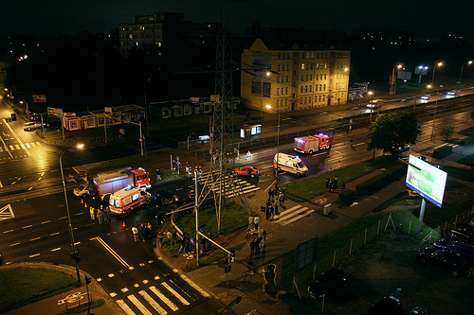  
**Car Accident at Legnicka Street of Wroclaw, Poland**

The first type of shot is the **overall or overview shot.** This shot seeks to give the viewer an overall impression of the event or situation. The scope of the shot will depend on the particular circumstances. It might be an overview of an entire city block, it might be an overhead look at a fairground, or it might be a long, wide shot of the room that the photograph is being taken in. What is the purpose of an overall shot? These types of photographs often provide a great deal of context not only for viewers, but also for the story that they may accompany. For those working with news outlets, these shots can also provide story editors more information about the event or situation, which can help them choose the photos that they will use to illustrate the article or make any changes to the article itself.

The overall shot will often be one of the first shots that you’ll take on the scene of the event. Once you arrive at the scene, you will need to assess the situation. After you feel that you’ve gained an understanding of what is happening, look for a place to get a higher view of the scene. Overview shots are often taken from a higher angle with a wide-angle lens. You may need to get creative to find this higher angle, particularly if there are few places that offer a higher vantage point. Ladders can be great ways to get above the action, but they are rarely available on the scene. Instead, you might look for a tree to climb, a nearby building with windows from which to photograph, the roof of your car, or even a helicopter, depending on the size and scope of the event. For example, if you were photographing a major flood, renting a helicopter could give you a better overview of the situation than being on the ground. However, for most situations, taking photographs from a higher vantage point on land will serve your purpose.

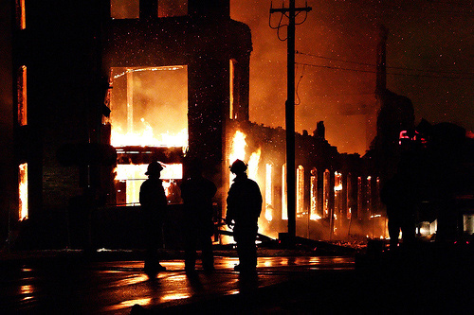  
**Three Alarm Fire at Former Grand Rapids Bicycle Factory**

Another type of photograph that photojournalists take on the scene is **medium range shots.** These are the photos that will “tell the story.” In other words, theses photographs will focus on more specific action or people, while still providing some context about the event or scene. For example, let’s say that you are covering a fire. A medium range shot here might include a firefighter with the burning building in the background. A photo with just the firefighter would be a nice shot, but by adding the burning building in the background, you’ve instantly added more context to the photo. The viewer would understand what the firefighter was doing (as opposed to, perhaps, doing a training exercise or dressing up for a costume party) and what the situation was about. Likewise, if the photograph included only the burning building, the viewers would be left wondering if emergency fire services were on the scene. The combination of the two helps to “tell the story” in a more complete way.

One way to introduce more drama and interest to a medium range shot is to include action in the photo. As with sports photography, this can be challenging as you’ll need to be able to anticipate the movement of others, but the payoffs can be large if you capture those moments where something important happens. In the case of the fire, perhaps you’ve been told that the roof is close to collapsing. Catching that moment in time when the roof is caving in and the sparks are leaping into the air can create a more dramatic photograph. The trick to capturing action in medium range shots is about anticipating the action and anticipating where it will take place. Not every scene will have great action, and photographers may not always be able to anticipate what will unfold. When you can, however, try to include action in these photographs.

Finally, **close-up shots** can also be a great addition to the photos that you take while covering a story or trying to tell a story. These photographs can add a great deal of drama to the story-telling and serve as a nice complement to the overview and medium range shots. Typically, close-up shots will not seek to put the scene in context, but rather will focus on one element of the story. In other words, a close-up photograph should isolate one element, whether it is a particular person or item at the scene. For example, imagine that you are photographing an accident involving a number of cars. You might photograph the bloodied face of one of the victims, a shoe that was tossed into the highway due to the accident, or a single car in the ditch. Imagine that you are covering a story on an elderly musician who is playing with the local symphony. A close-up shot of his or her hands on the instrument’s strings conveys some of the person’s story without ever showing the individual’s face or the background.

For close-up shots, photojournalists have several options for photographing the particular element. A telephoto lens (such as a 200mm lens) can allow a photographer to get that close-up shot without having to get close to the subject of the photo. In some cases, photographers may be restricted from a crime or accident scene or kept at a safe distance from a scene. The telephoto lens then is a great tool to have because it can help create that close-up shot without having to be near the subject. A telephoto lens can also be used to blur the background and foreground slightly, which helps put the focus on the subject of the photo. Some photojournalists will also carry a macro lens or extension tubes for close-up shots. This can be beneficial for photographs where the photojournalist is able to get close to the subject of the photo, as when photographing the musician’s hands.

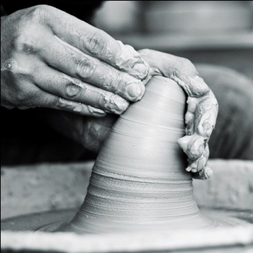  
**Hands of Worker**

With each of these three types of photojournalism shots, it is important to keep in mind that each photographer will have his or her own style. Each photographer will find his or her own preferred angles and subject matter within the whole scene or event. In some cases, we may be tempted to try to capture the same shot that we’ve seen in another photograph. While it’s great to be inspired by the work of others, if we focus too much on trying to copy the look and style of another photographer, we might miss the good shots in the scene where we are. Each situation and scene will be slightly different, and learning to use these differences to create great photographs can benefit us more than always trying to copy someone else.

Catching That Candid Shot

You’ve probably seen a photo in a newspaper or online that captures exactly what is happening. It may be a fireman carrying a child away from a disaster or the tearful reunion of a mother and a lost child. Photojournalism is one type of photography that relies almost exclusively on taking candid shots. In other words, few of the photos that a photojournalist takes will be posed or with the scene manipulated to get the photo. To some degree, capturing that perfect shot is a matter of being in the right place at the right time. However, photojournalists can use different techniques to increase their chances of being in the right place at the right time and actually capturing that defining photograph.

One step to catching that defining moment starts with making sure that you have your camera prepared. When you think that something may be happening that you’ll want to capture, you may want to prefocus your camera on the area. You can use a similar lighted area to the one that you want to shoot if you need to meter for shutter speed and aperture settings. Similarly, you can often focus on an item the same distance away as your subject, if needed, in order to focus the camera. These techniques are helpful if you do not want people to know that you are going to take their photograph, which might affect their behavior or facial expressions. Some photojournalists will also use the autofocus on their cameras. While this may not always result in a technically great shot in terms of focus or exposure, it does allow you to concentrate on the scene and not on adjusting your camera for the scene.

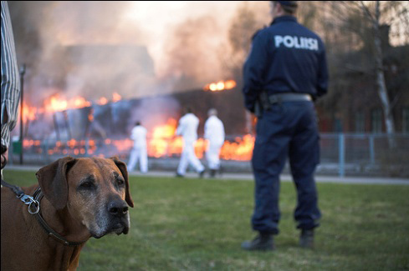  
**Dog and Policeman**

Photojournalists have different methods of capturing the candid moments. The methods may depend not only on the photographers’ preferences, but also on the situation they are photographing. Some photojournalists prefer to take their photographs out in the open, by introducing themselves to the people that they will be photographing. This can make people feel more comfortable with someone snapping their picture and, in some cases, it would be difficult to hide the fact that you are photographing them. In other cases, photojournalists may choose a more hidden approach. By using a telephoto lens, a photographer can stay in the background without giving away what or who is being photographed. In this case, people may act more naturally because they do not realize that they are being photographed. There are also some methods between these two extremes that photographers can be use in the situation. For example, a photographer may take a more hit-and-run approach to a subject by approaching, quickly snapping a photo, and retreating.

Photographing for News Stories

For the photojournalists who work for news outlets such as newspapers, many of the events that they will photograph revolve around crimes and fires. Think about the last time you read the local paper. Most likely it contained information about local and national crimes, and it may have included photographs of the scenes with this coverage.

One of the first considerations for photojournalists covering a crime or a fire is the time of day. As photojournalists often have to work with available light or portable flashes, the time of day has a great influence on the equipment they will use. For example, a photojournalist who typically photographs at night will need some means of illuminating dark places. Flashes and other portable artificial lights can be used, but they do alert people to the fact that you are photographing them. This often makes it imperative to get the shot right the first time. It is important to note, however, that flashes should not be used in some circumstances, as powerful flashes could temporarily blind law enforcement.

Many daytime photographers carry several different cameras and/or lenses to help them capture the different types of scenes. Daytime photographers often find that a long telephoto lens can be invaluable, as law enforcement and other emergency personnel may not allow reporters and photographers to get close to the scene of the crime or fire. Thus, the ability to take a photo from a distance is valuable.

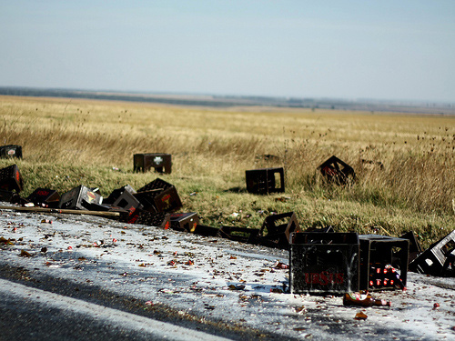  
**Beer Accident**

When working in the area of crime scenes and fires, photojournalists will encounter different receptions from law enforcement and emergency personnel. Some of the responses will be hostile toward photojournalists and other media individuals, while other responses will be more helpful. Photojournalists will need to understand what their rights are under the law in terms of photographing crime and fire scenes. In some cases, the photojournalist may have to push a bit to have these rights respected. In other circumstances, it is in the best interest of the photographer to back away and to follow the directions offered by law enforcement. Photojournalists will need to make decisions about what to do based on specific situations.

Photojournalist Responsibilities

During the twentieth century, photojournalists documented many of the defining moments and events of the century. They provided proof to societies of genocide, massacres, and wrongdoing. They documented the horror and violence of wars and then turned around and documented the joy of victory and political change. While photojournalism has not stopped wars, violence, or crime, it has been instrumental in recording these events to inform. It has focused the world’s attention on famines, genocides, and natural disasters around the globe.

Within this framework, photojournalists carry a great deal of responsibility in the photos that they take. As recorders of information, photojournalists need to be mindful of presenting the world as they see it, without manipulating the scene or telling half-truths through the visual image. The images created can carry a great deal of weight, even if the photographer is not aware of it at the time. Photographing something in a way that obscures what really happened could have real consequences for the individuals involved.

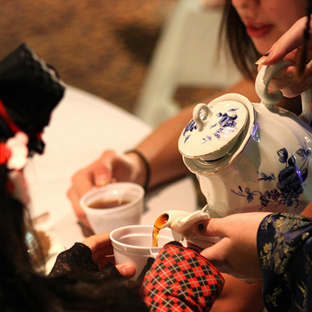  
**Saboten-Con Tea Party**

Photojournalists must also weigh the purpose of their photographs. Sometimes, the tendency is to shoot the loaded image, the one with the greatest amount of emotional content. While emotion in the photos is not an entirely bad thing, it must also be balanced by the people and events in the photos. The photograph of a dying child after an accident might have plenty of emotion to it, but is the photograph really needed? We might argue that in some cases, the picture of the dying child is part of the record and one that is appropriate in the circumstances, such as coverage of a war, act of terrorism, or large natural disaster. In others, the sole purpose of an image might be to sensationalize the event and try to manipulate the emotional response of the viewer, as in the case of a local car accident. To weigh the ethics of the photos they take, photojournalists must constantly be mindful of the purpose of the photograph and the moral and ethical guidelines of their profession.

Photojournalists may also find themselves in difficult situations, where they may witness acts of violence or danger. These situations create the choice of whether the photographer should get involved to stop the violence and help someone or whether he or she should continue to document the situation. The choice is a difficult one, and it is one that has to be made by each photographer within the context of the situation. In some cases, the greater good may be to continue to document the situation as proof that it happened, such as in the case of photographing aspects of war. In other cases, the photographer may choose to put him- or herself in jeopardy to help someone, such as a child in danger of getting run over by a car during a high-speed chase. Photojournalists should be aware of how their actions can influence not only the immediate event but also larger policies and understandings of an event.

In this unit, we examined the area of photojournalism and its role of informing society about the events that occur in our world. Photojournalism records visual information at the same time that journalism records written information. We examined some of the different types of shots that photojournalists take when covering an event or situation and some of the techniques used to capture great candid photographs. Finally, we discussed some of the responsibilities that photojournalists have and the ethical decisions that they may face while covering a story.