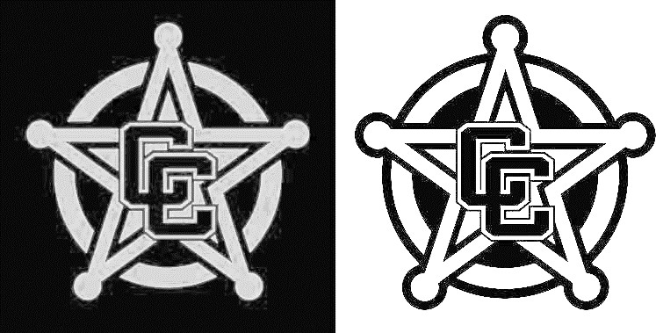 **Come be a part of a program that has produced multiple league champions, CIF place winners, champions, masters and state qualifiers in the recent years. Chino Wrestling is looking for students interested in challenging themselves in a unique sport that will help you improve your strength, speed, coordination, conditioning, and confidence. Here are just some of the reasons to join:**

**CHINO WRESTLING**

**SUMMER CAMP**

* **It is one of the most fun and challenging sports in the world.**
* **You can learn an actual martial art that will teach you self-defense.**
* **You will get into the best shape you have ever (or maybe will ever) be.**
* **All starters are determined through challenges, not selection.**
* **You can be successful individually and as a team.**

* **No other camp offers more opportunity for learning and improving.**

*All participants must have a physical dated after May 1, 2022, and be registered for wrestling on athleticclearance.com. Please have physicals turned into CHS before 6/9/2022.*

**Summer Wrestling Camp**

**This summer camp is a designed to help returning and incoming wrestlers gain an understanding of the sport of wrestling. Wrestling drills, live wrestling, and strength and conditioning will all be taught during this summer camp. Strategies, and theory of competitive wrestling will be shown to prepare wrestlers for the upcoming season.**

|  |  |  |
| --- | --- | --- |
| **Camp Directors:** | **Chino High Wrestling Staff** | **Wrestling Training** |
| **Dates:** | **1st Session: 6/6 – 6/23 2nd Session: 7/11 – 7/28** |  |
| **Time:** | **12:30 – 4PM (Mon – Thu) 12:30- 4PM (Mon – Thu)** |
| **Location:** | **Chino High Gymnasium and Weight Room** |
| **Cost:** | **$60 (includes stipends and camp shirt) Open camera 🡪** |

CONTACT:

Coach Angulo in Room 41, alex_angulo@chino.k12.ca.us, or Instagram @ chs.wrestling

*Must have proof of insurance, signed waiver, and payment due PRIOR to joining.*

**CHINO VALLEY UNIFIED SCHOOL DISTRICT**

**RELEASE AND WAIVER OF LIABILITY AND INDEMNITY AGREEMENT** **_____________________________________________________________________________________**

In consideration of being permitted to participate in the fall athletic, performing arts, and/or activity programs, field trip or excursion, sponsored, planned, and directed by the CHINO VALLEY UNIFIED SCHOOL DISTRICT, the undersigned for himself or herself and any personal representatives, heirs, and next of kin, hereby agrees to the following:

1. PARENT/GUARDIAN HEREBY RELEASES, WAIVES, DISCHARGES, AND COVENANTS NOT TO SUE THE CHINO VALLEY UNIFIED SCHOOL DISTRICT, their officers, employees, board and agents (hereinafter referred to as “releases”) from all liability to the undersigned, their personal representatives, assigns, heirs, and next of kin for any loss of damage, and any claim or demands therefore on account of injury to the person, exposure to illness, property damage, loss of property, or resulting in death of the undersigned, while the undersigned participates in the sponsored athletic/activities program, field trip or excursion, sponsored, planned and directed by the CHINO VALLEY UNIFIED SCHOOL DISTRICT.

2. PARENT/GUARDIAN HEREBY AGREES TO INDEMNITY AND SAVE AND HOLD HARMLESS the releases and each of them from any loss, liability, damage or cost they may incur due to the participation of the undersigned in the athletic/activities program, field trip or excursion, sponsored, planned, and directed by the CHINO VALLEY UNIFIED SCHOOL DISTRICT;

3. PARENT/GUARDIAN HEREBY ASSUMES FULL RESPONSIBILITY FOR RISK OF BODILY INJURY, ILLNESS, DEATH, OR PROPERTY DAMAGE while participating in the athletic/activities program, field trip or excursion, sponsored, planned, and directed by the CHINO VALLEY UNIFIED SCHOOL DISTRICT.

4. PARENT/GUARDIAN IS AWARE THAT PARTICIPATION IN THE ATHLETIC/ACTIVITIES PROGRAM PRESENTS A RISK OF PHYSICAL HARM. The undersigned is also aware that participating in the athletic/activities programs, field trip, or excursion under pandemic conditions may result in exposure to and infection with COVID-19, in addition to an injury that may result while participating in said athletic/activities program. The undersigned is aware of the risk that any part of his/her body or any of his/her body systems may be hurt, injured, or become ill by participating in the athletic/activities program. The undersigned hereby acknowledges that he/she knowingly and voluntarily assumes any and all risks of bodily injury and illness against the CHINO VALLEY UNIFIED SCHOOL DISTRICT while participating in the athletic/activities program.

PARENT/GUARDIAN further expressly agrees that the foregoing RELEASE, WAIVER AND INDEMNITY AGREEMENT is intended to be as broad and inclusive as is permitted by the law of the State of California and that if any portion thereof is held invalid, it is agreed that the balance shall, notwithstanding, continue in full legal force and effect.

My signature below indicates I have read this waiver and agreement, understand, and agree to its terms. Parent Signature _________________________________________ Date _____________

Student Name(s) and DOB(s): ______________________________________________________

Please return a signed copy of this form to your student’s coach, director, teacher, or advisor on the first day of practice or rehearsal.