**“For the Love of Facts”**

Full directions are in the summer assignment directions.

|  |  |
| --- | --- |
| “Watson, Jeopardy and Me, the Obsolete Know-It-All” by Ken Jennings (17:52) | |
| *Trivia whiz Ken Jennings has made a career as a keeper of facts; he holds the longest winning streak in history on the US quiz show Jeopardy. But in 2011, he played a challenge match against IBM's supercomputer Watson — and lost. With humor and humility, Jennings tells us how it felt to have a computer literally beat him at his own game, and makes the case for good old-fashioned human knowledge.* | |
| Evidence used by the speaker in the video | Reasonings/explanations used in the video |
|  |  |
| The video’s argument (keep in mind the argument rubric at the end of this document): | |
| What did you notice about the speaker’s presentation skills (eye contact, facial expressions & body language, visuals, animation, etc.)? What was the effect of these skills (how you viewed the presenter and the information)? | |

**“For the Love of Facts”**

|  |  |
| --- | --- |
| “Why People Believe Weird Things” by Michael Shermer (13:25) | |
| *Why do people see the Virgin Mary on a cheese sandwich or hear demonic lyrics in “Stairway to Heaven?” Using video and music, skeptic Michael Shermer shows how we convince ourselves ot believe—and overlook the facts.* | |
| Evidence used by the speaker in the video | Reasonings/explanations used in the video |
|  |  |
| The video’s argument (keep in mind the argument rubric below): | |
| What did you notice about the speaker’s presentation skills (eye contact, facial expressions & body language, visuals, animation, etc.)? What was the effect of these skills (how you viewed the presenter and the information)? | |

**“For the Love of Facts”**

|  |  |
| --- | --- |
| “Why We Should Trust Scientists” by Naomi Oreskes (19:14) | |
| *Many of the world's biggest problems require asking questions of scientists — but why should we believe what they say? Historian of science Naomi Oreskes thinks deeply about our relationship to belief and draws out three problems with common attitudes toward scientific inquiry — and gives her own reasoning for why we ought to trust science.* | |
| Evidence used by the speaker in the video | Reasonings/explanations used in the video |
|  |  |
| The video’s argument (keep in mind the argument rubric below): | |
| What did you notice about the speaker’s presentation skills (eye contact, facial expressions & body language, visuals, animation, etc.)? What was the effect of these skills (how you viewed the presenter and the information)? | |

**“For the Love of Facts”**

|  |  |
| --- | --- |
| “How to Separate Fact and Fiction Online” by Markham Nolan (13:29) | |
| *By the end of this talk, there will be 864 more hours of video on YouTube and 2.5 million more photos on Facebook and Instagram. So how do we sort through the deluge? At the TEDSalon in London, Markham Nolan shares the investigative techniques he and his team use to verify information in real-time, to let you know if that Statue of Liberty image has been doctored or if that video leaked from Syria is legitimate.* | |
| Evidence used by the speaker in the video | Reasonings/explanations used in the video |
|  |  |
| The video’s argument (keep in mind the argument rubric below): | |
| What did you notice about the speaker’s presentation skills (eye contact, facial expressions & body language, visuals, animation, etc.)? What was the effect of these skills (how you viewed the presenter and the information)? | |

**“For the Love of Facts”**

|  |  |
| --- | --- |
| “The Danger of Science Denial” by Michael Specter (19:01) | |
| *Vaccine-autism claims, “Frankenfood” bans, the herbal cure craze: All point to the public's growing fear (and, often, outright denial) of science and reason, says Michael Specter. He warns the trend spells disaster for human progress.* | |
| Evidence used by the speaker in the video | Reasonings/explanations used in the video |
|  |  |
| The video’s argument (keep in mind the argument rubric below): | |
| What did you notice about the speaker’s presentation skills (eye contact, facial expressions & body language, visuals, animation, etc.)? What was the effect of these skills (how you viewed the presenter and the information)? | |

**“For the Love of Facts”**

|  |  |
| --- | --- |
| “Why You Think You’re Right—Even If You’re Wrong” by Julia Galef (11:37) | |
| *Perspective is everything, especially when it comes to examining your beliefs. Are you a soldier, prone to defending your viewpoint at all costs—or a scout, spurred by curiosity? Julia Galef examines the motivations behind these two mindsets and how they shape the way we interpret information, interweaved with a compelling history lesson from 19th-century France. When your steadfast opinions are tested, Galef asks: “What do you most yearn for? Do you yearn to defend your own beliefs or do you year to see the world as clearly as you possibly can?”* | |
| Evidence used by the speaker in the video | Reasonings/explanations used in the video |
|  |  |
| The video’s argument (keep in mind the argument rubric below): | |
| What did you notice about the speaker’s presentation skills (eye contact, facial expressions & body language, visuals, animation, etc.)? What was the effect of these skills (how you viewed the presenter and the information)? | |

**“For the Love of Facts”**

|  |  |
| --- | --- |
| “Battling Bad Science” by Ben Goldacre(14:19) | |
| *Every day there are news reports of new health advice, but how can you know if they’re right? Doctor and epidemiologist Ben Goldacre shows us, at high speed, the ways evidence can be distorted, from the blindingly obvious nutrition claims to the very subtle tricks of the pharmaceutical industry.* | |
| Evidence used by the speaker in the video | Reasonings/explanations used in the video |
|  |  |
| The video’s argument (keep in mind the argument rubric below): | |
| What did you notice about the speaker’s presentation skills (eye contact, facial expressions & body language, visuals, animation, etc.)? What was the effect of these skills (how you viewed the presenter and the information)? | |

**“For the Love of Facts”**

DIRECTIONS: Using your notes on the assigned YouTube video listed below (and possibly re-watching the video, if needed), complete the chart as a group. At the end of the period, place this sheet in the period progress drawer.

|  |  |
| --- | --- |
| “On Being Wrong” by Kathryn Schulz(17:51) | |
| *Most of us will do anything to avoid being wrong. But what if we’re wrong about that? “Wrongologist” Kathryn Schulz makes a compeling case for not just admitting but embracing our fallibility..* | |
| Evidence used by the speaker in the video | Reasonings/explanations used in the video |
|  |  |
| The video’s argument (keep in mind the argument rubric below): | |
| What did you notice about the speaker’s presentation skills (eye contact, facial expressions & body language, visuals, animation, etc.)? What was the effect of these skills (how you viewed the presenter and the information)? | |

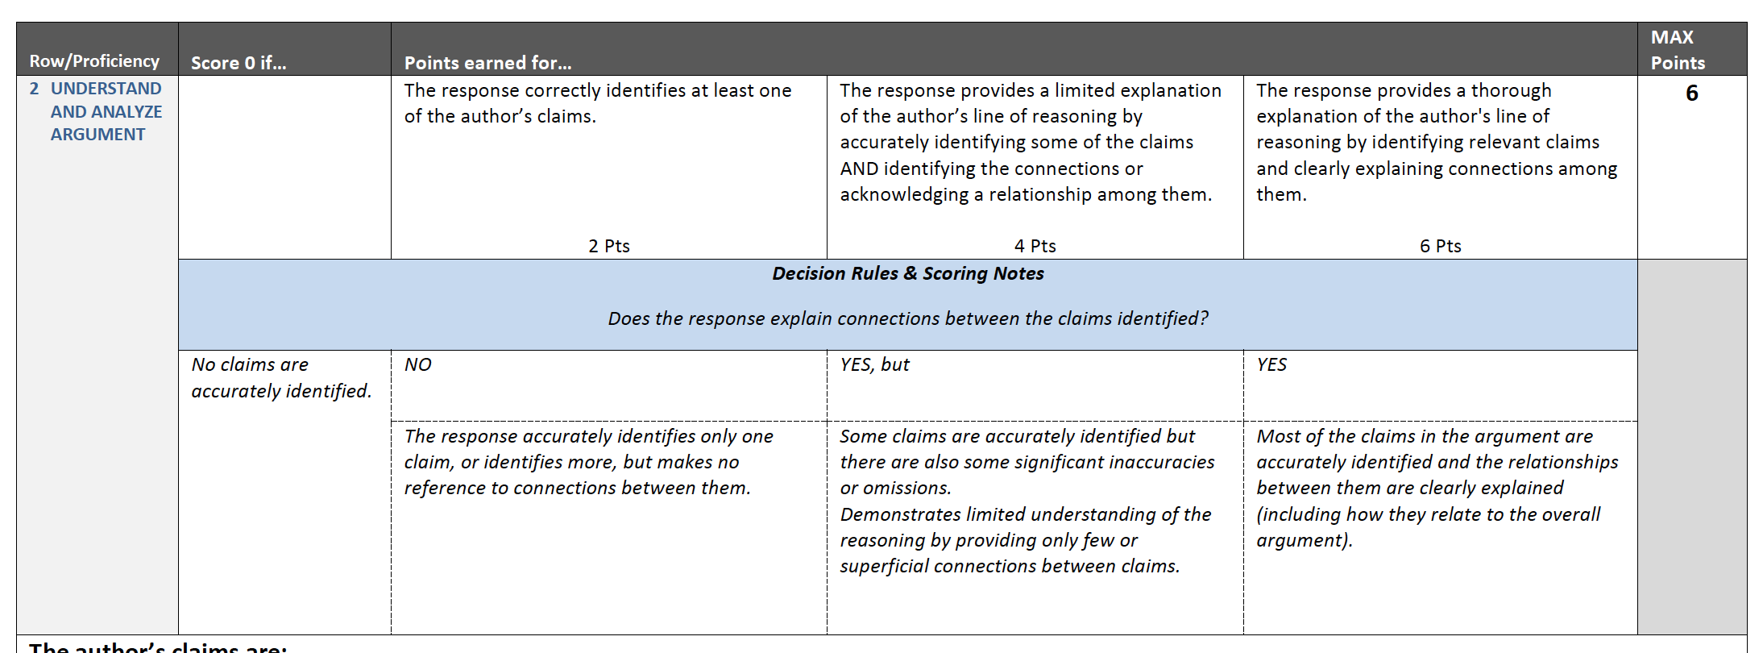

**DON’T FORGET TO WRITE YOUR 1-3 PARAGRAPH SYNTHESIS ON THE PERCEPTION OF EVIDENCE:** OUR ATTRACTION TO THEM, SOCIETAL ATTITUDES TOWARDS THEM, AND THEIR PURPOSE IN OUR SOCIETY.