## Reading Further - A Great Awakening

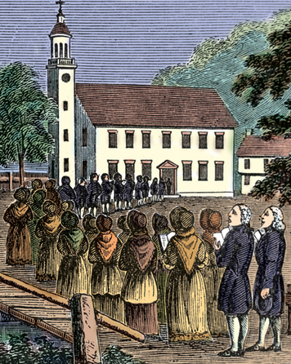**In the 1730s and 1740s, the Great Awakening shook up the English colonies. This religious movement caused an outpouring of Christian faith. It also prompted new ways of thinking about the church and society. As a result, it helped lay the foundations for political changes to come.**

Nathan Cole was working on his farm on the morning of October 23, 1740, when he heard the news. George Whitefield was coming.

A famous preacher, Whitefield was known for his powerful sermons. He had traveled all over the colonies, drawing huge crowds wherever he went. Now he was in Connecticut. In fact, he was preaching in nearby Middletown that very morning. Cole knew he had to move fast.

I dropped my tool . . . and ran to my pasture for my horse with all my might fearing that I should be too late to hear him. I brought my horse home and soon mounted and took my wife up and went forward as fast as I thought the horse could bear . . .

And when we came within about half a mile [from the mainroad] . . . I saw before me a Cloud or fog rising. I first thoughtit came from the great river, but as I came nearer . . . I hearda noise something like a low, rumbling thunder and presentlyfound it was the noise of horses’ feet coming down the road andthis Cloud was a Cloud of dust . . . As I drew nearer it seemedlike a steady stream of horses and their riders . . . Every horseseemed to go with all his might to carry his rider to hear newsfrom heaven for the saving of Souls.

—Nathan Cole, in George Leon Walker, Some Aspects of Religious Life in New England, 1897.

Thousands of people were rushing to Middletown to hear Whitefield speak. “I saw no man at work in his field,” Cole wrote, “but all seemed to be gone.” When Cole and his wife reached the town, they found a large crowd gathered there. The mood was electric as they waited for Whitefield to appear.

What was behind all this excitement? Why would a preacher’s arrival cause a commotion like that of a rock star or a Hollywood celebrity today?

In fact, Whitefield was a superstar of his time. He was the most famous figure in a religious revival that was sweeping the colonies. People were seeking a deep spiritual experience and a direct connection to God. They found that connection in preachers like Whitefield.

### Origins of the Awakening

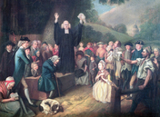Religion played a major role in the lives of colonists in the early 1700s. Most people attended church regularly. There were a number of different churches, but most provided a similar experience. They emphasized traditional religious teachings. Their ministers were educated men who valued reason over emotion. The atmosphere in church was calm and orderly.

Some ministers, however, believed that the church had lost its way. They feared that religion had become a collection of formal, empty rituals. They wanted to wake people up and renew their faith. In their sermons, they offered an emotional message of sin and salvation that was aimed at the heart, not the head.

By the 1730s, a split was developing between old-line ministers and those favoring a new way. These two groups became known as the Old Lights and the New Lights. The Old Lights stressed tradition and respect for authority. The New Lights called for a more individual, personal form of worship. They wanted people to feel the spirit of God for themselves.

Whitefield and other New Light ministers often preached at open air revivals. They depicted the glories of heaven and the miseries of hell. Hearing these highly charged sermons, many people were seized by feelings of great joy or despair. They would weep, moan, and fall to the ground. As news of the revivals spread, the movement gained strength.

### Leading Lights: Whitefield and Edwards

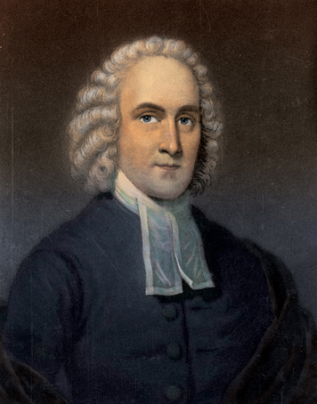A number of ministers played key roles in the Great Awakening. The leading figures, however, were George Whitefield and Jonathan Edwards. If Whitefield was the star of the movement, Edwards was its most important thinker.

Whitefield was a young Anglican minister in England when he joined the revival movement. In 1739, he defied church authorities by holding revival meetings across the country.

That same year, he traveled to the colonies, where he caused a sensation. Whitefield was a magnificent speaker with a beautiful voice and the skills of an accomplished actor. His words and gestures could lift audiences into an emotional frenzy. He toured from Maine to Georgia, appearing in towns and cities along the way. In Boston, some 20,000 people gathered to hear him speak. He was the most celebrated man in America.

Whitefield was pleased with his success. But he was also troubled by the wealth and vanity he saw in the colonies. Noting the fine clothing worn by wealthy citizens, he argued that Christians should dress simply and plainly. In Boston, he was disturbed to see young children dressed in fancy clothes:

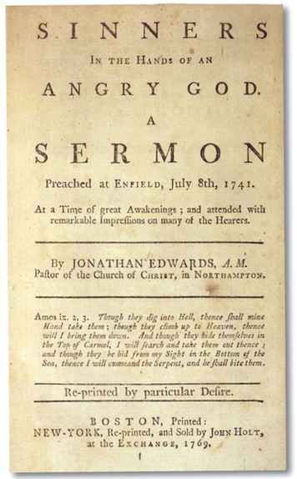The little infants who were broughtto baptism were wrapped up in suchfine things . . . that one would thinkthey were brought thither [there] tobe initiated into, rather than to renounce, the pomps and vanities of this wicked world.

While in Massachusetts, Whitefield visited Jonathan Edwards at his home in Northampton. Edwards had helped start the revival movement and had been a great influence on Whitefield. Edwards, in turn, recognized that Whitefield had given new life to the movement. He decided to increase his own efforts to win converts. In this way, he said, he hoped to “make New England a kind of heaven upon earth.”

Edwards began to preach in neighboring towns. In 1741, he gave his most famous sermon in Enfield, Connecticut. Called “Sinners in the Hands of an Angry God,” this sermon was directed at a congregation that had resisted the revival message. Edwards told them that they had angered God with their sinful ways. God held them in his hand, he said, and could cast them into hell at any moment.

The God that holds you over the pit of hell,much as one holds a spider . . . is dreadfullyprovoked; his wrath towards you burns likefire . . . ’Tis nothing but his hand that holdsyou from falling into the fire . . . Oh sinner!Consider the fearful danger you are in . . .

And now you have an extraordinaryopportunity, a day wherein Christ has flungthe door of mercy wide open, and standsin the door calling and crying with a loudvoice to poor sinners; . . . many that werevery lately in the same miserable conditionyou are in, are in now a happy state, . . . rejoicing in the hope of the glory of God. Howawful is it to be left behind at such a day!

These words had a devastating effect. The congregation began to wail and beg for mercy. The “shrieks and cries were piercing,” wrote one witness. The uproar was so great that Edwards could not even finish his sermon.

### The Impact of the Awakening

Over the next few years, such incidents became more common. At the same time, the split between Old Light and New Light ministers grew wider. Churches were breaking apart. For the sake of unity, both sides agreed to make peace and heal their divisions. By the late 1740s, the Great Awakening was over.

The impact of the movement was deep and ongoing, however. New Light preachers had encouraged people to think for themselves and to make their own choices about religious faith. As a result, the church no longer had absolute authority in religious matters. Preachers also taught that everyone was equal in the eyes of God. As one preacher said, “The common people . . . claim as good a right to judge and act for themselves . . . as civil rulers or the learned clergy.” By encouraging people to act independently and defy authority, the Great Awakening helped lay the groundwork for rebellion against British rule.

**Preparing to Write: Analyzing Speeches**

In the 1730s, George II was the King of England. Few, if any, colonists questioned their loyalty to the king—even though he was more than 3,000 miles away. However, colonists soon began to think differently about the king. In less than 50 years, they would declare independence from English rule altogether.

Historians believe that some of the seeds of that new way of thinking were planted during the Great Awakening. Read these two excerpts from sermons at the time.

*The wrath of kings is very much dreaded, especially of absolute monarchs, who have the possessions and lives of their subjects wholly in their power . . . But the greatest earthly potentates [rulers] in their greatest majesty and strength . . . are but feeble, despicable worms of the dust, in comparison of the great and almightly Creator and King of heaven and earth.* —Jonathan Edwards, “Sinners in the Hands of an Angry God,” 1741

*The essence of government (I mean good government . . . ) consists in the making and executing of good laws [that provide for the common welfare] of the governed . . . We may very safely assert . . . that no civil rulers are to be obeyed when they [make laws] inconsistent with the commands of God . . . All commands running counter to the declared will of the Supreme Legislator of heaven and earth are null and void, and therefore disobedience to them is a duty, not a crime. Another thing may be [argued] with equal truth and safety, is, that no government is to be submitted to at the expense of that which is the sole end of all government—the common good and safety of society.* —Jonathan Mayhew, “A Discourse Concerning Unlimited Submission and Non-Resistance to the Higher Powers,” 1750

* 1. What does Jonathan Edwards say about the power of kings?
  2. According to Edwards, which is greater: the power of God or the power of kings? Why?
  3. What is the duty of good government, according to Jonathan Mayhew?
  4. According to Mayhew, when should citizens disobey their government?
  5. If you believed the teachings of Edwards and Mayhew, would you think you had a right—or even a duty—to disobey the king? If so, under what circumstances?

**Writing a Diary Entry**

Suppose you had lived in one of the 13 colonies in 1750. Write a diary entry about the your experience of the Great Awakening. In your entry, do the following:

1. Tell how the sermons of the Great Awakening have affected you.
2. Explain whether you feel the same way about people in authority as you did before the Great Awakening, and why or why not.
3. use this rubric to evaluate your diary entry. Make changes in your entry if you need to.

|  |  |
| --- | --- |
| **Score** | **Description** |
| 3 | The diary entry has a clear point of view and many details. It is well constructed as a diary entry. It addresses the points listed. It has no spelling or grammar errors. |
| 2 | The diary entry has a clear point of view and some details. It is fairly well constructed as a diary entry. It addresses most of the points listed. It has few spelling or grammar errors. |
| 1 | The diary entry does not have a clear point of view and has few details. It is not well constructed as a diary entry. It addresses few of the points listed. It has many spelling or grammar errors. |