UNIT FOUR: Photography Software

“There are three key things for good photography:  
the camera, lighting and...Photoshop.” –Tyra Banks

Darkrooms have been used for many years by professional photographers to develop and fix images taken with film cameras. While some photographers will use darkrooms to develop their photographs, many amateur and professional photographers are turning to digital cameras for their photographs. This change in technology has opened up the door for the photo editing software that many of us use today.

  
**Fireworks montage. The photograph merges eight different images.**

**Photo editing software programs** allow a photographer to edit or manipulate photographs that were taken by a digital camera (or that were taken with a film camera and scanned into the computer). Some of these programs are commonly included in the software packages that accompany a new computer or a new digital camera. Other programs are marketed to professionals, while still others are built by a community of people interested in photography and image manipulation. In today’s world, photo editing software has become a part of our daily lives. If we don’t use it ourselves, we still see the products of the software online and in advertising. For professionals, this software can help them enhance their images in a variety of ways.

In this unit, we will consider photo editing software and the changes that it is making to photography. We’ll examine some of the common programs available and some of the tools and features that photographers often use in manipulating and changing their images. Even if a photographer chooses not to use the programs, knowledge of them can help photographers stay competitive in the field.

Photo Editing Software Choices

As digital cameras have become more available and accessible for the average photographer, the market has also seen an increase in the number of photo editing software programs available. The software ranges from the more expensive to free and from more complicated programs to those that can only do a few types of editing to a photo. Although photo editing software often comes included in many new computer purchases, you may find that a different program allows you to do more of what you want to do.

Which software program is best? The answer may depend on you. The best photo editing software program is one that meets your price range and that allows you to do the editing you need to do without being too confusing or advanced for your skills. Some individuals will buy one of the more expensive programs with all of the bells and whistles, but then they can’t figure out how to use those bells and whistles. Many photographers have a particular program that they are comfortable with and that they have a preference for.

Adobe Photoshop

This software editing program is one of the most popular on the market, as well as one of the more expensive options. You may have heard image editing referred to as “Photoshopping.” This speaks to the popularity and power of this software option. **Adobe Photoshop** has been considered the industry standard for image editing for many years. Although other photo editing software is challenging this status, Photoshop is still probably the most popular for professionals.

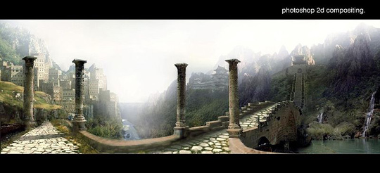  
Illustration of a Photoshop mattpainting artwork

Adobe Photoshop has several advantages that are worth noting. For professionals, Photoshop offers most, if not all, of the tools and actions that you would want in an image editing program. It has a wide range of filters that can create interesting effects in images, for example. It also offers photographers the ability to do special effects, create animation, and edit photographs in many different ways.

However, Adobe Photoshop also has some important disadvantages that photographers need to be aware of. One of those is that Photoshop is expensive. It is one of the most costly photo editing programs (currently the latest version is priced at over $600). Student versions are lower in price, although still relatively expensive, and can offer a more reasonable introduction to Photoshop. Many of the same editing actions can be accomplished by free software programs. Adobe Photoshop also contains a lot of features, and while this is an advantage for some users, it can be a disadvantage for others. The casual user may find that the program has too many features that they don’t want or need, and the amount of features can be quite confusing for many beginner users as well. It does have a steep learning curve for beginners, and many find that taking Photoshop courses or tutorials is a necessary step in learning the software.

Adobe Photoshop Elements

In addition to the normal Photoshop software program, Adobe also offers **Photoshop Elements,** which is a pared down version of the original. Although the software does not have some of the higher-end components, it does have the core set of tools and features that have made Adobe Photoshop so popular over the years. While Photoshop combines features for both image editing and other areas such as graphics and animation, Photoshop Elements focuses on the image editing side of things, which is a plus for digital photographers. The program is also much less expensive than the original Photoshop, which makes it attractive to both amateur and many professional photographers. The interface is also easier to learn and master than the original, which benefits beginners to photo editing as well as experienced users.

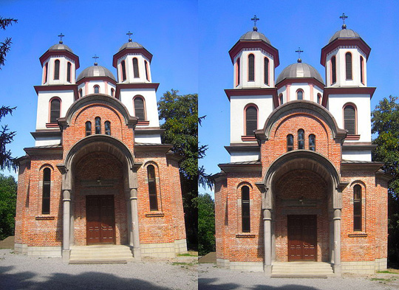  
**Original picture on left; picture on right is after using Lens Correction in Photoshop**

As the software does lack some of the features of Adobe Photoshop, Photoshop Elements may not be the right program for everyone. In some cases, work-arounds can be developed to mimic the tools in Photoshop, but not everyone will want to take the time or the effort to find and develop them. Some professional users will also want or need the higher-end tools and features that are not included in this software.

Adobe Photoshop Lightroom

Another of Adobe’s photo editing software options, **Lightroom** was created to help professionals manage and speed up the processing of RAW photographs. The program can sync with Photoshop or it can stand on its own as an image editor. Falling between Photoshop and Photoshop Elements in cost, Lightroom helps photographers organize and manage the photos that they take. As you can imagine, professional photographers may have thousands of images that they need to keep track of and Lightroom offers support in the tagging and organization of those photographs.

The software does lack some of the higher-end features of Photoshop, so some professionals use both Lightroom and Photoshop. Since the same company makes both, the programs are set up to work together.

Lightzone

Light Crafts **Lightzone** is a software program similar to Adobe’s Lightroom in both operation and cost. It is designed to handle RAW image files. As a photo editor, it contains most of the usual tools and features. It also includes the ability to work in layers, which makes it easier to remove a change that you don’t like after you’ve tried it.

PaintShop Pro

**PaintShop Pro** by Corel is another popular image editing software program on the market. Like Adobe Photoshop, PaintShop Pro is considered one of the more premier image editing programs. It is more expensive than software such as Photoshop Elements, but it is less expensive than Adobe Photoshop, at less than half the cost. This makes it a popular option for professional photographers who want a more advanced software program, but don’t want to pay the full price of Adobe Photoshop.

While PaintShop Pro lags behind Photoshop in a few areas, it has most of the same features and tools. One of the few drawbacks of the program for some users is that it is only available for Windows users. There is not currently a version that will work on a Mac computer, which does limit its usage.

Serif PhotoPlus

**PhotoPlus** offers another lower cost alternative to Photoshop. Although the software lacks some of the higher-end features of Photoshop, it is often priced below $100, making it attractive to many photographers. While most professionals will want a software program that allows for more editing options, PhotoPlus can be an option for beginners or for those who only do lighter editing.

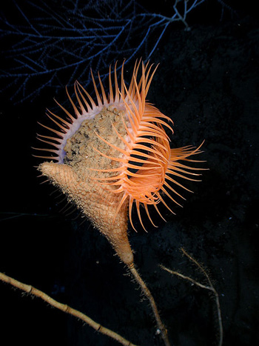  
Venus flytrap anemone (Actinoscyphia aurelia) in the Gulf of Mexico

GIMP

Not all photo editors cost a lot of money though. **GIMP** is a free open source editing program that is often compared to Photoshop. GIMP stands for GNU Image Manipulation Program, and as it is developed by the community that uses it, it is updated frequently with the types of tools and features that photographers and image editors want to see and use. You can even modify the program so that it looks and feels more like Photoshop, if you are used to that software or want to prepare yourself to use it.

GIMP doesn’t have all of the features of Photoshop, but for a free software option, it does fairly well. Like Photoshop, however, it can be somewhat confusing to use, and there is a learning curve in mastering the software. Another thing to keep in mind is that because it is user developed and maintained, there is not a traditional support option. In other words, if you have a problem with the software, you can’t call up tech support for help figuring out the problem. Instead, you would have to post on a GIMP message board or forum and ask other users for help.

Other Software Options

There are any number of other photo editing software options on the market today. The software programs that we’ve discussed, as some of the more commonly used programs, are just the tip of the iceberg. For professionals, the key is to find an editing program that offers the features that you want in a format that you understand and like. Many photo editing software options do offer trial periods, which can give you a sense of whether you will like the program long term. This can be particularly helpful if you are thinking about a program that costs several hundred dollars.

Photo Editing: Doing It Right

With the greater availability of photo editing software today, it is common for both professional and amateur photographers to use editing software. While photo editing can be helpful in many circumstances, it should also be undertaken with care. A great photograph might be lost in seconds or changed in a way that takes away from the good elements in the original photograph. Thus, it is important when doing photo editing to keep a few things in mind.

[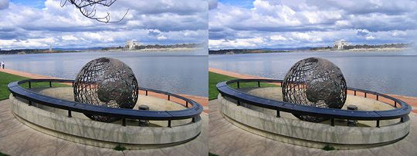](https://chino0988-chinovalleyvirtual-fps.gradpoint.com/Resource/600107,4C9,0,0,3A/Assets/04Unit04/WEB/04Unit04/images/image009-full.jpg)  
**Can you spot the difference?**  
Click image for larger size

One of the basic guidelines to remember when editing photographs with a photo editing software program is that less is often more. Many inexperienced photographers will make all sorts of adjustments to their photographs. These adjustments can become too much. In some cases, it may distort parts of the photograph or make the photograph look unreal. Because of the influence that editing software can have on a photo file, it is always important to make a copy of the original file. This way, if you do get a bit overzealous on an edit, you’ll still have the original file of the photo.

Photo editing software can be a useful tool, but it also is constrained by the photograph itself. In other words, photo editing software programs cannot magically transform a bad photograph into an award-winning one. While the editing tools can make enhancements or edits to a photo that will make it better, the foundation of a great photograph needs to be present in order for the final copy to be a great photograph. Too often, photographers will snap photographs thinking that they will be able to change the photograph later. It is better to start off with the idea that you want a great photograph that doesn’t need to be touched up at all. This can help you focus on the composition, lighting, and other aspects of the photograph so that you have a good base to use. Then, if editing on the photograph is needed, they will more than likely be smaller edits that the software can more easily accomplish.

Another helpful hint for professional photographers who will use photo editing software is to take the photos in the highest quality and highest resolution settings possible on the camera. Many photographers prefer to use the RAW setting, for example. The quality and resolution will affect your ability to resize or edit a photo without having a noticeable decrease in the quality of the image. The image files will be larger and you may want a memory card with more room, but you’ll benefit from higher quality photographs in the end.

When editing photographs with software on a computer, you’ll also want to make sure that the computer monitor colors are displaying correctly. Imagine adjusting the color in a photo only to discover later that what you thought looked white on the screen actually looks gray when the photograph is printed. To avoid these problems, you can calibrate your monitor and pay attention to how photographs look when you’ve printed a few that you’ve edited.

  
Photo montage

Being able to successfully edit photographs manually requires that the person doing this have both time and skill. Editing photographs using a software program is a creative process. It is about knowing how much of a change will have the greatest effect and improve the image. Photographers may need to spend time practicing with the different tools and features to achieve the best results using photo editing software.

Common Editing Tools and Actions

Regardless of the photo editing software program that you choose to use, there are some common tools that are often included in these programs. Not all programs will have the same tools available or be able to perform all forms of image editing. For example, those targeted toward consumers will often have fewer tools than those targeted at professional photographers.

One common feature that many software programs have is a way of selecting certain areas or parts of a photo. This feature allows the editor to choose particular areas of the image to make changes to without having to alter the entire image. For example, you might want to blur the background of a photo while leaving your subject in focus or you might want to change the color of a flower while leaving the rest of the image the way it was in the original. Selection tools include lassos (think of a rope lasso), marquee tools, and vector pen tools. all can accomplish the goal of selecting certain areas of the photo. Selection features are often used to accomplish many of the actions and changes that we’ll discuss below.

**Image scaling** is the process of resizing an image, making it either smaller or larger in size. This is important to do when creating prints of an image or when placing an image online. For example, high resolution images can be quite large. In order to post one of these photographs online, you might need to reduce the image to a smaller size (which would also reduce the image file size on your computer).

**Cropping** is another tool that many people are familiar with since it appears in most image editing software programs. Simply put, cropping means to create a new image by selecting a particular portion of the original photograph. It is similar to taking a pair of scissors and cutting off part of the original. Cropping is typically used to improve the composition of the image. For example, you might have a photo with a flower in it, but you’ve also got a lot of distracting items around the flower. You could crop the original photograph so that only the flower is present. This type of cropping works best when you have a high resolution image available.

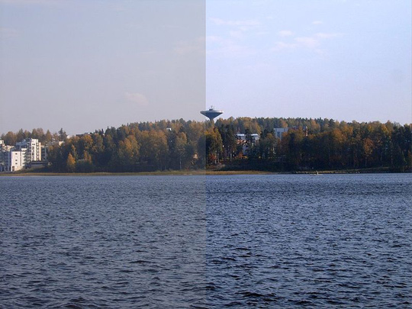  
**Contrast correction. Left side of the image is unmodified; right side has been touched with GIMP**.

**Color adjustments** can be made in a number of ways and for a number of reasons. In some cases, you may find that the white balance is off. In many image editing software programs, you can adjust the image so that the white in your photograph is truly white, which will also adjust the other colors as well. Editing tools can also be used to lighten or darken colors as well as to selectively change the color of particular objects in a photo.

**Layers** are a feature in some software programs that separates various elements in an image. They can perhaps best be thought of as a sort of transparency or overlay that is placed over the top of an image to change that image in some way. For example, you might have a photo of a beach and you want to add an umbrella to the image. By using a layer containing an umbrella, you could place this overtop the beach image, instantly adding it to your image. Some images will have multiple layers, each adding or changing the image in some way. In addition to simply superimposing something on an image, you can adjust parts of the layer as well. For example, maybe you have a picture of a graveyard and you want to superimpose a ghost using a layer. You can make the layer containing the ghost partially transparent so that it appears more ghostlike in the graveyard. In addition, layers can also be used to adjust the color, saturation, or other aspects of a photo in certain areas. Those changes are then superimposed on the original to create a new image. Layers also provide a way to make changes that are nondestructive to the original image.

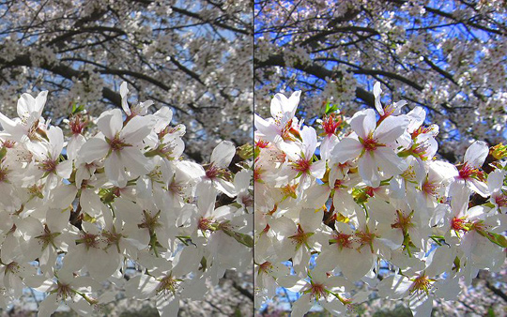  
**Example of color correction**

Another way that layers are sometimes used is to merge images together into one image. In some cases, a collage effect may be sought while in others, the images are brought together in such a way that they appear to have been part of the same image all along. Some photo editing software uses this to create panoramic photographs. The merging of images can be done in other ways as well, depending on the software being used.

**Noise reduction** is a feature that has become increasingly popular as individuals try to sell photographs on stock image sites, use them on computer screens, or post them online. In simple terms, noise reduction reduces speckling, dust particles, scratches, and minute light disturbances in the image. Noise is more likely when a photo has been taken in low light conditions, but it can appear in any photograph. While noise reduction features can eliminate noise in the image, it can also lead to a loss of detail in the image. In some cases, a photographer may want to actually add noise to produce a grainy type image that appears like an old photograph. Many software programs have this capability as well.

**Perspective control** features help photographers make all lines vertical that are vertical in reality. Have you ever taken a photo of a tall building? Chances are that if you did, the vertical lines of the building appear to be getting closer the higher they go. This distortion occurs because we often tilt the camera back from the building in order to get it all in the frame. You may have noticed this perspective distortion happen with railroad tracks as well, as they appear to grow closer the farther out they are. This can be fine in real life, where those perspectives help us to gauge distance and depth, but it’s not always a desired trait in an image. Perspective control allows the photographer to correct this in the photo, making all vertical lines vertical.

Photo editing software is also often used to eliminate unwanted images from a photo. In some cases a photographer might crop an image to eliminate an object or person from the image, but in others, cropping is not an option as it would ruin the photo. In these cases, tools such as cloning can help a photographer remove an item and replace it with another piece of the image. For example, if you had a picture of a car, but there was a piece of trash next to the tire, you could clone the pavement in the picture and place this over the piece of trash, eliminating it from the photo. Cloning and other tools can also be used to eliminate power lines, branches, and other elements that might distract from the focus of the image.

Image editors are a common feature of photo editing software. These tools are used to enhance an image through changing the contrast, adjusting the brightness of the image, or adjusting the color. Some image editors can eliminate red eye in a photo or change other aspects of the photo.

  
**This is an example of the special kinds of effects that image editors can add to images.**

**Filters** are another common feature in many photo editing software programs. Filters are used to create different effects in the photos, and you can usually control the degree to which the filter will change the photo. For example, there are filters that take an image and make it look like a painting, filters that blur the photo, and filters that distort the photograph in different ways. Filters can also add lighting effects, add texture or pattern to the image, and stylize the image. In addition, filters may be used to create special effect type photographs, although there are often other ways to achieve these special effects, as well.

In this unit, we examined the “digital darkroom” of photo editing software programs. With the growth of digital cameras for both amateur and professional photographers, photo editing software has become a tool that many photographers use. These software programs allow photographers to make minor changes to improve a photo or to apply special effects for an entirely different look to the image. We examined a few of the common image editing software programs, some general guidelines in working with these editing tools, and some of the common features and tools that the programs contain.